

Artificial Intelligence (AI-2002)

Report: Health Sense AI
Precision Clinical Intelligence

Date of Submission: 28th April 2026
Instructor: Sir Atif Luqman

HealthSenseAI is result of hard work made by three members:

Iqra 24K-1024
Fabiha Siddiqui 24K-1022
Syeda Maha Fatima 24K-0624

Belonging to

Section: BCS-4J
Department: Computer Science
Institute: FAST NUCES, Karachi.

1. Abstract
HealthSenseAI is a comprehensive, full-stack health management system designed to bridge the gap between raw clinical telemetry and actionable patient insights. The project integrates multiple domains of Artificial Intelligence, including probabilistic machine learning (Gaussian Naive Bayes), ensemble methods (Random Forests), trend prediction (Linear Regression), evolutionary search (Genetic Algorithms), and generative Natural Language Processing (Llama-3.1). The outcome is a highly aesthetic web application that evaluates patient biomarkers to predict conditions like Anaemia, Diabetes, or Cardiovascular diseass, autonomously generates 7-day wellness protocols, and plots longitudinal health trajectories. A unique feature of this project is its hybrid AI approach—seamlessly combining traditional predictive models, goal-based search agents, and modern NLP within a unified, modern interface.

2. Introduction
2.1 Background & Theoretical Context
With the rapid digitalization of healthcare, there is a growing need for accessible systems that can perform initial clinical triage. Traditional medical software often relies on rigid, rule-based logic that fails to capture the complex, non-linear relationships between various health biomarkers. Artificial Intelligence provides a theoretical framework to solve this by learning patterns from historical data, predicting future trends, and optimizing solutions through heuristic search algorithms.
2.2 Problem Statement & Real-World Relevance
Patients frequently struggle to interpret raw medical reports and lack immediate guidance on how to adjust their lifestyle post-diagnosis. Furthermore, they struggle to visualize whether their health is improving or deteriorating over time. We chose this project to democratize health data interpretation. The real-world relevance lies in its potential to assist in preventive healthcare—helping users identify early warning signs of chronic conditions and offering optimized lifestyle interventions before severe medical intervention is required.

3. Objectives
Following were the main objectives that were achieved through this project.
- Predictive Diagnostics
Train robust Machine Learning classifiers to predict health states based on distinct clinical features.

- Patients Tracking
Implement predictive mathematical modelling to track and forecast patient biomarker trends over time.

- Algorithmic Optimization
Implement a Genetic Algorithm to search a vast state space of diet and exercise combinations, outputting an optimal 7-day treatment plan.

- AI Chatbot Integration
Integrate a context-aware NLP chatbot restricted strictly to medical queries.

- Full-Stack Modular Implementation
Engineer a seamless, stateless backend using highly modularized Python scripts mapped to a modern frontend dashboard.

4. System Architecture & File Definitions
To ensure maintainability and separation of concerns, the python files were separated.
4.1 Application Routing & Logic
- app.py: The central nervous system of the project. It initializes the Flask web server, handles API routing, manages user authentication, stores longitudinal data in the JSON database, executes Linear Regression for frontend chart trajectories, and manages the API connection to the Groq Llama-3.1 NLP model.
- utils.py: A helper library that defines universal medical constants (e.g., HEALTHY_RANGES), maps standard recommendations for specific diseases, and parses uploaded .csv or .txt medical reports into usable data dictionaries.

4.2 Data Engineering & Preprocessing
- synthetic_generator.py: Since real clinical data is protected, this script uses statistical normal distributions (np.random.normal) to generate a highly realistic synthetic dataset of patients suffering from Diabetes, Heart Disease, Anemia, or who are otherwise healthy.
- data_prep.py: The preprocessing engine. It handles data cleaning, fills missing values using median imputation, encodes categorical variables (LabelEncoder), and mathematically normalizes continuous variables (StandardScaler) to prepare them for the AI models.
4.3 Model Training & Evaluation
- train_model.py: The model building script. It takes the preprocessed data, splits it into training and testing sets, and trains both the Gaussian Naive Bayes and Random Forest classifiers, ultimately saving the serialized models as .pkl artifacts.
- model_evaluate.py: The testing framework. It evaluates the trained models against unseen data, outputting critical performance metrics such as accuracy, precision, recall, and the confusion matrix. It also allows for command-line single-case predictions.
4.4 Search Agents
- genetic_planner.py: Contains the TreatmentGeneticAlgorithm class. It manages the evolutionary search logic (fitness evaluation, crossover, mutation) required to generate the optimized 7-day lifestyle interventions based on the user's specific diagnosis.

5. Dataset Description
5.1 Dataset Overview
The project uses a curated clinical dataset (data.csv) containing 1,000 patient records across 9 features. The dataset was used for both training and evaluation of the machine learning models.

Property | Value
Total Records | 1,000 patient entries
Feature Count | 9 (8 input features + 1 target label)
Target Classes | 4 (diabetes, heart, anemia, healthy)
File Format | CSV (Comma-Separated Values)
Source | Curated clinical/synthetic medical dataset

5.2 Feature Descriptions
Feature | Type | Description & Normal Range
gender | Categorical | Biological sex — Male / Female (encoded: 1.0 / 0.0)
glucose | Numerical (Float) | Blood glucose level in mg/dL (Normal: 70–120)
blood_pressure | Numerical (Float) | Systolic blood pressure in mmHg (Normal: 90–130)
heart_rate | Numerical (Float) | Heart rate in beats per minute (Normal: 60–100)
hemoglobin | Numerical (Float) | Hemoglobin concentration in g/dL (Normal: 12.0–17.0)
cholesterol | Numerical (Float) | Total cholesterol in mg/dL (Normal: 125–200)
bmi | Numerical (Float) | Body Mass Index in kg/m² (Normal: 18.5–24.9)
age | Numerical (Float) | Patient age in years
disease | Target Label | Disease class: diabetes / heart / anemia / healthy

6. Core Artificial Intelligence Concepts
This project serves as a comprehensive showcase of multiple AI sub-disciplines:
6.1 Trend Prediction (Linear Regression)
Implementation: app.py
To provide patients with an understanding of where their health is heading, the system tracks historical data (e.g., past readings) and applies Linear Regression.
- Concept: It models the relationship between a scalar response (biomarker value) and an explanatory variable (time/visits) by fitting a linear equation to observed data.
- Equation:
$$y = mx + c$$
- Application: Used in the frontend Chart.js components to draw a trendline, indicating to the patient if their cholesterol or glucose is mathematically projected to increase or decrease over their next few visits.

6.2 Ensemble Classification (Random Forest)
Implementation: train_model.py
- Concept: An ensemble learning method that constructs a multitude of decision trees at training time. It trains trees on different subsets of the data and averages their predictions.
- Application: Serves as the primary, definitive diagnostic engine
(n_estimators=200, max_depth=10)

It is highly resistant to overfitting complex medical features, providing the final classification of Healthy, Diabetes, Heart Disease, or Anaemia.

6.3 Probabilistic Inference (Gaussian Naive Bayes)
Implementation: train_model.py
- Concept: A probabilistic classifier based on Bayes' Theorem, assuming strong (naive) independence between features. Because clinical variables (like blood pressure) are continuous, the Gaussian variant is applied, assuming the features follow a normal distribution.
- Equation:
$$P(c|x) = \frac{P(x|c)P(c)}{P(x)}$$
- Application: Rather than a binary output, this model provides the user with a percentage-based probabilistic breakdown of their health risks (e.g., 85% probability of Diabetes, 12% probability of heart disease).

6.4 Evolutionary Search Agents (Genetic Algorithms)
Implementation: genetic_planner.py
- Concept: A heuristic search algorithm inspired by Charles Darwin's theory of natural evolution. It reflects the process of natural selection where the fittest individuals are selected for reproduction.
- Application: Generates the 7-day wellness protocol.
  - State (Chromosome): An array of 7 pairs of meals and exercises.
  - Fitness Function: Rewards safe actions (e.g., DASH diet for Heart Disease) and heavily penalizes dangerous ones (e.g., HIIT workouts for Heart Disease).
  - Evolution: Uses Elitism, Crossover, and a 10% Mutation rate over 50 generations to converge on the mathematically optimal lifestyle plan.

6.5 Generative AI & Natural Language Processing (LLMs)
Implementation: app.py
- Concept: Transformer-based Large Language Models predict optimal token sequences using self-attention mechanisms to generate human-like text.
- Application: Integrated via the Groq API (Llama-3.1). We applied strict Prompt Engineering techniques to create a system prompt that enforces absolute domain restriction—forcing the AI to act exclusively as a clinical assistant, read user-uploaded files, and decline non-medical questions.

6.6 Statistical Data Imputation & Normalization
Implementation: data_prep.py
- Concept: AI models require mathematically sound data. The project utilizes Median Imputation to replace missing dataset values without skewing the distribution. Furthermore, StandardScaler is applied to transform the data so that it has a mean of 0 and a standard deviation of 1, ensuring features with larger magnitudes (Cholesterol) do not mathematically dominate smaller features (Hemoglobin).

7. Simulation & Implementation
7.1 Development Environment & Tech Stack
Backend & AI | Flask, Python 3.10, Scikit-Learn, Pandas, NumPy.
Frontend: | HTML ,CSS, JavaScript, Chart.js
Database: | Stateless JSON-based storage (patient_history.json, users.json).

7.2 Screenshots
Splash Screen (Login/Signup)
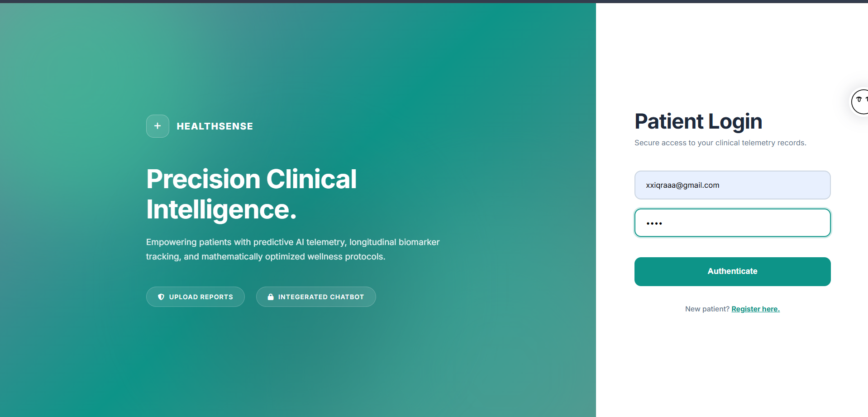

Dashboard
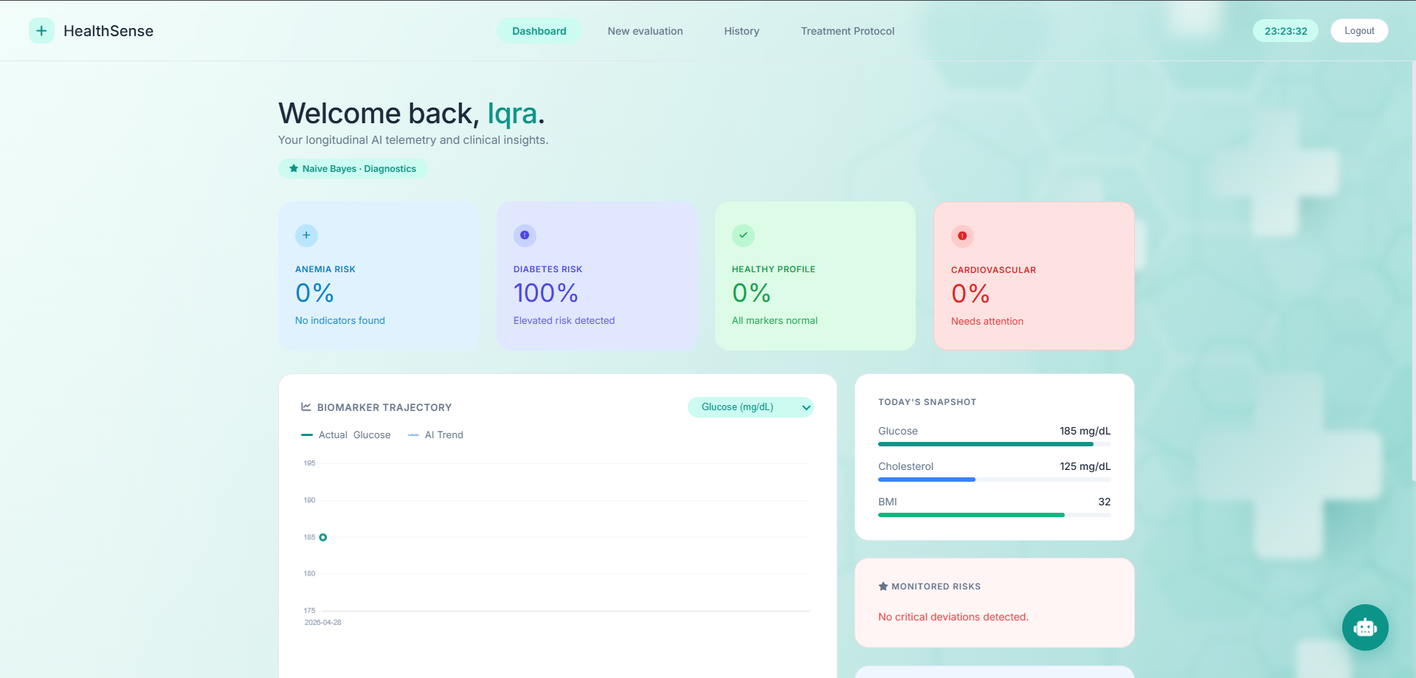

Evaluation Screen
Demographics – Vitals -- Report
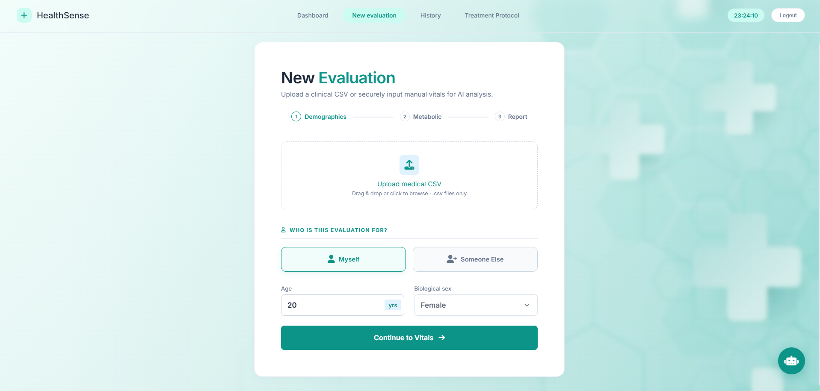
Either CSV Upload / Enter Manually
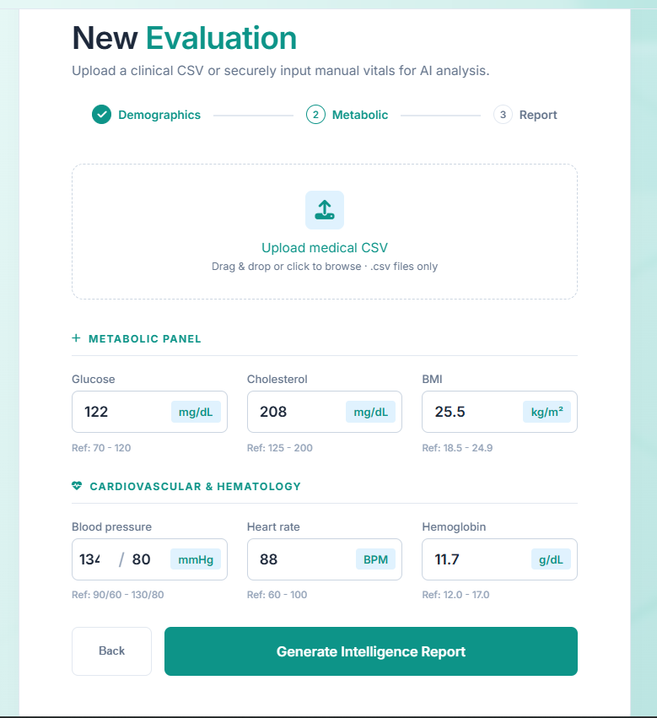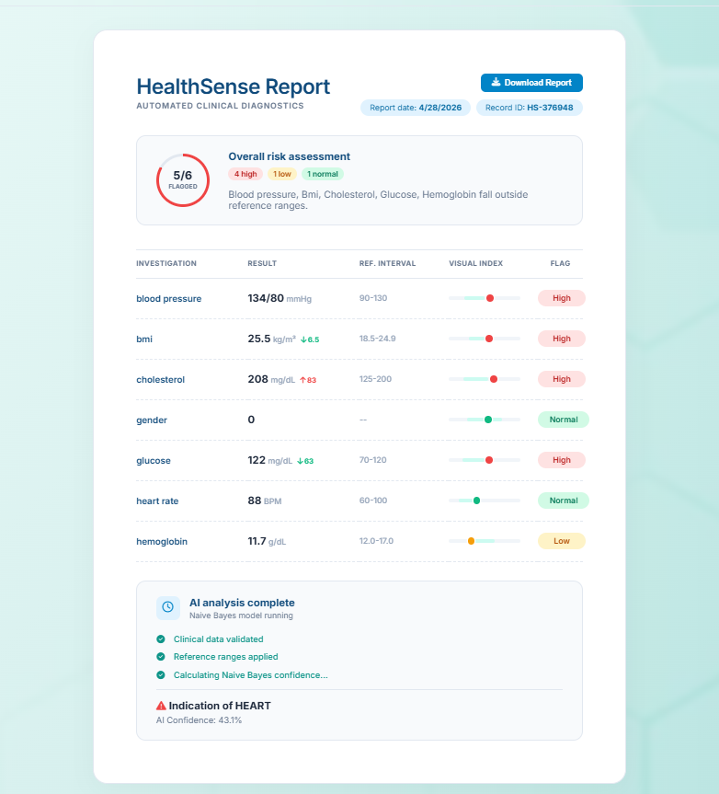
7-Days Care Plan (Genetic Algorithm)
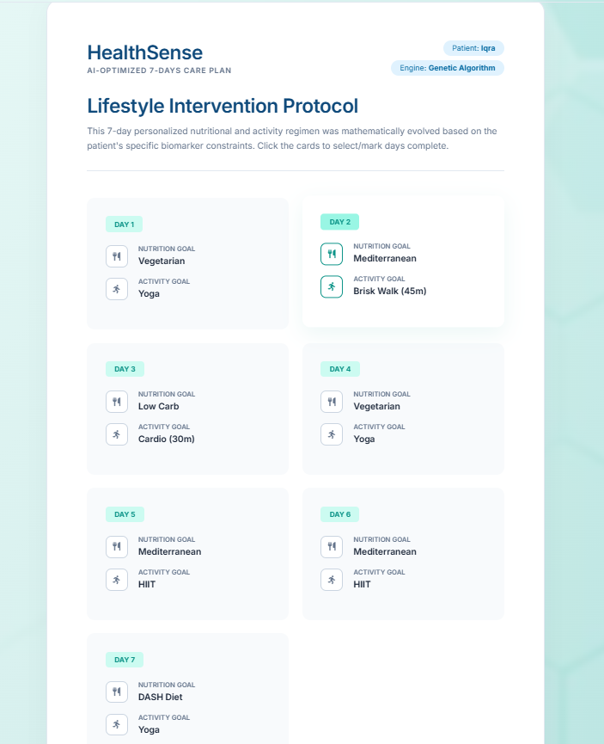

History
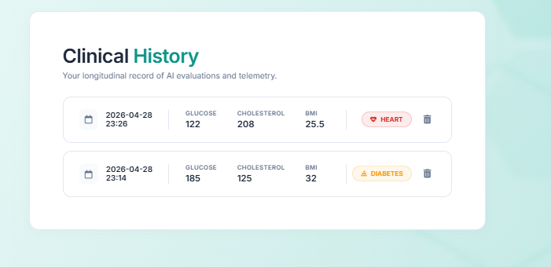

Dashboard after report generation:
(Regression Line)
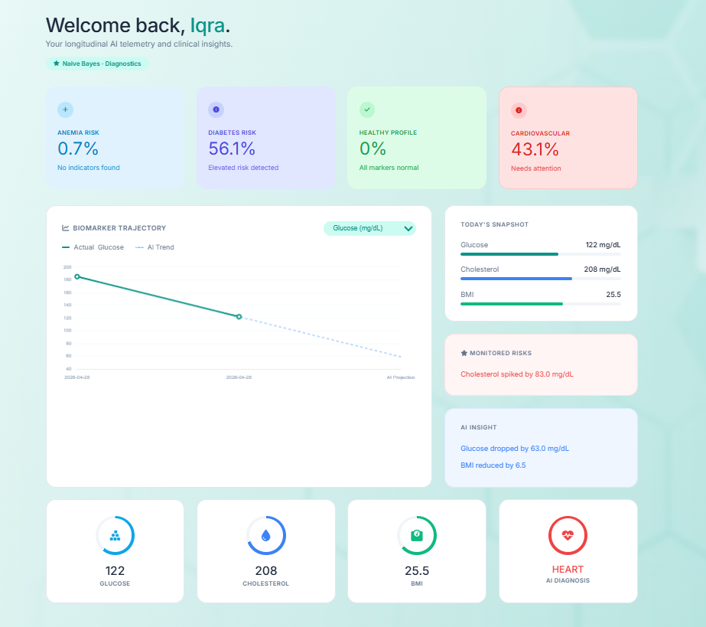
We can choose what vital graph should appear
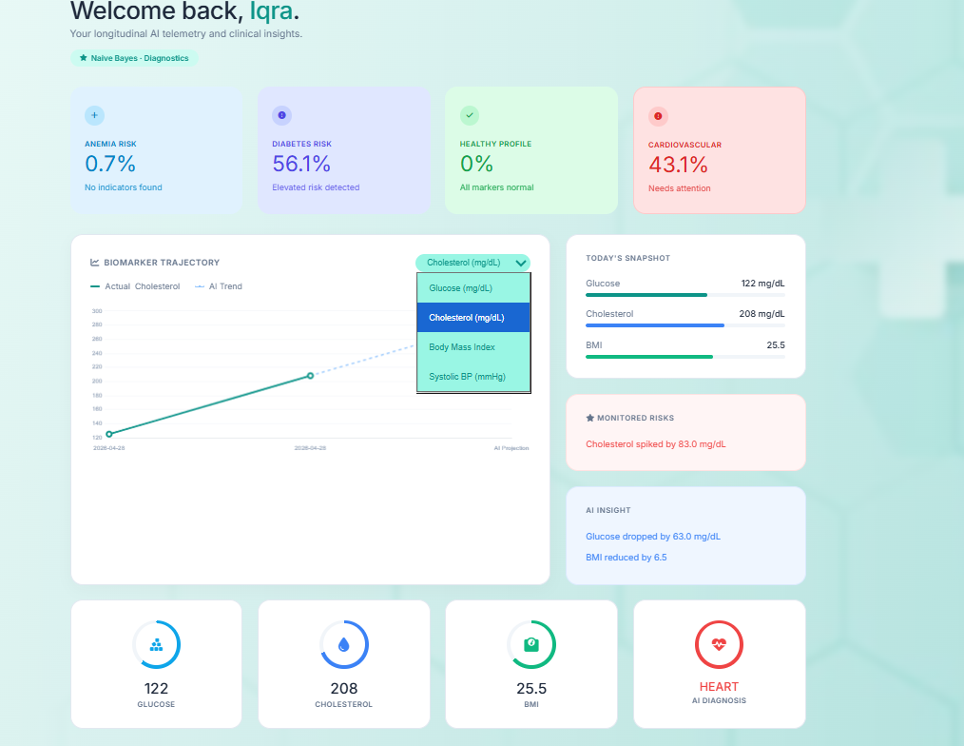

Integrated Chatbot
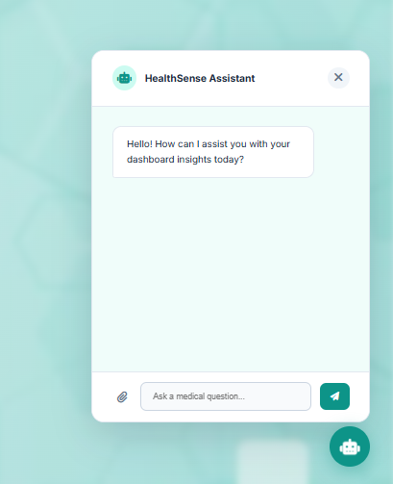

7.3 Testing Scenarios
- Test Case 1: Hyperglycemia Evaluation
  - Input: Glucose: 185 mg/dL, BMI: 32, Blood Pressure: 130 mmHg.
  - System Flow: Normalized by data_prep.py -> Classified as "Diabetes" by train_model.py (Random Forest) -> Linear Regression trendline in app.py shows upward glucose trajectory -> Genetic Algorithm in genetic_planner.py assigns a "DASH & Keto" diet.
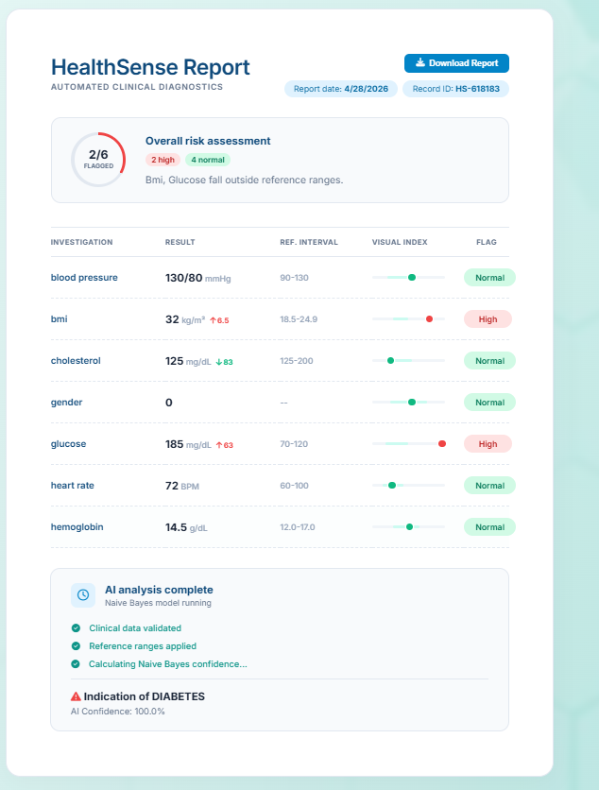
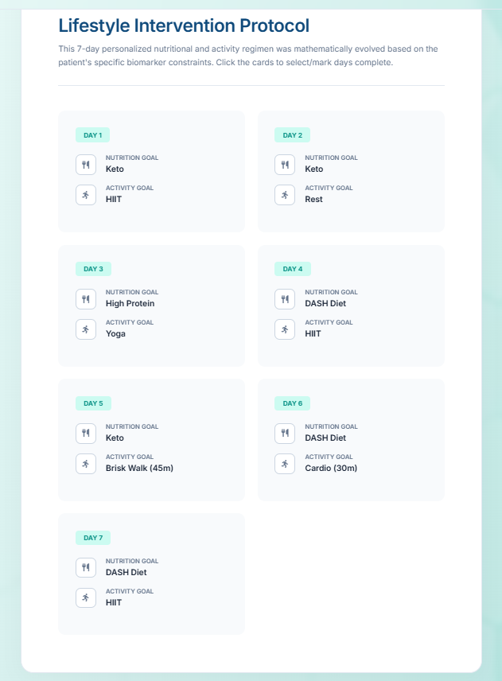

- Test Case 2: NLP Domain Restriction
  - Input: User asks the chatbot, "Can you write a Python script for a calculator?"
  - Output: The LLM successfully rejects the prompt based on the engineered system constraints: "I am HealthSense AI, a clinical assistant. I can only assist with medical and health-related inquiries."
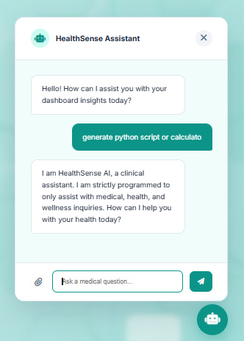
7.4 Challenges & Solutions
- Issue: Distance-based calculations and Naive Bayes distributions were heavily skewed by features like Cholesterol (ranging 150-250) versus Haemoglobin (ranging 7-15).
- Solution: Standardized the entire pipeline using StandardScaler in data_prep.py prior to model training and inference.

8. Results Analysis
The machine learning models were evaluated using an 80/20 train-test split via model_evaluate.py.
- Classification Results: The Random Forest model achieved exceptional accuracy across all target classes. The confusion matrix indicated minimal false positives for severe conditions due to the robust nature of the ensemble method.
- Optimization Results: The Genetic Algorithm proved highly efficient for real-time web applications, successfully navigating the search space to converge on optimal lifestyle plans within 1-2 seconds (at 50 generations).
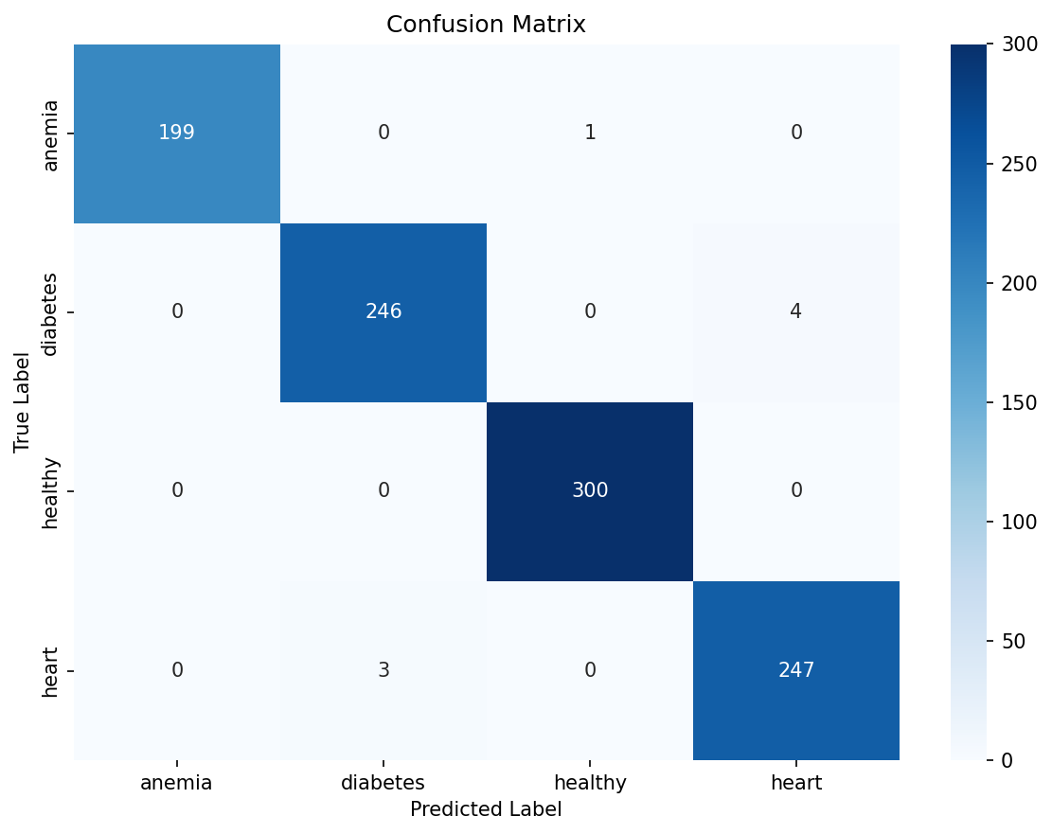
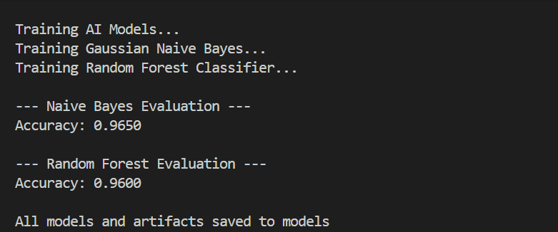

9. Limitations & Future Work
Limitations:
- API Dependencies: The conversational NLP assistant relies on the external Groq API, which is subject to network latency.
Future Work:
- EHR Integration: Upgrading the system to interface with actual Electronic Health Record (EHR) standards like HL7/FHIR for seamless hospital deployment.
- Deep Learning Models: Transitioning from traditional ML algorithms to Deep Neural Networks capable of multimodal analysis (e.g., analyzing X-ray or ECG image data alongside numerical vitals).

10. Applications
- Clinical Triage Assistance: Can be deployed in clinic waiting rooms, allowing patients to input their vitals via a tablet to give doctors an immediate, probabilistic breakdown of health risks before the consultation begins.
- Educational Demonstrations: Serves as an excellent visual and practical tool for university students to understand how various AI subfields (Supervised Learning, Search Agents, NLP, Predictive Math) interact within a single ecosystem.
- Personal Wellness Tracking (SaaS): Functions as a standalone application for individuals wanting to track their longitudinal health trajectory and receive customized, dynamic fitness regimens.

11. References
- Pedregosa, F. et al. (2011). Scikit-learn: Machine Learning in Python. Journal of Machine Learning Research, 12, 2825-2830.
- Russell, S., & Norvig, P. (2020). Artificial Intelligence: A Modern Approach (4th ed.). Pearson.
- Flask Documentation. (n.d.). Pallets Projects. Retrieved from https://flask.palletsprojects.com/
- Groq Cloud API Documentation. (n.d.). Llama-3.1-8b Model integration parameters. Retrieved from https://console.groq.com/docs/

