**CPM DIAGRAM**

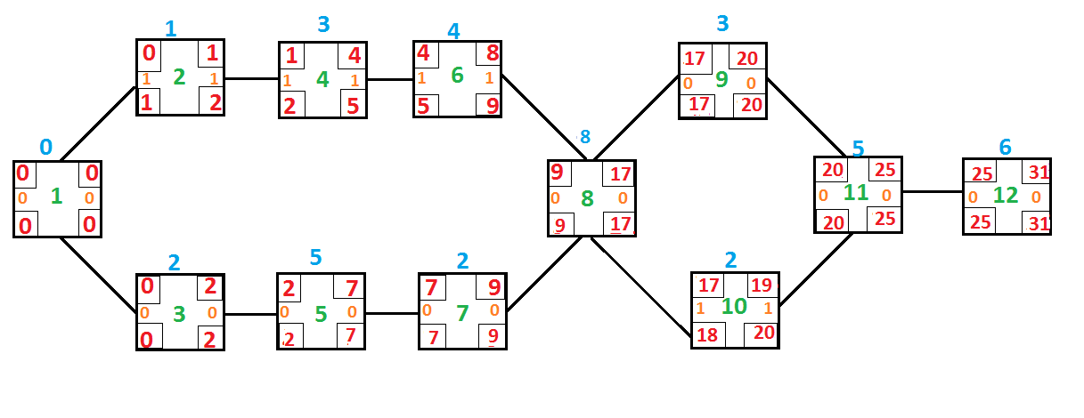

**NETWORK DIAGRAM**

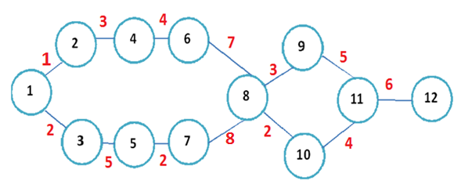

**CHORMOSOME TABLE**

|  |  |  |  |  |  |  |  |  |  |  |  |  |  |  |  |  |  |  |  |  |  |  |  |  |  |  |  |  |  |  |  |  |
| --- | --- | --- | --- | --- | --- | --- | --- | --- | --- | --- | --- | --- | --- | --- | --- | --- | --- | --- | --- | --- | --- | --- | --- | --- | --- | --- | --- | --- | --- | --- | --- | --- |
|  | **1** | | **2** | | | **3** | | | **4** | | | **5** | | **6** | | | **7** | | **8** | | | **9** | | | **10** | | | **11** | | **12** | | |
| **1** | 0 |  | | 1 |  | | 2 |  | | 0 |  | 0 |  | | 0 |  | 0 |  | | 0 |  | | 0 |  | | 0 |  | 0 |  | | 0 | |
| **2** | 0 |  | | 0 |  | | 0 |  | | 3 |  | 0 |  | | 0 |  | 0 |  | | 0 |  | | 0 |  | | 0 |  | 0 |  | | 0 |
| **3** | 0 |  | | 0 |  | | 0 |  | | 0 |  | 5 |  | | 0 |  | 0 |  | | 0 |  | | 0 |  | | 0 |  | 0 |  | | 0 |
| **4** | 0 |  | | 0 |  | | 0 |  | | 0 |  | 0 |  | | 4 |  | 0 |  | | 0 |  | | 0 |  | | 0 |  | 0 |  | | 0 |
| **5** | 0 |  | | 0 |  | | 0 |  | | 0 |  | 0 |  | | 0 |  | 2 |  | | 0 |  | | 0 |  | | 0 |  | 0 |  | | 0 |
| **6** | 0 |  | | 0 |  | | 0 |  | | 0 |  | 0 |  | | 0 |  | 0 |  | | 7 |  | | 0 |  | | 0 |  | 0 |  | | 0 |
| **7** | 0 |  | | 0 |  | | 0 |  | | 0 |  | 0 |  | | 0 |  | 0 |  | | 8 |  | | 0 |  | | 0 |  | 0 |  | | 0 |
| **8** | 0 |  | | 0 |  | | 0 |  | | 0 |  | 0 |  | | 0 |  | 0 |  | | 0 |  | | 3 |  | | 2 |  | 0 |  | | 0 |
| **9** | 0 |  | | 0 |  | | 0 |  | | 0 |  | 0 |  | | 0 |  | 0 |  | | 0 |  | | 0 |  | | 0 |  | 5 |  | | 0 |
| **10** | 0 |  | | 0 |  | | 0 |  | | 0 |  | 0 |  | | 0 |  | 0 |  | | 0 |  | | 0 |  | | 0 |  | 4 |  | | 0 |
| **11** | 0 |  | | 0 |  | | 0 |  | | 0 |  | 0 |  | | 0 |  | 0 |  | | 0 |  | | 0 |  | | 0 |  | 0 |  | | 6 |
| **12** | 0 |  | | 0 |  | | 0 |  | | 0 |  | 0 |  | | 0 |  | 0 |  | | 0 |  | | 0 |  | | 0 |  | 0 |  | | 0 |
|  | | | | | | | | | | | | | | | | | | | | | | | | | | | | | | |

**POSSIBLE PATH**

**1🡪 2🡪 4🡪 6🡪 8 🡪9🡪 11🡪 12 = 29**

**1 🡪3🡪 5🡪 7🡪 8🡪 9🡪 11🡪 12 = 31**

Critical path

**1🡪 2🡪 4🡪 6 🡪8🡪 10🡪 11 🡪12 = 27**

**1🡪 3🡪 5🡪 7🡪 8 🡪10🡪 11 🡪12 = 29**