Iqra Akhtar

shopping store (srs document)

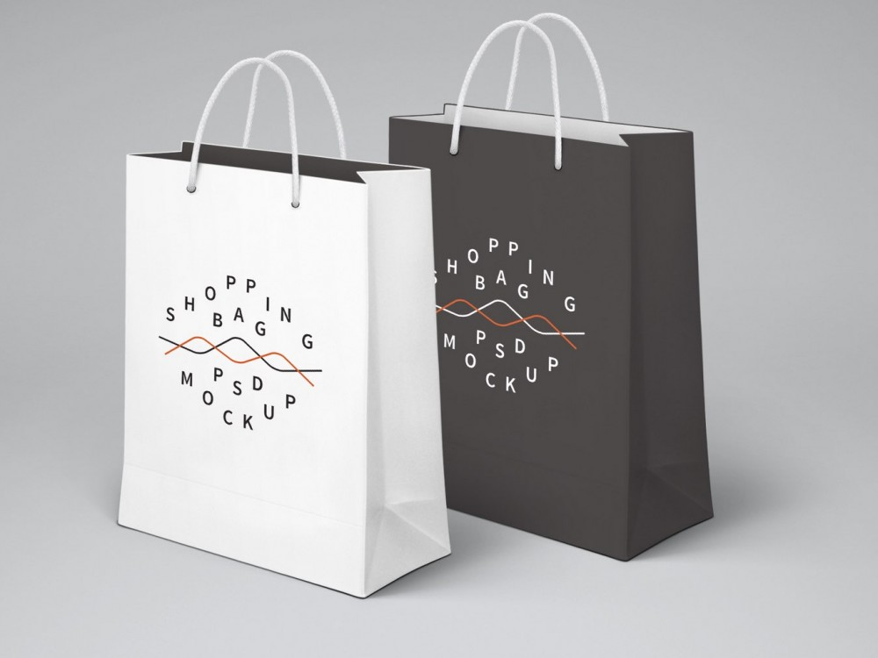

Shopping Store

General Description

The Shopping system enables vendors to set up products, customers to browse through the shops and buy, and a system administrator to approve and reject requests for adding new products and items. This shopping system will use the internet as the sole method for selling goods to its consumers.

SCOPE:

The system shows all product categories to customer. The customer wants to buy item, then selected item will be listed in shopping cart for buying.

The payment will made with credit card. If customer wants to cancel the order before shipping, then he/she can cancel it.

buying report will be sent to email provided by customer.

USER

* **Administrators**:

ones who adds or administers the categories for the products and administers the Vendors.

* **Sellers**:

Sellers will add their products to the database, which will be seen in the website to the end users.

* **End Users/Customers**:

The end user will be the one who visits the website and buys products.

FUNCTIONAL REQUIREMENTS

Registration:

Customer will register before shopping.

Changes to Cart:

Changes to cart means the customer can make order or cancel order of the product from the shopping cart.

Payment:

Online payment method is available.

Report Generation

After all transaction the system can generate the pdf and then sent one copy to the customer’s Email-address and another one for the system.

non-Functional requirement

Security:

The system must automatically log out all customers after a period of inactivity.

The system should not leave any cookies on the customer’s computer containing the user’s password.

Availability

The system should be available at all time, meaning the user can access it using a web browser.

 Maintainability

A database is used for maintaining the database and the application server takes care of the site.

**USE CASE DIAGRAM:**

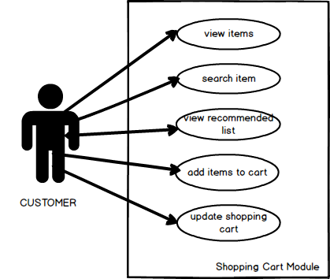

**FLOW PROCESS DIAGRAM:**

LOGIN

END

CONFIRM ORDER

ENTER PAYMENT DETAILS

SAVE CAHNGES

MAKE CHNAGES TO CART

VIEW CART

PAYMENT TO PURCHASE?