**SQL PORTFOLIO PROJECT**

**(FOODIE-FI)**

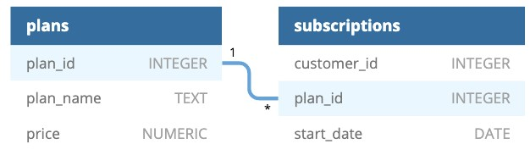

**Query 1:**

How many customers has Foodie-Fi ever had?

SELECT COUNT(DISTINCT customer_id) AS total_customers

FROM foodiefie.subscriptions;

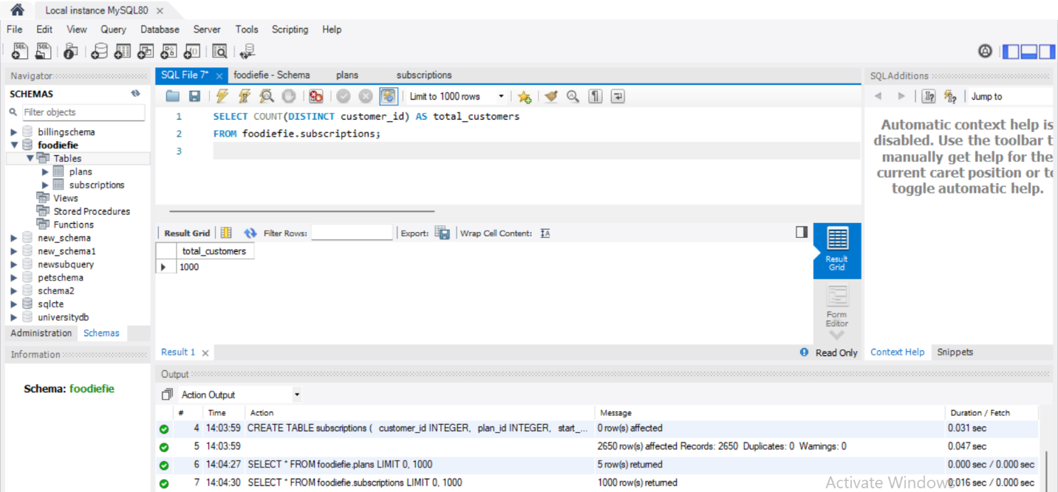

* **The total customers of Foodie-Fi are 1000.**

**QUERY 2**

What is the monthly distribution of trial plan start_date values for our dataset - use the start of the month as the group by value

SELECT EXTRACT(MONTH from start_date) AS months, COUNT(*)

FROM foodiefie.subscriptions

where plan_id = 0

Group by months

order by months;

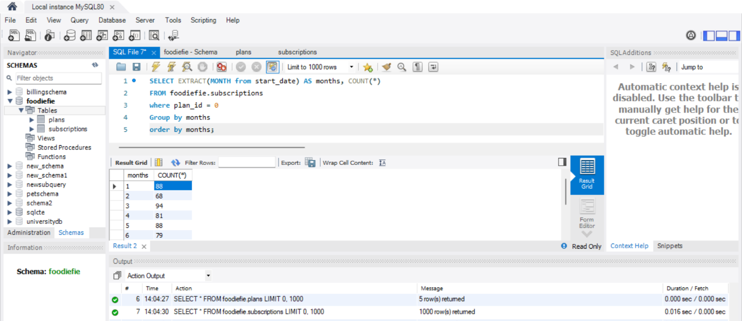

* March (3) has the highest number of trial plans, while February (2) has the lowest number of trial plans.

**QUERY 3**

What plan start_date values occur after the year 2020 for our dataset? Show the breakdown by count of events for each plan_name

SELECT plan_id, count(*)

as events_2021

from subscriptions

where EXTRACT(YEAR FROM start_date) >= '2021-01-01'

GROUP BY plan_id

ORDER BY plan_id

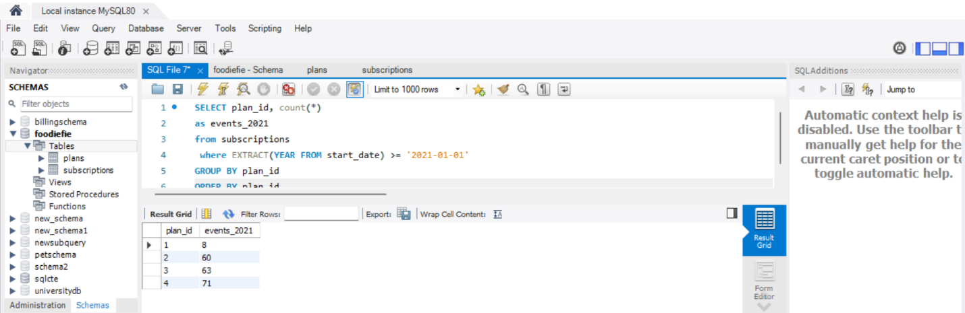

* There was no trial plan recorded for 2021

**QUERY 4:**

What is the customer count and percentage of customers who have churned rounded to 1 decimal place?

Select count(*) as churn_count ,

ROUND (count(*) / 10, 1) AS churn_percentage

from subscriptions

where plan_id = 4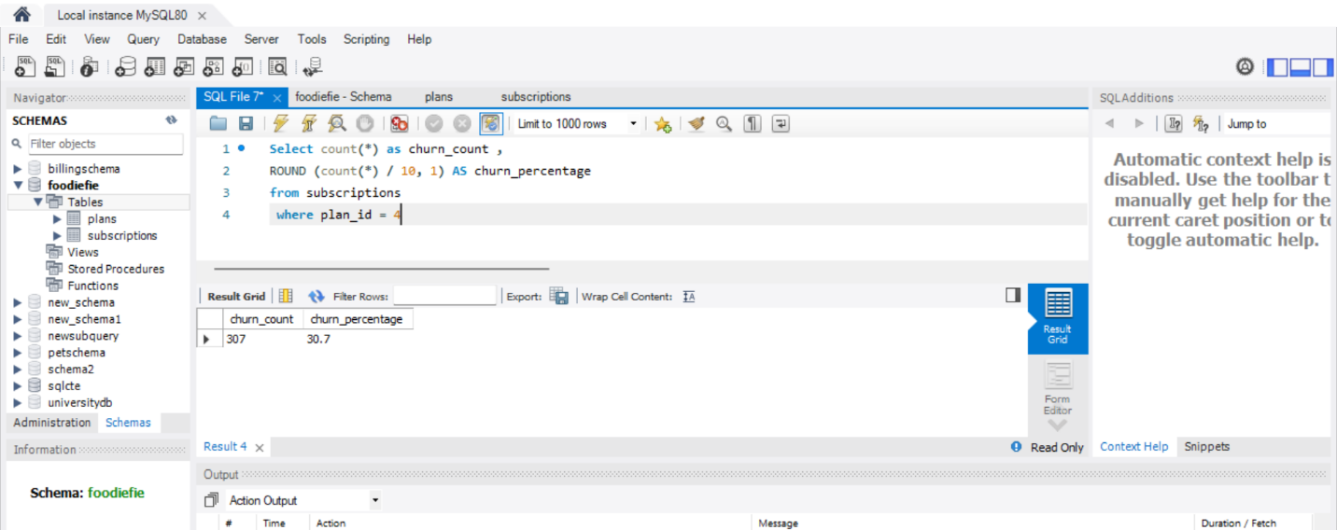

* 307 customers, or 30.7% of the total customers have churned from Foodie-fi.

**Query 5:**

How many customers have churned straight after their initial free trial - what percentage is this rounded to the nearest whole number?

WITH CTE AS (

SELECT

customer_id,

plan_name,

ROW_NUMBER() OVER(PARTITION BY customer_id ORDER BY start_date ASC) as rn

FROM subscriptions as S

INNER JOIN plans as P on S.plan_id = P.plan_id

)

SELECT

COUNT(DISTINCT customer_id) as customers_churned_afer_trial,

ROUND((COUNT(DISTINCT customer_id) / (SELECT COUNT(DISTINCT customer_id) FROM subscriptions))*100,0) as churn_after_trial_percent

FROM CTE

WHERE rn = 2

AND plan_name = 'churn';

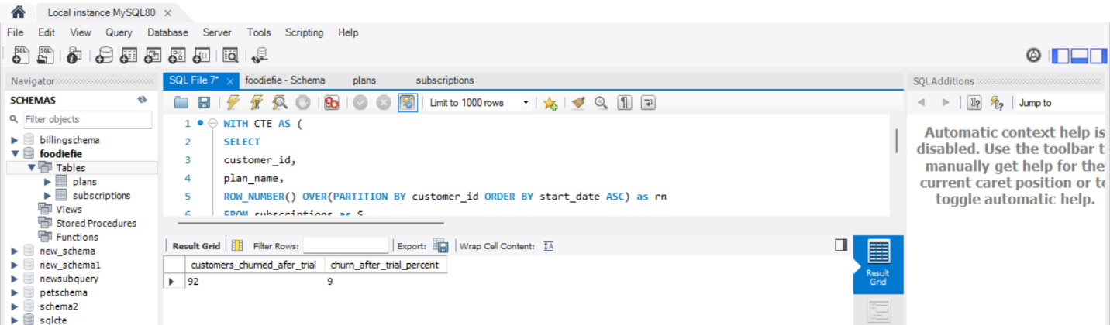

* 92 customers, or 9% of the total customers, have churned straight after their initial trial from Foodie-fi.

**QUERY 6:**

What is the number and percentage of customer plans after their initial free trial?

WITH CTE AS (

SELECT

customer_id,

plan_name,

ROW_NUMBER() OVER(PARTITION BY customer_id ORDER BY start_date ASC) as rn

FROM subscriptions as S

INNER JOIN plans as P on P.plan_id = S.plan_id

)

SELECT

plan_name,

COUNT(customer_id) as customer_count,

ROUND((COUNT(customer_id) / (SELECT COUNT(DISTINCT customer_id) FROM CTE))*100,1) as customer_percent

FROM CTE

WHERE rn = 2

GROUP BY plan_name;

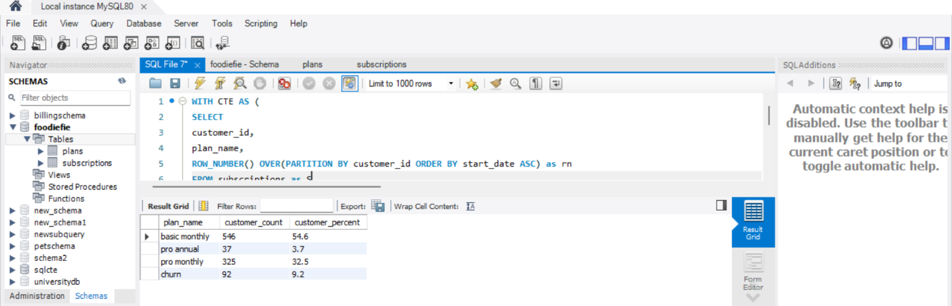

* More than 80% of customers are on paid plans.

**QUERY 7**

What is the customer count and percentage breakdown of all 5 plan_name values at 2020-12-31?

WITH CTE AS (

SELECT *

,ROW_NUMBER() OVER(PARTITION BY customer_id ORDER BY start_date DESC) as rn

FROM subscriptions

WHERE start_date <= '2020-12-31'

)

SELECT

plan_name,

COUNT(customer_id) as customer_count,

ROUND((COUNT(customer_id)/(SELECT COUNT(DISTINCT customer_id) FROM CTE))*100,1) as percent_of_customers

FROM CTE

INNER JOIN plans as P on CTE.plan_id = P.plan_id

WHERE rn = 1

GROUP BY plan_name;

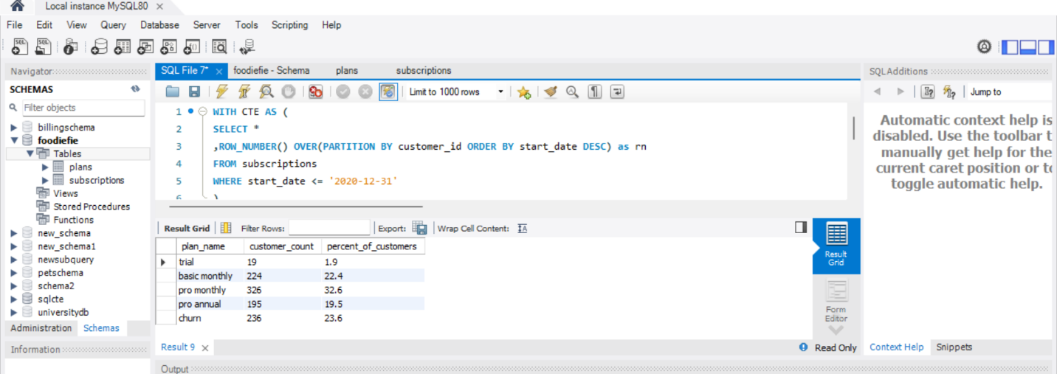

* More people upgraded to the pro monthly plan, but fewer people signed up for the trial plan.

**QUERY 8 :**

How many customers have upgraded to an annual plan in 2020?

SELECT COUNT(DISTINCT customer_id) AS total_customers

FROM subscriptions

WHERE plan_id = 3 AND EXTRACT(YEAR from start_date ) = '2020'

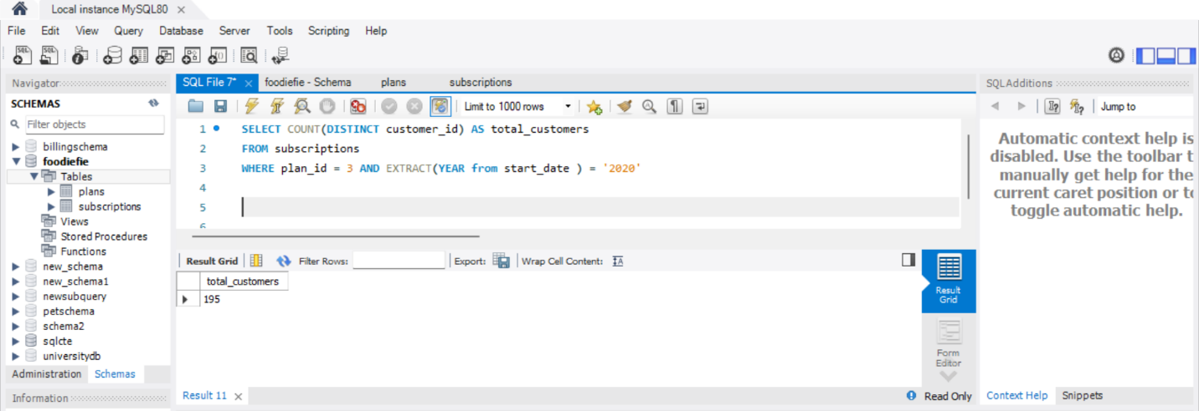

* 195 customers upgraded to an annual plan in 2020.

**QUERY 9**

How many days on average does it take for a customer to an annual plan from the day they join Foodie-Fi?

WITH trial_plan AS (

SELECT customer_id,

start_date AS trial_date

FROM subscriptions

WHERE plan_id = 0

),

annual_plan AS (

SELECT customer_id,

start_date AS annual_date

FROM subscriptions

WHERE plan_id = 3

)

SELECT ROUND(AVG(ABS(DATEDIFF(trial_date, annual_date))), 0) AS avg_days_to_upgrade

FROM trial_plan tp

JOIN annual_plan ap ON tp.customer_id = ap.customer_id;

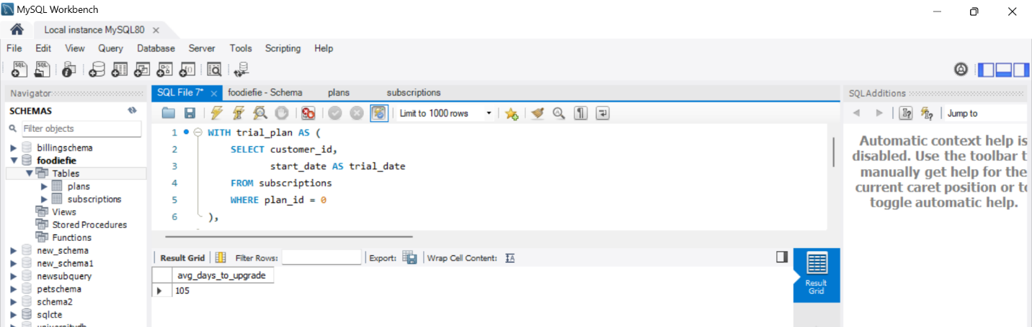

* On average, it takes 105 days for customers to upgrade to an annual plan after they join Foodie-Fi.

**QUERY 10 :**

Can you further breakdown this average value into 30 day periods (i.e. 0-30 days, 31-60 days etc)

WITH TRIAL AS (

SELECT customer_id,

start_date AS trial_start

FROM subscriptions

WHERE plan_id = 0

),

ANNUAL AS (

SELECT customer_id,

start_date AS annual_start

FROM subscriptions

WHERE plan_id = 3

)

SELECT

CASE

WHEN DATEDIFF(annual_start, trial_start) <= 30 THEN '0-30'

WHEN DATEDIFF(annual_start, trial_start) <= 60 THEN '31-60'

WHEN DATEDIFF(annual_start, trial_start) <= 90 THEN '61-90'

WHEN DATEDIFF(annual_start, trial_start) <= 120 THEN '91-120'

WHEN DATEDIFF(annual_start, trial_start) <= 150 THEN '121-150'

WHEN DATEDIFF(annual_start, trial_start) <= 180 THEN '151-180'

WHEN DATEDIFF(annual_start, trial_start) <= 210 THEN '181-210'

WHEN DATEDIFF(annual_start, trial_start) <= 240 THEN '211-240'

WHEN DATEDIFF(annual_start, trial_start) <= 270 THEN '241-270'

WHEN DATEDIFF(annual_start, trial_start) <= 300 THEN '271-300'

WHEN DATEDIFF(annual_start, trial_start) <= 330 THEN '301-330'

WHEN DATEDIFF(annual_start, trial_start) <= 360 THEN '331-360'

END AS intervals,

COUNT(T.customer_id) AS customer_count

FROM TRIAL AS T

INNER JOIN ANNUAL AS A ON T.customer_id = A.customer_id

GROUP BY intervals;

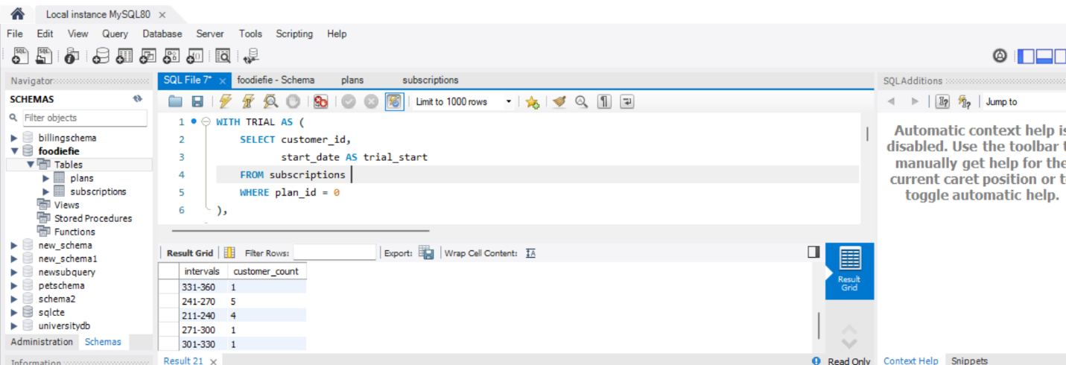

* The majority of customers tend to subscribe or upgrade to an annual plan within the first 30 days.

**Query 11:**

How many customers downgraded from a pro monthly to a basic monthly plan in 2020?

WITH next_plan_cte AS (

SELECT customer_id,

plan_id,

start_date,

LEAD(plan_id) OVER(PARTITION BY customer_id ORDER BY plan_id) AS next_plan

FROM subscriptions

)

SELECT COUNT(*) AS downgraded

FROM next_plan_cte

WHERE start_date <= '2020-12-31'

AND plan_id = 2 AND next_plan = 1;

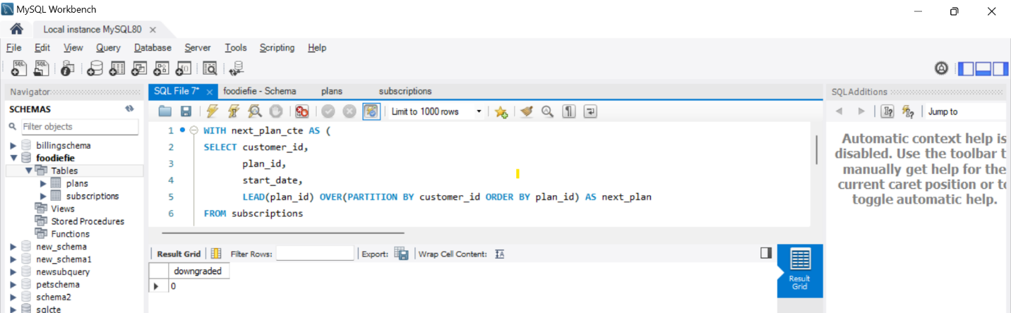

* No customer has downgraded from pro monthly to basic monthly in 2020.