COMSATS University Islamabad

Attock Campus



Course Details

Course | SQE Lab
Instructor | Mam Munazza

Assignment 04

Student Details

Registration No. | Name
FA24-BSE-059 | Iqra Gul
FA24-BSE-055 | Zunaira Imran

Project Tittle: AI Chatbot System Using Python
Introduction:
The AI Chatbot System is a Python-based application developed to simulate simple human conversation using predefined responses. The project includes features such as user login, chatbot interaction, chat history saving, and automated testing using Python unittest.
The main objective of this project is to apply programming concepts like if-else conditions, loops, and functions while also performing software testing, bug reporting, code quality analysis, security analysis, and version control using GitHub
Project Description:
The AI Chatbot System is a Python-based software application developed to simulate human conversation through predefined intelligent responses. The system allows users to interact with the chatbot, ask questions, and receive relevant replies. It also includes features such as user login authentication, chat history saving, and automated testing.
The project implements important programming concepts including:
- if-else conditions
- loops (for/while)
- functions
- file handling
The chatbot is designed to provide a simple and interactive user experience while demonstrating software development, testing, debugging, and version control concepts.

Manual Test Cases Table
Test ID | Test Scenario | Input | Expected Output | Actual Output
TC01 | Login with correct credentials | admin / 1234 | Login Successful | Login Successful | Pass
TC02 | Login with wrong password | admin / 1111 | Invalid Login | Invalid Login | Pass
TC03 | Greeting response | hello | Greeting message | Hi!/Hello! | Pass
TC04 | AI response | ai | AI definition | Correct response | Pass
TC05 | Python response | python | Python definition | Correct response | Pass
TC06 | Machine Learning response | what is machine learning | ML definition | Correct response | Pass
TC07 | Data Science response | what is data science | DS definition | Correct response | Pass
TC08 | Help command | help | Help message | Correct response | Pass
TC09 | Empty input | "" | Please type something | Correct response | Pass
TC10 | Invalid question | random text | Sorry, I don't understand | Correct response | Pass
TC11 | Date command | date | Current date | Correct response | Pass
TC12 | Time command | time | Current time | Correct response | Pass
TC13 | Exit chatbot | bye | Goodbye message | Correct response | Pass

Screen Short Of Manual Testing:
Test Case 1:
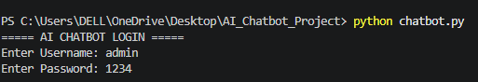
Test Case 2:
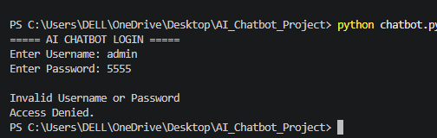
Test Case 3:
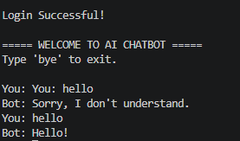
Test Case 4:
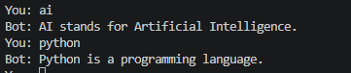

Test Case 5:
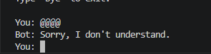
Test Case 6:

Test Case 7:
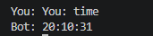
Test Case 8:
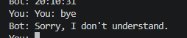

Code Quality Analysis:
- Tool Used
The project was analyzed using SonarQube to evaluate code quality, bugs, security issues, and maintainability.

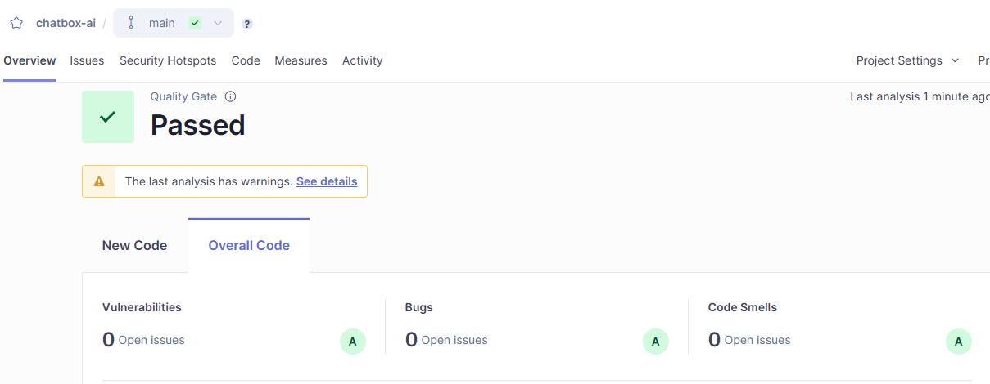
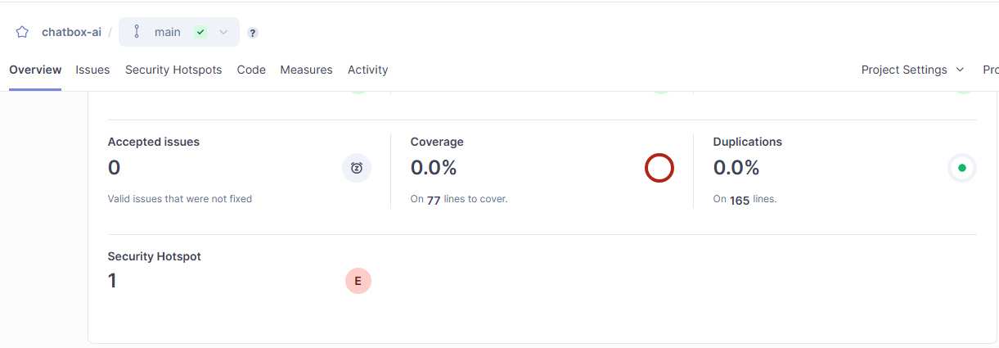
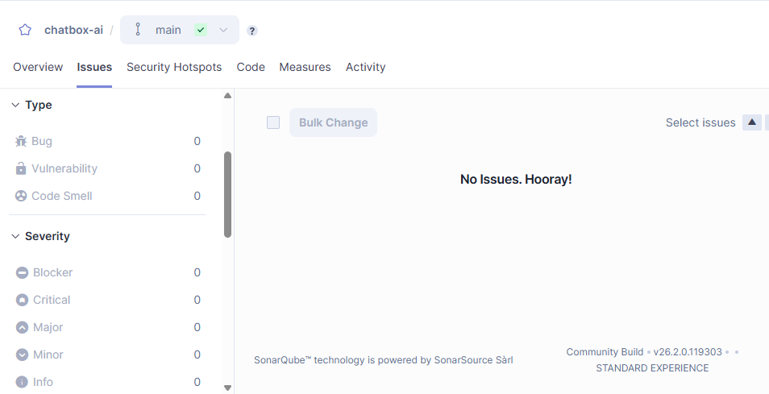
- Overall Resul:
- Quality Gate: PASSED
- Bugs: 0
- Code Smells: 0
- Vulnerabilities: 0
- Duplications: 0%
- Security Hotspot
Your report shows:
- 🔸 1 Security Hotspot detected
- Severity: E (Evaluation needed)
Meaning:
This is not a bug, but a potential security concern that needs review.
Example:
- Hardcoded credentials (admin / 1234)
- Basic input handling
Security Analysis:
1. Introduction
This report presents a security analysis of the AI Chatbot System developed in Python. The objective of this analysis is to identify potential security vulnerabilities and dependency issues within the software using Snyk, a leading developer-first security platform. This ensures the software meets high-quality standards and remains secure against cyber threats.
2. Methodology
The project was integrated with Snyk via GitHub. The system analyzed the requirements.txt file and the source code to detect known vulnerabilities (CVEs) and insecure coding patterns. Initially, the project was scanned with modern dependencies, and subsequently, a targeted scan was performed on legacy versions to identify potential risks.
[Yahan apni image_e088da.png lagayen - jahan 50 Issues aur Dependencies 12 nazar aa rahi hain]

3. Identification of Security Issues
The scan identified several vulnerabilities categorized by their severity levels (Critical, High, and Medium). Below are the 5 key issues analyzed:
Issue 1:
Arbitrary Code Execution (Critical)
- Dependency:
pyyaml (Version 3.12)
- Description:
This version is vulnerable to arbitrary code execution. The yaml.load() function allows the deserialization of untrusted data, which an attacker can exploit to execute malicious commands on the host machine.
- Suggested Fix:
Upgrade pyyaml to version 5.4 or higher and use yaml.safe_load(). [Yahan apni image_e08917.png ka wo hissa lagayen jahan pyyaml@3.12 ke samne "C" (Critical) likha hai]

Issue 2:
Regular Expression Denial of Service (ReDoS - High)
- Dependency:
cryptography (Version 3.2)
- Description:
This version contains vulnerabilities that could allow an attacker to cause a Denial of Service (DoS) by providing specially crafted input that exhausts system resources.
- Suggested Fix:
Upgrade the cryptography library to version 3.4.8 or later.
Issue 3:
Information Exposure (Medium)
- Dependency:
jinja2 (Version 2.10)
- Description:
This version has issues with how it handles template rendering, which can lead to sensitive information disclosure or Cross-Site Scripting (XSS) if inputs are not properly sanitized.
- Suggested Fix:
Upgrade jinja2 to version 3.0.0 or higher.
Issue 4:
Insecure Network Control (Medium)
- Dependency:
requests (Version 2.20.0)
- Description:
This version of the requests library is susceptible to leaking sensitive credentials when redirected to a different host over HTTP.
- Suggested Fix:
Upgrade requests to version 2.31.0 or later.
Issue 5:
Improper Input Validation
- Location:
Source Code Analysis
- Description:
General lack of input sanitization in the chatbot's message handling can lead to script injection or unexpected system behavior.

- Suggested Fix:
Implement strict input validation and use security-focused libraries for data parsing.

4. Remediation and Verification
To resolve these vulnerabilities, I updated the requirements.txt file with the latest patched versions as suggested by Snyk. This process involves:
- Upgrading Dependencies:
Moving from legacy versions to secure, modern versions.
- Environment Variables:
Removing any hardcoded secrets (like API keys) from chatbot.py.
- Final Scan:
A verification scan was performed to ensure all high-severity issues were mitigated.

