Iqra Irshad

Transformation of information (the Wealth of nations) into insights and building Dashboard using Microsoft Excel and Tableau.

Data Visualisation

Assignment 1

Table of Contents

1. **Policies and Procedures2**
2. **Excel3**

Step 13

Step 2, 34

Step 4, 55

Step 66

Step 7, 87

Step 98

Step 10, 119

Step 12, 1310

Step 1411

Step 1512

1. **Tableau13**

Step 1, 213

Step 3, 414

Step 5, 615

Step 716

Step 817

**Policies and Procedures**

Following are the policies and Procedures to adhere to when working with Data.

* Computer Misuse Act 1990
* Data Protection Act & GDPR
* Designs and Patents Act

The main goal of these policies and procedures is to protect and secure all the data consumed managed, and stored by the companies and organizations dedicated to standardizing the use, monitoring, and management of data. It is not required by law but is commonly used to help organizations comply with these standards and regulations.

Data analysis and Data evaluation are becoming vital in every sector. Organizations and companies tend to collect more data to be analyzed and stored more frequently in databases, and having that digital information obscured from regulators will undermine our societal safeguards.

The following aspects should be considered:

* The scope of required data protection.
* Data protection techniques and policies applied by relevant parties.
* Any applicable legal or compliance requirements for data protection.
* The roles and responsibilities related to data protection.
* Data custodians and roles specifically responsible for data protection activities.

**Excel**

I have used the Data Set “The Wealth of nations” to evaluate insights analysis for 20 Top Ranking countries in Microsoft Excel.

Overview of the Assignment by following the steps while working in Microsoft Excel is as follows:

**Step 1:**

Setting up a password for the Excel file. Click on File at the top left corner > Select info from the list > Click Protect Workbook.

A pop-up will appear to create a password > type password > click OK.

**Step 2:**

Changing the Data type of Column “GDP-per Cpita (PPP)” to Display in British Pound symbol.

Highlight the Column header by clicking on it > Go to the Home tab > Select Currency as shown in the screenshot and select the Pound symbol.

**Step 3:**

Converting the GDP sheet into Table Format.

Select the Table range > Go to Insert tab > Select Table as shown in the screenshot below.

**Step 4:**

Filtering the Table to show the data only for 2019.

Click on the Arrow on the right of the column header (Year of Information) as shown in the screenshot > Select the year 2019 from the Drop Down.

**Step 5:**

Creating a chart showing the information “Rank, Country, and GDP-per Capita (PPP).

Create a pivot table > Select Table range > Go to Insert tab > Click Pivot Table > Check all columns as shown in the screenshot below.

Create a filter that will show the data only for 2019, Change the currency to the British Pound by Following steps 2 and 3.

**Step 6:**

Create a Chart by Clicking on Insert tab > Click on Recommended charts > A pop-up will appear showing different charts > Select Clustered Column Chart from the following.

**Step 7:**

Creating a visually pleasing Chart by giving suitable Titles (GDP of Countries in 2019), and x and y labels (Country and GDP respectively).

Moving on to a new sheet and giving it a relevant name (GDP 2019).

**Step 8:**

Create a sort for 20 highest-ranking countries in 2019 by applying the filter following Step 3.

Create a Clustered Bar chart following Step 5.

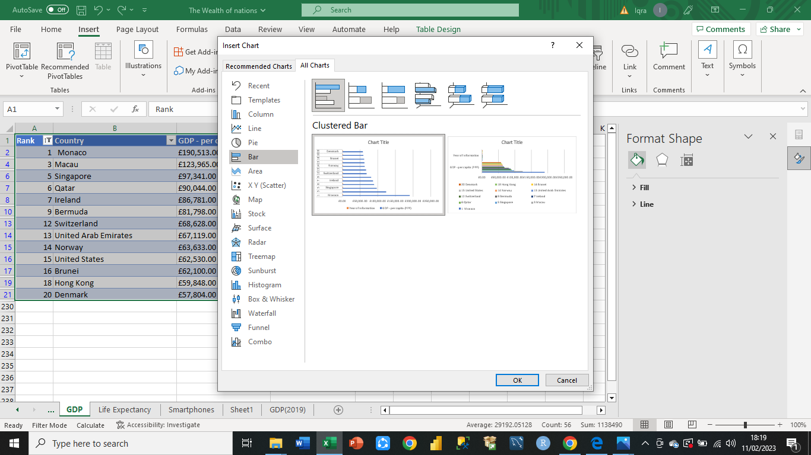

**Step 9:**

Now placed the chart underneath the table. Change the background colour of the chart by selecting the area and right-clicking > a pop-up will appear > Select the colour of your choice.

Create three buttons (Print, Save, Copy) by clicking Insert Tab > Click Illustrations > Select shapes.

**Step 10:**

To Create Macros > Enable Developer Option > Righty Click Insert tab > Select Customize the Ribbon > A pop-up will appear > Click Developer as shown in the screenshot > Click Ok.

The developer tab will appear on the tab bar.

**Step 11:**

Click on the Developer Tab > Create Three Macros (Copy, Print_Macro, Save_Macro) by clicking on Record Macro, Stop recording when you finish, and assign them to three buttons by right-clicking on the buttons.

**Step 12:**

We can also create Macros in Visual Basic. Clicking on Visual Basic underneath the Developer tab > Create a new Module and code for the Macros > Assign them to three Buttons created before.

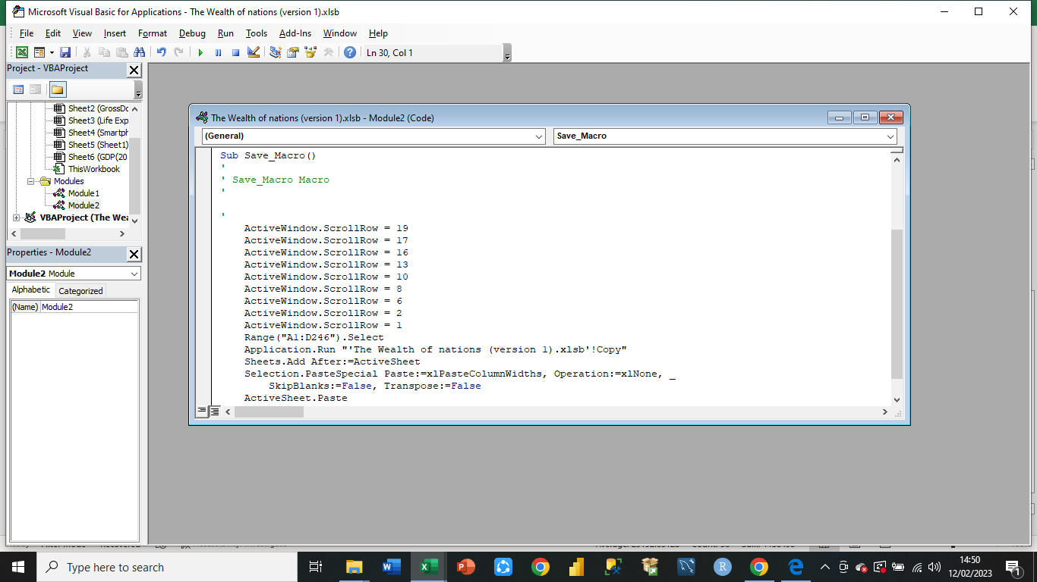

**Step 13:**

Now Copy and Paste the Table and Graph for the (GDP of the 20 highest-ranking countries in 2019) in Microsoft Word by using Copy Macro keeping the same formatting. Give it the Title ‘GDP (Gross domestic product)’ and save it as ‘Word Gross domestic product report 1’.

**Step 14:**

Add a Header and Footer > Click on the View tab from the top > Go to Workbook Views > Select Page Layout, it will show the page Header and footer as shown below:

Write (Name, GLA DATA 1) in the Header section.

Write (Date, Assignment Name) in the Footer section. Return to Normal View.

**Step 15:**

Save the Excel file as “Excel-Macro Enabled Workbook (*.xslm)” named as “Excel Gross domestic product report 1”.

**Tableau**

Continuing with the Data Set “The Wealth of nations” to build a Dashboard by creating more graphs for 20 Top Ranking countries in Tableau.

**Step 1:**

Import the data set into Tableau > Select Microsoft Excel as it is an Excel Workbook (.xlsx) file.

**Step 2:**

After importing the Excel workbook, you can see the sheets in the left pane. Drag the sheets to the main page > Build relationships by equalizing Country In each sheet.

Check the Data types of all columns in each sheet > changed the data type of the Year column Number to date in each sheet and Decimal to Whole of GDP column in GDP sheet.

**Step 3:**

Build the first chart on Sheet 1 named as “GDP of 20 Highest Ranking Countries”.

**Step 4:**

Build the second chart on sheet 2 named as” Life Expectancy of 20 Highest Ranking Countries in 2020”.

**Step 5:**

Build the third chart on sheet 3 named as “Smartphone Users of 20 Highest Ranking Countries in 2020”.

**Step 6:**

Build the fourth chart on sheet 4 named as “GDP from 2003 to 2020”.

**Step 7:**

Create a field to filter top 20 Countries > Click on the Analysis tab > Select Calculated Field > Type the name “TOPN(Rank)” and The formula “Index <= 20” > click Ok.

Put this TopN (Rank) into filters > click true checkbox from select from list > uncheck exclude from custom value list > click apply and Ok.

Apply this filter to all the above charts.

**Step 8:**

Finally, create a Dashboard by putting all four charts that show GDP, Life Expectancy, and Smartphone users of the Top 20 countries.

