ARTIFICAL INTELLIGENCE
LAB TASK 5

Program:
BS Artificial Intelligence

Submitted by:
IQRA
SU92-BSAIM-F25-221

Submitted to:
Sir Rasikh Ali

Topic:
MINIMAX & ALPHA BETA PRUNING

Task 1: Trace the supplied tree by hand using Minimax.

GRAPH TREE:

MAX

MIN
MIN

0
0
5
MAX
MAX
MAX
MAX
0
7
9
2
3

Calculate values from bottom to top
MAX nodes
MAX always selects the larger value.
- MAX (3, 5) = 5
- MAX (2, 9) = 9
- MAX (0, 7) = 7
- MAX (0, 0) = 0
MIN nodes
MIN always selects the smaller value.
- MIN (5, 9) = 5
- MIN (7, 0) = 0
Root MAX node
Finally, MAX selects the larger value:
MAX(5,0)=5
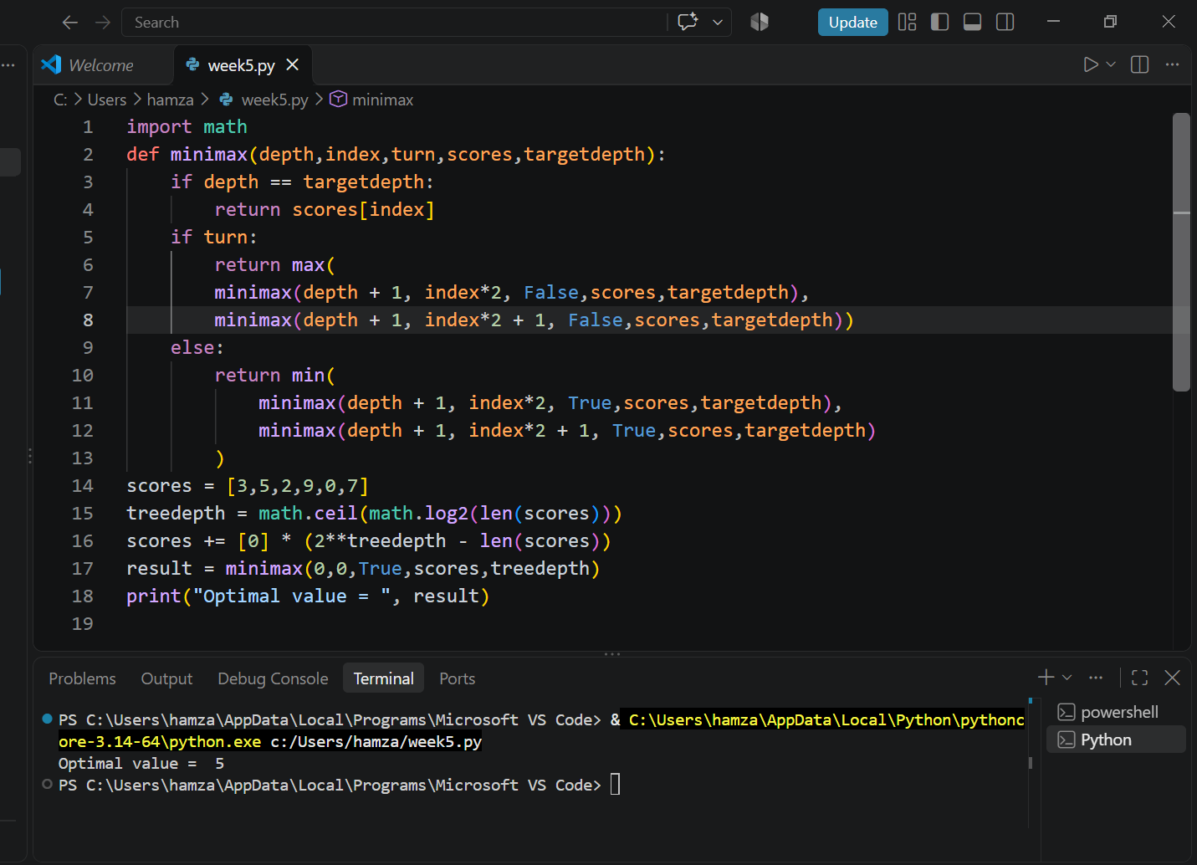

TASK 2:
Add a leaf-evaluation counter to both algorithms

Leaf-evaluation counter:
A leaf-evaluation counter counts how many terminal nodes (final scores) an algorithm visits while searching the game tree.
We use it to compare:
- Minimax: Evaluates every leaf node.
- Alpha-Beta Pruning: Skips branches that cannot affect the final decision.
Minimax with counter:
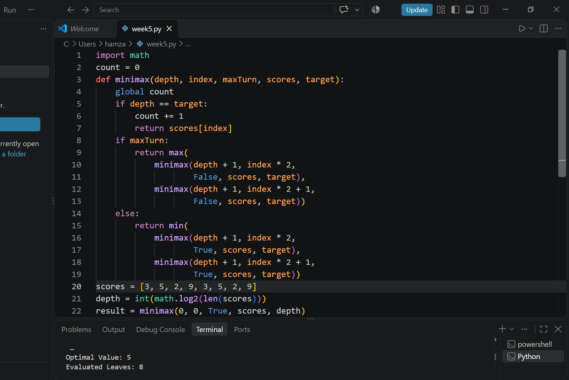

Explanation:
Minimax evaluates all 8 leaf nodes because it does not skip any branch.

Alpha-Beta Pruning with counter
We add a counter to the terminal-node condition of the Alpha-Beta algorithm.
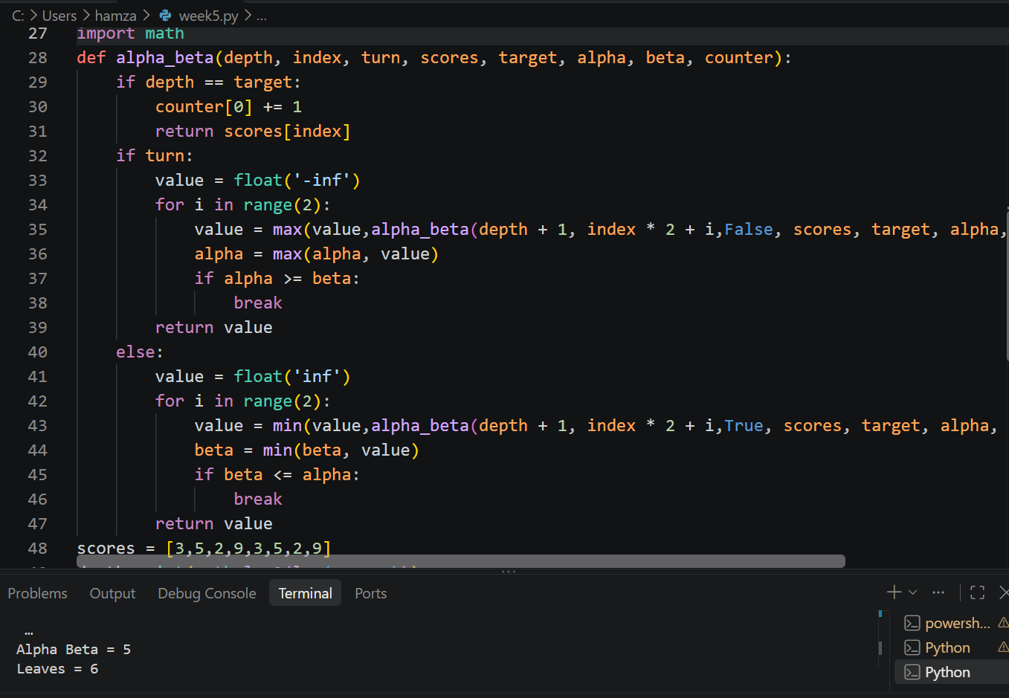
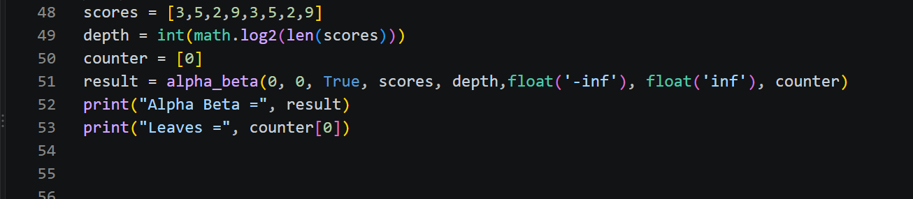

Compararing:
Comparison | Minimax | Alpha-Beta
Optimal value | 5 | 5
Total leaf nodes | 8 | 8
Evaluated leaves | 8 | 6
Pruning | No | Yes
Interpretation: Minimax evaluates all 8 leaf nodes, whereas Alpha-Beta evaluates only 6.Both algorithms return the same optimal value (5), but Alpha-Beta reduces unnecessary calculations by pruning branches.

TASK3:
Reorder branches and observe how pruning changes
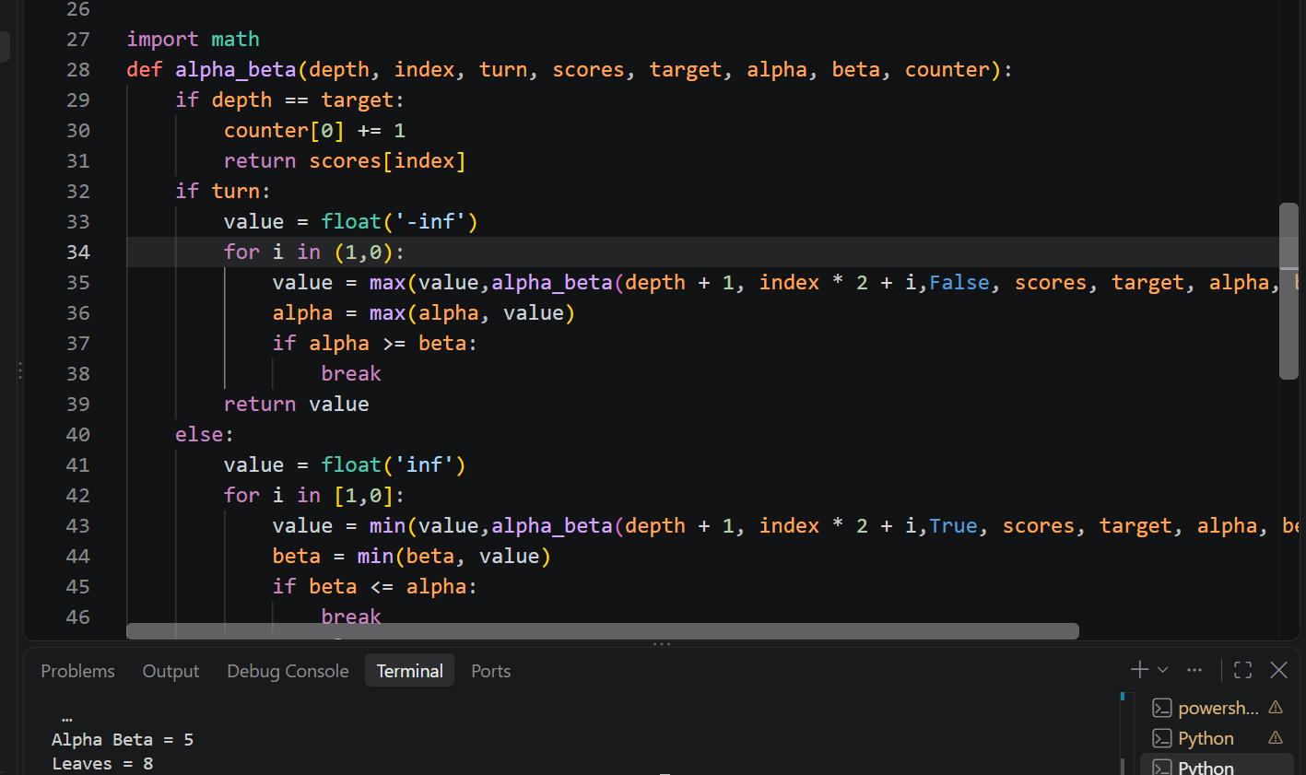
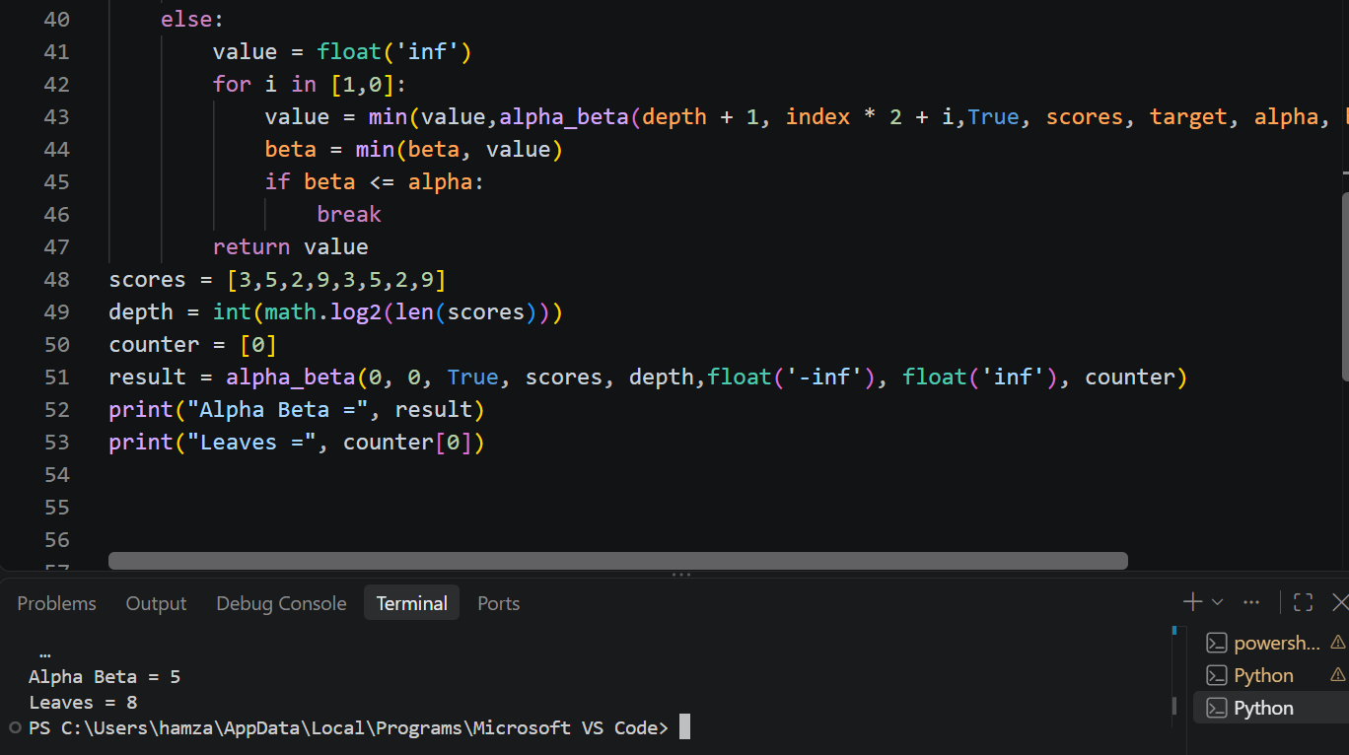

If we change for i in range(2) to for i in[1,0] it makes the algorithm explore the right branch first and the left branch second.

Comparing:
Algorithm / Ordering | Root Value | Evaluated Leaves
Minimax | 5 | 8
Alpha-Beta (left first) | 5 | 6
Alpha-Beta (right first) | 5 | 8
Interpretation:
- Minimax always evaluates all leaf nodes.
- Alpha-Beta can reduce the number of evaluations.
- Left-first ordering evaluates 6 leaves.
- Right-first ordering evaluates 8 leaves.
- The optimal value remains 5 in all cases.
This proves that branch ordering affects pruning efficiency, not the optimal decision.

