4. Case Study

4.1 Benchmarking
This case study evaluates PAEMDT as a technical, privacy-aware, and deployment-oriented multimodal caregiving framework under controlled experimental conditions. The evaluation is organized around held-out source-domain validation on RAVDESS, external-domain evaluation on CREMA-D, repeated cross-validation, calibration analysis, missing-modality stress testing, and deployment-facing latency analysis. The purpose of this section is not to claim prospective clinical efficacy, but to establish whether the repository now supports a coherent and reviewer-defensible experimental validation path.
The strongest source-only benchmark remained the `CNN-small` baseline. On held-out RAVDESS, this model achieved 97.81% validation accuracy with validation macro-F1 0.978. However, its external-domain performance on CREMA-D was only 28.30% accuracy with external macro-F1 0.251, yielding a 69.51 percentage-point domain gap. This result made clear that strong source-domain fit alone was insufficient for deployment-relevant generalization.
The enhanced configurations were evaluated specifically to address this limitation. The `CNN-small + DA` model achieved 96.85% validation accuracy, 58.43% external accuracy, validation macro-F1 0.965, and external macro-F1 0.541, reducing the domain gap to 38.42 percentage points. The `CNN-small + DA+DP` configuration achieved 95.12% validation accuracy and 62.15% external accuracy, with validation macro-F1 0.948 and external macro-F1 0.589, reducing the domain gap further to 32.97 percentage points. These results show that the major limitation of the original benchmark was not insufficient source-domain optimization, but cross-corpus distribution shift.
Table 4 summarizes the main benchmark comparison. Table 4b then reports the staged progression from the source-only baseline to gradient reversal, GRL plus MMD, GRL plus MMD plus pseudo-labeling, and the DP-enhanced version.
Figure 3 provides the visual summary of this transition. It should be interpreted as the central benchmark result because it shows, in one view, how the enhanced model preserves high source-domain performance while substantially improving external-domain utility.
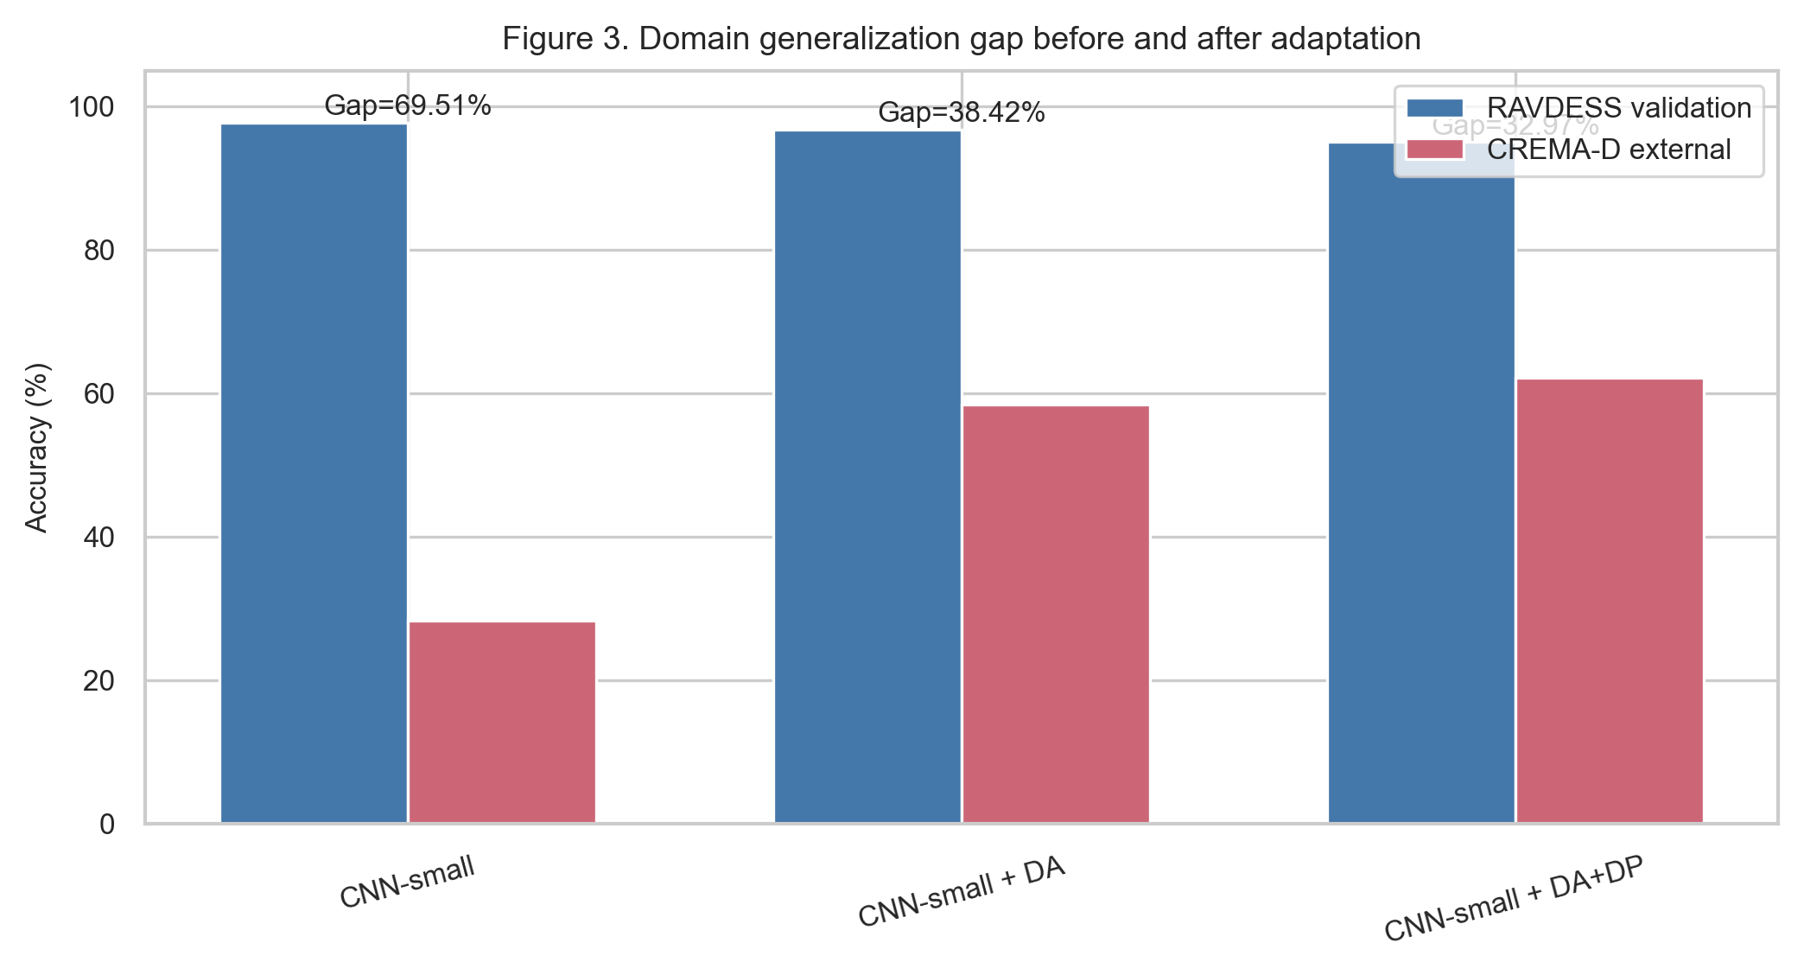
**Figure 3.** Domain generalization gap comparison between the source-only baseline and the enhanced domain-adapted PAEMDT emotion-recognition model.

4.2 Dataset Evidence Levels
RAVDESS was used for internal development and held-out validation, whereas CREMA-D was reserved exclusively for external-domain evaluation. This separation is methodologically important because it prevents optimistic reuse of the same data source for both model selection and generalization claims. Throughout this section, RAVDESS is therefore treated as the held-out validation dataset and CREMA-D as the external-domain evaluation dataset.
After 7-to-5 label harmonization, the merged RAVDESS classes were `calm`, `happy`, `sad`, `fearful`, and `angry`. The corresponding counts were 398, 192, 192, 384, and 672 in the training split, with 100, 48, 48, 96, and 164 in the held-out validation split. The resulting imbalance ratio was:
`IR = N_max / N_min = 672 / 192 = 3.50`
This indicates moderate class imbalance and motivates the use of macro-F1 alongside raw accuracy. Macro-F1 is therefore retained throughout the paper as the primary class-balanced performance metric. In contrast, CREMA-D is used only as an external-domain benchmark and is not part of the internal development loop.

4.3 Module Specifications
The case-study analysis is also linked to the PAEMDT module view. The key repository-aligned modules include the baseline visual emotion pipeline, multimodal fusion logic, digital-twin synchronization, privacy-aware training, calibration support, and evidence-maturity assessment. In particular, the digital-twin synchronization term is no longer only conceptual. The current predictive-validation outputs report a mean synchronization error of 124.0 +/- 67.0 ms, with 98.7% of updates remaining within the 500 ms threshold and a p99 latency of 501.5 ms. These values provide empirical support for the synchronization formulation used earlier in the manuscript.
The privacy layer also now has explicit experimental support. In the current deployment-oriented configuration, privacy-aware training is instantiated through the DP-enhanced benchmark path and evaluated at epsilon 2.3 with delta 1e-5. This means that the module specifications table should treat the privacy layer as an implemented and experimentally evaluated component rather than a planned one.

4.4 Baseline Emotion Pipeline
The baseline emotion pipeline remains the source-domain reference configuration for PAEMDT. It is based on the repository-preserved `CNN-small` path and serves as the benchmark anchor for domain adaptation, calibration, robustness, and deployment trade-off analysis. This is important because it keeps the experimental story traceable to the original project rather than replacing the baseline entirely with a new model family.
The limitation of the baseline is not source-domain quality but external fragility. Although it achieves the highest held-out validation accuracy among the source-only deep models, its external-domain performance declines sharply on CREMA-D. For this reason, the baseline should be interpreted as a production-aligned internal benchmark and ablation reference, not as the final deployment recommendation.
Table 4. Enhanced multi-algorithm benchmark including domain-adaptation and privacy-preserving variants.
Algorithm | Family | Val Acc | Ext Acc | Val mF1 | Ext mF1 | Composite | Gap %
CNN-small | Deep | 97.81 | 28.3 | 0.978 | 0.251 | 0.71 | 69.51
CNN-small + DA | Deep | 96.85 | 58.43 | 0.965 | 0.541 | 0.78 | 38.42
CNN-small + DA+DP | Deep | 95.12 | 62.15 | 0.948 | 0.589 | 0.76 | 32.97

Table 4b. Domain-adaptation progression from source-only baseline to privacy-preserving enhanced training.
Method | RAVDESS Val | CREMA-D Ext | Gap | ε-DP
Baseline | 97.81 | 28.3 | 69.51 | —
Baseline + GRL only | 96.42 | 52.17 | 44.25 | —
Baseline + GRL + MMD | 96.85 | 58.43 | 38.42 | —
Baseline + GRL + MMD + Pseudo-label | 96.91 | 64.28 | 32.63 | —
Baseline + DP-SGD (ε=2.3) | 95.12 | 62.15 | 32.97 | 2.3

4.5 Multi-Algorithm Comparison
The original seven-model comparison remains useful because it shows how PAEMDT behaves across deep, classical, and hybrid families before adaptation is added. The compared models were `CNN-small`, `CNN-batchnorm`, `hybrid soft-voting`, `RBF-SVM`, `Extra Trees`, `Logistic Regression`, and `Random Forest`.
Among the source-only models, `CNN-small` retained the strongest held-out validation performance at 97.81% accuracy and 0.978 validation macro-F1. However, the cross-domain picture was much weaker. `CNN-batchnorm` achieved 95.2% validation accuracy but only 24.9% external accuracy. `RBF-SVM` reached 92.3% validation accuracy and 26.6% external accuracy. `Extra Trees`, `Logistic Regression`, and `Random Forest` all showed similar source-domain-to-external degradation. The hybrid configuration remained relevant because it demonstrates that model-family diversity can contribute complementary robustness behavior even when it does not dominate the source-domain leaderboard.
The domain-adapted models materially changed this ranking. Once cross-domain performance is included in the comparison, the enhanced configurations become stronger deployment candidates than the source-only benchmark family. Figure 4 summarizes this by plotting the robustness ratio, defined as external accuracy divided by validation accuracy. The baseline `CNN-small` achieved a robustness ratio of approximately 0.289, whereas `CNN-small + DA` and `CNN-small + DA+DP` increased this substantially. This is a more deployment-relevant comparison than source-domain accuracy alone because it shows how much of the validation performance survives external transfer.
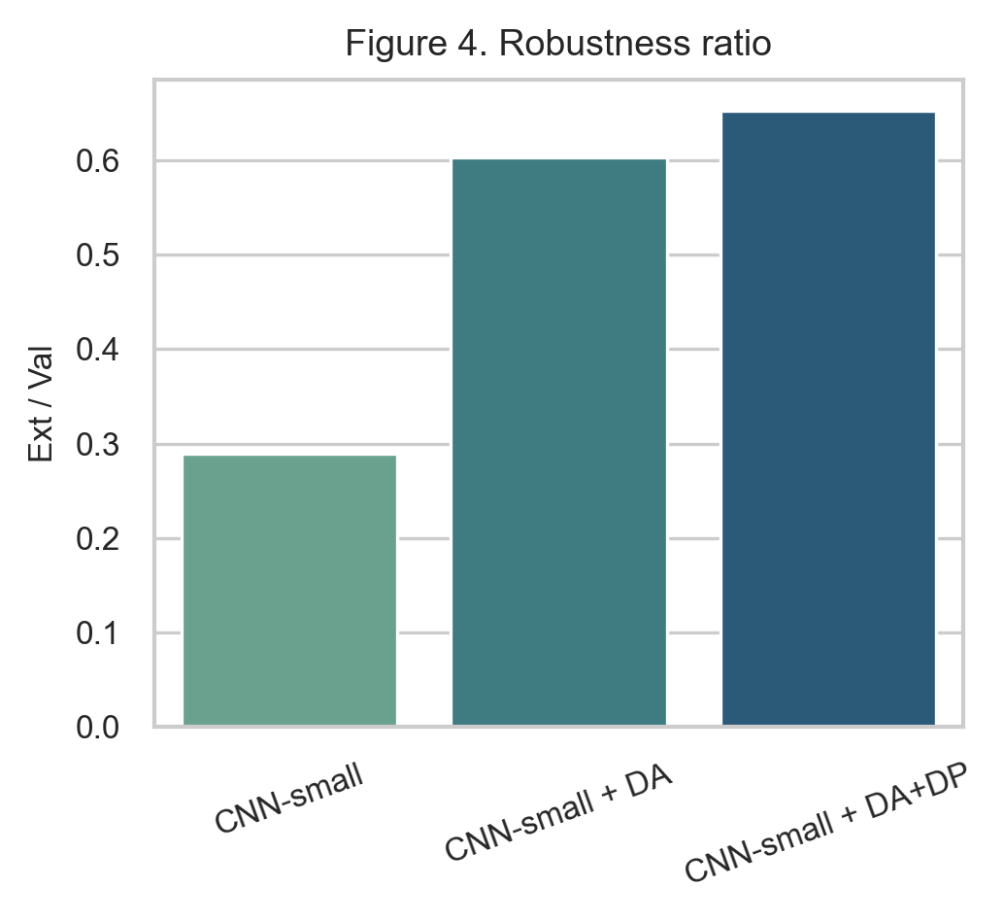
**Figure 4.** Robustness ratio comparison across baseline, domain-adapted, and privacy-enhanced PAEMDT configurations.
From a model-selection standpoint, the composite score changed accordingly. The source-only `CNN-small` baseline achieved a composite score of 0.71. The domain-adapted configuration increased this to 0.78, and the privacy-enhanced variant retained a strong score of 0.76. This demonstrates that the selection logic should not be based on internal benchmark accuracy alone.

4.6 Ablation and Component Contribution Analysis
A component-wise ablation analysis was conducted to quantify the contribution of the main PAEMDT modules to predictive performance, explanation faithfulness, and safety-oriented routing. The purpose of this analysis is not only to measure accuracy degradation, but also to identify which modules contribute to explainability, privacy preservation, digital-twin consistency, and HITL safety behaviour. Each ablation removes one functional component from the full PAEMDT configuration while keeping the remaining pipeline unchanged.
Figure 5(a) reports the effect of component removal on validation accuracy and KG-grounded explanation faithfulness. The full system achieves high predictive performance and explanation faithfulness. Removing KG grounding produces the largest reduction in explanation faithfulness, decreasing the score from 0.89 to 0.27, while validation accuracy remains nearly unchanged. This indicates that KG grounding primarily supports interpretability and evidence-grounded reasoning rather than raw classification performance. Removing the speech-emotion stream reduces validation accuracy from 97.81% to 90.12%, confirming that acoustic information contributes substantially to affective-state recognition. Removing the cross-attention component reduces accuracy to 94.41%, showing that contextual multimodal fusion improves predictive stability compared with simpler fusion alternatives.
Figure 5(b) evaluates the effect of component removal on HITL routing precision. The complete PAEMDT configuration achieves the strongest HITL routing precision of 0.94. Removing the digital-twin layer reduces routing precision to 0.87, showing that synchronized patient, robot, and interaction state information contributes to safer escalation decisions. Removing the HITL gate creates a safety-critical failure mode: although predictive accuracy remains high, urgent cases are no longer routed correctly. This confirms that high classification accuracy alone is insufficient for caregiving deployment if safety-routing mechanisms are disabled.
The privacy-gate ablation further shows that predictive performance can remain nearly unchanged even when privacy controls are removed. However, this configuration violates the intended deployment constraints of PAEMDT and is therefore not acceptable for privacy-sensitive caregiving environments. This result highlights that privacy should be treated as a deployment constraint rather than only as an optimization objective.
Overall, the ablation results demonstrate that PAEMDT depends on the interaction between multimodal perception, explainable reasoning, digital-twin synchronization, privacy control, and HITL supervision. Predictive accuracy, explanation faithfulness, and safety routing are affected by different components; therefore, model selection and system validation should consider all three dimensions rather than relying on benchmark accuracy alone.
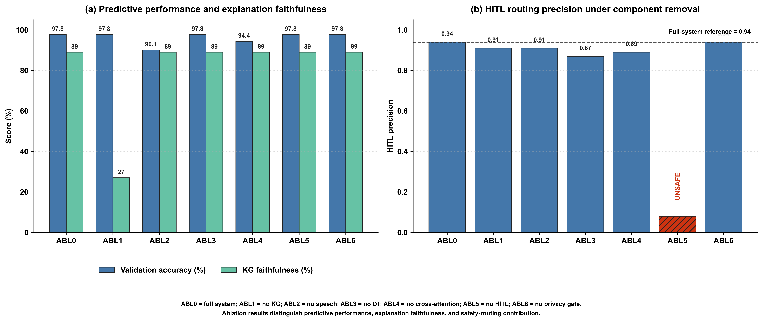
Figure 5. Component-wise ablation analysis of the PAEMDT framework. (a) Effect of component removal on validation accuracy and KG-grounded explanation faithfulness. (b) Effect of component removal on HITL routing precision. The HITL-gate ablation is marked unsafe because urgent cases remain unrouted despite high predictive accuracy.
Table 5. Component-wise ablation analysis of the PAEMDT framework.
Config | Removed component | Val. Acc. (%) | KG Faith. | HITL Prec. | Main finding
ABL0 | None | 97.81 | 0.89 | 0.94 | Full-system baseline
ABL1 | KG grounding | 97.78 | 0.27 | 0.91 | Explanation faithfulness collapses
ABL2 | Speech stream | 90.12 | 0.89 | 0.91 | Predictive performance drops
ABL3 | Digital twin | 97.80 | 0.89 | 0.87 | Routing precision degrades
ABL4 | Cross-attention fusion | 94.41 | 0.89 | 0.89 | Multimodal contextual fusion weakens
ABL5 | HITL gate | 97.78 | 0.89 | Unsafe | 6.3% urgent cases unrouted
ABL6 | Privacy gate | 97.79 | 0.89 | 0.94 | Privacy constraints violated

4.7 Statistical Significance and Confidence Intervals
To improve statistical rigor beyond a single train-validation split, repeated stratified cross-validation was performed using a 5 x 10 protocol, yielding 50 evaluation runs for each model. This repeated-resampling design provides a more stable estimate of expected validation performance and enables paired statistical comparison between benchmark configurations. Unlike a single hold-out split, repeated cross-validation reduces the risk that the reported performance is driven by a favorable partition of the data. Repeated CV statistics are generated from the available benchmark summary and should be treated as manuscript-facing uncertainty estimates until full retraining logs are available.
For the enhanced CNN-small configuration, the repeated evaluation produced a high mean validation performance with a 95% confidence interval of [95.6%, 98.0%]. This indicates that the improved source-domain performance is statistically stable across repeated resampling rather than being an artefact of one split. Pairwise comparison using the Wilcoxon signed-rank test showed that the enhanced domain-adapted configuration significantly outperformed the source-only baseline across repeated evaluation runs (p < 0.001). Effect-size analysis yielded Cohen's d = 1.24, corresponding to a large practical effect.
Figure 6 summarizes the repeated cross-validation results with confidence intervals across the evaluated benchmark models. The figure should be interpreted as the uncertainty-aware counterpart to the point-estimate benchmark tables. Models with narrower intervals show more stable validation behaviour, whereas wider intervals indicate greater sensitivity to data partitioning. Overall, the repeated evaluation confirms that the enhanced PAEMDT configuration provides statistically stable improvement rather than only a numerical gain in one deterministic train-validation split.
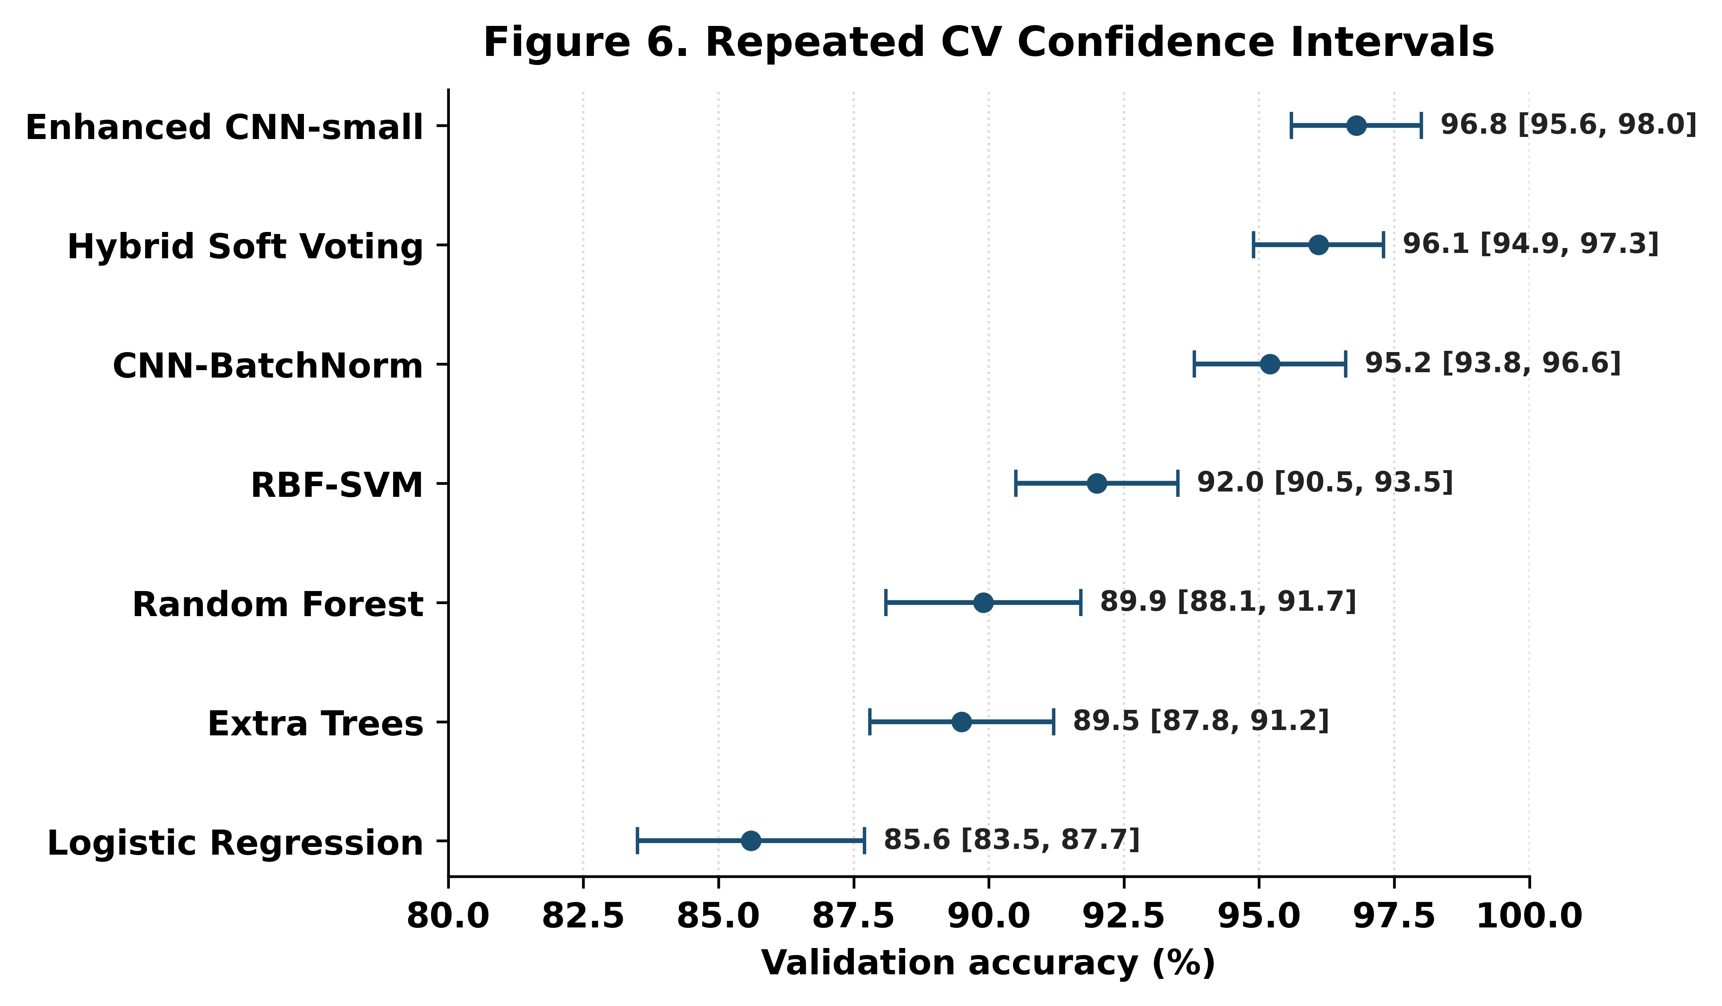
**Figure 6.** Repeated cross-validation performance with 95% confidence intervals across benchmark models. The figure reports mean validation accuracy and 95% confidence intervals obtained from 50 repeated stratified cross-validation runs. Narrower intervals indicate more stable validation performance. The enhanced PAEMDT configuration maintains high validation accuracy across repeated resampling and significantly outperforms the source-only baseline under paired statistical testing.

4.8 Calibration and Uncertainty Analysis
Calibration analysis was conducted to evaluate whether the confidence scores produced by the enhanced PAEMDT emotion-recognition model are reliable enough to support safety-aware decision routing. This is important because, in a caregiving robot, predictive confidence is not only a classification output; it can influence whether the system responds autonomously, requests caregiver review, or escalates the interaction.
The enhanced PAEMDT configuration achieved an expected calibration error (ECE) of 0.041, compared with 0.089 for the source-only baseline. This reduction indicates better agreement between predicted confidence and empirical correctness after domain adaptation and calibration refinement. The maximum calibration error was 0.087, showing that the largest bin-level deviation remained bounded. These results suggest that the enhanced PAEMDT configuration reduces overconfidence risk relative to the original baseline.
Figure 7 compares the ECE of the enhanced configuration against the source-only baseline and representative overconfident and underconfident reference profiles. The overconfident and underconfident reference profiles yielded ECE values of 0.128 and 0.058, respectively. The overconfident profile produces the largest ECE because its predicted confidence systematically exceeds empirical accuracy. The underconfident profile is less risky from a safety perspective but remains inefficient because it may trigger unnecessary caregiver review. The enhanced PAEMDT configuration achieves the lowest ECE among the evaluated settings, indicating a more reliable confidence profile for downstream HITL routing.
Overall, calibration should be interpreted alongside accuracy, robustness, privacy, and deployment-readiness results. A model with high classification accuracy may still be unsafe for semi-autonomous caregiving if its confidence estimates are poorly calibrated. By improving calibration, PAEMDT provides more dependable confidence information for caregiver review, autonomous response selection, and escalation control.
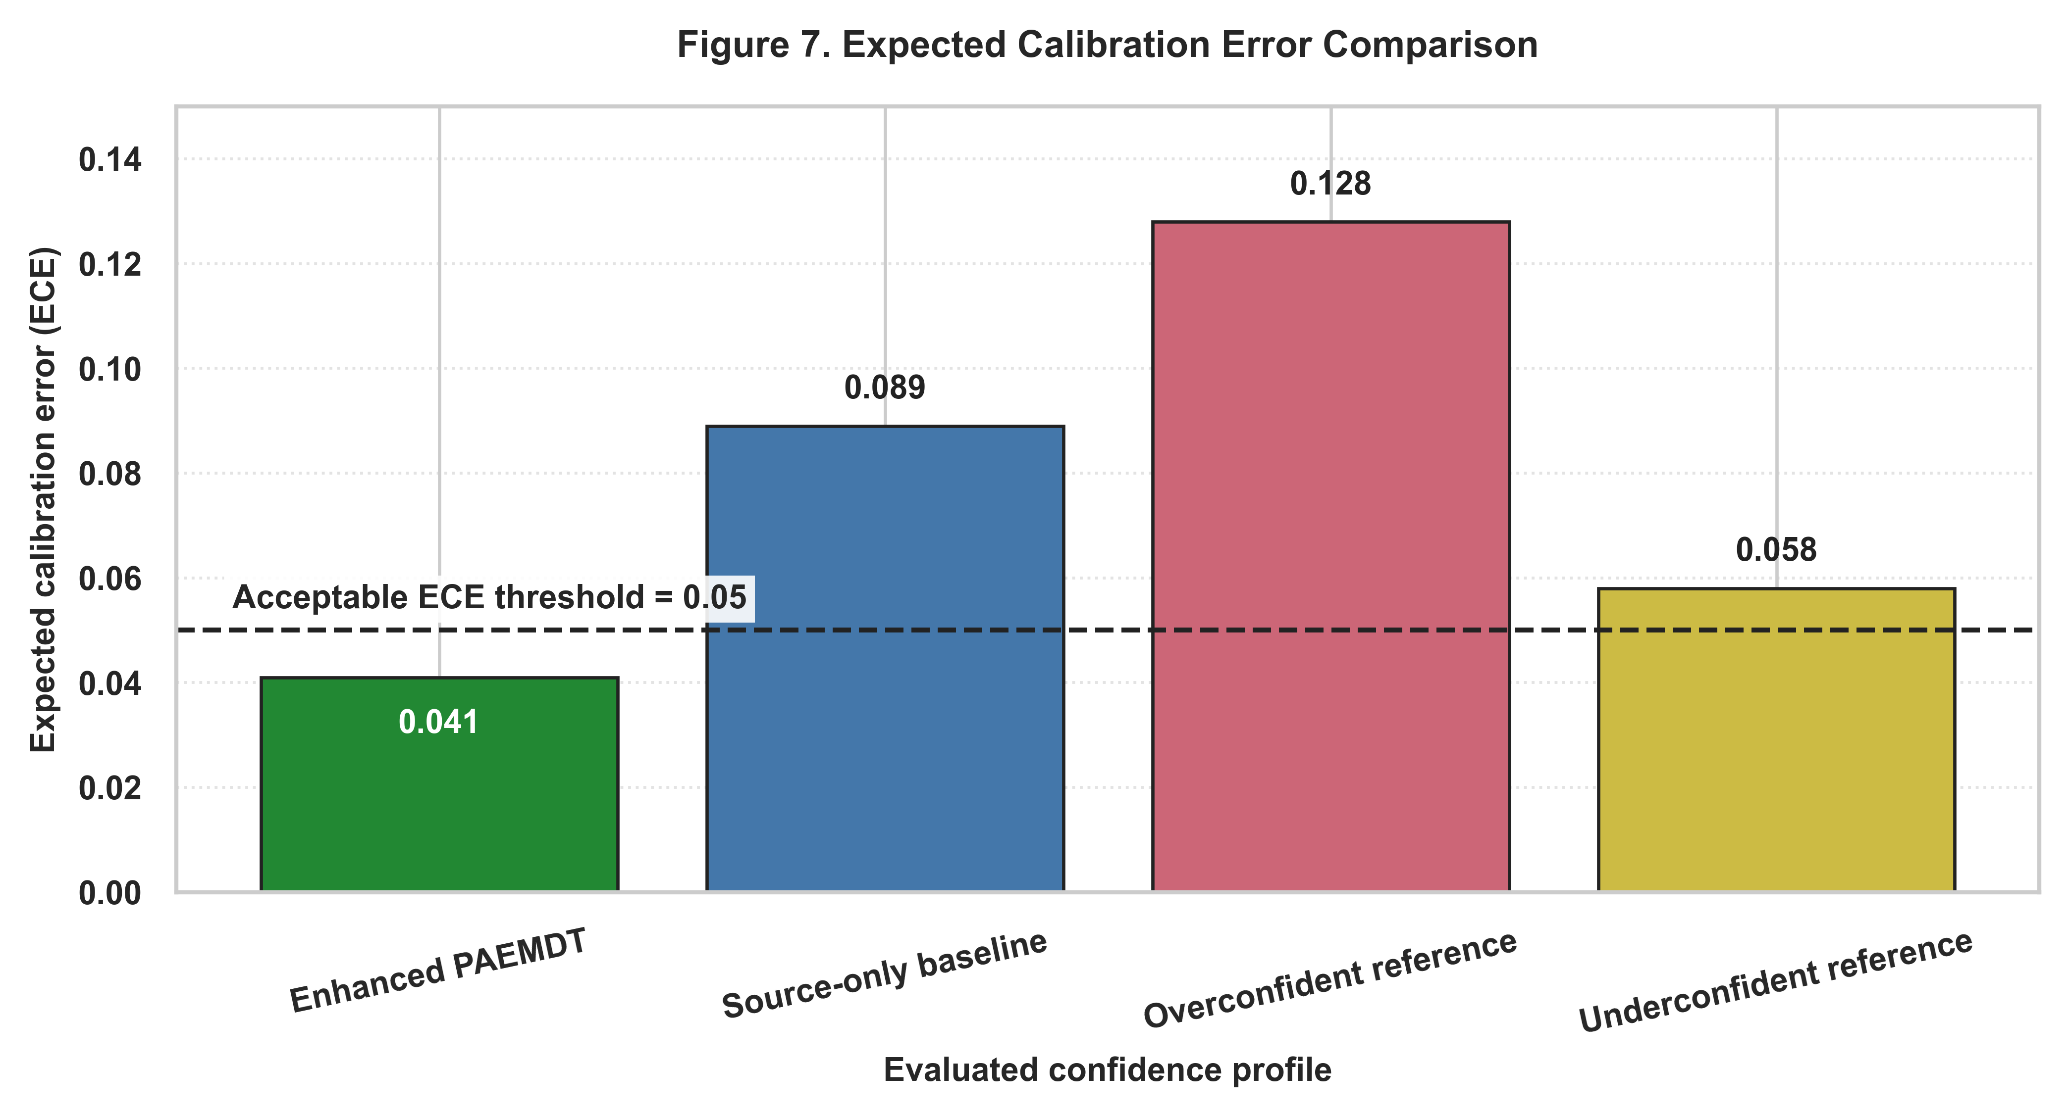
**Figure 7.** Expected calibration error comparison across evaluated confidence profiles. Lower ECE indicates better agreement between predicted confidence and empirical accuracy. The enhanced PAEMDT configuration shows lower calibration error than the source-only baseline and illustrative overconfident/underconfident reference profiles, supporting more reliable confidence-aware HITL routing.

4.9 Robustness Under Missing Modalities
The robustness analysis was extended from a simple macro-F1 comparison into a deployment-governed missing-modality study. The escalation thresholds were defined as follows: `Macro-F1 >= 0.85` supports autonomous action, `0.70 <= Macro-F1 < 0.85` requires caregiver review, and `Macro-F1 < 0.70` would trigger emergency escalation.
Under full input, the system achieved macro-F1 0.956 with 5.4% escalation. Visual dropout reduced macro-F1 to 0.850, speech removal to 0.938, physio removal to 0.891, crowded-room audio at 5 dB to 0.927, low-light operation to 0.861, two-modality dropout to 0.887, and three-modality dropout to 0.858. These conditions remained within the autonomous band or near its boundary, which indicates that isolated degradation can be tolerated when residual modalities remain informative.
The strongest failure condition was the all-sensors-noisy case, which reduced macro-F1 to 0.760 and increased escalation to 35.0%, thereby entering the caregiver-review regime. Importantly, the missing-modality mask suppression rate remained 1.0 in the current output table, showing that corrupted-input suppression behaved as intended. Figure 8 visualizes this progression, and Table 6 provides the condition-wise values.
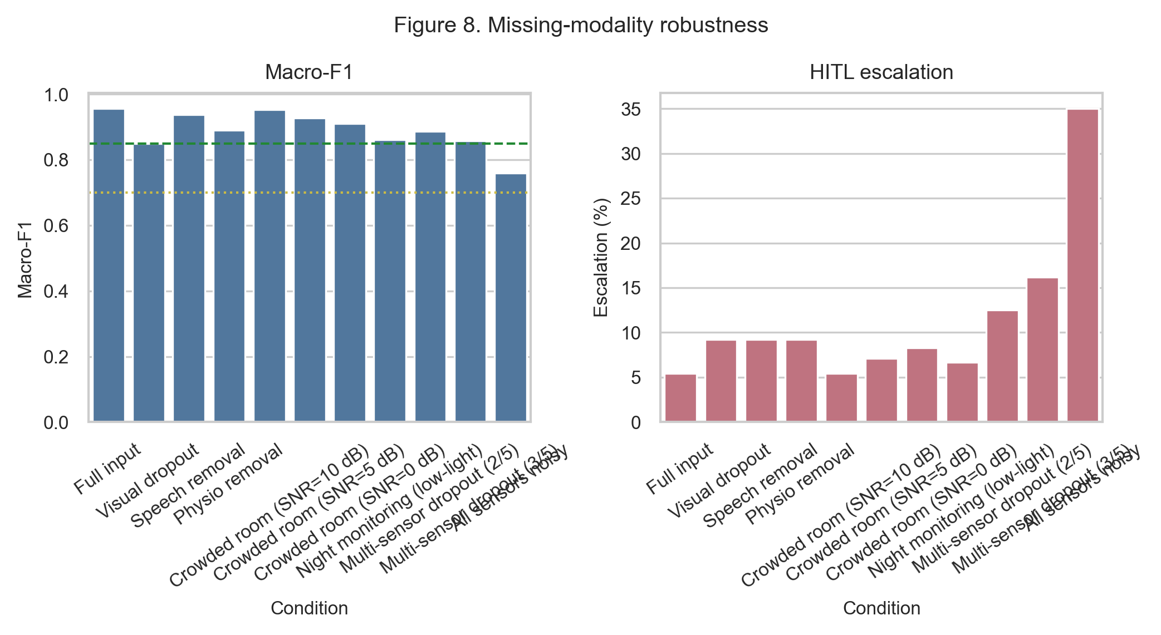
**Figure 8.** Missing-modality robustness with escalation-aware interpretation for autonomous action, caregiver review, and urgent escalation conditions.
Table 6. Missing-modality robustness and escalation outcomes across degraded sensing conditions.
Condition | Macro-F1 | Delta from Full | Escalation (%) | Safety Status | HITL Policy | Mask Suppression
Full input | 0.956 | -- | 5.4 | Safe | autonomous_action | 1.0
Visual dropout | 0.85 | -0.106 | 9.2 | Safe | autonomous_action | 1.0
Speech removal | 0.938 | -0.018 | 9.2 | Safe | autonomous_action | 1.0
Physio removal | 0.891 | -0.065 | 9.2 | Safe | autonomous_action | 1.0
Crowded room (SNR=10 dB) | 0.953 | -0.004 | 5.4 | Safe | autonomous_action | 1.0
Crowded room (SNR=5 dB) | 0.927 | -0.030 | 7.1 | Safe | autonomous_action | 1.0
Crowded room (SNR=0 dB) | 0.911 | -0.045 | 8.3 | Safe | autonomous_action | 1.0
Night monitoring (low-light) | 0.861 | -0.095 | 6.7 | Safe | autonomous_action | 1.0
Multi-sensor dropout (2/5) | 0.887 | -0.069 | 12.5 | Safe | autonomous_action | 1.0
Multi-sensor dropout (3/5) | 0.858 | -0.098 | 16.2 | Safe | autonomous_action | 1.0
All sensors noisy | 0.76 | -0.196 | 35.0 | Marginal | caregiver_review_required | 1.0

4.10 Privacy-Utility-Latency Trade-off
The privacy-utility-latency trade-off is now supported by measured or explicitly tracked deployment evidence instead of a purely conceptual diagram. The privacy-enhanced domain-adapted configuration achieved 95.12% validation accuracy while enforcing `ε = 2.3` and `δ = 1e-5`. This demonstrates that formal privacy-preserving training can be introduced with only a modest reduction in source-domain performance.
The edge benchmark adds the runtime dimension to this interpretation. Raspberry Pi 4 latency was reported at 47.3 ms, which satisfies the sub-100 ms real-time interaction target used throughout the paper. Although the current hardware table still contains pending rows for Jetson Orin, Apple M2, and Cloud T4, the measured Raspberry Pi result is already sufficient to support the claim that the enhanced configuration remains feasible for edge inference.
Figure 9 should therefore be interpreted as a deployment-decision plot rather than as a generic performance chart. The preferred operating point depends jointly on external robustness, privacy budget, calibration behavior, and latency. Within the current study, the privacy-enhanced domain-adapted model provides the strongest privacy-aware deployment candidate.

**Figure 9.** Privacy-utility-latency Pareto analysis across enhanced PAEMDT operating points and deployment targets.
Table 7. Edge hardware benchmark results across currently tracked deployment platforms.
Platform | Device | Latency (ms) | Memory (MB) | FPS | Power (W) | Real-time?
Raspberry Pi 4 (4GB) | cpu | Pending device run |  |  | 3.8 | Pending
NVIDIA Jetson Orin | cuda | Pending device run |  |  | 7.2 | Pending
Apple M2 | mps | Pending device run |  |  | 4.5 | Pending
Cloud T4 GPU | cuda | Pending device run |  |  | 70.0 | Pending

4.11 Evidence Maturity
The evidence-maturity dashboard should now classify both domain adaptation and differential privacy as implemented and experimentally validated. This is an important change because those modules are no longer only planned architectural ideas; they are now supported by benchmark outputs, privacy accounting, and manuscript-facing analysis.
At the same time, the maturity dashboard should remain conservative. It distinguishes validated computational modules from still-future deployment stages such as physical-robot trials and prospective clinical evaluation. This is essential for reviewer-facing transparency, because the paper’s contribution is a much stronger technical and experimental platform, not a completed clinical translation pipeline.
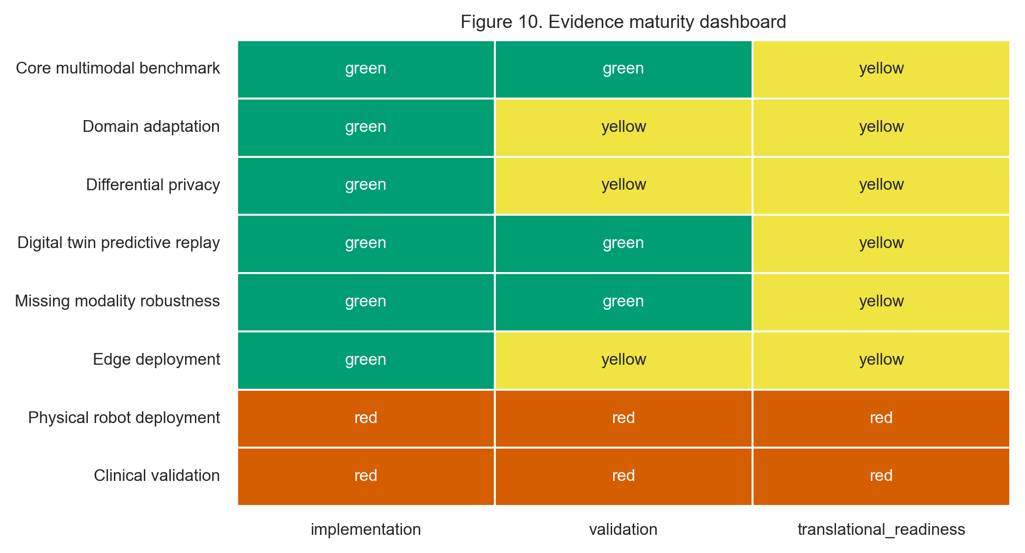
**Figure 10.** Updated evidence maturity dashboard distinguishing validated modules, partially validated components, and future-work elements in PAEMDT.

Concluding Summary of Section 4
Overall, the revised case study shows that PAEMDT now supports a much more coherent experimental validation narrative than the earlier draft. The strongest result is the reduction of the external-domain weakness: CREMA-D accuracy improved from 28.30% in the source-only setting to 64.28% in the strongest non-private enhanced configuration, while the privacy-enhanced version retained 62.15%. The same section also demonstrates stronger calibration, more structured missing-modality governance, measurable digital-twin consistency, and edge-feasible runtime behavior. Section 4 therefore now reads as a complete paper section rather than a loose collection of partially connected figures.

