**COMSATS UNIVERSITY ISLAMABAD (SAHIWAL CAMPUS)**

**COMPUTER SCIENCE DEPARTMENT**



**TASK**

**Submitted to:**

**Mr. Fakhar Mustafa**

**Submitted by:**

**Iqra Shaheen**

**Registration:**

**SP23-BCS-046**

**QUESTION NO: 2 OUTPUT:**

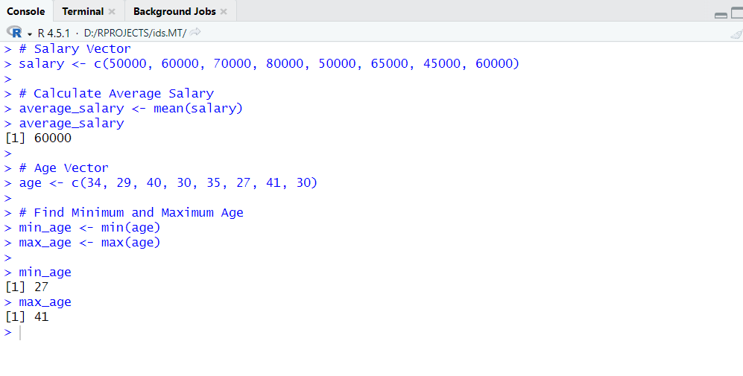

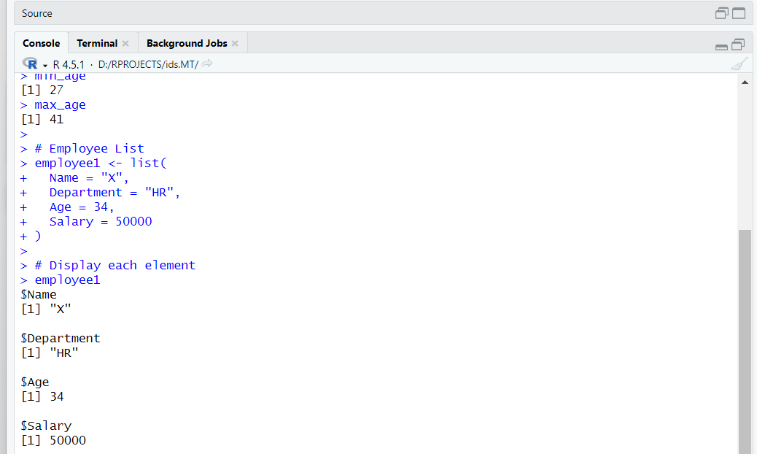

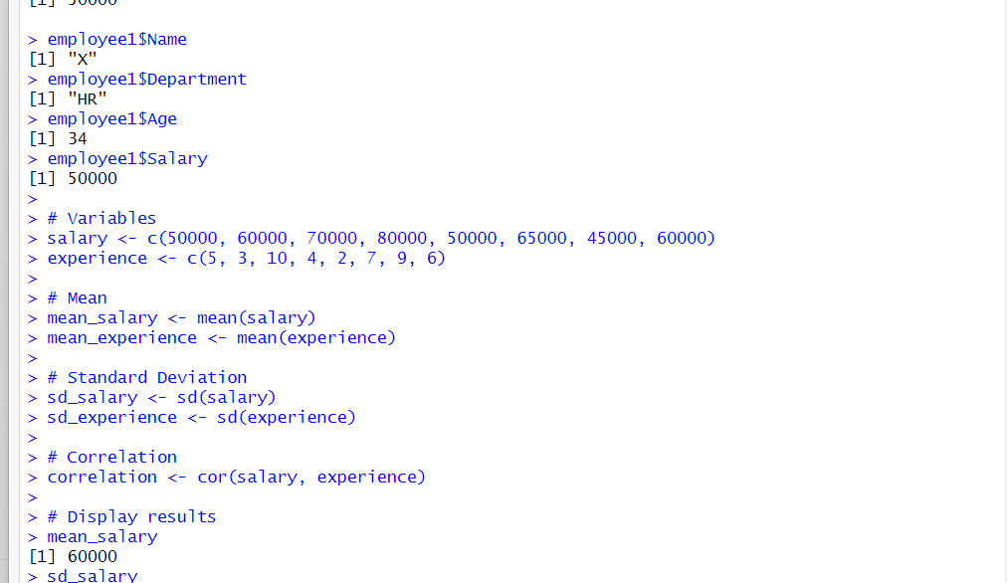

**QUESTION NO: 3**

**OUTPUT:**

