

**Stethoscope Digitization**

**Report**

**Submitted to:** Zubair Malik

**Date: 19 Mar. 17**

**Aaira Suhail BSCS13015**

**Sheryar Zahid BSCS13042**

**Iqra Shahzad BSCS13060**

**Syed Muhammad Hassan BSCS13073**

**Problem domain**

The problem which our group is working on is related to health. We want to develop somethings useful for the patients of pneumonia as well as the doctors.

Pakistan is among the five countries that account for 99 percent of childhood pneumonia cases. Pneumonia accounts for 15% of all deaths of children under 5 years old, killing 920136 children in 2015. Pakistan was ranked third in 2014 in the list of 15 high burden countries. At least 92,000 children die of pneumonia annually due to lack of proper health facilities in remote areas. It can be caused by viruses, bacteria, or fungi and can be prevented by immunization, adequate nutrition, and by addressing environmental factors. Pneumonia caused by bacteria can be treated with antibiotics, but only one third of children with pneumonia receive the antibiotics they need. [1]

**Initial Point of View**

We first conducted a survey with five doctors of Ganga Ram hospital and inquired from them about the use of stethoscope and the detection of pneumonia using the device.

Dr Sumaira: Pneumonia and asthma are the diseases that can be detected using the stethoscope. She used applications related to the heart and respiration sounds to differentiate between the sounds. Children themselves cannot tell how they are feeling; whether they are unwell or not, so it that case the reliable method to check is through the stethoscope.

It would be game changing to differentiate between different sounds of heart and respiration.

Dr Ayesha Fatima: Clinical picture of every disease is different. In pneumonia child has fever and his respiratory rate increases. Stethoscope is important to auscultate the chest. Diaphragm size is different for adult and child. Standard points for auscultation are same universally. Accuracy of the system is important. She feared that if made any system it would not provide accurate results and it may not detect disease correctly. Patient would also not be satisfied if the doctors will be using our system so the system should have some link with the doctor for the satisfaction of the patient. Also the unexperienced doctors can use this kind of system and will aid in their learning process.

It would be game changing to help the doctors through technology and gain their confidence.

Saba: Patients history plays and important role in diagnosis and also the sensitivity of the stethoscope. If a patient is unconscious then we totally rely on the stethoscope and it strengthens the examination. Different diseases have different sounds and most patients use internet to diagnose disease themselves and most of the time their diagnoses is correct. Time consumption for diagnosis will be reduced if some system is made which amplifies the sounds. It would be game changing if we reduce the diagnosis time and make her distinguish between the sounds.

**Additional Need-finding Results**

**Dr. Mohammad Usman**

****We interviewed Dr. Mohammad Usman from Children Hospital. We asked him about the detection of pneumonia and he answered that it depends on the age of the patient. He further said that the breathing rate is different in different ages. A small age child will always breathe faster than the older one. Checking the patient’s chest is the second part, we diagnose whether the nose is connected properly with the breathing mechanism or not. According to him, x ray is the third way of detecting pneumonia. We asked him whether cough can tell if the person is suffering with pneumonia or not. He said not only cough. Fever, breathing and cough, all of these are main things for the detection of pneumonia. We asked him about any application he uses for such purpose and he instantly replied no. But he said that he uses internet sometimes when he need some information about any of the disease or medicine. We asked him will he be facing any difficulty in detecting pneumonia without stethoscope, then, he said yes for sure, as the condition of the heart cannot be determined without a stethoscope. Finally, we asked him about the application, that if he wants an application for such purpose or not. He replied that he doesn’t actually need any of these devices but this device can help patients. As they will be able to detect pneumonia at home.

It will be game changing to make an application through which patients can detect pneumonia themselves.

**Dr. Ayesha**

We interviewed Dr. Ayesha from Ittefaq Hospital. We asked her about the difficulties she face while detecting pneumonia. She replied that there are no such difficulties. We also asked about the method of diagnosing pneumonia. She said that the main thing is patient history, then the patient’s look, whether the patient looks toxic or not, the nose being swell or not. Finally, we listen to the sounds coming from inside of the body and we discover whether the person is suffering with pneumonia or not. We then asked her about x ray and she said that X ray is not very much important in diagnosing pneumonia. We take x ray when we have extra findings in the body of the patient or when we feel suspicious about a specific person. We then asked that if you don’t have stethoscope then what do you do. She replied then we check for the overall condition and appearance of the patient. She also said that stethoscope is an essential product for the doctors and they cannot diagnose a lot of diseases without it. She also said that pneumonia is a very vast disease, the infection can be very less or more. Sometimes a patient couldn’t even breathe and sometimes the patient seems unhurt. Then we asked her about any of the application she uses for such purpose and she replied no. She said that doctors are very used to detect pneumonia with stethoscope that they wouldn’t want to switch their device. We also asked her that did she face any difficulty in the beginning of her job and she said that she didn’t as they she learnt everything like this in her house job.

**Azra bibi**

We interviewed a mother of a patient. We asked her that what problems she faced when her daughter had pneumonia. She said that she was very much disturbed of the routine as she had to take her to the doctor every day. She said that an application with all the details of how to 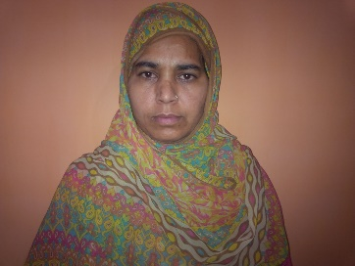cure pneumonia would have saved her time. She also said that if she gets any application she may not believe on the result and will go to the doctor anyway. Finally, we asked for a better way that people can trust in our application, she proposed an application which can have precautions installed into it and one can get every single method to keep away from pneumonia.

**Revised POVs and HMW Statements**

We met Saba a final year medical student. We were surprised to hear that she face difficulty while hearing the sounds of a disease through stethoscope and also to distinguish between them. It also requires her to auscultate multiple times to diagnose correctly. It would be game changing if we reduce the diagnosis time and make her distinguish between the sounds. Listed below are some of the HMW statements we generated for Saba’s POV:

* How might we make the app useful for doctors?
* How might we differentiate between different sounds to detect pneumonia?
* How might we make stethoscope such that it plays the primary role in the detection?
* How might we make are app reliable for the doctors?
* How might we reduce the time for diagnosis?
* How might we convince the doctors to leave the ordinary stethoscope and switch to ours?
* How might we make a user friendly interface of the app for doctors?

We met Dr Usman, a child specialist from children hospital. According to him he would want us to think from the patient’s perspective. It will be game changing to make an application through which patients can detect pneumonia themselves. Listed below are some of the HMW statements we generated for Dr Usman’s POV:

* How might we make the device easier to use?
* How might we teach the rural area patients to use our device?
* How might we convince the patient that the results shown on our app are correct?
* How might we gain the trust of the patient?
* How might we diagnose patient properly?
* How might we give best advice/medication for pneumonia?
* How might we cover all the areas related to the diagnosis to the disease?

We met Azra bibi, mother of a patient who suffered from pneumonia. She had to take her to the doctor every day. It will be game changing if she could cure her daughter at home and reduce the visits to the doctor. Listed below are some of the HMW statements we generated for Azra bibi’s POV:

* How might we make her believe that she can trust our application?
* How might we reduce the visits to the doctor?
* How might we provide expert opinion?
* How might we reduce her stress?

**Three Experience Prototypes**

**Prototype 1**

As Saba said that she would want to have an aid to help her distinguish between multiple sounds and also to reduce the diagnosis time. Therefore we thought that we might catch the sounds and amplify them in our android application. Below is the prototype of the android application. It will also tell what kind of voice is it. As there are different voices like wheeze, crepes that aid in the detection of pneumonia. We assumed that the fresh doctors would find it helpful. It would also aid in their learning.

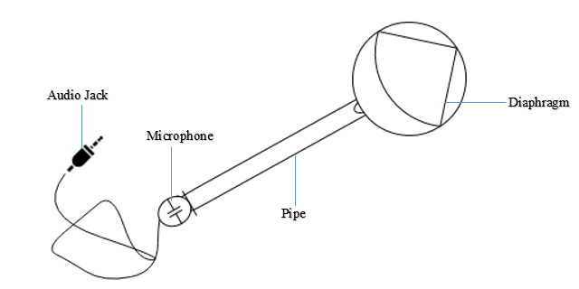 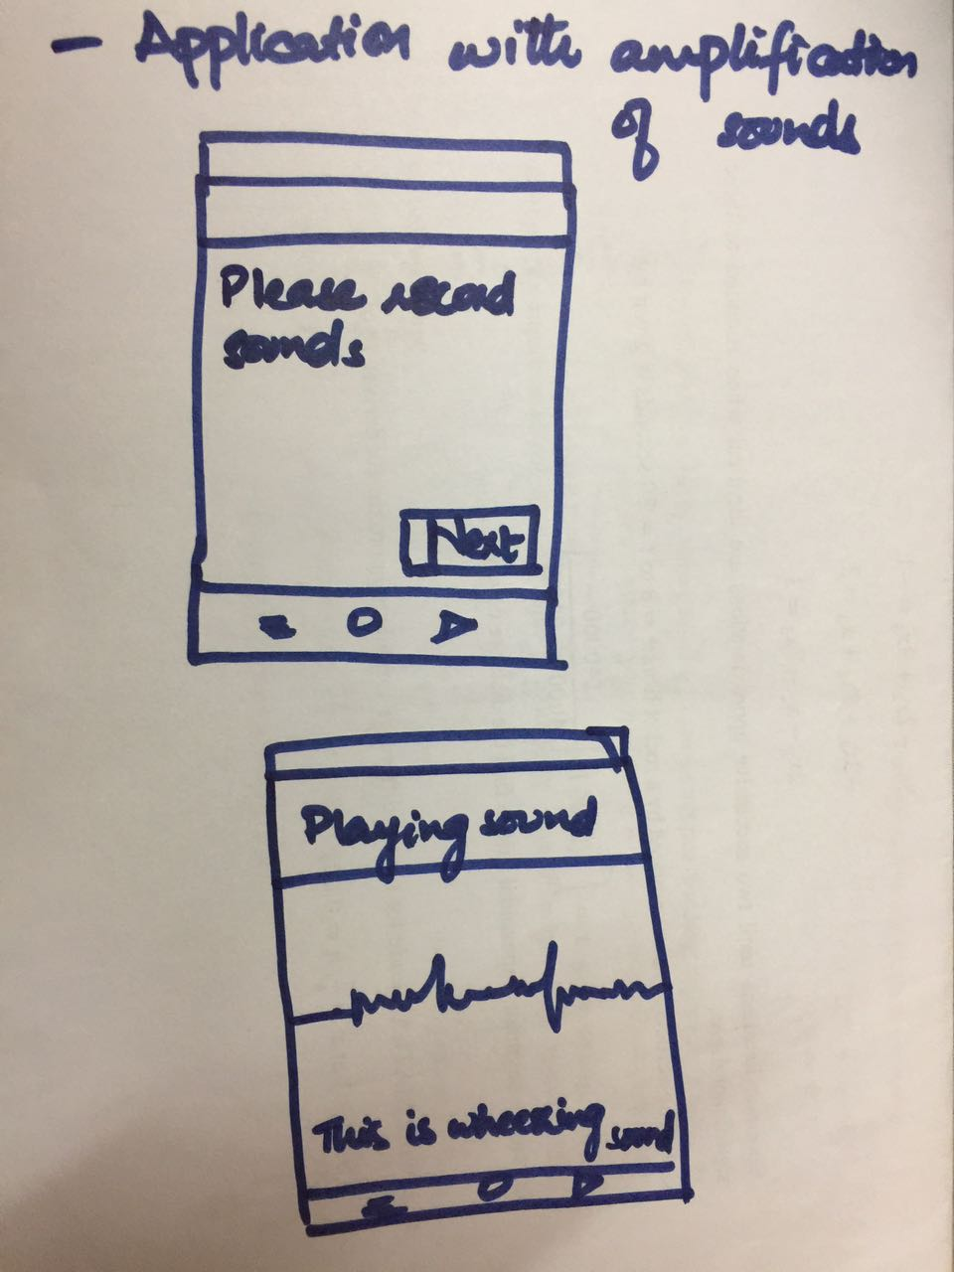

We tested the prototype with the doctors and they were concerned about how accurate result would it give. Our stethoscope does not work correctly so the doctors were quite sceptical. Experienced doctors said that we do not need this device as we can tell from the physical examination. When we went to fresh doctors they said that pneumonia is a complex disease only the voice detection is not enough for its detection. This device should include the input of fever, chest rigidity and cough. The type of cough is also very important for pneumonia identification. Furthermore, the results of the blood test should be included in the application. The components of the blood that should be incorporated in the device are RBC, WBC, platelets and blood culture. According to experienced professionals the radiological examination of the patient is a key factor for the examination of pneumonia for this patients should take the opinion of their consultant. Moreover, the development of this device will reduce the probability of hit and trial method for the identification of pneumonia.

**Prototype 2: Application for Pnemonia Remedies**

The below prototype was made for the patient so that it would help them save their visits to the doctors. This application will include the remedies for the patients so that they can cure their disease at their home. It will suggest the medication and it will also contain advices from expert doctors.

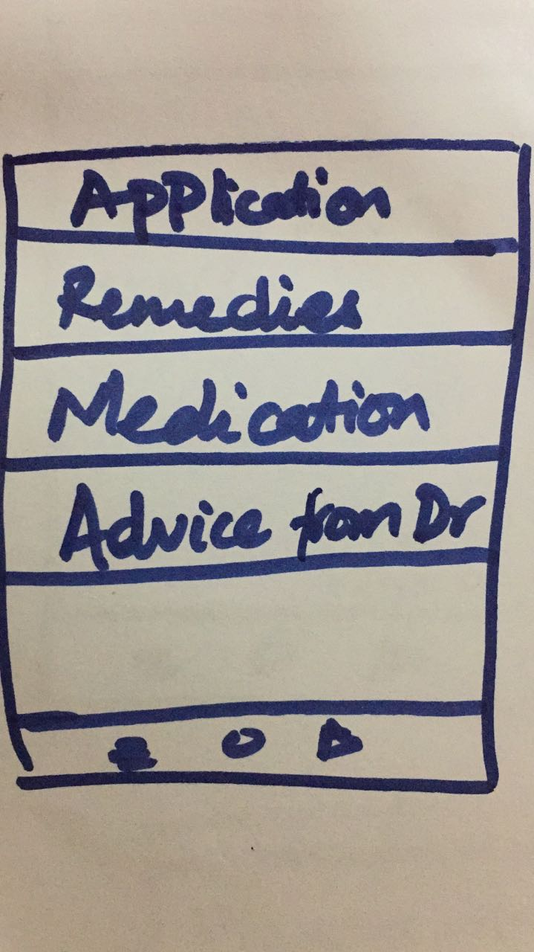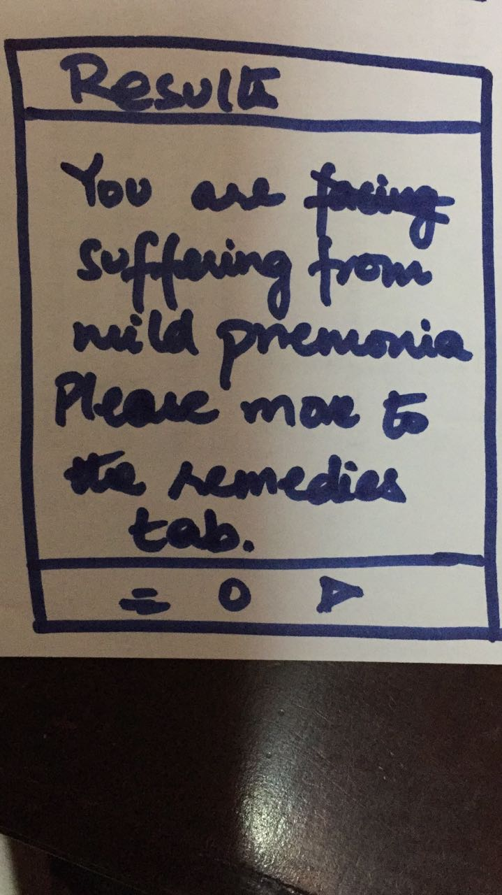

We have tested the application on the pneumonia patients. Overall the response was fair. The problems faced by the patient were the selection of the medicines. In markets there are different kind of medicines available for the same disease. For instance fever can be cured by Panadol 1mg and Panadol extra 1.0 mg. So the patient gets confused in the selection of medicines. However, herbal and home remedies are proved to be good solutions for the patients. In general these remedies have less side effects and after effects on the patients' health, so patients are more comfortable using these remedies.

**Prototype 3**

Patients will be able to detect whether he is facing pneumonia or not with the following prototype. The hypothesis behind the development of the application is to provide comfort to the patients. In these days peoples are much busy in their life issues. Both the doctors and the hospitals are not really available for instant treatment. In under developing countries the situation is worse, so in these circumstances this application will act as a stepping stone to reduce the gap of doctors between the disease and its cure.

We also assumed that the patient who would be using the application is a literate person. We also assumed that the patients knows the auscultation point and that he already has the report of his blood test.

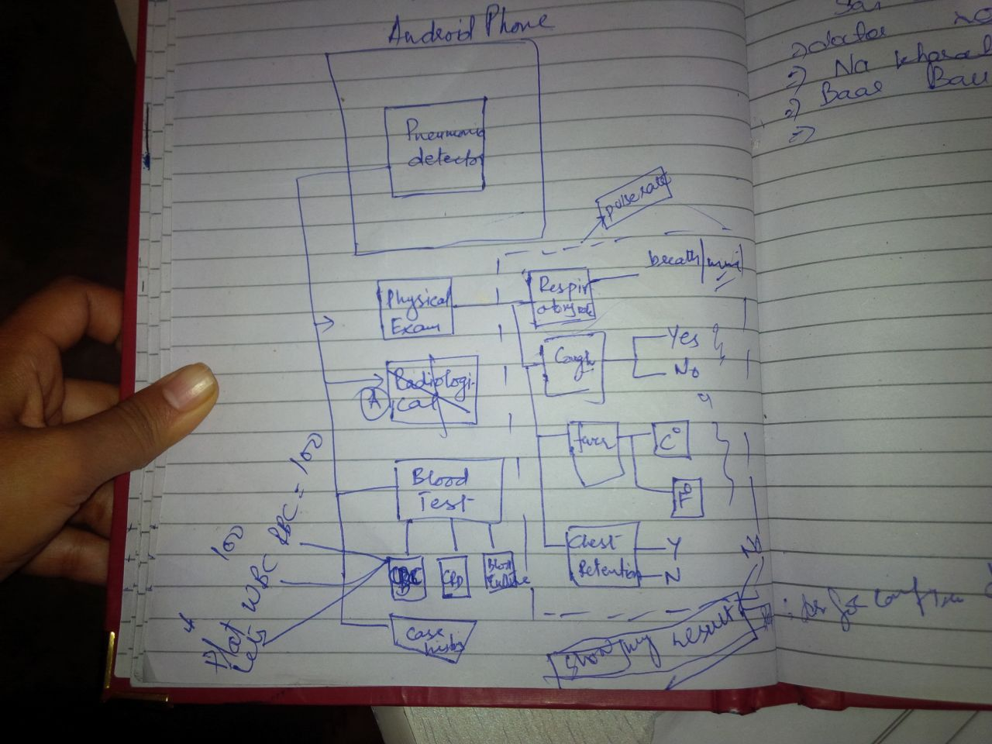

We tested the API (Application of Pneumonia Identification) on different patients. The application includes the insertion of patient's physical examination data, medical history and disease symptoms. The statistical analysis of the data shows that this application enables the patients to identify the pneumonia at early stages. However, in case of severe conditions of pneumonia this application refer proper examination from doctor. This feature of application was well appreciated by the patients.

We would need to modify the application for illiterate people. May be we could use simple language in that case. The patient also need to have his blood test before hand for accurate detection.

**Best Prototype**

Out of the above mentioned prototypes third one is proved to be most effective and implementable. This is because it includes the measurement of physical symptoms like breath rate, heartbeat, pulse rate, fever and cough. More over the result of blood test will also be incorporated in the application. These entries are concrete and scientific for the identification of pneumonia for any patient.