Report

# **The team:**

* Aaira Suhail (BSCS-13015)
* Sheryar Zahid (BSCS-13042)
* Iqra Shahzad (BSCS-13060)
* Syed M. Hassan (BSCS-13073)

**Introduction:**

Digital Doctor is an android based application which can help you diagnose pneumonia very easily without even the help of doctor. The application can provide the prescription as well but if the case is very severe then the application will refer you to go to a doctor. The interface of the application is very user friendly that anyone can use it easily.

**Initial Sketches:**

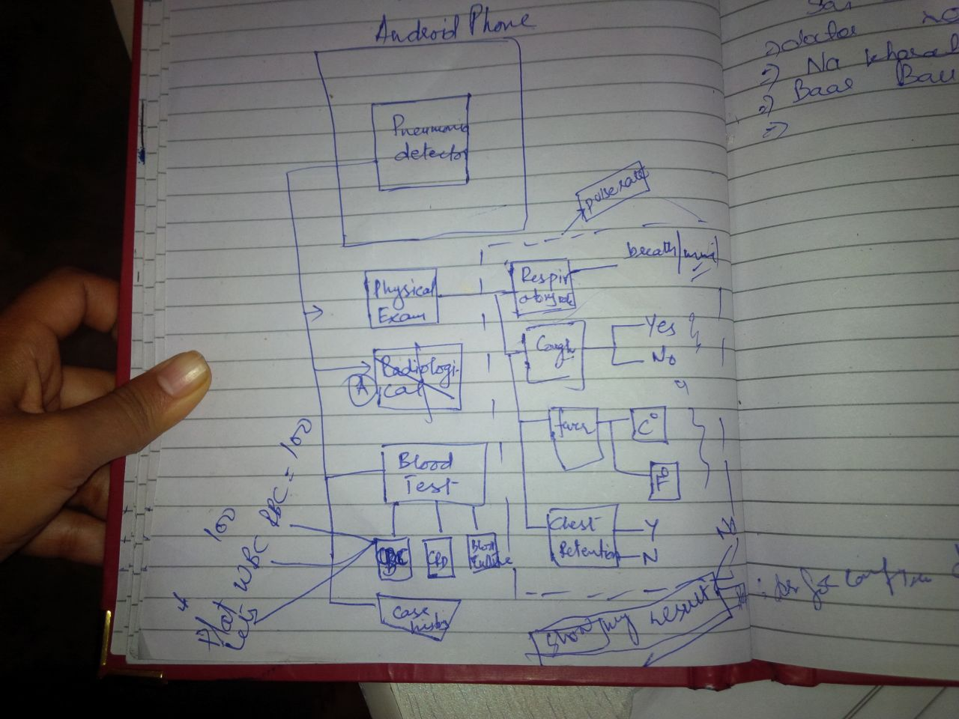

**Prototype 1:**

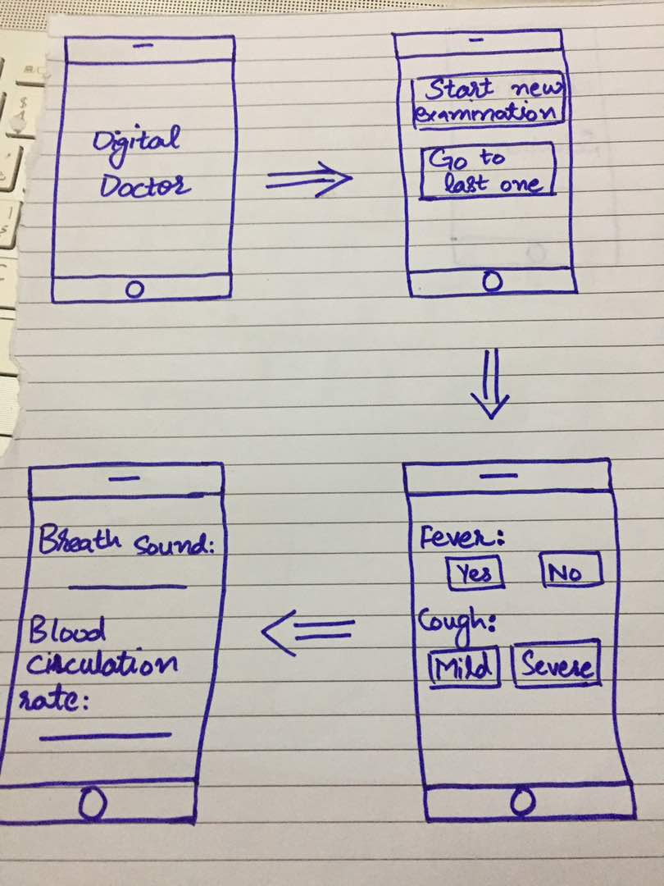

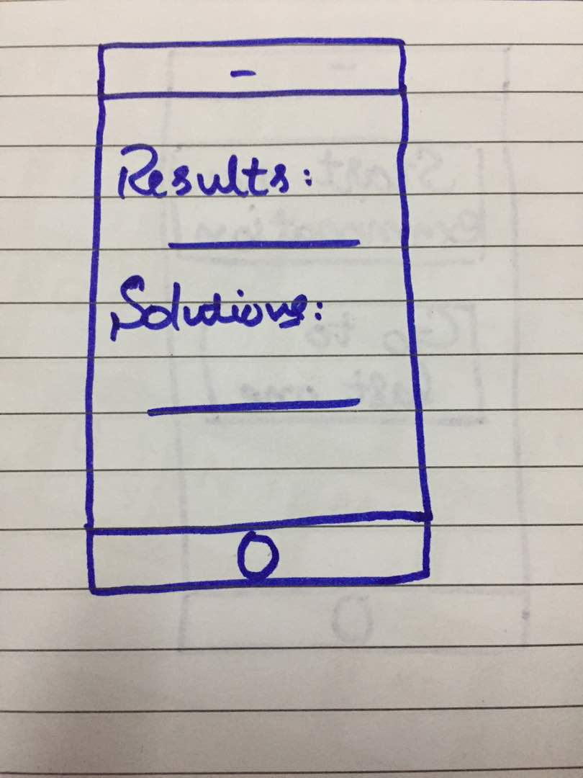

When you start the application, “**Digital Doctor**” will be shown to you and then a new screen will be shown. The second screen will have two options, “Start new examination” and “Go to the previous one”. If you select **start a new examination**, then the application will take you to a new screen which will be asking you about **cough** and **fever.** There are two options for cough “Mild” and “Severe”. After entering the required information on the third page you will be taken to the fourth page where the stethoscope will be providing some information. Finally, after these simple steps, the result will be shown on the fifth page that whether you are suffering from pneumonia or not. The last page will also have the solutions bar. Based on your condition the application will provide you some recommendations.

* What happens if you choose **Go to the previous one?**

The application will take you straight towards the fifth page where your last results and solutions were shown. So you may able to see the recommendations each time you want to or you may want to show your results to a doctor. This will save your time as you won’t have to check yourself each time.

**Testing:**

We tested this prototype on a housewife. We asked her to diagnose herself with the help of our application. She found it very easy as all the things were extremely straight forward. She had no medical history and that was the biggest reason she was satisfied that the application did everything by itself. According to her, the prototype was very easy to use. So, **Hall of fame** for this prototype.

**Prototype 2:**

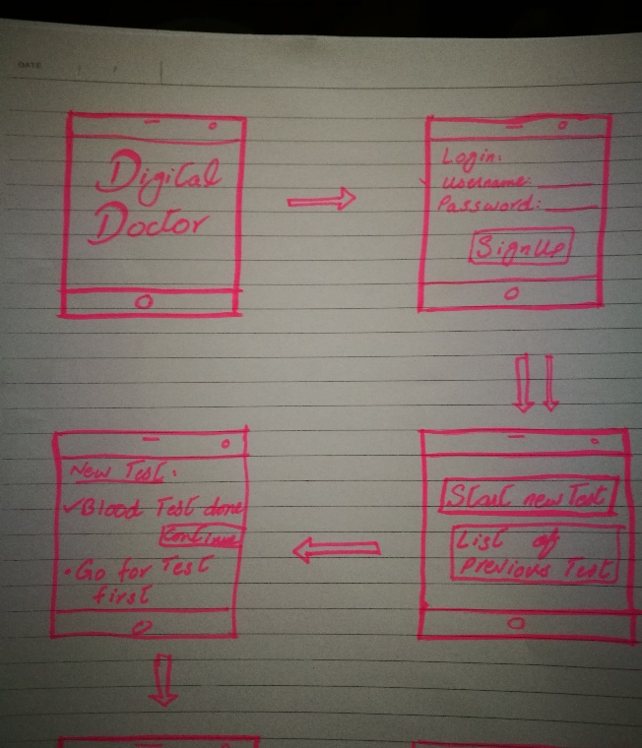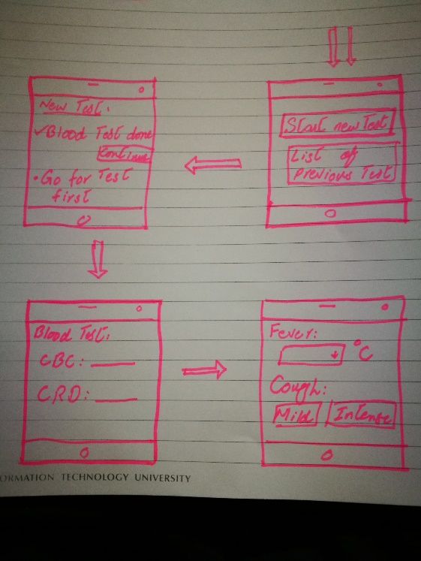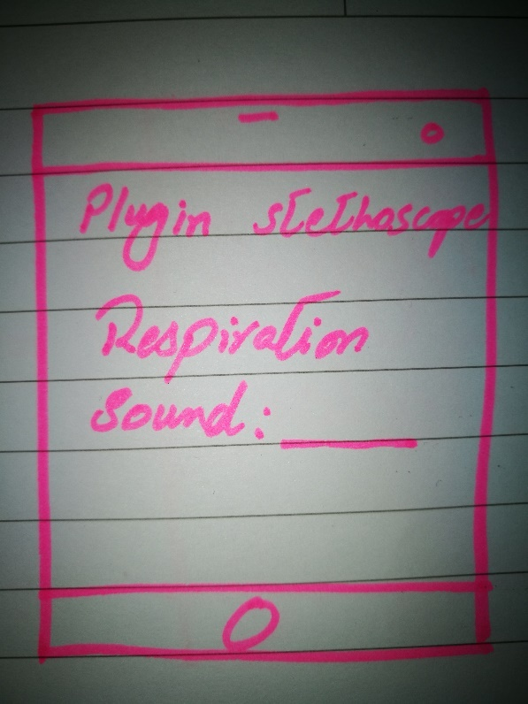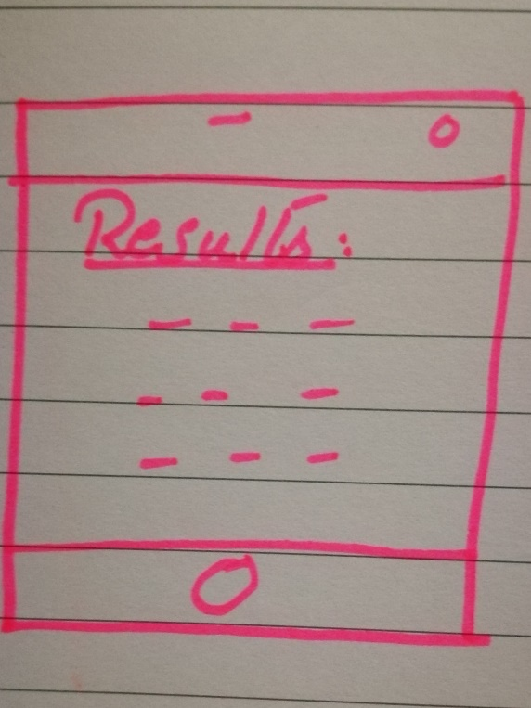

The prototype first of all requires a sign up, if you already have an account you can login to it. The application asks you about a new test or go to the previous one. When you choose start a new test then the application asks you about the blood test and you have to enter the CBC and CRD into the application. Later on, the application askes you about cough and fever, after entering all the required fields you have to plug in the stethoscope and it will display the respiration sound. Finally, the application will show you the results of the test.

**Testing:**

We tested this prototype on a lady who was already suffering from mild pneumonia and using this prototype she got exactly the same answer. The application showed “mild pneumonia” to the lady. She was very much convinced with the prototype as it was very easy to use and showed the right result.

**Prototype 3:**

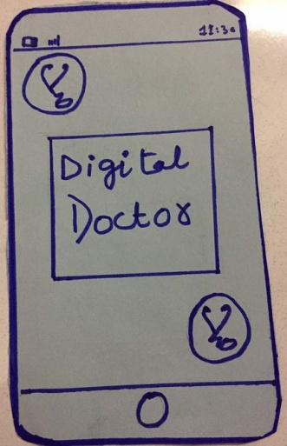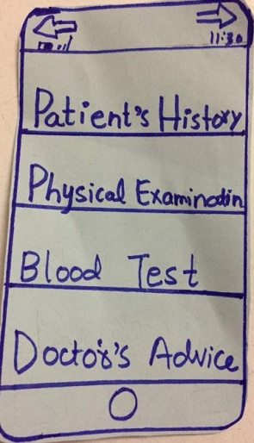

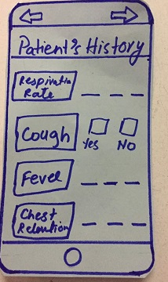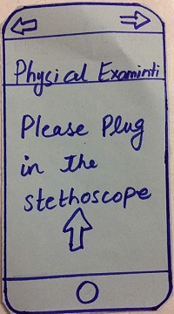

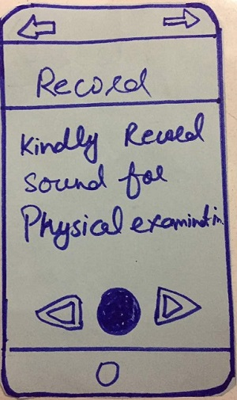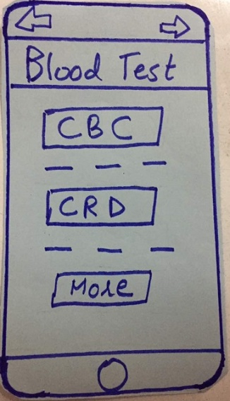

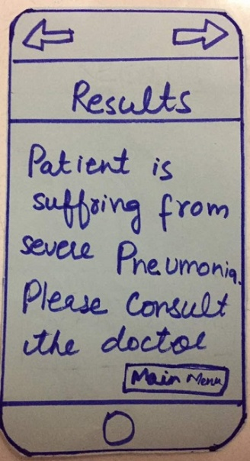

Our low-fi prototype includes a paper model of a phone and multiple paper screens that can be inserted into the phone one at a time. The major interface screens include the home screen includes the home screen, Patient History screen, Physical examination screen, Blood test screen and Result screen. We have a limited number of screens (7 in total). Since we are assuming that our user has very little time to begin with, we don’t want to waste their time by clicking through a lot of options or navigating through a lot of screens. Ideally, we want to be able to give them the content they want in just one click.

**Method:**

In this prototype firstly when you start the application title of the application “Digital Doctor” will be appear. After pressing the next error, you will see a home page which includes different options like patient’s history, physical examination and blood test etc. So If you click on the physical examination button then the next screen will be appearing in which you need to plug in the stethoscope for continuing the diagnoses. If you click the patient history then the screen will be appearing with different questions like cough, Temperature and chest retention etc. You have to tick mark the options or ill the fields where required. For detecting the pneumonia, you also need to have a blood test report as you have to enter the blood test related fields in the next screen which include the options like CBC and CRD. Finally, your diagnosis is completed and the result screen will be appearing on screen. There is an option of getting doctor’s advice in the last screen so can go to this option by clicking “**Go to main menu**” option.

**Test:**

We tested this prototype with the child who was having a cough and fever. She also had chest retention. We were assuming that the patient has its blood test report with her. We stared our application and entered all field carefully. We also use stethoscope for physical examination. After checking from our application we diagnosed that she is suffering from mild pneumonia. Her parents weren’t able to trust as they want to get more knowledge about the symptoms.

**Prototype chosen:**

We chose the **third prototype**as our best prototype as it is much more detailed and easier to use, compared to the others. The first prototype requires very less information for detection which can cause in poor results. The second prototype requires a sign up process in the beginning which a lot of illiterate people can’t. On the other hand, the third prototype includes all the parameters which are useful in the detection of pneumonia. The whole prototype is very easy to use as well.