Data description

There are 20 subjects tested for decoding accuracies in each condition. Each row represents each subject.
In this study, each subject is tested for two frames of reference and 5 regions in the brain.
The experiment design is 2 frames of reference (FoR) X 5 regions of interest (ROI), where is region is independent.
2 FoR are “anat” and “ext”
5 ROI are “lS1”, “lMTt”, “rMTt”, “lhMT”, “rhMT”
The first five rows consist of observations from the 5 ROIs in “anat” FoR.
The next five rows consist of observations from the 5 ROIs in “ext” FoR.

Q1. Which test is best to study the interactions across the FoR and the ROIs?
Q2. Two-way ANOVA or repeated measures ANOVA?
Q3. Linear mixed models (lmm)?
Q4. I would also like to test all the assumptions behind these statistical analyses.
Q5. Since I am not familiar with R, would it be possible to get a report/script of all the steps taken and functions used with the results?

We have already tested the significance of decoding accuracies in each condition using a non-parametric technique by combining permutations and bootstrapping (Stelzer method).
Now, we are interested in studying the interactions across these factors and comparing the
the differences between the two FoR in each of the 5 ROIs.

(similar to the figure below, where x-axis has the 5 ROIs, y-axis shows the decoding accuracies.)

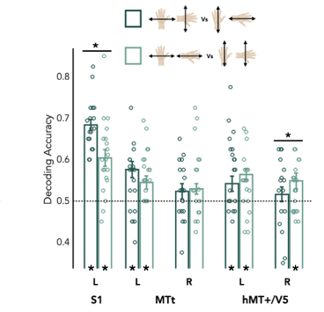
ext
anat

