PHISHING AWARENESS ANALYSIS
The Phishing Triage Toolkit
Project 3 · Cyber Security · DecodeLabs Industrial Training Kit · Batch 2026

1. The Mission
The modern security perimeter is no longer the network firewall — it is the user. This report is a practical toolkit any employee can use to spot, classify, and respond to phishing attempts. It covers the warning signs, a step-by-step way to inspect an email, a triage decision tree, and worked examples of real-world lures.
Around 80% of security breaches involve phishing, and in controlled red-team tests roughly 40% of employees fall for a well-crafted lure — with attackers landing their first click in an average of about 82 seconds. One spear-phishing campaign alone cost Google and Facebook over $100 million by spoofing a legitimate supplier's domain and forging invoices. Technical filters help, but they cannot fully compensate for human reaction. That is why every person is part of the “human firewall.”
Every phishing attack follows the same three-part shape: the Bait (how the message is delivered and disguised), the Psychology (the emotional triggers that push you to act before thinking), and the Defense (recognising the red flags and responding correctly). This toolkit covers all three.

2. The Red Flag Checklist
These are the warning signs of a phishing message, grouped so a non-expert can scan them quickly. One flag means “be careful”; several together almost always mean the message is an attack.

A. Sender & identity
- Sender-domain mismatch — the display name says one thing (e.g., “Microsoft Support” or your CEO), but the actual email address is an unrelated or external domain.
- Lookalike domains — small visual tricks: typosquatting (amaz0n.com with a zero), homoglyphs (a Cyrillic ‘a’ inside paypal.com), or combosquatting (yourcompany-secure-login.com).
- Free / public email for a “corporate” sender — a bank or company writing from a @gmail.com address.
- Failed authentication — the domain has weak or missing SPF, DKIM, or DMARC records (a technical tell your mail system may flag).

B. The message & the psychology
- Urgency — artificial time pressure (“account locked in 30 minutes”, “act within 24 hours”) to trigger a fight-or-flight response and stop you thinking.
- Authority — impersonating the CEO, IT, or law enforcement to demand unquestioned compliance.
- Fear or greed — legal threats and account-closure warnings, or unexpected prizes and refunds.
- Secrecy / bypass — “keep this strictly confidential”, “don’t tell anyone”, or “skip the normal approval process.”
- Requests for sensitive data — asking for passwords, MFA codes, or payment / bank-detail changes over email.
- Generic greetings or unexpected threads — “Dear Customer,” or a forwarded chain you were never part of.

C. Links & attachments
- Suspicious links — hover (don’t click) to reveal the true destination; if it doesn’t match the sender, stop.
- URL shorteners — bit.ly-style links that hide the real domain.
- Dangerous attachments — uncommon extensions like .iso, .js, .scr, or .html posing as normal documents.
- Fake login pop-ups — Browser-in-the-Browser sign-on windows that cannot be dragged outside the main browser.
- QR codes — unsolicited codes pushing you to scan on a mobile device where spoofed links are harder to spot.

D. Context & behaviour
- MFA fatigue — repeated, unprompted approval push notifications designed to wear you down until you tap “Approve.”
- Callback scams (TOAD) — an email with no link, only a phone number urging you to call “support” about a fake charge.
- Alarmist sign-in alerts — “unusual login detected” messages that link straight to a login page instead of telling you to navigate there yourself.

3. How to Inspect an Email (Header & URL SOP)
When a message looks off, work through these steps before you click anything.
- 1. Check the real sender. Expand the full header and compare three things: the display name, the actual “From” address, and the Return-Path. If they disagree, or use an external / free domain, treat the message as suspicious.
- 2. Read links without clicking. Hover over any link on desktop (or long-press on mobile) to reveal the true URL before you act on it.
- 3. Read the domain right-to-left. The true root domain is the last two labels before the first single “/”. Everything to the left can be faked.
Example: www.decodelabs.tech.login-update.com → the real root is login-update.com (malicious). “decodelabs.tech” is only a fake subdomain meant to reassure you.
- 4. Watch for lookalike tricks. Typosquatting, homoglyphs from other alphabets, combosquatting, and shortened URLs are all designed to fool the eye.
- 5. Never open uncommon attachments. Files ending in .iso, .js, .scr, .html, or .exe that you weren’t expecting should never be opened — even if the name looks like a normal document.

4. The Triage Decision Tree
Every suspicious email must end in one definitive action. Classify it, then act — never leave it sitting in the inbox “just in case.”
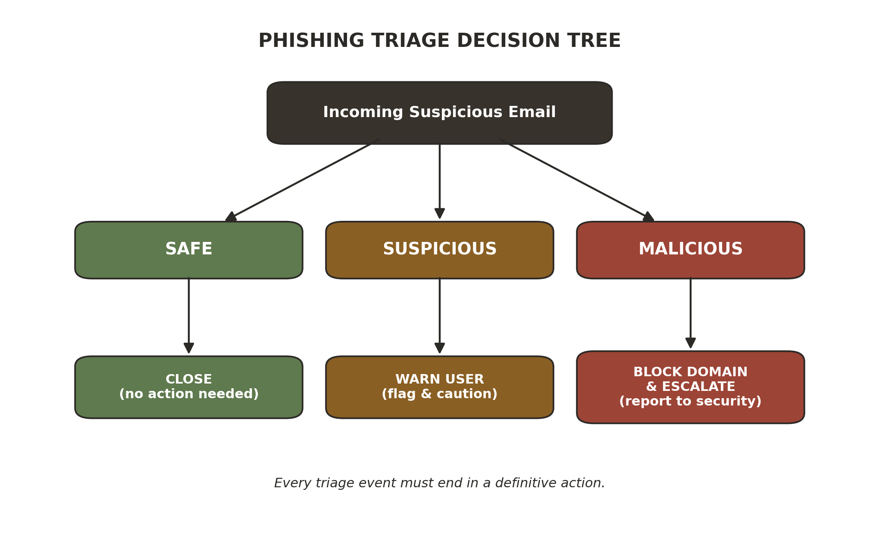
- Safe → Close. No action needed; carry on.
- Suspicious → Warn User. Flag it and caution the recipient; verify before trusting it.
- Malicious → Block Domain & Escalate. Report it to the security team. Do not just delete it — reporting lets them purge the same threat from every other inbox.

5. Sample Email Analysis
Three worked examples. Each shows the message, the red flags it contains, the suspicious links or keywords, why it is unsafe, and the triage verdict. (All addresses and links below are fictional, defanged samples for training.)

Example 1 — Mass Phishing (fake account suspension)
From: Amazon Support <no-reply@amaz0n-account-verify.com>
Subject: [URGENT] Your account has been suspended — verify within 24 hours

Dear Customer, we detected unusual activity on your account. Your account will be permanently suspended unless you verify your details within 24 hours.
Click here to restore access: http://amaz0n-account-verify.com/login
Red flags found:
- Lookalike domain — “amaz0n” uses a zero, plus reassuring extra words (“account-verify”). The real root is not amazon.com.
- Urgency + threat — “suspended within 24 hours” pressures you to act fast.
- Generic greeting — “Dear Customer” instead of your name (mass, low-personalisation lure).
- Mismatched link that requests a login — classic credential-harvesting page.
Suspicious link / keywords: amaz0n-account-verify.com, “suspended,” “verify within 24 hours,” “click here.”
Why it’s unsafe: the link leads to a fake login page that steals your Amazon credentials. Amazon would address you by name and would never host its login on a random look-alike domain.
Verdict: Malicious → Block domain & escalate.

Example 2 — Spear Phishing / Business Email Compromise (CEO wire transfer)
From: David Chen (CEO) <ceo.urgent@executive-update.com>
Subject: IMMEDIATE ACTION REQUIRED — Confidential wire transfer

I’m tied up in meetings and need you to process an urgent wire transfer of $48,500 to a new vendor before end of day.
This is strictly confidential — do not discuss it with anyone. Please bypass the usual approval process; I’ll explain later. Send confirmation once it’s done.
Red flags found:
- Authority impersonation — appears to come from the CEO to demand quick compliance.
- External look-alike domain — executive-update.com is not the company’s real domain.
- Urgency — “before end of day” removes time to think or verify.
- Secrecy + bypass — “strictly confidential,” “do not discuss,” “bypass the usual approval” exist only to stop you checking.
- Unusual financial request — a new vendor and an out-of-process payment.
Suspicious keywords: “IMMEDIATE ACTION,” “strictly confidential,” “do not discuss,” “bypass the usual approval,” “before end of day.”
Why it’s unsafe: this is Business Email Compromise (BEC) — the attacker impersonates an executive to trigger a fraudulent wire transfer. The demand for secrecy and to skip approvals is deliberately designed to prevent verification.
Verdict: Malicious → Block & escalate; confirm any real request via a known phone number (out-of-band).

Example 3 — Credential Harvesting (IT “password expiry”)
From: IT Security <support@it-helpdesk-login.com>
Subject: Action Required: your password expires in 24 hours

Our records show your corporate password will expire in 24 hours. To avoid being locked out, please re-validate your credentials immediately using the secure portal below.
Update password: https://sso-login-update.com/portal
Attachment: Password_Policy_2026.html
Red flags found:
- Sender-domain mismatch — “IT Security” but the domain is external, not your company’s internal IT.
- Urgency — “expires in 24 hours” to force a fast click.
- Link to an external look-alike SSO page — sso-login-update.com is not your real sign-in portal.
- Dangerous .html attachment — HTML files can host a local fake login page (HTML smuggling).
- Alarmist alert linking straight to login — instead of telling you to navigate there yourself.
Suspicious link / keywords: it-helpdesk-login.com, sso-login-update.com, the .html attachment, “expires in 24 hours,” “re-validate your credentials.”
Why it’s unsafe: it harvests credentials through a fake sign-in page. Legitimate IT handles password changes inside internal systems and does not email you a login link or an HTML attachment.
Verdict: Malicious → Block & escalate (do not open the attachment or click the link).

6. The Golden Rule: Pause → Verify → Report
- Pause. Recognise the cognitive trigger (urgency, fear, authority) and stop interacting with the message. Apply the five-minute rule — nothing genuinely urgent breaks by waiting five minutes to think.
- Verify. Confirm the request through a second, out-of-band channel. If it arrived by email, call the person on a known number from the company directory — never the number written in the message.
- Report. Use the internal reporting tool rather than simply deleting the email. Reporting lets the security team remove the same threat from everyone else’s inbox.

7. Quick Triage Checklist (print & keep)
Before you click, reply, or act — tick what applies. Any tick means slow down and verify.
☐ | Does the display name match the actual email address and domain?
☐ | Is the domain a look-alike (extra words, swapped letters, odd spelling)?
☐ | Is the message creating urgency, fear, or pressure to act now?
☐ | Does it ask for a password, MFA code, or a payment / bank change?
☐ | Does it demand secrecy or ask me to bypass the normal process?
☐ | Does the link’s real destination (hover) match the sender?
☐ | Is there an unexpected attachment, especially .iso / .js / .scr / .html?
☐ | Was I actually expecting this message from this person?
If in doubt: Pause → Verify → Report.

Conclusion
Phishing succeeds in the gap between a technical control and a human reaction. By learning the red flags, inspecting headers and URLs properly, and following the Pause → Verify → Report loop, every employee becomes an active defence layer — the human firewall that closes that gap. Your first caught “phish” starts with the very next suspicious email you slow down on.

