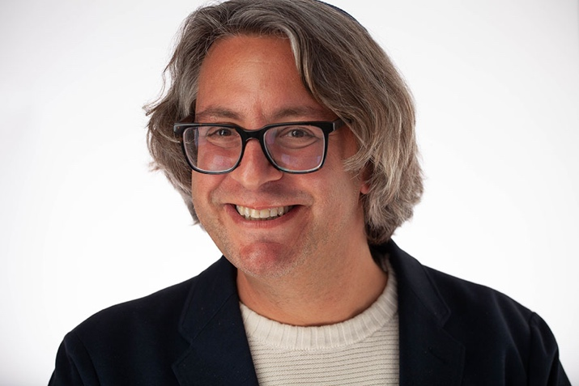

Rabbi Ari Blech is a graduate of Yeshiva University where he studied English and Philosophy as befits someone planning to work in the Rabbinate and not get a “real job.” While at Yeshiva, he studied under Rabbi Michael Rosensweig while picking up enough awards in writing to help his parents *shep*a lot of*nachas*, which as an only son is really the very least he could do. Rabbi Blech received his semicha from Chabad and has spent the last four years helping successfully build Bradley Beach, NJ into a year-round community. He has been a Visiting Rabbi for Rosh Hashanah and Yom Kippur programs in New York and New Jersey in addition to other lecture series and Scholar in Residence bookings. An 11th generation Rabbi, and the most eclectic example to date, Ari and his wife Alaethia (plus their adorable dog Eden, and cats, Kugel and Agape) love hosting guests, playing Rose and Thorn, learning, teaching, laughing, and Stand Up Paddleboarding.

------

Pesach activities: I’m very open to giving the drasha in shul which is a top skill of mine. I am also a strong lainer and can leading davening on Chol HaMoed. I would be happy to teach a couple of classes and could possibly host a singles event with my Wife.

Pesach themed classes:

1. Elijah: The “It’s Complicated” Seder Guest
2. Thankful: The Role of Gratitude in the Pesach Story – and Beyond
3. White Space: Lavan, Elusion and Allusion in the Arami Oved Avi story
4. Zeicher L’Yitziat Mitzrayim: The Real Meaning Behind Our Delivery from Egypt

Or:

From Shabbat to Seder: the Deeper Meaning of Zeicher L’Yitziat Mitzrayim, Then and Now

1. “What’s Love Got to Do with It?”: Why We Read Song of Songs on Pesach

-----------

Talks or Activities from Alaethia Doctor-Blech:

1. Qigong & Davening

In this hands on demonstration, learn how Qigong can help prepare us for davening, our most familiar form of Jewish meditation.

1. Loving the Geir: Lessons from Egypt – & Stories from My Life

Alaethia can also lead at least one Qigong session.

In addition to what’s mentioned above:

We are very warm, funny and approachable, as well as clearly (if labels must be used) Modern Orthodox.

In my experience, many, even the majority of people from the Modern Orthodox community, would not be comfortable attending a program which in staff and attendance is primarily Black hat or Yeshivish. Having us there, especially with me as one of the Rabbis, will signal that all are welcome and make sales to the larger Modern Orthodox crowd a much easier proposition.

(We also do know a ton of people; I went to Modern Orthodox sleepaway camp my whole life; YU for college; lived on the Upper West Side for over 20 years etc.)