**Closed User Group**

**Drupal 8 Module**

**Overview**

Closed User Group module provides functionality to create users and roles to easily assign limited access and redirect them on login to the configured pages. 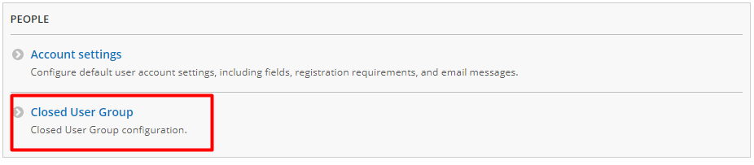

1. Configuration menu for CUG

Users and roles can be created in the configuration page for the CUG with a subpath *“/admin/config/people/cug/users”*.

Login destination of where the users with a certain role are redirected, can be set in the settings page with a subpath *“/admin/config/people/cug/cug_redirect”*.