The NatWatch platform specification
A stackable and extensible board platform for nature observation and environmental monitoring
Current version: Preliminary (1.0.0-a.1+20180130)

Table of Contents
List of tables 2
List of drawings 2
1. Document versions 3
2. Introduction 4
3. Scope of the specification 5
4. Glossary 6
5. Mechanical board properties 7
5.1 Board sizes 7
5.2 Board outline 8
5.3 Clearance for component mounting 8
5.4 Mounting holes 8
5.5 Sliding/guide rails 9
5.6 Stacking connector position 9
5.7 Interface connectors position 9
6. Electrical board properties 11
6.1 Stacking connector types 11
7. Licensing and contributing 12
List of tables
Table 1: Stacking connectors manufacturer part numbers 11
List of drawings
Drawing 1: Various board sizes (from the left): QWHD, HWHD, FWHD 8
Drawing 2: Place for component mounting on the top and bottom sides 9
Drawing 3: Size and position of the mounting hole 9
Drawing 4: Keep-out area for enclosure PCB rails 10
Drawing 5: Extension board top stacking connector 13
Drawing 6: Base board top stacking connectors 13

Document versions
Version | Date | Name | Comments
1.0.0-a.1 | 2018-01-30 | Marek Koza <qyx@krtko.org> | Initial version

Introduction
The IoT hype has come to our lifes in the recent years. Many large and small companies, before completely unknown (start-ups), are trying to come with IoT solutions which could earn them money or can make living more awesome by various useless gadgets (WiFi connected juicer).
Alongside such market-driven development, there is a huge amount of devices and platforms for educational purposed. They are developed (mostly) by enthusiasts to be used by make:r (another hype) community and students and usually they are freely shared in the community. Some PCB manufacturers directly support this approach by encouraging you to share your design.
Despite huge amount of devices of different quality which could be used for environmental monitoring, there are only a few actually usable by common researchers and people interested in such projects. There are professional devices which are hard to get for a reasonable price. There are devices developed by small commercial manufacturers which are technologically obsolete for almost 10 years (meteorological instrumentation and dataloggers). There are simple and commercially available devices which are usually very cheap (china-imported loggers, weather stations, automatic plant watering sensors and systems). But usually they are too simple to be usable. And the rest of the devices available are half-finished community-built devices and devices for education and makers (see Arduino, RaspberryPi, Beaglebone, Grove and similar and their extension boards).
This is an attempt to specify an extensible platform in the hope that it will be useful. A platform built by electronic engineers and enthusiasts for researchers in environmental sciences for nature observation and monitoring. A platform, where the actual user is not required to have soldering skills, doesn't have to download arduino.exe and handcraft some code, where the devices are able to withstand severe environmental conditions, be reconfigurable and extendable in the field and are made to be useful for the intended purpose.
For now, I selected a simple name "NatWatch" for the platform specification.

Scope of the specification
A NatWatch device usually consists of multiple parts:
- base devices (ie. base boards) which run a suitable system (RTOS, HAL, programming framework, etc.)
- communication extensions to provide some means of uploading data from remote locations (cellular networks, WiFi, LoRa, other mesh networks)
- data acquisition extensions to measure voltages, currents, resistances, to sample some signals and waveforms, to communicate with sensors, etc.
- power extensions. Their only purpose is to provide power to the system by various means (photovoltaic MPPT chargers and other energy harvesters, generic industrial 24V power supplies, etc.)
- batteries providing backup power
- a ruggedized waterproof, shockproof, animalproof, ... case
This specification talks about the "extensions" part of the system. It covers the following topics:
- how the boards are stacked and mechanically fastened
- sizes of the boards
- hole and connector positions
- extension connector specification, manufacturers, types
- extension connector pinout
- signals available on the extension connector and communication protocols
- recommended layouts of the boards in various cases/enclosures

Glossary
Term | Definition
board, a Netwatch board | A printed circuit board made of FR4 or other suitable material with holes for mounting it on top of another one (stacking) and with stacking connectors on top and optionally on bottom to connect it to another board.
stacking connector | A connector of a board-to-board type with variable stacking height (distance between surfaces of two boards mated together with the stacking connector)
base board | A single specific board in the board stack doing the master in the communication. Usually it is the bottom one.
board top | A side for mounting future extension boards (the stack grows up)
board bottom | Side of the board when the stacking connector for connecting to the base board or pevious extension boards is located.
extension board | Any other board except the base one.

Mechanical board properties

Board sizes
The base board size is 160x100mm euro-card size. All NatWatch board sizes are derived from this standard size.
Width of the board is defined as a distance from the left side to the right side of the board. Depth of the board is a distance from the front side to the back side of the board. Height if the board is defined as a minimum clearance for the components on the top of the board. The actual height for the board includes top clearance, board thickness and bottom clearance. Note that the bottom stacking connector is protruding from the bottom clearance distance.
Depth of the board can be one of the following:
- full-depth (shortly "FD") is 160mm. It is not allowed by the specification.
- half-depth (shortly "HD") is 80mm. It is the standard depth and the only one allowed by this version of the specification.
- quarter-depth (shortly "QD") is 40mm. It is not allowed by the specification.
Width of the board:
- full-width (shortly "FW") is 100mm. Standard size for extension boards requiring many connectors or include large power devices or connectors.
- half-width (shortly "HW") is 50mm. Recommended size for standard extension boards.
- quarter-width (shortly "QW) is 25mm. Used when the board is indended for space-constrained applications or when the board design is simple enough to fit. Large portion of the board space is wasted by stacking connectors and mounting holes.
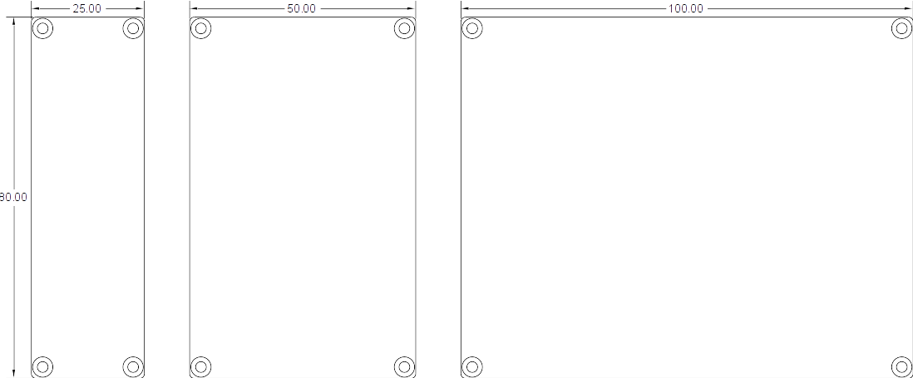
Drawing 1: Various board sizes (from the left): QWHD, HWHD, FWHD

Board outline
There MUST NOT be any parts protruding the outline of the board except when explicitly alloed. Connectors MAY protrude maximum of 5mm on the front of the board.
The outline of the board have rounded corners with radius of 1mm.

Clearance for component mounting
Height of the board is the same as the clearance required for components mounted on the top side of the board. The clearance also defines the top stacking connector mating height. Recommended top clearance is 6.5mm, but may vary if appropriate connector is used.
Bottom clearance is defined to be 1.5mm. The board is free to have any components on the bottom side provided that their height is not greater than 1.5mm.
If required, a suitable method for improving isolation on the bottom side can be used (eg. a polyimide tape).
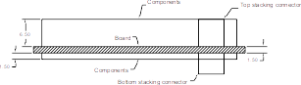
Drawing 2: Place for component mounting on the top and bottom sides

Mounting holes
All extension boards excluding base boards MUST have four mounting holes in the corners with diameter of 2.4mm. Hole center is always 2.5mm from the edges. Thus the distance between two holes is width - 5mm or depth - 5mm.
The holes are plated and electrically connected to the system and chassis ground. The hole ring MUST have 4.5mm diameter and MUST be conductive with suitable material finish.
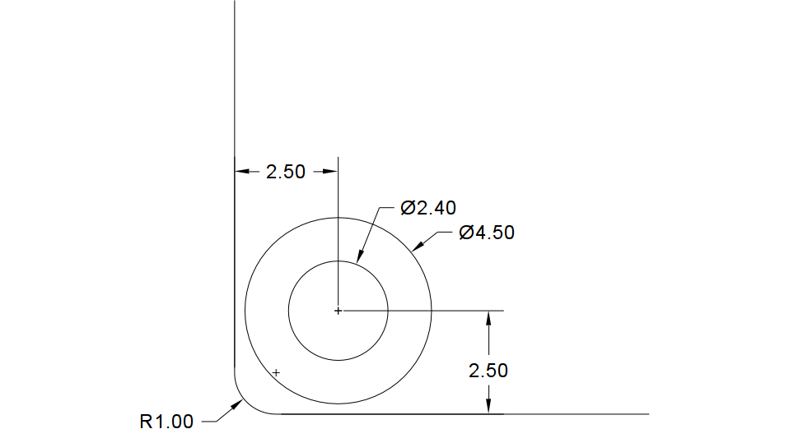
Drawing 3: Size and position of the mounting hole
Extension boards MUST have 4 mounting holes as depicted in the section 5.1 Board sizes. Base board is an exception and it MUST have mounting holes for all extension board sizes of the same or smaller size as the base board. Holes for QWHD boards are the same for both extension and base boards.

Sliding/guide rails
As there are many aluminium extruded enclosures available which have rails for 50mm and 100mm board widths, the specification allows using them.
To preserve board compatibility with such enclosures, the board MUST not place any components on top and bottom of the board 2mm from both sides (left and right). The keep-out area is detailed in the drawing.
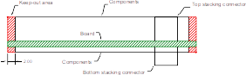
Drawing 4: Keep-out area for enclosure PCB rails

Interface connectors position
Many extension boards communicate with the world using interfaces with specific connectors. As the board stack can be mounted in different enclosures, the specification places some constraints on the interface connector placement.
Interface connectors with cables connected during normal operation MUST be placed on the front side of the board. They may be placed on top, bottom or in the middle in a PCB cut-out. Connector height MUST respect constraints for component placement on both top and bottom sides. The connector MUST NOT protrude more than 5mm from the front edge of the board. Additionally, if the connector has a lock, it SHOULD be possible to unmate the connector when there is another board stacked on top.
Interface connectors which are connected during debug (debug connectors), manufacturing, provisioning and setup only MAY be placed on the back side of the PCB. Same requirements apply as for connectors placed on the front side except that the maximum protrusion is limited to 2mm behind the back edge of the board. Those connectors will not be accessible during normal operation.
Card connectors (SIM holders, memory card holders, etc.) MAY be placed on the right side of the board. However, other constraints still apply (such as enclosure rail keep-out, height of components, stacking connector placement, board mounting holes). Card connector with a card in the inserted position MUST not violate the enclosure rail keep-out.
Enclosures SHOULD be designed in a way that front side of the board stack is accessible during operation and there is space reserved for cable pigtails, the back side is covered and the right side is accessible only when the enclosure is opened and/or the system is pulled out from the enclosure.

Stacking concept
The base board SHOULD be mounted on the bottom of the stack. Usually it is mounted on a mounting plate or placed in an enclosure with sliding rails.
<todo picture>

Electrical board properties

Stacking connector types
Recommended top and bottom connectors are Har-Flex series manufactured by Harting. They are fully shrouded and keyed 1.27mm pitch headers and receptacles with 12 contacts in two rows. Stacking height is adjustable.
Manufacturer part numbers are listed in the following table.
Type | Part no. | Connector picture
Bottom | 15 11 012 2601000, 1.75mm stacking height | 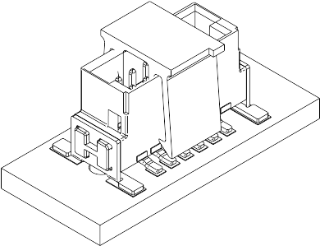
Top, board height 6 - 7.5mm (distance between stacked board surfaces is 8 - 9.5mm) | 15 21 012 2601000, 6.25 stacking height | 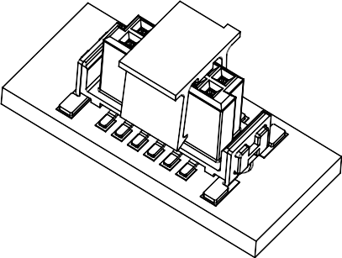
Top, board height 8.8 - 10.3mm  (distance between stacked board surfaces is 10.8 - 12.3mm) | 15 22 012 2601000, 9.05 stacking height | 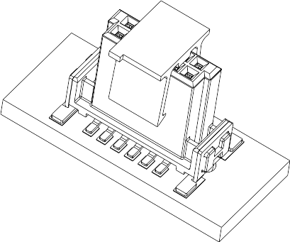
Table 1: Stacking connectors manufacturer part numbers

Alternative manufacturers and connector types are allowed if they are mechanically compatible. List of alternative connector types is below.
TBD

Stacking connector position
Both top and bottom stacking connector centers are offset 8mm from the right side and 17mm from the back side of the extension board. Orientation is as depicted below.
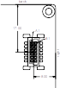
Drawing 5: Extension board top stacking connector

The bottom stacking connector is mounted in the same orientation in order to match the neighboring board.
Base board is an exception as it MUST have connectors to fit all sizes of extension boards which are equal or smaller than the base board itself. Hence it has stacking connectors placed as follows:
- Full-width base board has 3 connectors placed 8mm, 8+25mm and 8+50mm from the right side and 17mm from the back side.
- Half-width base board has 2 connectors placed 8mm and 8+25mm from the right side and 17mm from the back side.
- Quarter-width base board has the same connector placement as the quarter-width extension board and 17mm from the back side. See the previous picture.
Position and orientation of the HWHD and FWHD base board connectors is shown on the picture below.
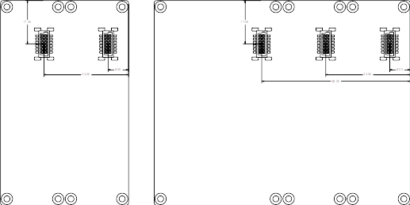
Drawing 6: Base board top stacking connectors

Stacking connector pinout
All pins on the top stacking connector MUST be directly connected with appropriate pins on the bottom stacking connector. If the board needs a signal for its own usage, it makes a "tap".
Pin | Signal name | Description
A1 | IRQ | Open-drain interrupt request line (extension board is the source)
A2 | Reserved
A3 | ID | Open-drain identifier match indicator
A4 | Reserved
A5 | Reserved
A6 | VBUS | 5V power supply for the base board and extension boards. Maximum of 2A current draw is allowed.
B1 | GND | System ground
B2 | CLK | Bidirectional multidrop SPI bus clock
B3 | GND | System ground
B4 | DATA | Bidirectional multidrop SPI bus data
B5 | GND | System ground
B6 | FRAME | Bidirectional multidrop SPI bus frame synchronization and wake-up signal

Signal description and levels
An extension board MUST NOT alter any signals going through the extension board from upper and lower boards. An extension board MUST NOT cause any bus malfunction or signal distraction when it is unpowered, when no extension board firmware is uploaded or the firmware is not functioning.
Notification signals are used to notify the base board about various events pending on one of the extension boards:
- ID signal is an active low open-drain signal pulled up to 3.3V with a 4K7 resistor on the base board. It MUST be 5V level tolerant. The base board MCU and pull-up voltage MAY be lower than 3.3V, but not less than 2.8V. It gets asserted with a ASSERT_ID control frame and deasserted by DATA frame or NOP control frame. It is used to determine if an identifier match occured within the specified range of identifiers during extension board enumeration.
- IRQ signal is an active low open-drain signal pulled up to 3.3V with a 4K7 resistor on the base board. It MUST be 5V level tolerant. The base board MCU and pull-up voltage MAY be lower than 3.3V, but not less than 2.8V. It is used by the extension board to signal a pending interrupt which the base board should process. The base board may wake-up if needed and query all extension boards for pending interrupts.
Power lines are used to provide power to the base board and extension boards. The base board itself is not required to provide any power. See the following section for details.
- GND is a system ground. It is connected to the chassis ground by interface connectors and board mounting screws.
- VBUS is a nominal 5V (range 4.5 - 5.5V) power for the base board and all extension boards. Stacking connectors allow up to 2A current flow. VBUS volage level is used to determine the amount of surplus energy available.
UXB bus (abbreviation of the former name uNode extension bus) is a SPI compatible push-pull multidrop bus driven by one board at a time. It consists of CLK, DATA and FRAME signals. Detailed description is in the "UXB bus signals and waveforms" section.

Powering the system
Power in the system is distributed using the VBUS pin on the stacking connector. A board (base board or extension board) MAY provide or consume VBUS power. The board providing power is called a VBUS source, the board consuming power is called a VBUS sink. There is no restriction on number of VBUS sources. However, each VBUS source MUST provide a power-or device on its output or it must be designed to be operated in parallel with other VBUS sources. Recommended solution is an ideal diode controller.
The VBUS voltage range is 4.5 - 5.5V and it is used to indicate the amount of surplus energy available in the system.
- Sources with infinite energy available, such as grid connected power supplies, renewable photovoltaic and other energy harvesters, etc. SHOULD regulate the VBUS to 5.25V. If the power demand is higher than the source is able to supply, the voltage will be lowered accordingly.
- Sinks which are able to use the surplus energy but do not use it for basic system function (such as backup battery chargers) MUST use minimum-voltage regulation to 5V. They MUST NOT sink more power than other sources are able to provide, ie. they may sink power only if they are able to maintain 5V regulation on the VBUS line.
- Backup sources with limited energy available MUST regulate to 4.75V to let the system know it is running on the backup power and no energy can be wasted (eg. for charging other batteries).
- Generic sinks providing power to the base board and extension boards MAY sink power in all circumstances and are not required to maintain a stable VBUS voltage. However, they MUST be designed in a way that a voltage level lower than 4.5V does not cause any malfunction (brown-out detection). This can happen if no renewable nor backup power is available.

Overcurrent, overvoltage and transient protection
If the base board or an extension board is able to provide VBUS power, it MUST include appropriate overcurrent protection. It MUST be reversible and rated for continuous overcurrent. It SHOULD be implemented as a PTC fuse, electronic fuse or a current limit in the regulator providing the power.
Any board in the stack MAY protect itself by providing a voltage clamp on the VBUS line, such as PTC fuse + zener diode. The voltage clamp MUST withstand the 5.5V operating voltage without conducting more than 0.1mA of current.
A board providing power MUST include overvoltage protection on the VBUS line which should be sized appropriately to not allow any voltages higher than 5.5V to pass. Note that continuous protection is necessary, e.g. by tripping the overcurrent device.
All boards SHOULD also include a TVS transient protection on the VBUS line.
The stacking connectors are not exposed to any external overvoltages and transients more than the board itself, therefore it is usually not necessary to include any discrete transient protection on the data lines (IRQ, ID, CLK, DATA, FRAME) as the MCU internal protection suffices.

UXB bus signals and waveforms

Communication protocol

Licensing and contributing
All work done on the NatWatch platform specification is licensed under a Creative Commons Attribution-ShareAlike 4.0 International License. Follow the link to see the license.

Author of the original text is Marek Koza <qyx@krtko.org>. Other authors are listed in the table "document revisions" in the beginning.
The document is available on the following locations:
- http://qyx.krtko.org/projects/natwatch/
- http://github.com/iqyx/natwatch

