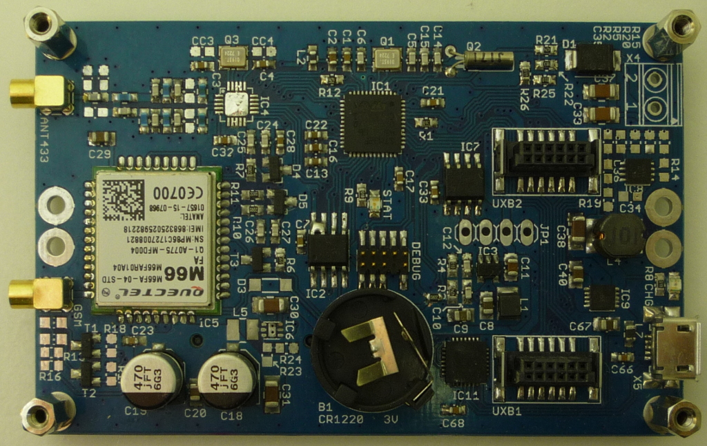
plumpot-cellular
A plumpot series base board with a sub-1GHz radio and a GPRS/EDGE cellular modem
Features:
- half-length, half-width form factor (80x50mm)
- mounting holes for half-length half-width and half-length quarter-width extension boards
- two extension bus connectors (UXB1 compatible - multidrop half-duplex SPI bus, I2C bus, wakeup request, interrupt request and 5V power)
- AX5243 sub-1GHz radio module with a 50ohm MMCX antenna connector
- Quectel M66 2.5G GPRS/EDGE cellular modem with a 50ohm MMCX antenna connector and network activity LED indicators
- 6-60V Vin power supply step down regulator for providing system and bus power (5V, 0.2A)
- micro-B USB port with a CP2101 serial to USB bridge (console access and power input)
- RTC with a CR1220 lithium coin cell backup

The board is developed as an open source hardware using tools freely available for non-commercial usage. It is able to run free and non-free commercial software without any restrictions. It is not locked to a specific firmware and contains a standard 10-pin Cortex Debug connector. A multitude of free and commercial development tools exist to develop and modify the firmware for the board.
For additional information see the licensing section.

Table of Contents
1.Versions of the board 3
2.Document revisions 3
3.Changes and issues (errata) 4
4.Board layout and connections 5
5.System components 6
5.1CPU 6
5.2Memories 6
5.3Interfaces 6
5.4Extension bus 6
6.Electrical characteristics and power consumption 7
6.1Power supply 7
6.2Cellular modem 7
6.3Radio modem 7
6.4Extension bus 8
7.CE conformity 9
8.Licensing and contributing 10
9.Schematic 11

List of tables
Table 1: Power supply input characteristics 7
Table 2: Cellular modem parameters 7
Table 3: Sub-1GHz radio modem parameters 8
Table 4: UXB extension bus parameters 8

List of drawings
Drawing 1: Layout of the base board with description 5

Versions of the board
Name, version | Date released | License and contributors | Comments
plumpot-cellular-0.1.0 (old name unodex-connect-42) | 2017-05-04 | CC-BY-SA, Marek Koza <qyx@krtko.org> | Initial revision
plumpot-cellular-1.0.0 | planned 2018

Document revisions
Date | Name | Comments
2017-10-30 | Marek Koza | Initial revision

Changes and issues (errata)
Version | Change/issue
0.1.0 | SPI Flash HOLD input issue (reported by Marek Koza)  The SPI NOR flash memory was unusable as a result of an undefined HOLD input state. The issue will be resolved in the next revision. You can patch the board by making a solder bridge between pins 7 and 8 on the SPI flash chip.
0.1.0 | Cellular modem step-down regulator unavailable (reported by Marek Koza)  The regulator used for the cellular modem (NCP1521) in the DFN6 package is not available anymore from the common distributors. The issue will be resolved in the next revision by changing the step-down regulator IC.
0.1.0 | I2C bus is unstable (reported by Marek Koza)  I2C bus on the board uses only the internal STM32 pull-up resistors. External resistors with a value around 4.7K should be added.
0.1.0 | 60V power suplly is insufficient to power the cellular modem (reported by Marek Koza)  The 200mA output power supply TPS54061 is unable to power the cellular modem during high power peaks and the modem ocassionaly powers off on undervoltage. This can be resolved by a software patch to restart the modem on undervoltage or using an extension board with a power supply capable of delivering at least 0.5A current.

Board layout and connections
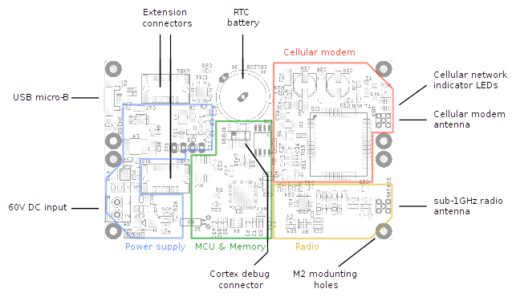
Drawing 1: Layout of the base board with description

System components

CPU
The board contains an ARM Cortex-M4 MCU running at 84MHz (max), 16MHz (idle). The STM32F401CCU7 microcontroller was selected because of its good availability, low cost, good documentation, development tool availability and a great community being built around the STM32 series of microcontrollers.
The processor contains 64kB of internal SRAM and 512kB of internal Flash for the bootloader and the plumCore firmware.

Memories
There is also a 32kB I2C EEPROM memory on the base board together with a 1MB SPI NOR flash memory sharing the SPI bus with the radio modem. Those memories may be used to store configuration and log data.

Interfaces
The CP2102 USB to serial interface bridge was selected to provide a console access for the bootloader and plumCore command line interface. It can also be used to power the board during development and configuration. It is not recommended to power the board using the USB connector in the field as there is no overvoltage or overcurrent protection included.
There is also a 4 pin 2.54mm male header with I2C bus signals for small sensors and modules.

Extension bus
There are two extension bus connectors included on the base board designed to be compatible with a range of other extension boards for data acquisition, power delivery and communication. The bus contains lines required for half-duplex multidrop (multiple slaves) SPI communication with fast extension boards, I2C lines for slower and simpler extension boards, wakeup signal to wake the boards before an actual data transmission occurs, interrupt request signal to notify the master than a new data is available and a 5V/2A power provided by at least one power board. Multiple boards can provide power as the power OR-ing feature is mandatory on them.

Electrical characteristics and power consumption

Power supply
Parameter | Conditions | Min | Typical | Max | Unit
USB power supply voltage |  | 4.50 | 5.00 | 5.50 | V
External 5V power supply voltage | Voltage supplied over the extension bus connector | 4.50 | 5.00 | 5.50 | V
5V current consumption idle | No extension boards populated, all onboard peripherals idle, cellular modem off, radio modem off, LEDs off, CPU in the running mode, idle (16MHz), T=25°C |  | 20 |  | mA
5V current consumption max | LEDs on, cellular modem connected to the network, PDP context active, transmitting data, radio modem transmitting data, CPU in the running mode, performance (84MHz), T=25°C | 80 | 120 | 150 | mA
Vin power supply voltage |  | 10.00 | 24.00 | 60.00 | V
Vin current consumption max | Vin=60V | 15 | 20 | 40 | mA
Table 1: Power supply input characteristics

Cellular modem
Parameter | Conditions | Min | Typical | Max | Unit
Table 2: Cellular modem parameters

Radio modem
Parameter | Conditions | Min | Typical | Max | Unit
Modulation type |  |  | FSK, MSK, 4FSK,  GFSK,  GMSK,  ASK, AFSK,  FM, PSK
Frequency range |  | 27 | 433 | 1050 | MHz
Data rate |  | 0.1 |  | 125 | kbps
Sensitivity | 0.1kbps, FSK, 868MHz | -135 |  |  | dBm
Sensitivity | 100kbps, FSK, 868MHz | -107 |  |  | dBm
Antenna input power |  |  |  | 0 | dBm
Maximum output power |  |  |  | 16 | dBm
XTAL frequency |  |  | 16 |  | MHz
XTAL frequency tolerance |  |  | 20 |  | ppm
Table 3: Sub-1GHz radio modem parameters

Extension bus
Parameter | Conditions | Min | Typical | Max | Unit
Output voltage | No other power source on the bus | 4.90 | 5.00 | 5.10 | V
I2C interface speed |  |  |  | 400 | kHz
I2C interface level |  |  | 3.0 |  | V
SPI interface speed | CPU in the running state, performance mode | 1 | 21 | 42 | MHz
SPI interface speed | CPU in the running state, idle mode | 1 | 1 | 1 | MHz
SPI interface level |  |  | 3.0 |  | V
wake-up and irq pin level |  |  | 3.0 |  | V
Table 4: UXB extension bus parameters

CE conformity

Licensing and contributing
All work done on the base board and its documentation is licensed under a Creative Commons Attribution-ShareAlike 4.0 International License. Follow the link to see the license.

Author of the original design is Marek Koza <qyx@krtko.org>. Resources for the board can be found on the following locations:
- http://qyx.krtko.org/projects/plumpot-cellular/
- http://github.com/iqyx/plumpot-cellular
Everyone is free to use, create and modify the design under the mentioned licensing terms. If you find a bug, you can submit a report on the GitHub project page.
List of contributors:
- empty
This is a list of software you can use to open and modify files provided in the board repository:
- Cadsoft Eagle (free version is enough), or Autodesk Eagle to open and modify schematic and board layout files. If you do not have this software installed or cannot use it, you can find PDF exports of the schematic and board layout layers in the repository. Gerber exports are available too. You can use them to submit the board for manufacturing.
- Any text editor to view and edit README, BOM and other text files and write/modify your firmware files. BOM files are used to find and order components required for the board.
- GCC to compile the bootloader and firmware files. There are also many commercial compilers and IDE tools to compile your code provided for free (with some restrictions).
- OpenOCD to upload your compiled files to the board using the 10 pin Cortex Debug connector and a compatible debugger (such as STLink on all Discovery and Nucleo boards from ST).

Schematic
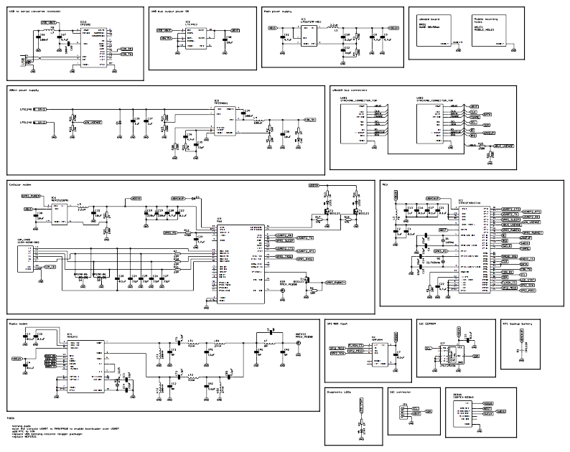
The schematic is included for a quick reference only. The original version is included in the repository.

