Documentation of the task

“Comparing the strength of Texas Hold’em Hands”

Author: Ilja Repko

# How to run the program?

1. Download the code from GitHub;
2. Open/Make the input.in file and write Texas Hold’em hands and board cards according to the task description;
3. Make the output.out file if it does not exist;
4. Save and close the input.in file
5. Open the HW-poker.cpp file using CodeBlocks, VisualStudio or another tool.
6. Build, run and compile the code
7. Program result can be read in the output.out file.

# Restrictions

1. The program cannot check the correctness of the input.in file
2. The program cannot work with Omaha

# The model of the program

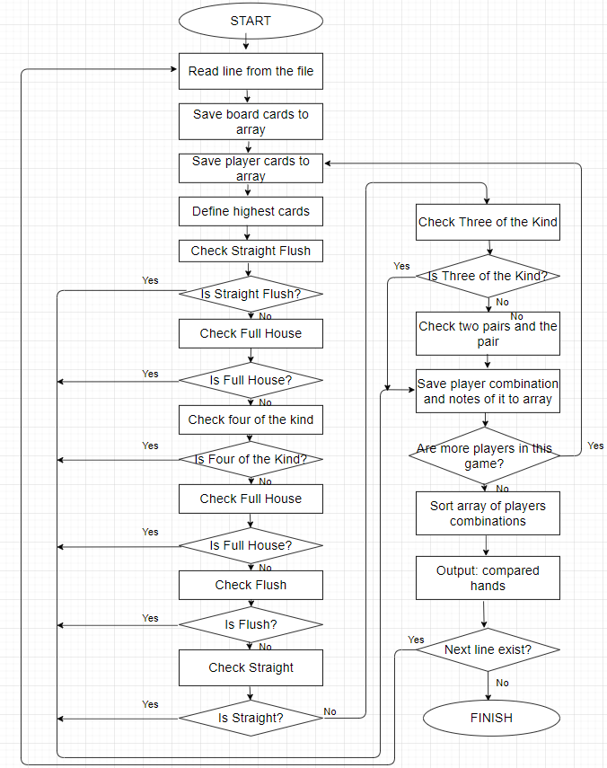

# Testing

The Result ‘+’ => The Result is equal to the expected(correct) output

|  |  |  |  |  |  |
| --- | --- | --- | --- | --- | --- |
| № | Input | Expected (correct) output | what is being checked | Explanations | Result |
|  |  |  |  |  |  |
| 1 | 4cKs4h8s7s Ad4s Ac4d As9s KhKd 5d6d | Ac4d=Ad4s 5d6d As9s KhKd | Given | Ac4d=Ad4s => ThreeKind  (three 4, kickers: A,K)  Qh2s => Straight  from 4 to 8  As9s => Flush  As Ks 9s 8s 7s  KhKd =>FullHouse  (three K, two 4) | + |
| 2 | 2h3h4h5d8d KdKs 9hJh | KdKs 9hJh | Given | KdKs =>Pair(K), Kickers: 8,5,4  9hJh =>Flush(h), (2,3,4,9,J) | + |
| 3 | 3h2s7h5d8d ThKh 9dAs | ThKh 9dAs | High  Two different hand cards | ThKh=> High (K,T,8,7,5)  9dAs=> High (A,9,8,7,5)  A>K | + |
| 4 | 3h2s7h5d8d ThKh 9dKs | 9dKs ThKh | High  One same card for 2 pl. | ThKh=> High (K,T,8,7,5)  9dKs=> High (K,9,8,7,5)  K=K, but T>9 | + |
| 5 | 3h2s7h5d8d 9hKh 9dKs | 9dKs =9hKh | High  Two same cards for 2 pl. | 9hKh=> High (K,9,8,7,5)  9dKs=> High (K,9,8,7,5) | + |
| 6 | JhTs7h5d8d 2h3h 3d4s | 3d4s =2h3h | High  5 highest cards from the board | 2h3h=> High (J,T,8,7,5)  3d4s=> High (J,T,8,7,5) | + |
| 7 | JhTs7h5d8d 2h3h 3d6s | 2h3h 3d6s | High  4 highest cards from the board | 2h3h=> High (J,T,8,7,5)  3d6s=> High ( J,T,8,7,6)  6>5 | + |
| 8 | 7d2s8sTsAs AdKd 8hJh | 8hJh AdKd | Pair  Two different pairs | AdKd=> Pair(A) Kickers(K,T,8)  8hJh=> Pair(8) Kickers(A,J,T)  A>8 | + |
| 9 | 7d2s8sTsAs AdKd AhJh | AhJh AdKd | Pair  Similar pairs | AdKd=> Pair(A) Kickers(K,T,8)  AhJh=> Pair(A) Kickers(J,T,8)  A=A, but K>J | + |
| 10 | 2dQs8s9sAs Qd3d Qh4h | Qh4h=Qd3d | Pair  Similar pairs | Qd3d=> Pair(Q) Kickers(A,9,8)  Qh4h=> Pair(Q) Kickers(A,9,8)  Q=Q ; Kickers=Kickers | + |
| 11 | 2dQs8s9sAs QdJd QhTh | QhTh QdJd | Pair  Similar pairs | QhTh=> Pair(Q) Kickers(A,T,9)  QdJd=> Pair(Q) Kickers(A,J,9)  Q=Q ; J>T | + |
| 12 | 2d8d8s9sAs TdJd 3hTh | 3hTh TdJd | Pair  Pair from the board | TdJd => Pair(8) Kickers(A,J,T)  3hTh=> Pair(8) Kickers(A,T,9)  8=8 ; J>T | + |
| 13 | 2d8d8s9sTs TdJd 3hTh | 3hTh TdJd | Two pairs  1st pair – board  2nd pair – different | 3hTh=>Two pairs(T,8) Kick (9)  TdJd=> Two pairs(T,8) Kick(J)  T=T ; 8=8 ; J>9 | + |
| 14 | Ts3d7s9sJs TdJd 3hTh | 3hTh TdJd | Two pairs  1st pair – different  2nd pair – different | 3hTh=>Two pairs(T,3) Kick(J)  TdJd=>Two pairs(J,T) Kick(9)  T<J | + |
| 15 | Ts3d7sAsJs TdJh ThJd | TdJd=ThJh | Two pairs  Similar pairs | TdJd=>Two pairs(J,T) Kick(A)  ThJh=>Two pairs(J,T) Kick(A)  J=J ; T=T ; A=A | + |
| 16 | Ts3d7s3sJs TdJh ThJd | TdJd=ThJh | Two pairs  3 pairs –>choose the best | TdJd=>Two pairs(J,T) Kick(7)  ThJh=> Two pairs(J,T) Kick(7)  J=J ; T=T ; 7=7 | + |
| 17 | AsAdKsKdJs QdQs ThJd | ThJd QdQs | Two pairs  3 pairs –>choose the best | ThJd=>Two pairs(A,K) Kick(J)  QdQs=>Two pairs(A,K) Kick(Q)  Q>J | + |
| 18 | 9s9dKsKdJs QdQs ThJd | ThJd QdQs | Two pairs  3 pairs – >choose the best | ThJd=>Two pairs(K,J) Kick(T)  QdQs=>Two pairs(K,Q) Kick(J)  Q>J | + |
| 19 | 2d4d5s7h8h 7d7s 5d5h | 5d5h 7d7s | Three of a Kind  Different three of kind | 7d7s=>ThreeKind(7) Kick(8,5)  5d5h=>ThreeKind(5) Kick(8,7)  7>5 | + |
| 20 | 2d4dTs4h3h 7d4s 4c5h | 4c5h 7d4s | Three of a Kind  Similar three of kind | 4c5h=>ThreeKind(4) Kick(T,5)  7d4s=>ThreeKind(4) Kick(T,7)  4=4 ; T=T ; 5<7 | + |
| 21 | 5h4dTs4h7d 3h4s 4c2d | 3h4s=4c2d | Three of a Kind  Similar three of kind | 3h4s=>ThreeKind(4) Kick(T,7)  4c2d=>ThreeKind(4) Kick(T,7)  4=4 ; T=T ; 7=7 | + |
| 22 | 5h4d4c4h7d 3hTs 3d2d | 3d2d 3hTs | Three of a Kind  ThreeKind on the board | 3hTs=>ThreeKind(4) Kick(T,7)  3d2d=<ThreeKind(4) Kick(7,5)  4=4 ; T>7 | + |
| 23 | 7s5c6dAsAd 3d4c 4d8s | 3d4c 4d8s | Straight  Different straights | 3d4c=>Straight (from 3 to 7)  4d8s=>Straight (from 4 to 8)  3-7 < 4-8 | + |
| 24 | 7s5c6d8s9d 3d4c 4d8h | 3d4c=4d8h | Straight  Similar straights | 3d4c=>Straight (from 5 to 9)  4d8h=>Straight (from 5 to 9) | + |
| 25 | 4s5cAdJs3d Qd2c 2d6s | Qd2c 2d6s | Straight  Straight from A to 5 | Qd2c=>Straight (from A to 5)  2d6s=>Straight (from 2 to 6)  A-5 < 2-6 | + |
| 26 | 4s5sAsJs3s Qd2c 2d6d | Qd2c=2d6d | Flush  Flush with 5 board cards | Qd2c=>Flush (A,J,5,4,3)  2d6d=> Flush (A,J,5,4,3) | + |
| 27 | 4s5sAsQc3s Qs2c KsJs | Qs2c KsJs | Flush  Flush with 4 board cards | Qs2c=>Flush (A,Q,5,4,3)  KsJs=>Flush (A,K,J,5,4)  K>Q | + |
| 28 | 4s5sAsQs3s Ts7s KsJs | Ts7s KsJs | Flush  7 cards –> choose the best | KsJs=>Flush (A,K,Q,J,5)  Ts7s=>Flush (A,Q,T,7,5)  A=A ; K>Q | + |
| 29 | 4s5s5d5c3s 4hJh Ts3d | Ts3d 4hJh | Full House  Three on the board  Two – different | 4hJh=>FullHouse (5,3)  Ts3d=>FullHouse (5,4)  5=5 ; 3<4 | + |
| 30 | 4sKsKd5c3s 5s5h 3h3d | 3h3d 5s5h | Full House  Two on the board  Three – different | 3h3d=>FullHouse (3,K)  5s5h=>FullHouse (5,K)  3<5 | + |
| 31 | 5hKsKd5c5s 2d3c 4h6d | 4h6d=2d3c | Full House  Three on the board  Two on the board | 4h6d=>FullHouse (5,K)  2d3c=>FullHouse (5,K)  5=5 ; K=K | + |
| 32 | 4h4s5h4c4d 5d2h 5c6s | 5d2h 5c6s | Four of a Kind  Four on the board | 5d2h=>FourKind (4) Kick(5)  5c6s=>FourKind (4) Kick(6)  4=4 ; 5<6 | + |
| 33 | 4h4s5hAhAd 4d4c AcAs | 4d4c AcAs | Four of a Kind  Two on the board | 4d4c=>FourKind (4) Kick(A)  AcAs=>FourKind (A) Kick(5)  4<A | + |
| 34 | Ac3c4c5cJc 2cTh 6c7c | 2cTh 6c7c | Straight Flush  from A to 5 | 2cTh=>StraightFlush (A-5)  6c7c=>StraightFlush (3-7)  A-5 < 3-7 | + |
| 35 | 7c3c4c5c6c 2hTh 6h7h | 6h7h=2hTh | Straight Flush  5 cards from the board | 2hTh=>StraightFlush (3-7)  6h7h=> StraightFlush (3-7) | + |
| 36 | AhThJhQh2c Kh2h AcAd | AcAd Kh2h | Straight Flush Royale  4 cards from the board | AcAd=>ThreeKind(A) Kick(Q,J)  Kh2h=>Royale | + |
| 37 | AhThJhQhKh Kc2h AcAd | AcAd=Kc2h | Straight Flush Royale  5 cards from the board | AcAd=>Royale  Kc2h=>Royale | + |
| 38 | 4s5cJdJs3s Qd2c Jc3d 5d5h AhAc KsQs | Qd2c AhAc KsQs 5d5h Jc3d | 5 players | Qd2c=>Pair(J) Kick (Q,5,4)  AhAc=>TwoPairs(A,J) Kick(5)  KsQs=>Flush(K,Q,J,4,3)  5d5h=>FullHouse(5,J)  Jc3d=>FullHouse(J,3) | + |