MIT WORLD PEACE UNIVERSITY
Database Management Systems · Mini Project
MINI PROJECT REPORT
AI-Assisted Resume and Job Matching Database
How a college placement cell keeps students, companies, and applications straight — in one MySQL schema.
SUBMITTED BY
Sr. No. | Name | PRN
1 | Ria Mudhole | 1262251691
2 | Mansi Kumari | 1262251426
3 | Aditya Agarwal | 1262251124
4 | Dhani Jain | 1262251217
MySQL 8 · Python · Streamlit

Contents
01 Abstract 3
02 Introduction 3
03 ER Diagram 4
04 Table Schema 5
05 Table Schema 6
06 Application 7
07 Application 8
08 Future Improvement 9
09 Conclusion 9
10 Reference 10
11 Snapshot of Execution 10

Abstract
College placement cells handle hundreds of students, dozens of recruiting companies, and thousands of resume submissions, usually across spreadsheets that go stale the moment a job closes or a CGPA is updated. This project, the AI-Assisted Resume and Job Matching Database, addresses that problem with a MySQL 8 database that keeps students, companies, jobs, resumes, and applications in one place.
The database verifies a company before any of its jobs go live, tracks every resume version and status change automatically, and computes the exact skill gap between a student’s profile and a job’s requirements. It gives a data-backed answer to “am I qualified for this?” instead of a guess.
The design consists of 12 tables, 8 views, 4 triggers, and 2 procedures. The triggers stop bad data before it is stored, the procedures do the matching work, and the views turn common questions into single ready-made queries. A Python and Streamlit front-end, connected to MySQL through mysql-connector-python, gives students and staff an interface over all of it.
PROJECT AT A GLANCE
12  TABLES | 8  VIEWS | 4  TRIGGERS | 2  PROCEDURES

Introduction
Placement cells work with a large number of students, recruiting companies, and resume submissions. When this information is kept in spreadsheets, it goes stale as soon as a job closes or a CGPA changes, and two problems follow:
- There is no reliable way to confirm that a student actually meets a job’s requirements before the student is nudged to apply.
- There is no single source of truth for what changed on an application, when, or why.
This project’s answer is an AI-assisted MySQL database that:
- Verifies a company before any of its jobs go live.
- Tracks every resume version and status change automatically.
- Computes the exact skill gap between a student’s profile and a job’s requirements.
- Gives a data-backed answer to “am I qualified for this?” instead of a guess.
The project is built on MySQL 8 and was reviewed for logic gaps before it ships. The remaining sections present the ER diagram, the relational schema, the application of the database, future improvements, the conclusion, references, and snapshots of execution.

ER Diagram
The ER diagram below shows the entities of the Job Matching System, their attributes, and the relationships between them.
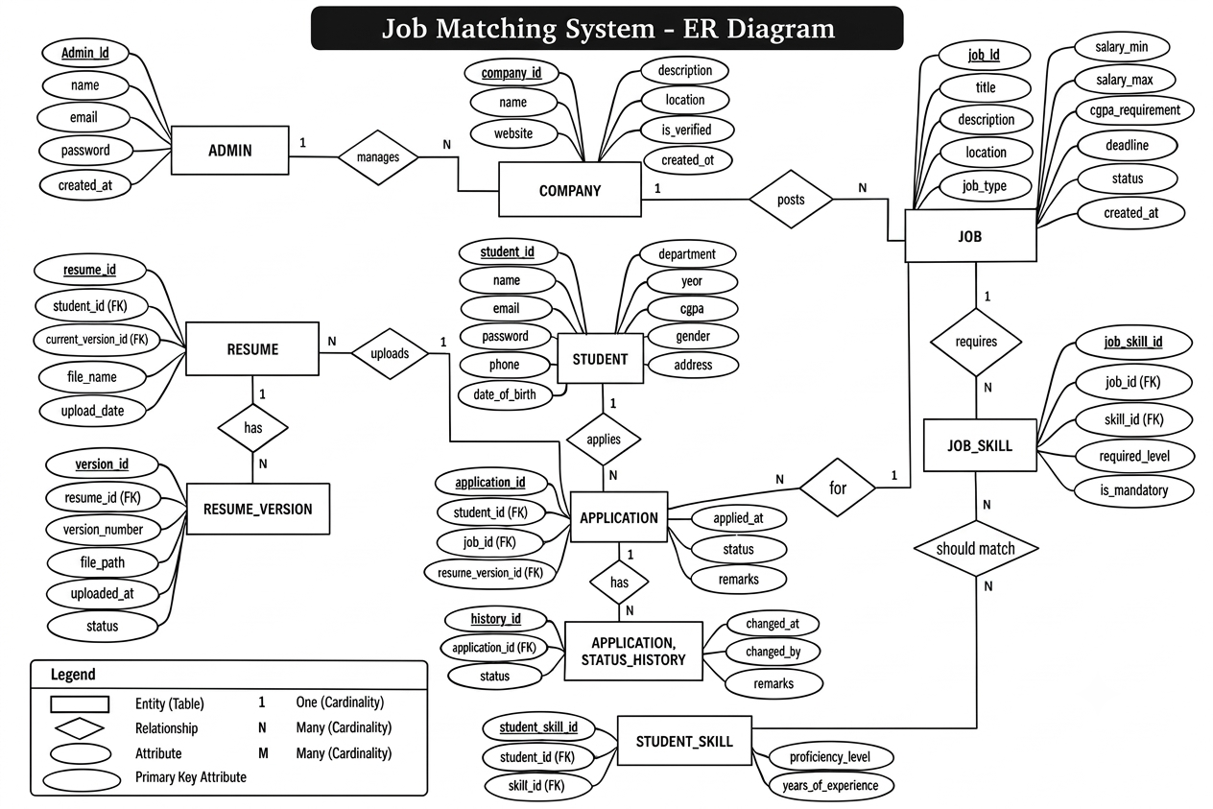
Figure 1: Job Matching System – ER Diagram

Table Schema
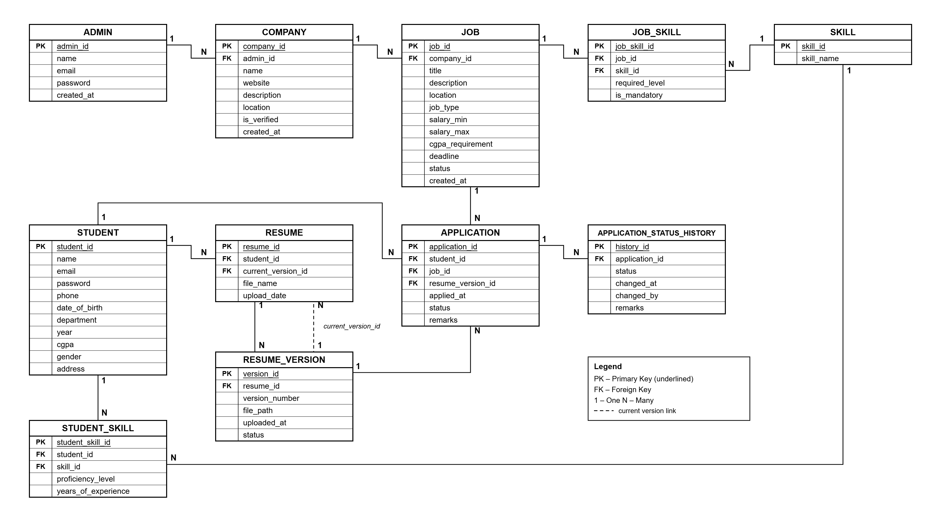
Figure 2: Relational Schema

Table Schema
The tables fall into four groups:
1 | Who’s using it  ADMIN · STUDENT  Just the people: staff logins, and every student’s department, year and CGPA.
2 | The skills graph  SKILL · STUDENT_SKILL · JOB_SKILL  One shared list of skills, so a student’s Python and a job’s Python are the same row.
3 | The hiring side  COMPANY · JOB  Companies have to be verified before a single job of theirs can go live — enforced by a trigger, not just a form.
4 | The paper trail  RESUME · RESUME_VERSION · APPLICATION · APPLICATION_STATUS_HISTORY  Every resume version and every status change is kept, so nothing about an application is ever a guess.

Tables at a glance
Table | Columns
ADMIN | admin_id (PK), name, email, password, created_at
STUDENT | student_id (PK), name, email, password, phone, date_of_birth, department, year, cgpa, gender, address
SKILL | skill_id (PK), skill_name
STUDENT_SKILL | student_skill_id (PK), student_id (FK), skill_id (FK), proficiency_level, years_of_experience
JOB_SKILL | job_skill_id (PK), job_id (FK), skill_id (FK), required_level, is_mandatory
COMPANY | company_id (PK), admin_id (FK), name, website, description, location, is_verified, created_at
JOB | job_id (PK), company_id (FK), title, description, location, job_type, salary_min, salary_max, cgpa_requirement, deadline, status, created_at
RESUME | resume_id (PK), student_id (FK), current_version_id (FK), file_name, upload_date
RESUME_VERSION | version_id (PK), resume_id (FK), version_number, file_path, uploaded_at, status
APPLICATION | application_id (PK), student_id (FK), job_id (FK), resume_version_id (FK), applied_at, status, remarks
APPLICATION_STATUS_HISTORY | history_id (PK), application_id (FK), status, changed_at, changed_by, remarks

Constraints
The create-table scripts enforce column- and row-level constraints (NOT NULL, CHECK, FOREIGN KEY) in the schema, not just in application code.

Application

Triggers
Four triggers stop bad data before it lands:
Trigger catches | What happens
Unverified company posting a job | Blocked outright; verification has to happen first.
Application after the deadline | Blocked, and the same applies if the job has been closed.
Resume that is not the applicant’s | Blocked; the resume has to belong to the applicant.
Application status change | Logged automatically, from the very first ‘Applied’.

Procedures
Two procedures do the matching legwork:
Procedure | What it does
GetStudentJobs(id) | “What should I even apply to?” with every open, qualifying job in one call.
GetSkillGap(id, job) | “What am I missing?” with the exact skills a student still needs for one job.

Views
Eight views turn common questions into a single ready-made query:
Group | View | Question it answers
Jobs & companies | ACTIVE_JOBS | “What jobs are open right now?”
Jobs & companies | COMPANY_VERIFICATION_REPORT | “Is this company legit yet?”
Application pipeline | JOB_APPLICATION_REPORT | “How many applied to this job?”
Application pipeline | APPLICATION_STATUS_REPORT | “Where’s everyone in the pipeline?”
Matching & skills | STUDENT_JOB_MATCHES | “Who’s a good fit for what’s open?”
Matching & skills | STUDENT_SKILL_REPORT | “What can this student actually do?”
History & demand | APPLICATION_HISTORY_REPORT | “What happened to this application?”
History & demand | MOST_DEMANDED_SKILLS | “What skills are companies chasing?”

Application

Worked example: tracing one student
Using the sample data already in the tables, the database traces Rahul Sharma (Computer, Year 2, CGPA 8.50) against the Python Developer Intern job at Tech Solutions, Pune.
Rahul Sharma  Computer · Year 2  CGPA 8.50  SKILLS ON FILE  - Python — Intermediate  - SQL — Advanced  - HTML — Intermediate  2 resume versions on file; applies with resume v2 | Python Developer Intern  Tech Solutions, Pune  Needs CGPA ≥ 7.50  IT IS ASKING FOR  - Python — Intermediate (required)  - SQL — Intermediate (required)  - Git — Beginner (nice to have)  Deadline: 31 Dec 2027 · still open
✓ Result: he qualifies.
His CGPA clears the 7.50 bar, and both required skills are on his profile. GetSkillGap would report nothing missing — the only gap is Git, and that is optional.
Worth knowing: GetStudentJobs itself only checks for one shared skill, not all required ones — Rahul happens to pass either way.

Implementation deliverables (Review 2)
01 DDL statements
Create-table scripts for all the tables, with column- and row-level constraints (NOT NULL, CHECK, FOREIGN KEY) enforced in the schema, not just in application code.
02 DML queries
Ten-plus real user requests — “what jobs are open for me”, “who applied to this posting” — written first in plain English, then mapped to the SQL that answers them.
03 Relational algebra
Each DML query is first written as a relational algebra expression, then translated to SQL. For example:
π title, location ( σ is_active = 1 ∧ deadline ≥ today ( JOB ) )
σ → WHERE · π → SELECT · ⋈ → JOIN
04 PL/SQL blocks
GetStudentJobs and GetSkillGap as procedures with cursors, plus supporting functions and the four triggers already covering verification, deadlines, resume ownership, and status logging.
05 Front-end
A Python + Streamlit interface, connected to MySQL via mysql-connector-python, giving students and staff a UI over the queries and procedures above.

Future Improvement
The database runs cleanly end to end on MySQL 8. The points below are refinements, not bugs.
1 | Matching is a bit too generous  GetStudentJobs shows a job if a student shares just one skill with it — mandatory or not. Rahul’s fine either way, but someone missing every required skill could still show up because of an optional one.
2 | Rejecting a company doesn’t undo its jobs  If a company is verified, posts a job, and later gets rejected, that job stays live. It is worth adding a trigger that closes it out automatically.
3 | Verification fields can drift apart  Nothing stops verification_status saying ‘Verified’ while verified_by is still empty. A small check would keep the two in sync.
4 | A few indexes are worth adding  JOB.deadline, JOB.is_active, APPLICATION.status, and COMPANY.verification_status — every view filters on one of these.

Conclusion
The AI-Assisted Resume and Job Matching Database gives a placement cell one source of truth for students, companies, jobs, resumes, and applications. A company must be verified before its jobs go live, every resume version and status change is recorded, and the skill gap between a student and a job can be computed exactly. Four triggers keep bad data out, two procedures handle the matching, and eight views answer the common questions in a single query.
The project runs cleanly end to end on MySQL 8, and the limitations identified are refinements rather than bugs. Together, the database and its Python + Streamlit front-end replace guesswork about “am I qualified for this?” with a data-backed answer.

Reference
Technologies and tools used in this project, as named in the project presentation:
Tool | Role in the project
MySQL 8 | Database platform on which the schema, views, triggers and procedures are built.
Python | Language of the front-end interface.
Streamlit | Framework used to build the front-end interface.
mysql-connector-python | Connector used to link the Python front-end to MySQL.
Job Matching Database – project presentation (AI-Assisted Resume and Job Matching Database), Ria Mudhole, Mansi Kumari, Aditya Agarwal, Dhani Jain.

Snapshot of Execution
The snapshots below show the database working on the sample data already present in its tables.
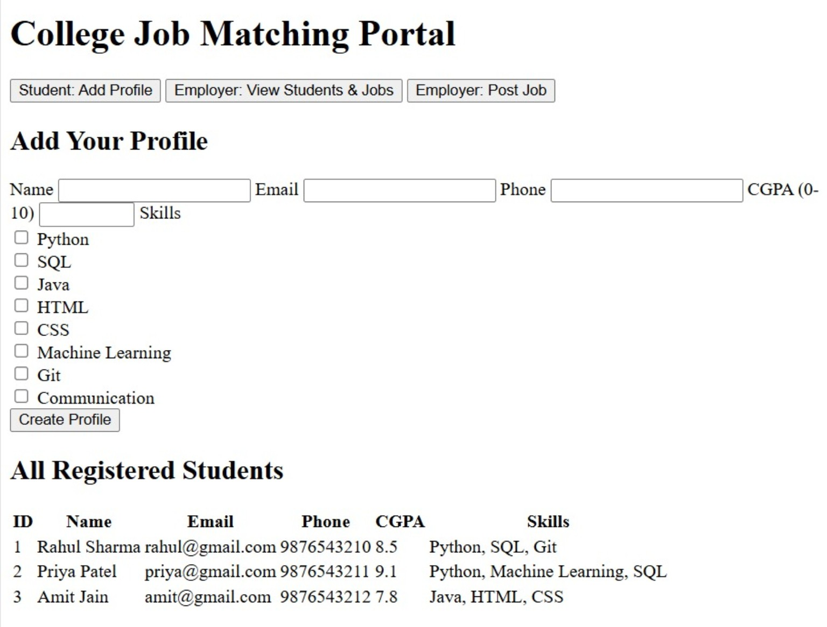
Figure 3: Execution output showing the College Job Matching Portal profile form and registered student records.
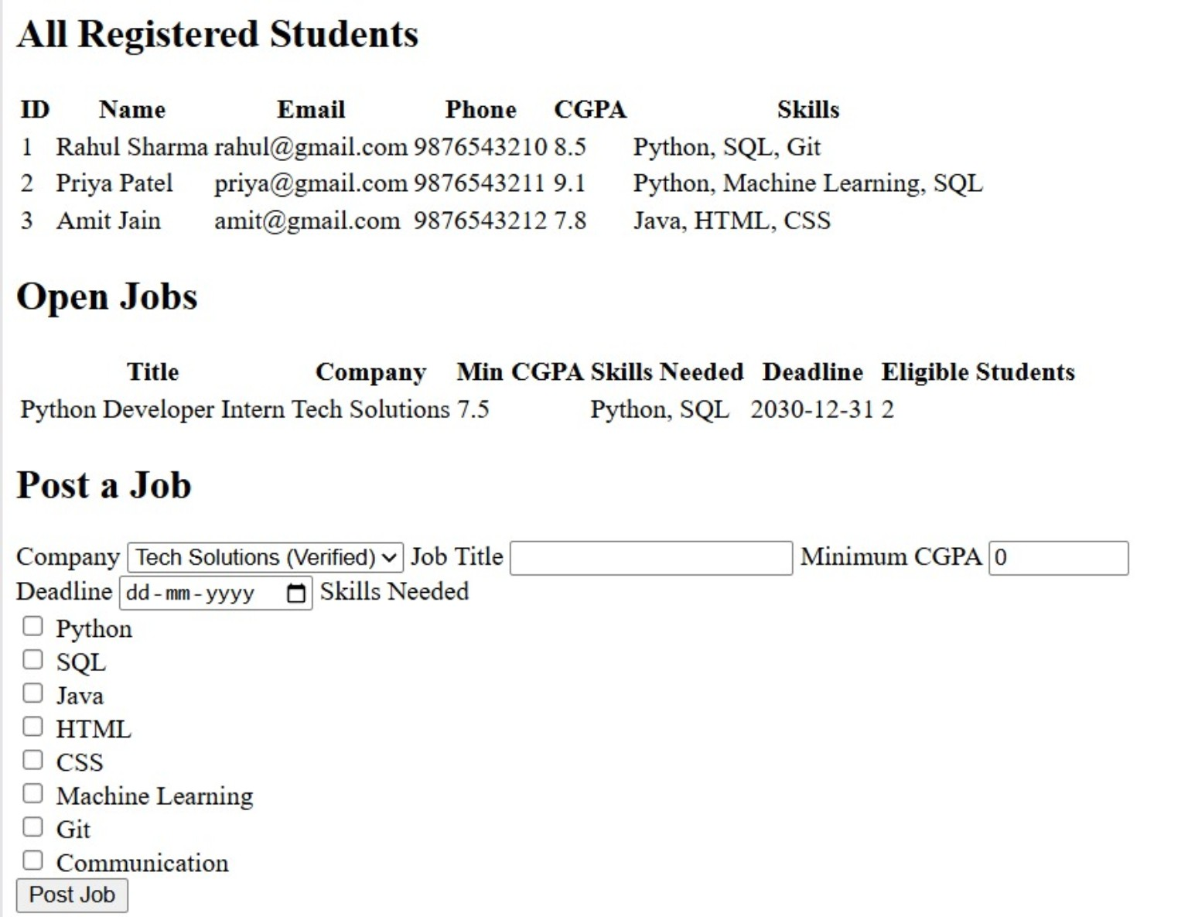
Figure 4: Execution output showing registered students, open jobs, and the Post a Job form.
