

Foundations of Programming
Assignment No. : 10

PROBLEM STATEMENT:
Write a program in C to simulate a simple calculator that performs basic arithmetic operations such as addition, subtraction, multiplication, and division. The calculator should also perform special operations like computing xʸ (power) and x! (factorial).

OBJECTIVE:
• To understand the use of switch-case statements in C.
• To perform basic arithmetic and special mathematical operations.
• To enhance problem-solving skills using menu-driven programs.

THEORY:
A calculator is a basic computing device used to perform arithmetic operations. In C programming, a simple calculator can be implemented using conditional or switch-case statements. Arithmetic operations like addition, subtraction, multiplication, and division are fundamental operations. Special operations such as power (xʸ) and factorial (x!) require loops for repeated calculations.

PLATFORM:
Linux

ALGORITHM:
Step 1: Start.
Step 2: Declare variables
Step 3: Accept values from user
Step 4: Check for the operator
Step 5: Compute operation with respect to operator
Step 6: Print answer
Step 7: Stop.

C PROGRAM:
#include <stdio.h>
#include <float.h>

int main() {
char op;
double a, b, res;
printf("Enter an operator (+, -, *, /): ");
scanf("%c", &op);
printf("Enter two operands: ");
scanf("%lf %lf", &a, &b);
switch (op) {
case '+':
res = a + b;
break;
case '-':
res = a - b;
break;
case '*':
res = a * b;
break;
case '/':
res = a / b;
break;
default:
printf("Error! Incorrect Operator Value\n");
res = -DBL_MAX;
}
if(res!=-DBL_MAX)
printf("%.2lf", res);

return 0;
}

INPUT:
User selects an operation from the menu and enters required values.
Example Input:
Choice: 1
Numbers: 10 20
Screen Shot of Input

OUTPUT:
Example Output:
Result = 30.00

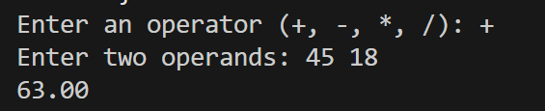CONCLUSION:
Thus, a simple calculator program was successfully implemented using C programming. The program demonstrates the use of switch-case statements, loops, and arithmetic operations.

FAQs:
- What is a simple calculator program?
- Why is switch–case preferred in calculator programs?
- How does the program handle division by zero?
- How is the power operation (xʸ) implemented without using math library functions?
- What is factorial and how is it calculated using loops in C?

