An Integrated, Explainable, and Auditable Pipeline for Personal Financial Risk Assessment and Cryptocurrency Portfolio Recommendation
[Author Name(s) — REQUIRES USER INPUT]
Department of Information Sciences
University of Education, Lahore — Vehari Campus, Punjab, Pakistan
Roll No(s). [REQUIRES USER INPUT] · Session [REQUIRES USER INPUT]
Supervisor: [REQUIRES USER INPUT]
Abstract—Retail financial-technology tools typically treat risk assessment, explanation, investment allocation, and record-keeping as separate problems, so a user seldom receives a single recommendation that is at once data-driven, interpretable, conservative, and independently verifiable. This paper presents a decision-support pipeline that unifies these concerns end to end. Five raw, user-supplied inputs are transformed into three interpretable financial ratios; unsupervised K-means clustering assigns Low, Medium, and High risk proxy labels; a leakage-aware multilayer perceptron learns to reproduce those labels from the raw inputs alone under an explicit feature contract; a deterministic guardrail and a most-cautious reconciliation rule combine the learned, cluster, and rule-based signals so that the system can only ever escalate risk; an occlusion-based explainer reports per-input influence; the reconciled band is mapped to a Bitcoin/Ethereum/USDC allocation and projected over twelve months; and every recommendation is hashed with SHA-256 into a verifiable audit record. On a synthetic dataset of 3,000 records the classifier attains 91.0% accuracy and a 0.881 macro-F1, with stable clusters (adjusted Rand index 0.868). The evaluation is held to a deliberately honest standard, and three findings shape its conclusions: the deterministic guardrail — not the learned model — binds the final decision for most users, escalating 60.6% to High risk on cash-flow grounds; the multilayer perceptron is statistically indistinguishable from logistic regression (McNemar p = 0.100); and two of the three clustering features are arithmetically recoverable from the classifier inputs. The work is therefore best read as a contribution in systems integration and transparency rather than in algorithms: a coherent, inspectable pipeline whose safety and auditability hold by construction, and whose limitations are measured and disclosed rather than hidden.
Index Terms—Explainable artificial intelligence, financial risk assessment, K-means clustering, multilayer perceptron, label leakage, portfolio allocation, decentralized finance, blockchain audit trail, decision-support systems.
I. Introduction
A. Background and Motivation
Retail investing and digital finance have put sophisticated financial decisions in the hands of individuals who rarely have formal training in risk management. Artificial-intelligence tools now promise to democratize functions once reserved for professional advisors, from automated portfolio construction to personalized financial guidance [1], [2], [8], and machine learning has become a standard instrument for financial forecasting and for flagging individuals at financial risk [3], [7], [18]. The same automation that makes these tools scalable also makes them hard to see into: a retail user is routinely asked to trust a single score with no explanation of how it was reached and no durable record of what was recommended or why.
Three concerns have moved to the center of this literature. One is explainability: as neural models enter financial tasks, methods that attribute a decision to its inputs have become essential to using them responsibly [10], [12], [21]. A second is trust and reliance — behavioral studies of AI financial advisors find that disclosing a system's limitations, rather than presenting it as infallible, produces more calibrated user reliance [11]. The third, verifiability, follows from the stakes involved: because financial recommendations carry consequences, tamper-evident audit trails, often built on blockchain-style hashing, let a recommendation be checked afterward against what was actually issued [13], [16], [22]. Cryptocurrency allocation sharpens all three, since the assets are volatile and the decentralized-finance setting adds liquidation and stablecoin-stability risks [5], [6].
B. Problem Statement and Existing Limitations
Despite substantial progress on each concern individually, they are almost always addressed in isolation. Robo-advisory and portfolio systems optimize allocations but seldom expose an interpretable risk rationale [8], [12]; distress- and risk-prediction models classify users but stop short of translating a prediction into an actionable, safety-constrained recommendation [18], [19]; explainability research develops attribution methods largely in the abstract [10], [21]; and blockchain-audit research secures records without connecting them to a live decision process [13], [14], [15]. A retail user is thus served by a patchwork of tools, none of which delivers a recommendation that is simultaneously data-driven, interpretable, conservative under uncertainty, and independently verifiable. A further and subtler limitation pervades applied financial machine learning: reported accuracies are frequently inflated by information leakage between how labels are constructed and what features a model is given, and by evaluation protocols that do not account for repeated entities [4]. Systems are seldom candid about the gap between a headline metric and the quality of the decision a user ultimately receives.
C. Research Gap
The gap this work addresses is therefore integrative and methodological rather than algorithmic. No single, inspectable system in the reviewed literature carries a user's raw financial inputs through interpretable feature construction, unsupervised risk labeling, a leakage-aware classifier, an explicit safety layer, per-decision explanation, risk-aligned allocation, and a verifiable audit record — while being explicit about where information leaks, which component actually determines the outcome, and what the evidence does and does not support. Closing this gap requires not a new estimator but a coherent architecture with enforceable properties and an honest evaluation of them.
D. Objectives and Research Questions
The objective of this work is to design, implement, and critically evaluate an end-to-end pipeline that integrates the five concerns above into a single decision-support tool, and to hold that tool to a transparent evidential standard. This objective is refined into six research questions:
RQ1. Can a user's financial risk be assessed from a small set of raw, deployable inputs while the ratios used to construct the risk labels are withheld from the classifier, so that leakage can be reasoned about explicitly?
RQ2. Do unsupervised clusters over interpretable financial ratios correspond to coherent, monotonically ordered Low/Medium/High risk bands suitable as proxy labels?
RQ3. Can a supervised classifier reproduce those proxy labels from the raw inputs alone with useful accuracy, and is a neural model warranted over simpler baselines?
RQ4. How can a learned signal, an unsupervised signal, and a deterministic rule-based signal be reconciled so that the system's failure mode is to over-warn rather than under-warn?
RQ5. Can a single explanation strategy provide per-decision, input-level attributions across different model types without retraining?
RQ6. Can the reconciled risk band be mapped to a risk-aligned cryptocurrency allocation and logged as a tamper-evident, independently verifiable record?
E. Contributions
Against these questions, the paper makes the following contributions:
C1) An integrated, end-to-end pipeline that unifies feature engineering, unsupervised proxy labeling, leakage-aware classification, conservative reconciliation, per-decision explanation, risk-aligned allocation, deterministic simulation, and cryptographic audit logging in one inspectable system, surfaced through a working application.
C2) An explicit feature contract that separates the ratios used for clustering from the raw inputs given to the classifier, together with a measured analysis of the residual arithmetic leakage that column-level separation does not remove.
C3) A conservative guardrail and a most-cautious reconciliation rule that provably cannot lower risk, accompanied by a quantitative demonstration that this deterministic layer — not the learned model — determines the outcome for most users.
C4) A model-adaptive, occlusion-based explanation mechanism that yields per-input influence scores for any probabilistic classifier in the pipeline without retraining.
C5) A risk-aligned allocation and a tamper-evident SHA-256 audit record, integrated so that every issued recommendation is both explainable and independently checkable.
C6) A candid evaluation methodology in which label leakage, guardrail dominance, and a statistically non-significant model-selection result are measured and reported rather than assumed away — offered as a template for honest appraisal of integrated financial AI systems.
F. Paper Organization
The remainder of the paper is organized as follows. Section II reviews related work thematically and positions the contribution against it. Section III presents the proposed framework, the dataset, the mathematical formulation, and each pipeline component. Section IV describes the experimental setup and reports results, including the clustering, classification, comparative, guardrail, simulation, and auditability findings. Section V discusses the implications, states the limitations and threats to validity in full, and separates the engineering contribution from the research contribution. Section VI concludes and outlines future work.
II. Related Work and Research Gap
A. Review Methodology
The literature was surveyed with a focus on works that connect machine learning to actionable, user-facing financial decisions. Studies were grouped into five themes — AI-driven wealth management, machine learning for forecasting and distress prediction, unsupervised risk profiling, explainable AI for financial models, and decentralized-finance risk together with blockchain auditing — chosen because each maps onto a stage of the proposed pipeline. Each theme is reviewed for what it contributes and, more importantly for this work, for the boundary at which it stops. The section closes with a capability matrix (Table I) that makes the integration gap explicit and positions the present contribution against it.
B. AI-Driven Wealth Management and Robo-Advisors
One strand of research examined how artificial intelligence could automate advisory functions for retail investors, from robo-advisory allocation to predictive analytics for wealth management [1], [2], [8]. These systems demonstrated that personalized, data-driven guidance was feasible at scale and increasingly expected by users. Multi-agent and collaborative designs pushed this further, coordinating specialized models for financial research [9]. What this line of work consistently left implicit, however, was the interpretable risk rationale behind an allocation and any durable record of the advice given; the emphasis was on optimizing the recommendation, not on making it transparent or verifiable.
C. Machine Learning for Forecasting and Distress Prediction
Supervised learning was applied to financial forecasting and to predicting financial distress or bankruptcy, including with multilayer perceptrons [3], [18], [19]; related work modeled the financial wellbeing of consumers to flag at-risk individuals [7]. These works established that classifiers could identify financial risk with useful accuracy. At the same time, methodological reviews cautioned that reported performance in financial machine learning was frequently undermined by leakage and by causal over-interpretation, and that pitfalls of this kind were common rather than exceptional [4]. This tension — strong headline accuracies alongside a warning that such accuracies are easily inflated — directly motivates the leakage-aware design and candid evaluation adopted here.
D. Unsupervised Segmentation and Risk Profiling
Where labeled risk outcomes were unavailable, unsupervised methods were used to segment users into behavioral groups; K-means clustering, in particular, was used to profile investor behavior into interpretable segments [20]. This supported the use of clustering to derive proxy risk bands when ground-truth outcomes were absent. The proxy nature of such labels is a well-known caveat: a cluster is a descriptive artifact, not a validated risk outcome, and any downstream classifier trained on it inherits that limitation — a point this work makes central rather than incidental.
E. Explainable AI for Financial Models
As neural models entered financial practice, attribution methods that explained a prediction in terms of its inputs became a research focus. Benchmarks of feature-importance methods for neural networks showed that no single method dominated and that combining methods was often advisable [10], and sensitivity-analysis techniques were developed specifically for neural networks [21]. Explainability was also applied directly to crypto-asset allocation [12]. These methods were typically studied as standalone techniques; comparatively little work embedded a per-decision explanation inside a running recommendation pipeline so that every issued decision carried its own attribution.
F. DeFi Risk, Stablecoins, and Blockchain Audit Trails
The remaining literature addressed the decentralized-finance setting and the verifiability of records. Empirical studies documented liquidation dynamics and instabilities in DeFi [5] and questioned the stability of stablecoins [6], establishing that crypto allocation carried structural risks beyond price volatility. Separately, a substantial literature developed blockchain-based, tamper-evident audit trails and reviewed blockchain applications in financial services [13], [16], [22], including the oracle-trust problem of connecting external data to on-chain records [14], [15]. Behavioral work added that disclosing a system's limitations improved user trust and reliance [11], [17]. Each of these strands secured or motivated one property in isolation; none integrated verifiable auditing with an explainable, risk-constrained recommendation for an individual user.
G. Comparative Literature Analysis
Table I summarizes the reviewed themes against the six capabilities that the proposed system integrates. The pattern is consistent: existing works implemented one or two capabilities and left the remainder unaddressed. The contribution of this paper is not the invention of any single column but their coherent unification in one inspectable system, together with an explicit leakage analysis that few applied studies report.
TABLE I
CAPABILITY COMPARISON OF REPRESENTATIVE PRIOR WORK AND THIS PAPER
Representative work | Risk assmt. | XAI | Guardrail | Allocation | Audit log | Leakage anal.
Robo-advisory / allocation [8], [12] | ○ | ○ | — | ✓ | — | —
Distress prediction [18], [19] | ✓ | ○ | — | — | — | —
K-means profiling [20] | ○ | — | — | — | — | —
XAI for finance [10], [21] | — | ✓ | — | — | — | —
Blockchain audit [13], [22] | — | — | — | — | ✓ | —
Trust & disclosure [11], [17] | — | ○ | — | — | — | ○
This work | ✓ | ✓ | ✓ | ✓ | ✓ | ✓
Legend: ✓ implemented and evaluated; ○ discussed or partially addressed; — not addressed. The audit log in this work is an in-memory simulated ledger (Section IV-H).
H. Research Gap and Positioning
Read together, the literature established each ingredient of a trustworthy financial recommender but not their integration. The gap this paper occupies is the assembly of interpretable risk assessment, per-decision explanation, a conservative safety layer, risk-aligned allocation, and verifiable logging into one pipeline whose properties are enforced by construction and whose weaknesses — chiefly the dominance of the rule layer over the learned model, and the arithmetic leakage between labels and features — are measured and reported. This positioning deliberately frames the contribution as one of honest systems integration rather than algorithmic novelty.
III. Proposed Methodology
A. System Overview
The system is a linear pipeline of nine stages that carries a user's raw financial inputs through to an explained, risk-aligned, and audited recommendation. Five raw inputs are engineered into three interpretable ratios; the ratios are clustered to produce proxy risk labels; a classifier learns to reproduce those labels from the raw inputs alone under a feature contract; a deterministic guardrail and a reconciliation rule enforce conservatism; an occlusion explainer attributes the decision to its inputs; the reconciled band is mapped to a cryptocurrency allocation, projected over twelve months, and hashed into an audit record. The complete flow is shown in Fig. 1. Each stage below is presented with the expression it implements, its variables, and the property it is designed to guarantee; only methods that the system actually implements are formalized.
Fig. 1. End-to-end architecture, separated into the offline training pipeline (top) and the online inference pipeline (bottom). During training the five raw inputs are engineered into three ratios that are standardized and clustered (k = 3) to create the proxy risk labels, whereas the classifier is trained on the five raw inputs only: a leakage-aware feature contract (Eq. 5) keeps the three ratios out of the classifier feature matrix, and only the proxy label crosses that boundary, as the supervised target. The fitted scaler, centroids, preprocessor, and network weights are then frozen. At inference a user's inputs drive three parallel signals — the frozen MLP (m), the frozen cluster assignment (k), and the deterministic guardrail (g) — which are reconciled to the most cautious band y* = max(m, g, k) (Eq. 14), then explained by occlusion, mapped to a BTC/ETH/USDC allocation, simulated over twelve months, and written to a hashed, verifiable ledger.
B. Dataset and Provenance
The system is developed and evaluated on a synthetic personal-finance dataset of 3,000 records. The data are generated rather than collected, which permits controlled coverage of financial scenarios but carries the external-validity caveat discussed in Section V. Two properties of the data are material to the evaluation and are therefore stated plainly. First, although the file contains 3,000 rows, it holds only 944 unique user identifiers, so roughly 95.8% of rows are repeat observations of a user already present elsewhere in the data; a naive row-level split therefore allows the same individual to appear in both training and test partitions. Second, each record is tagged with one of three macro scenarios — normal, inflation, or recession — which shapes the distribution of incomes and expenses. Table II summarizes the composition and the train/test protocol.
TABLE II
DATASET COMPOSITION AND EVALUATION PROTOCOL
Property | Value
Records / unique users | 3,000 / 944 (≈95.8% repeat rows)
Origin | Synthetic; 28 raw columns
Train / test split | 2,400 / 600 (80/20, seed 42)
Classifier inputs | 5 raw, user-facing fields
Cluster features | 3 engineered ratios
Proxy-label balance | Low 44.9% · Medium 45.9% · High 9.2%
Scenario tag | normal / inflation / recession
Toolchain | scikit-learn 1.5.0, fixed seed
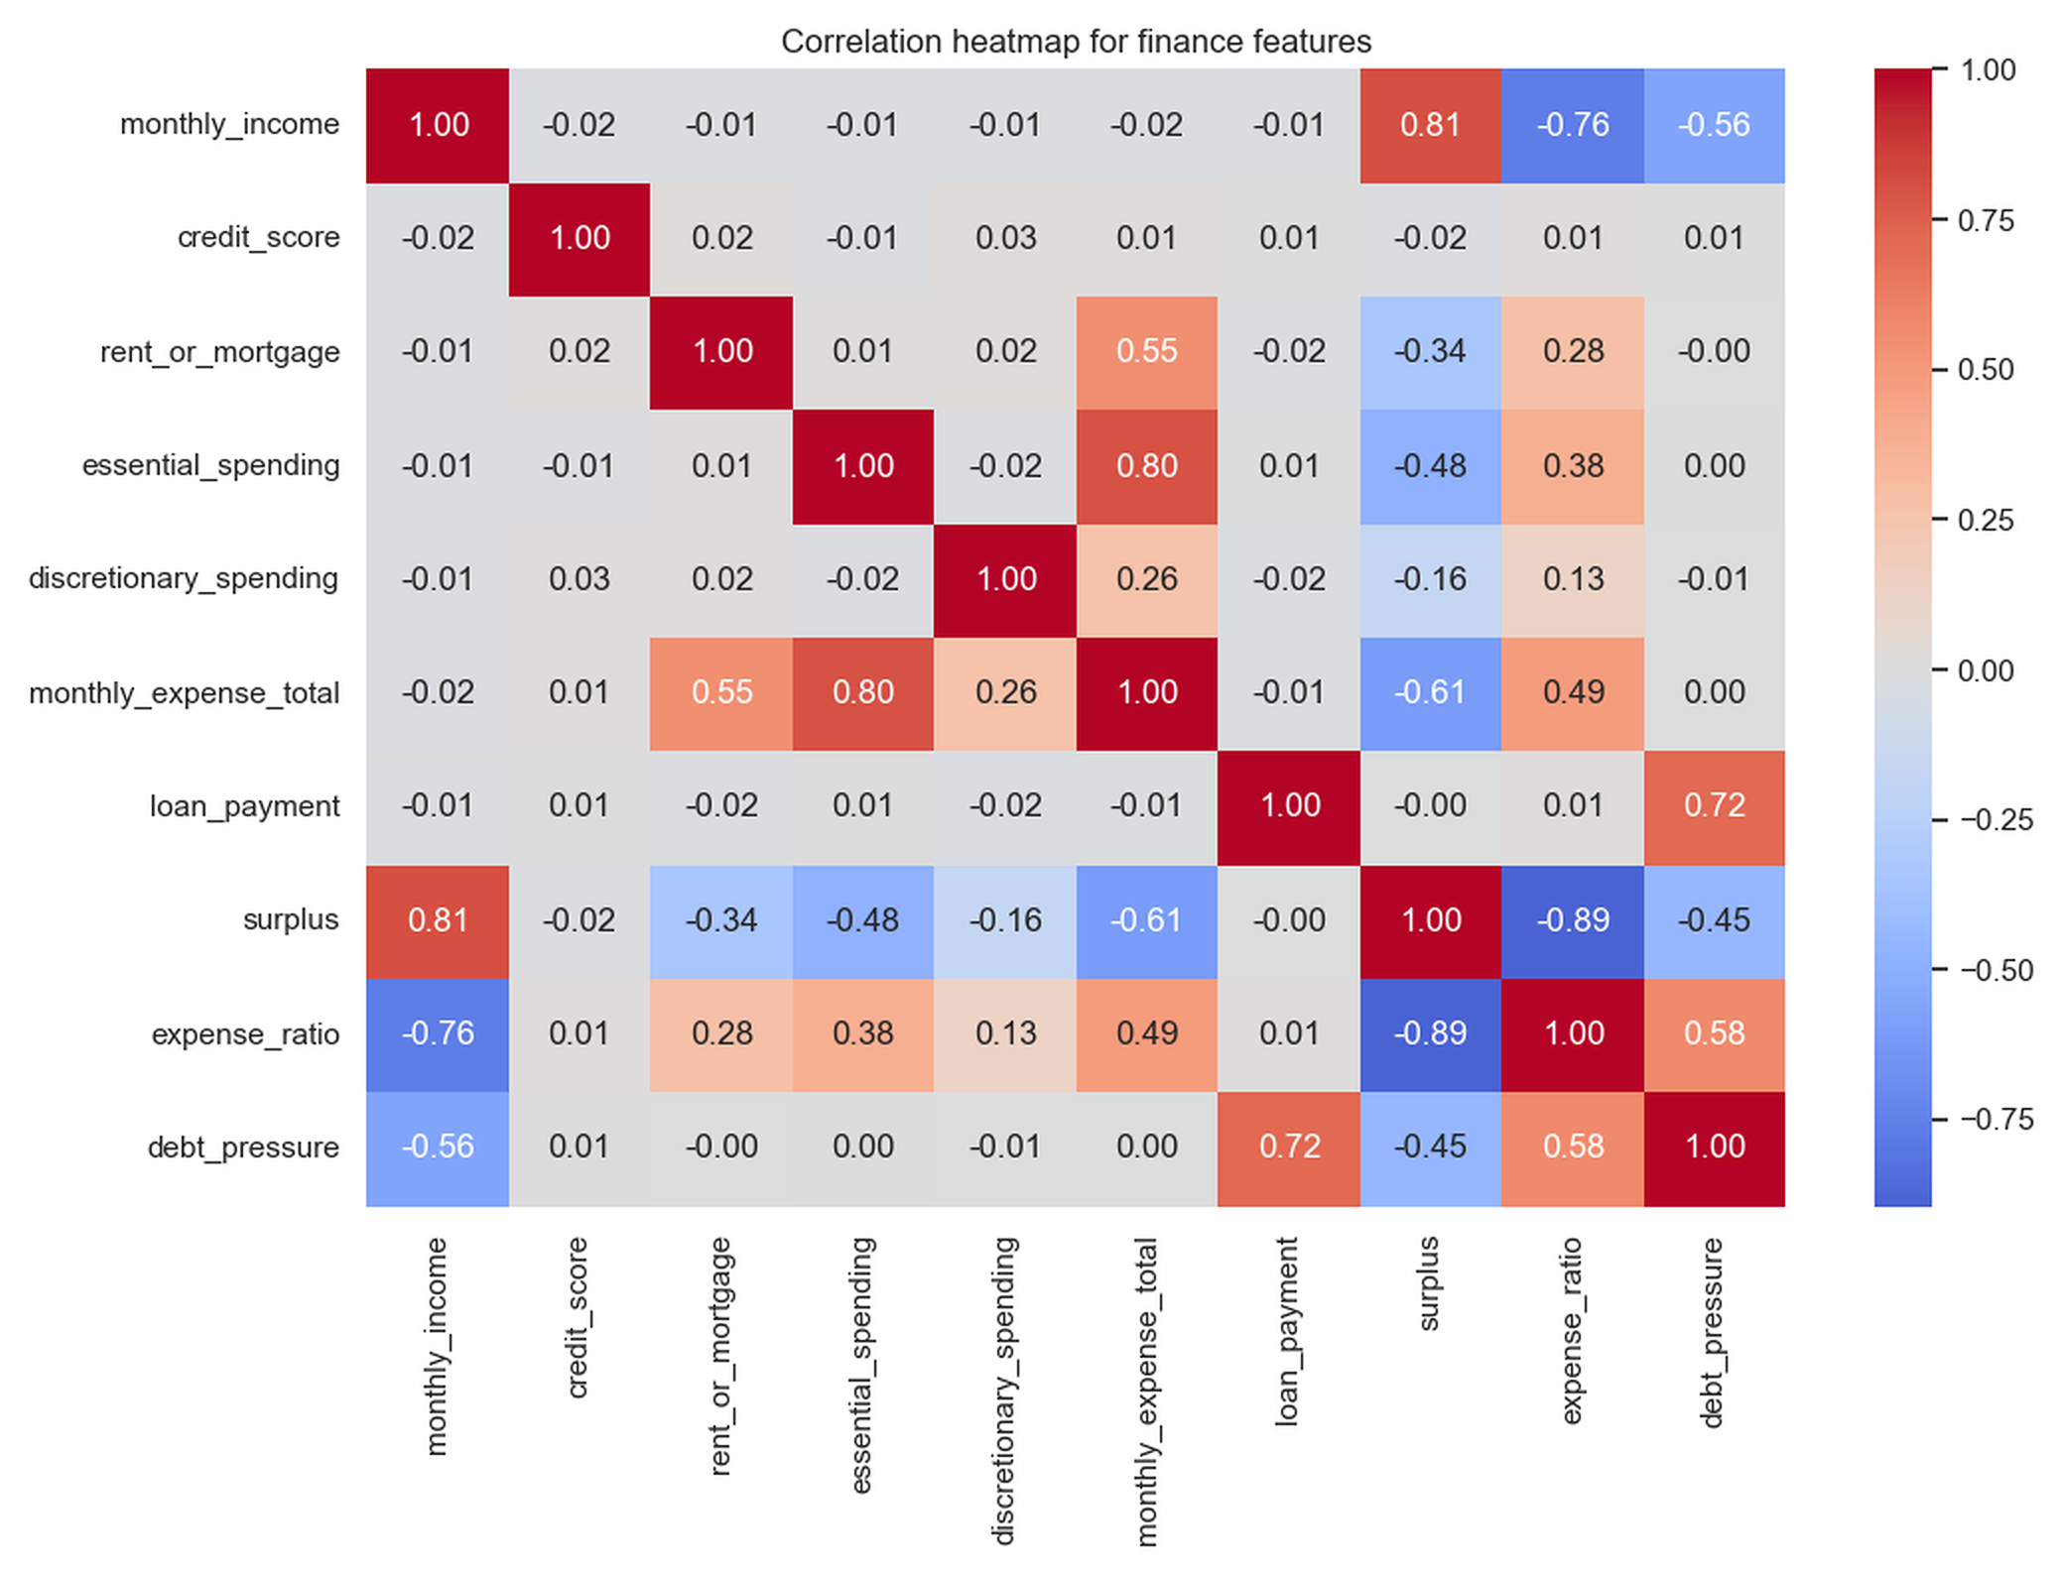
Fig. 2. Pearson correlation among the engineered financial quantities on the synthetic data. Surplus and expense ratio are strongly anti-correlated (−0.89) and income and surplus are strongly correlated (0.81), reflecting their shared algebraic origin.
C. Feature Engineering
Each user supplies monthly income, a credit score, rent or mortgage, essential spending, discretionary spending, and a loan payment. Total non-debt expenditure is the sum of the three living-cost components, with the loan payment held out so that debt burden is not double-counted:
E_{total} = R + S_{ess} + S_{disc} (1)
Monthly surplus is the income remaining after non-debt expenditure, and is the single strongest indicator of financial headroom in the system:
surplus = I − E_{total} (2)
The expense ratio expresses non-debt cost as a percentage of income, so that a value at or above 100% signals that ordinary spending alone consumes the entire income:
expense_ratio = (E_{total} / I) × 100 (3)
Debt pressure isolates the loan burden as a percentage of income:
debt_pressure = (L / I) × 100 (4)
In Equations (1)–(4), I is monthly income, R rent or mortgage, S_{ess} and S_{disc} essential and discretionary spending, and L the loan payment. When income is zero the two ratios are undefined, so the implementation substitutes a fixed sentinel (999.0) that flags the record as an extreme-risk outlier rather than dividing by zero. Table III lists every variable together with the feature set it belongs to.
D. The Leakage-Aware Feature Contract
Because the three ratios are used to construct the labels, handing them to the classifier would let it trivially recover its own target. The system therefore enforces a feature contract that partitions the columns into a clustering set and a disjoint classifier set:
F_{clu} ∩ F_{cls} = ∅ (5)
with F_{clu} = {surplus, expense_ratio, debt_pressure} and F_{cls} = {monthly_income, credit_score, rent_or_mortgage, essential_spending, discretionary_spending}. A validation routine aborts training if any blocked column reaches the classifier matrix. This column-level separation is real but incomplete, and the system reports the gap rather than concealing it: because surplus and expense_ratio are algebraic functions of the classifier inputs (Equations (1)–(3)), two of the three clustering features are exactly reconstructible from F_{cls}. Only debt_pressure is truly withheld, since it requires the loan payment, which is not a classifier input and is in fact set to zero at inference. This residual arithmetic leakage is the principal reason a high classification accuracy is attainable, and it is quantified in Section V.
TABLE III
VARIABLES AND THE LEAKAGE-AWARE FEATURE CONTRACT
Symbol | Meaning | Feature set | Recoverable from F_cls
I | Monthly income | Classifier | —
credit | Credit score | Classifier | —
R | Rent / mortgage | Classifier | —
S_ess | Essential spending | Classifier | —
S_disc | Discretionary spending | Classifier | —
L | Loan payment | Input (zeroed at inference) | —
surplus | I − E_total | Cluster | Yes
expense_ratio | (E_total / I) × 100 | Cluster | Yes
debt_pressure | (L / I) × 100 | Cluster | No (needs L)
E. Proxy Label Generation via Clustering
Because the data record no realized default or loss, risk labels are produced unsupervised. The three ratios live on very different scales, so each is standardized to zero mean and unit variance, with the statistics estimated on the training partition only:
z_{j} = (x_{j} − μ_{j}) / σ_{j} (6)
K-means then partitions the standardized vectors into k clusters by minimizing the within-cluster sum of squared Euclidean distances to the cluster centroids, assigning each point to its nearest centroid:
J = Σ_{i=1}^{k} Σ_{x∈Ci} ‖x − μ_{i}‖² (7)
c(x) = argmin_{k} ‖x − μ_{k}‖² (8)
where C_{i} is the set of points in cluster i, μ_{i} its centroid, and J the objective minimized. The cluster count is fixed at k = 3 to match the intended Low/Medium/High banding. This is a documented trade-off rather than an assumption: a two-cluster solution scores a higher silhouette (0.440), but two clusters cannot express a three-band policy, so the three-cluster configuration (silhouette 0.370, adjusted Rand index 0.868 ± 0.064 across resampling) is retained. Fitted clusters are ordered into risk bands by profile — the highest-surplus cluster becomes Low risk and the highest-expense-ratio cluster becomes High risk.
F. Risk Classification
A multilayer perceptron with two hidden layers of 64 and 32 units maps the classifier feature vector to a risk band. Each hidden layer applies an affine transform and a rectified-linear activation, and the output layer produces a distribution over the three classes by softmax:
h⁽¹⁾ = ReLU(W⁽¹⁾x + b⁽¹⁾) (9)
h⁽²⁾ = ReLU(W⁽²⁾h⁽¹⁾ + b⁽²⁾) (10)
ŷ_{c} = softmax(W⁽³⁾h⁽²⁾ + b⁽³⁾)_{c} (11)
The network is trained by minimizing the multiclass cross-entropy between the predicted distribution and the one-hot proxy label over the N training examples:
L = −(1/N) Σ_{i=1}^{N} Σ_{c=1}³ y_{i,c} log ŷ_{i,c} (12)
where W^{(l)} and b^{(l)} are the weights and biases of layer l, ŷ_{c} the predicted probability of class c, and y_{i,c} the one-hot target. The configuration of the clustering and classifier is given in Table IV.
TABLE IV
CLUSTERING AND CLASSIFIER CONFIGURATION
Component | Setting
Clustering | K-means, k = 3, n_init = 50, seed 42
Model search | K-means & GMM (k = 2–6), DBSCAN — 16 configs
Classifier | MLP, hidden (64, 32), ReLU, softmax(3)
Solver / regularization | Adam; L2, α = 0.001
Early stopping | val_fraction 0.15, patience 20, max_iter 1000
Scaling | StandardScaler fitted on train only
G. Rule-Based Safety Guardrail
A statistical prediction alone is not a safe basis for advice, so the classifier output passes through a deterministic guardrail that encodes conservative cash-flow rules and can only ever raise concern:
g = 2 if (surplus < 0 ∨ expense_ratio ≥ 90); 1 if expense_ratio ≥ 60; else 0 (13)
where 0, 1, and 2 denote Low, Medium, and High risk. A user whose spending exceeds income, or whose expense ratio reaches 90%, is treated as High risk irrespective of the model. The deployed guardrail routine additionally escalates on debt pressure — to High when debt_pressure ≥ 35% and to Medium when debt_pressure ≥ 20% — but on this dataset those branches are almost entirely subsumed by the cash-flow conditions: including them leaves the guardrail-only High share unchanged at 60.6% and shifts the Low/Medium split by under 0.2 percentage points, so (13) states the cash-flow conditions that drive the analysis in Section IV-F. A separate recommender module applies a different medium-risk threshold (75 rather than 60); this inconsistency is disclosed as a limitation in Section V.
H. Most-Cautious Reconciliation
The final band reconciles the model prediction m, the guardrail g, and the cluster assignment k by taking the most cautious of the three under the order Low < Medium < High:
y* = max(m, g, k) (14)
This guarantees that the assessed risk is never lower than any individual signal implies, so neither a classifier error nor an optimistic cluster can yield an unsafely low recommendation. Section IV quantifies how often each signal is decisive; the guardrail is the binding signal for most users.
I. Model-Adaptive Explanation
To explain a decision, the system measures how sensitive the predicted probability is to each input. For the deployed MLP, which exposes no linear coefficients, the influence of feature j is estimated by occlusion: the feature is replaced by its mean and the resulting drop in the predicted probability of the assigned class ĉ is recorded:
Δ_{j} = ŷ_{ĉ}(x) − ŷ_{ĉ}(x_{−j}) (15)
A large influence means the feature strongly supported the prediction. The strategy is model-adaptive — a linear model would instead report signed coefficients and a tree ensemble impurity importances — but for the deployed network the mean-imputation occlusion branch is the one actually exercised. This is an occlusion-based sensitivity method; it is neither SHAP nor a partial-derivative sensitivity method, and is not described as such.
J. Risk-Aligned Allocation
The reconciled band maps deterministically to a fixed Bitcoin/Ethereum/USDC allocation that scales crypto exposure down and stablecoin weighting up as risk rises:
w(Low) = (35, 35, 30); w(Med) = (20, 20, 60); w(High) = (0, 0, 100) (16)
with weights in percent summing to 100. A High-risk user is placed entirely in the USDC stablecoin, a choice motivated by the DeFi-instability literature reviewed in Section II.
K. Deterministic Twelve-Month Simulation
The allocation is evaluated by compounding an initial capital over twelve months using a fixed monthly return series for each asset. The portfolio value evolves as
V_{t} = V_{t−1} · (1 + Σ_{a} w_{a} r_{a,t}) (17)
and the return over the horizon is the total growth relative to the initial capital:
ROI = (V₁₂ − V₀) / V₀ (18)
where V_{t} is the value at month t (V₀ the initial capital), w_{a} the weight of asset a, and r_{a,t} its fixed monthly return. Because the returns are hardcoded constants rather than sampled or historical series, this is a deterministic scenario projection, not a market backtest. The originally reported ROI figures were affected by an off-by-one normalization (dividing by the first simulated month rather than the initial capital); Section IV reports the corrected values.
L. Tamper-Evident Audit Logging
Every recommendation is recorded in a tamper-evident ledger. The payload is serialized into a canonical form with sorted keys and hashed with SHA-256:
H = SHA-256( serialize(payload, sorted) ) (19)
The digest is stored with a unique transaction identifier; integrity verification re-serializes and re-hashes the stored payload and compares it against H, so any alteration is detectable. The ledger labels entries as a simulated testnet and runs in memory — it is not deployed to a live blockchain, a limitation revisited in Section V.
IV. Experimental Setup and Results
This section reports what the system was measured to do. To keep the evidential status of each figure explicit, results are labeled as one of four kinds: an experimental result (measured on held-out data), a system output (a value the pipeline emits by construction), a simulation result (an outcome of the deterministic projection), or a theoretical property (a guarantee that follows from the design). Every quantitative claim is drawn from the verified metric artifacts.
A. Experimental Setup
All models were trained with scikit-learn 1.5.0 under a fixed random seed for reproducibility, using the configuration in Table IV. Headline metrics are computed on a stratified 20% holdout of 600 records; stability is estimated with stratified five-fold cross-validation in which the clustering is refitted inside each fold so that no proxy-label information crosses the split. Uncertainty on the headline metrics is quantified by a bootstrap 95% confidence interval. The proxy-label distribution is imbalanced — Low 44.9%, Medium 45.9%, High 9.2% — which is the backdrop against which the minority High-risk results should be read.
B. Clustering Quality
Experimental result. The chosen three-cluster solution attains a silhouette coefficient of 0.370, a Calinski–Harabasz index of 2158.37, and a Davies–Bouldin index of 0.925 on the standardized ratios, with assignments stable under resampling at an adjusted Rand index of 0.868 ± 0.064. The three clusters map onto financially distinct, monotonically ordered groups, which supports their use as risk proxies: as Table V shows, mean surplus falls and mean expense ratio rises steadily from the Low to the High band. Fig. 3 shows the separation in principal-component space and in surplus–expense-ratio space with the guardrail thresholds overlaid.
TABLE V
MEAN FINANCIAL PROFILE OF EACH RISK CLUSTER (SYSTEM OUTPUT)
Risk band | Mean surplus | Mean expense ratio | Mean debt pressure
Low | +1171.67 | 76.04% | 10.43%
Medium | −583.14 | 117.76% | 14.30%
High | −1994.60 | 195.80% | 27.54%
The debt-pressure column is informative for profiling but is set to zero on the guardrail path at inference; the clusters themselves are formed on all three ratios.
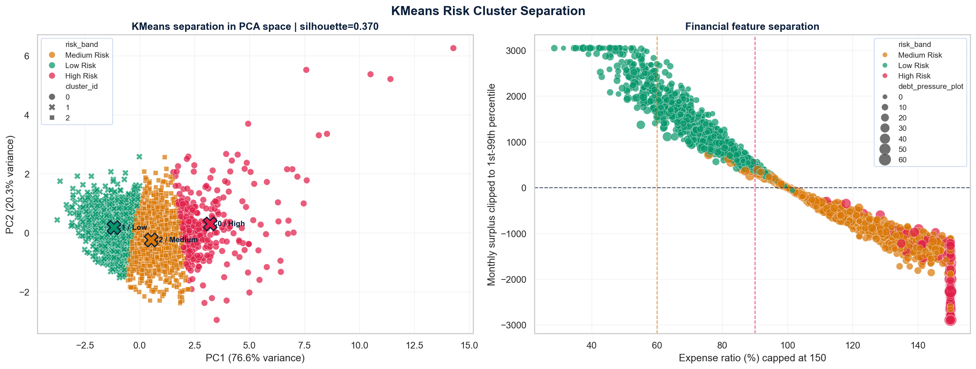
Fig. 3. K-means separation of the three risk segments (silhouette 0.370). Left: the first two principal components. Right: the same users in surplus–expense-ratio space with guardrail thresholds overlaid.
C. Classification Performance
Experimental result. On the 600-record holdout the MLP attains 91.0% accuracy and a 0.881 macro-F1, with a macro one-vs-rest ROC-AUC of 0.986 and a macro PR-AUC of 0.951. Five-fold cross-validation gives 91.2% ± 0.9% accuracy and 0.867 ± 0.018 macro-F1, so the holdout figure is representative rather than a favorable split, and a bootstrap 95% confidence interval places holdout accuracy in [0.888, 0.933] and macro-F1 in [0.847, 0.912]. Performance is uneven across bands (Table VI): the model is strong on the well-represented Low and Medium bands but markedly weaker on the minority High band, whose F1 of 0.791 reflects its small support (62 cases) and its overlap with the Medium band.
TABLE VI
PER-CLASS CLASSIFIER PERFORMANCE OF THE DEPLOYED MLP ON THE HOLDOUT (EXPERIMENTAL RESULT)
Risk band | Precision | Recall | F1 score | Support
Low | 0.922 | 0.971 | 0.946 | 242
Medium | 0.935 | 0.878 | 0.906 | 296
High | 0.761 | 0.823 | 0.791 | 62
Macro average | 0.873 | 0.891 | 0.881 | 600
Weighted average | 0.912 | 0.910 | 0.910 | 600
Precision, recall, and F1 are computed directly from the MLP confusion matrix in Fig. 4(a); the macro average is unweighted across classes and the weighted average is weighted by support. Weighted recall equals overall accuracy (0.910) by construction.
Fig. 4 shows the confusion matrix of every evaluated model on the identical 600-case holdout, which exposes the error structure that the aggregate scores hide. Three properties hold across all four models. First, errors are overwhelmingly single-band confusions between adjacent classes. Second — and this matters for a conservative advisory system — not one model ever confuses Low risk with High risk in either direction: both off-diagonal corners are exactly zero for the MLP, logistic regression, random forest, and decision tree alike, so on the classifier path the system never commits the catastrophic inversion of calling a high-risk user low-risk or vice versa. Third, the residual errors concentrate in the Medium band and at the Medium–High boundary, which is precisely where the deterministic guardrail is positioned to intervene.
The minority High band is where the models differ most, and the comparison does not favor the MLP. Reading recall along the High row of Fig. 4, logistic regression recovers 61 of 62 true High-risk users (recall 0.984), against 51 of 62 for both the MLP and the random forest (0.823) and 54 of 62 for the decision tree (0.871). Logistic regression attains this by escalating more readily — it also relabels 36 Medium users as High — so its High-band precision falls to 0.629 against the MLP's 0.761, the familiar precision–recall trade-off on a small class. For a safety-first system that would rather over- than under-state risk, the higher High-risk sensitivity of logistic regression is arguably the more desirable operating point, which further weakens any case for preferring the neural model on the minority class. The per-class ROC and precision–recall curves for the MLP in Fig. 5 corroborate the aggregate picture: near-perfect separability on the well-supported Low band and a visibly lower precision–recall area on the 62-case High band.
Fig. 4. Confusion matrices of all four evaluated classifiers on the identical 600-case holdout (rows: true label; columns: predicted label; each cell shows the count and the row percentage). Errors are confined to adjacent bands and no model produces any Low↔High confusion. All four panels are computed from the same held-out predictions and ground-truth proxy labels used for Tables VI–VIII, and reproduce the accuracy and macro-F1 of Table VII exactly.
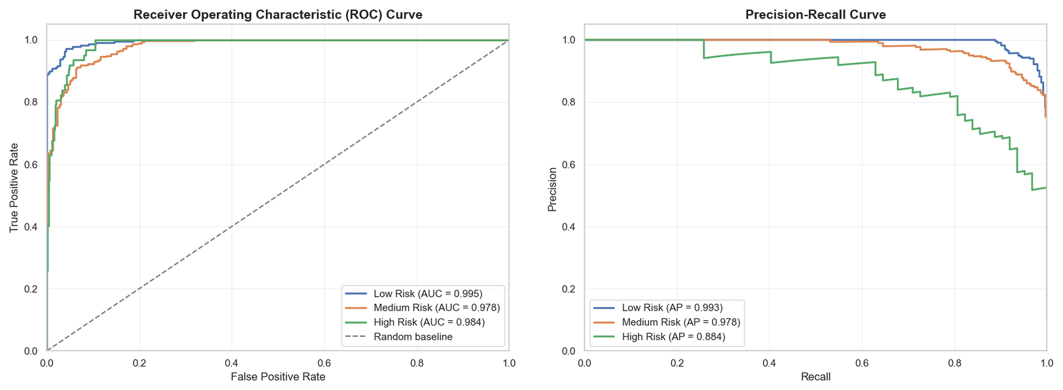
Fig. 5. Per-class one-vs-rest ROC curves (left) and precision–recall curves (right) for the MLP. The High-risk band shows the lowest average precision.
D. Comparative Analysis
Experimental result. The MLP was compared against logistic regression, a decision tree, and a random forest under the same protocol (Table VII, Fig. 6). The MLP leads on accuracy and macro-F1, but the margin over the two strongest baselines is slight, and logistic regression in fact marginally exceeds the MLP on both macro ROC-AUC (0.9861 vs. 0.9859) and macro PR-AUC (0.9520 vs. 0.9514) — an inversion to which an accuracy/F1 selection rule is blind. Only the decision tree is clearly behind.
TABLE VII
MODEL COMPARISON ON THE HOLDOUT SET (EXPERIMENTAL RESULT)
Model | Accuracy | Macro-F1 | ROC-AUC | PR-AUC
MLP (deployed) | 0.910 | 0.881 | 0.9859 | 0.9514
Logistic regression | 0.892 | 0.864 | 0.9861 | 0.9520
Random forest | 0.895 | 0.868 | 0.9764 | 0.9233
Decision tree | 0.795 | 0.765 | 0.9276 | 0.8359
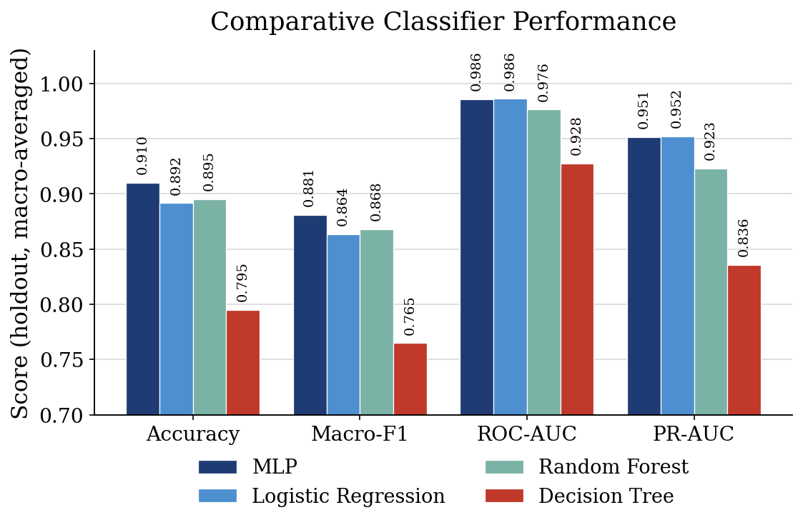
Fig. 6. Accuracy, macro-F1, ROC-AUC, and PR-AUC for the four classifiers. The MLP and logistic regression are statistically indistinguishable on this dataset (see Table VIII).
E. Statistical Validation
Experimental result. Because every classifier was evaluated on the same 600-case holdout with an identical class ordering, model differences can be tested on paired predictions. For each pairwise comparison the null hypothesis is that the two models have equal population error rates — equivalently, that their discordant predictions are symmetric — against the two-sided alternative of unequal error rates, at a significance level of α = 0.05. McNemar's test is the appropriate paired test for this design; it is computed with a continuity correction, and for the small discordant counts here an exact binomial test yields the same decisions. Table VIII reports each comparison against the deployed MLP.
The MLP is not statistically distinguishable from logistic regression (χ² = 2.70 on 24/13 discordant pairs, p = 0.100) or from the random forest (χ² = 1.83 on 22/13 pairs, p = 0.176) at α = 0.05; only the decision tree is beaten significantly (χ² = 48.67 on 82/13 pairs, p < 0.001). The discordant-pair odds ratios — a McNemar effect-size measure — are correspondingly modest for the two close baselines (1.85 and 1.69) and large only for the decision tree (6.31). Because three comparisons are made against the same MLP, a Holm–Bonferroni correction is applied across them; it leaves every decision unchanged, since the decision-tree result stays below its adjusted threshold while the logistic-regression and random-forest results stay above theirs.
These tests are read alongside the interval estimates. The headline metrics carry a bootstrap 95% confidence interval computed over 300 resamples of the holdout: holdout accuracy has a point estimate of 0.910 with a 95% interval of [0.888, 0.933], and macro-F1 a point estimate of 0.881 with a 95% interval of [0.847, 0.912]. Five-fold stratified cross-validation is consistent with these figures (accuracy 0.912 ± 0.009, macro-F1 0.867 ± 0.018). The overlapping intervals and the non-significant tests together mean the evidence does not support a claim that a neural model is necessary for this task; the MLP is retained for its probability outputs, which the occlusion explainer consumes, and the non-significant comparisons are reported as an absence of demonstrated superiority rather than as proof of equivalence.
TABLE VIII
STATISTICAL VALIDATION OF PAIRWISE MODEL DIFFERENCES (EXPERIMENTAL RESULT)
Comparison | Test | χ² (b/c) | p-value | α | Significant? | Interpretation
MLP vs. logistic regression | McNemar | 2.70 (24/13) | 0.100 | 0.05 | No | No demonstrated difference
MLP vs. random forest | McNemar | 1.83 (22/13) | 0.176 | 0.05 | No | No demonstrated difference
MLP vs. decision tree | McNemar | 48.67 (82/13) | < 0.001 | 0.05 | Yes | MLP significantly better
χ² is McNemar's statistic with continuity correction and (b/c) are the discordant-pair counts — cases the MLP classifies correctly and the comparator does not (b), versus the reverse (c). All p-values are two-sided; the ‘Significant?’ decision reflects the Holm–Bonferroni-adjusted threshold, which coincides with the uncorrected decision here.
F. Guardrail Dominance and Reconciliation
System output. Applied across the dataset, the guardrail alone assigns 5.87% of users to Low, 33.53% to Medium, and 60.60% to High risk. The guardrail signal is greater than or equal to the cluster signal for 100% of users and strictly greater for 84.13%, so the guardrail — not the classifier — is the binding signal in the reconciliation for most users. Read the other way (Fig. 7), when the model predicts Low its prediction never changes the final band (0.00% of cases), when it predicts Medium the final band changes for 5.87% of cases, and when it predicts High it changes for 39.40%. Substituting a constant Low-risk predictor would alter 0.00% of final decisions.
This is the single most consequential finding, and it qualifies a naive reading of the 91% accuracy. Because the conservative guardrail escalates so many users to High risk on cash-flow grounds alone, the learned classifier determines the end recommendation for only a minority of users. The accuracy is a genuine property of the classifier, but it is not a measure of the system's end-to-end decision quality, which is dominated by the deterministic layer.
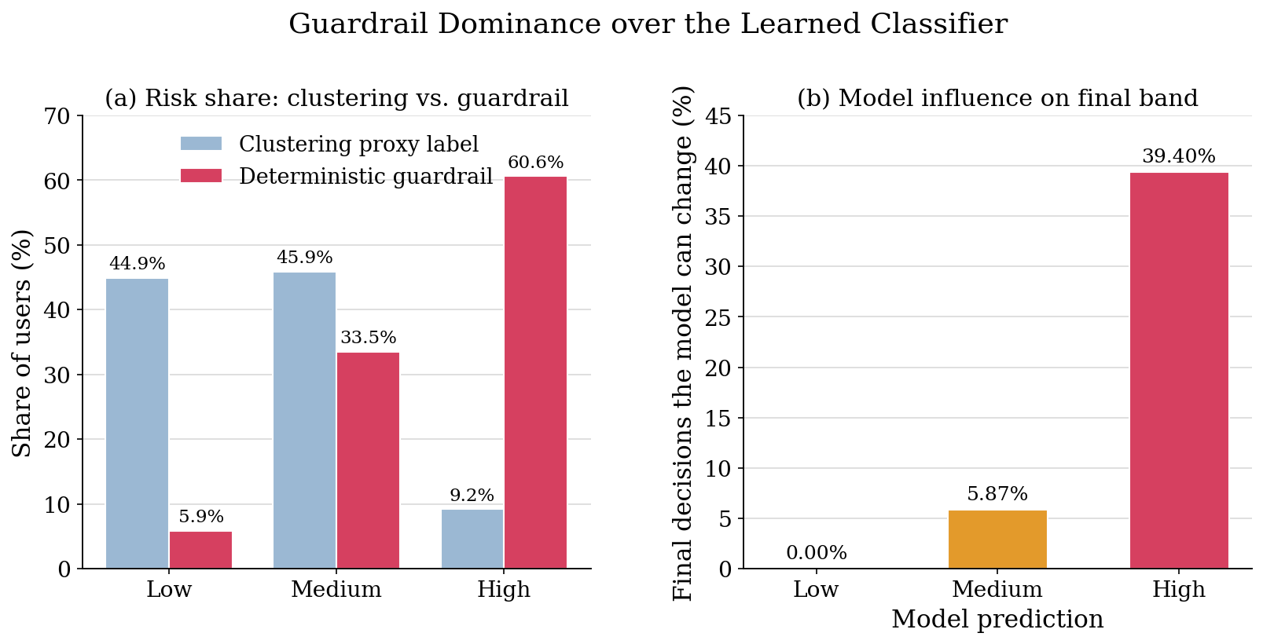
Fig. 7. Guardrail dominance. (a) Risk share under clustering alone versus the guardrail alone; the guardrail escalates 60.6% of users to High risk. (b) Share of cases in which the model prediction can still change the final band, by predicted class.
G. Portfolio Simulation
Simulation result. Under the deterministic twelve-month projection with fixed monthly returns, the corrected return on investment is 25.72% for the Low-risk allocation, 15.40% for Medium, and 2.43% for High, against a USDC-only baseline of 2.43% (Table IX, Fig. 8). Maximum drawdowns are −3.79%, −2.08%, and 0.00% respectively. The High allocation and the baseline coincide exactly because a High-risk user is placed entirely in USDC.
TABLE IX
ORIGINAL VERSUS CORRECTED TWELVE-MONTH ROI BY RISK BAND
Risk band | BTC/ETH/USDC | Original ROI | Corrected ROI | Max drawdown
Low | 35 / 35 / 30 | 20.18% | 25.72% | −3.79%
Medium | 20 / 20 / 60 | 12.34% | 15.40% | −2.08%
High | 0 / 0 / 100 | 2.22% | 2.43% | 0.00%
Baseline (USDC) | 0 / 0 / 100 | — | 2.43% | 0.00%
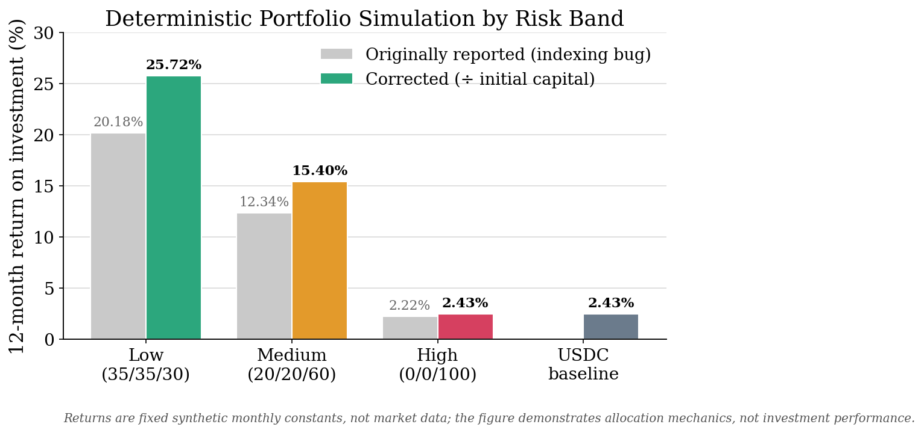
Fig. 8. Deterministic twelve-month simulated ROI by risk band: originally reported values (inflated by the backtester indexing error) versus corrected values, against the USDC-only baseline. The returns are fixed synthetic constants, so the figure demonstrates allocation mechanics rather than market performance.
Two cautions attach. First, these are the corrected values: the originally reported ROIs were inflated by an off-by-one normalization in the backtester. Second, and more fundamentally, the returns are generated from fixed, hardcoded monthly constants rather than live or historical market data, so they demonstrate the mechanics of the allocation policy — higher assessed risk yields a more conservative, lower-variance allocation — but are not evidence of real-world investment performance. They are best read as an internal consistency check on the allocation logic.
H. Auditability
Theoretical property. Every recommendation is hashed with SHA-256 over a canonicalized payload and stored with a unique transaction identifier, and a verification routine re-hashes a stored record to detect alteration. Tamper-evidence here is a property of the cryptographic construction rather than a measured outcome: any change to a logged payload changes its digest and is detectable on verification. The mechanism is exercised against an in-memory simulated ledger, not a deployed blockchain, so it demonstrates the auditability pattern rather than production-grade distributed immutability.
V. Discussion
A. Interpretation of Findings
The results support a nuanced reading of the system. The integration objective is met: a single user's raw inputs flow, without manual intervention, into an explained, risk-aligned, and independently verifiable recommendation, and the safety properties hold by construction rather than by training. What the evaluation also shows is that the headline classification accuracy is the wrong summary of how the system behaves. The deterministic guardrail escalates 60.6% of users to High risk on cash-flow grounds and is the binding signal for the majority, so the learned model is decisive for only a minority of users; its 91.0% accuracy is a real property of one component, measured on held-out data, but says little about end-to-end decision quality. The comparative and statistical results reinforce this modest reading: the MLP is statistically indistinguishable from logistic regression, which in fact edges it on both area-under-curve metrics, so a neural model is not shown to be necessary. These are not incidental caveats — they are the central empirical content of the evaluation, and reporting them is part of the contribution.
B. Engineering versus Research Contribution
Separating the two kinds of contribution is what keeps the claims honest. The engineering contribution is real and is the substance of the work: an integrated pipeline that unifies feature engineering, unsupervised proxy labeling, a leakage-aware classifier, a conservative guardrail, most-cautious reconciliation, model-adaptive explanation, risk-aligned allocation, deterministic simulation, and a hashed, verifiable audit log in one inspectable system with an explicit feature contract and a safety layer that cannot lower risk. That combination is exactly what the reviewed literature treats as missing. The research contribution is stated more modestly: the individual techniques are standard, and the results do not establish that any is novel or that the learned model beats a simple baseline. What the work contributes on the research side is methodological — a demonstration that an integrated financial-recommendation pipeline can be held to an honest evidential standard in which leakage is measured, guardrail dominance is quantified, and a model-selection result that fails significance is reported rather than dropped. Ordinary component integration is claimed nowhere as novel, and no claim is made of validation against real financial outcomes.
C. Limitations
The critical review surfaced seven limitations, stated here plainly with their severity in Table X. Three are of high severity. Guardrail dominance means the accuracy figure does not describe end-to-end behavior. Arithmetic label leakage means that, although the three ratios are withheld from the classifier at the column level, surplus and expense ratio are deterministic functions of the raw inputs and are therefore recoverable, making the classification task easier than one with independent labels; the strong surplus–expense-ratio correlation in Fig. 2 is the empirical footprint of this dependency. Most fundamentally, the labels are proxies produced by clustering, not recorded default or loss outcomes, so no real-world predictive validity is established. The medium-severity items are the statistically unjustified selection of the MLP over logistic regression, the corrected backtest indexing error (which even corrected rests on fixed synthetic returns), and entity leakage from a row-level split over data with only 944 unique users among 3,000 rows. Finally, at low-to-medium severity, part of the source tree is a not-yet-extracted presentation layer, the ledger is an in-memory simulation rather than a deployed chain, and the explainer is occlusion-based rather than SHAP or a partial-derivative method.
TABLE X
SUMMARY OF LIMITATIONS AND THEIR EFFECT ON CLAIMS
Limitation | Severity | Effect on claims
Guardrail dominance | High | Accuracy does not describe end-to-end decision quality.
Arithmetic label leakage | High | Classification easier than with independent labels.
Proxy labels, no ground truth | High | No real-world predictive validity established.
Non-significant model selection | Medium | MLP not statistically better than logistic regression.
Backtest indexing error | Medium | Original ROIs inflated; corrected values used.
Entity leakage in split | Medium | Generalization may be overstated.
Façade layer / simulated ledger | Low–Med | Prototype-stage engineering, not production.
D. Threats to Validity
The limitations map onto the standard categories of validity as follows, so that a reader can locate each concern precisely.
Internal. The arithmetic recoverability of two clustering features from the classifier inputs, and the row-level split over repeated identifiers, both create paths by which apparent performance can be inflated relative to a genuinely independent prediction task.
Construct. The target is a clustering-derived proxy for risk, not a recorded financial outcome; the twelve-month ROI is computed from fixed constants rather than market data. Both measure the intended construct only indirectly.
External. The data are synthetic and single-source, and the returns are hardcoded, so results should not be extrapolated to real users or markets without revalidation on recorded data.
Conclusion. The small High-risk support (62 holdout cases) widens the interval on its per-class F1, and the McNemar tests are underpowered to detect small differences; the non-significant results are therefore reported as an absence of demonstrated superiority rather than proof of equivalence.
E. Research Questions and Objective Fulfillment
Table XI closes the loop between the six research questions of Section I-D and the evidence gathered in Section IV, assigning each an explicit status of Supported, Partially supported, or Not demonstrated together with the method and result that justify it. The verdicts are deliberately mixed. Three questions are fully supported: the clustering yields coherent, monotonically ordered proxy bands (RQ2), the reconciliation enforces an over-warn failure mode by construction (RQ4), and the allocation-and-audit path produces tamper-evident, re-verifiable records (RQ6). The remaining three are only partially supported, and are labelled so on purpose — risk can be assessed from the withheld-ratio inputs, but column-level separation does not remove the residual arithmetic leakage (RQ1); the classifier reproduces the labels with high accuracy, yet a neural model is not shown to be warranted over logistic regression (RQ3); and the explanation mechanism returns per-decision attributions without retraining, but only its MLP branch is exercised in deployment (RQ5).
TABLE XI
MAPPING OF RESEARCH QUESTIONS TO METHODS, EVIDENCE, AND STATUS
RQ | Research question / objective | Method / experiment | Evidence / result | Status
RQ1 | Assess risk from raw, deployable inputs while withholding the label-defining ratios, so leakage is explicit. | Feature contract partitioning F_cls and F_clu (Eq. 5) with a validation abort; residual-leakage analysis (Sec. III-D, V-C). | Classifier uses five raw inputs only; column separation is enforced, but surplus and expense ratio stay arithmetically recoverable, so leakage is measured and disclosed rather than removed. | Partially supported
RQ2 | Do interpretable-ratio clusters form coherent, monotonically ordered Low/Medium/High proxy bands? | K-means (k = 3) on standardized ratios; silhouette, Calinski–Harabasz, Davies–Bouldin, and ARI stability; cluster profiling (Table V). | Silhouette 0.370 and ARI 0.868 ± 0.064; mean surplus falls and mean expense ratio rises monotonically from Low to High (Table V). | Supported
RQ3 | Can a classifier reproduce the proxy labels from raw inputs with useful accuracy, and is a neural model warranted over simpler baselines? | MLP versus logistic regression, random forest, and decision tree; McNemar tests; five-fold CV; bootstrap CIs (Tables VI–VIII). | 91.0% accuracy and 0.881 macro-F1, but the MLP is not significantly better than logistic regression (p = 0.100) or random forest (p = 0.176), which even edge it on AUC. | Partially supported
RQ4 | Reconcile the learned, unsupervised, and rule-based signals so the failure mode is to over-warn. | Escalate-only guardrail (Eq. 13) and most-cautious rule y* = max(m, g, k) (Eq. 14); guardrail-dominance measurement (Sec. IV-F). | Reconciliation cannot lower risk by construction; the guardrail is ≥ the cluster signal for 100% of users and escalates 60.6% to High risk. | Supported
RQ5 | Provide per-decision, input-level attributions across model types without retraining. | Model-adaptive occlusion sensitivity (Eq. 15): mean-imputation for the MLP, signed coefficients for linear models, impurity for trees. | Yields per-input influence scores for the deployed MLP without retraining; the other branches exist by construction, but only the MLP branch is exercised. | Partially supported
RQ6 | Map the reconciled band to a risk-aligned crypto allocation and log a tamper-evident, verifiable record. | Deterministic band→(BTC, ETH, USDC) map (Eq. 16); SHA-256 hashing of a canonical payload with re-hash verification (Eq. 19). | Allocation is deterministic and risk-monotone; any change to a logged payload changes its digest and is detected — though against an in-memory simulated ledger, not a live chain. | Supported
The three ‘supported’ verdicts rest on properties that hold by construction (RQ4, RQ6) or on direct metric evidence (RQ2); the three ‘partially supported’ verdicts mark exactly where an honest reading stops short — residual leakage, an unjustified neural model, and a single exercised explanation branch. No verdict claims validation against real financial outcomes, which remains outside the scope of this proxy-labelled study.
VI. Conclusion and Future Work
A. Conclusion
This paper set out to build an integrated, explainable, and independently verifiable decision-support pipeline that carries a single user's raw financial inputs through risk assessment, safety enforcement, explanation, portfolio allocation, and tamper-evident logging — a combination the reviewed literature treats as five largely separate problems. The pipeline delivers that integration end to end: it engineers three interpretable ratios from five raw inputs, derives Low, Medium, and High risk segments by clustering (silhouette 0.370, stable at an adjusted Rand index of 0.868), trains a leakage-aware MLP that reproduces the risk band at 91.0% accuracy and 0.881 macro-F1, routes every prediction through a conservative guardrail that can only escalate risk, explains each decision with a model-adaptive feature-impact method, maps the reconciled band to a risk-aligned BTC/ETH/USDC allocation, and records a SHA-256-hashed, verifiable receipt for every recommendation.
Equally central to the conclusion is what the work does not claim. The evaluation establishes that the conservative guardrail, not the learned model, determines most final recommendations; that the proxy labels are arithmetically entangled with the classifier inputs; that the MLP is not statistically better than logistic regression; and that the portfolio simulation rests on fixed synthetic returns. The contribution is therefore an engineering one — a coherent, inspectable integration of standard techniques with an explicit feature contract and a safety-first reconciliation — reported against an honest evidential standard rather than an inflated one. In answering its six research questions, the work shows that such a pipeline can be built and made transparent, while remaining candid that demonstrating real-world predictive validity lies outside its present scope.
B. Future Work
The limitations map directly onto a program of future work, ordered by how much each would strengthen the evidential standing of the system:
1) Replace the clustering-derived proxy labels with recorded default or loss outcomes, so the classifier predicts a ground-truth target rather than a clustering artifact [18], [19].
2) Adopt entity-level (grouped) splitting by identifier to remove the entity-leakage concern and yield a trustworthy generalization estimate.
3) Break the arithmetic label dependency by constructing labels from information not fully recoverable from the classifier inputs, or by explicitly modeling that dependency.
4) Rebalance the guardrail and the model — including resolving the 60/75 medium-threshold inconsistency — so the learned component contributes to more decisions.
5) Strengthen the explanation layer by adopting SHAP or a partial-derivative sensitivity method and combining attributions, as the benchmark literature recommends [10], [21].
6) Integrate historical or live market and DeFi data, modeling the liquidation and stablecoin-instability risks documented in the literature, to turn the deterministic projection into a genuine backtest [5], [6].
7) Deploy a real audit ledger via a smart contract, with attention to storage, throughput, and oracle-trust costs, to make the auditability claim production-grade [13], [14], [15], [22].
8) Move toward dynamic, causal allocation — reinforcement-learning rebalancing or an explainable optimizer — framed with the causal-inference caution raised for financial planning [4], [8], [12].
Taken together, these directions would progressively convert the present prototype — an honest demonstration of integration — into a system whose predictive and financial claims could be defended on external evidence. That progression, rather than any single algorithmic advance, is the path these findings point toward.
References
[1] J. Ng Kok Wah, "AI-Powered Wealth Management: Transforming Financial Literacy, Personalized Investments, and Risk Assessment Through Robo-Advisors and Predictive Analytics for the Future of Finance," Kexue Tongbao/Chinese Science Bulletin, vol. 70, no. 2, pp. 4401–4420, Feb. 2025.
[2] I. Sifat, "Artificial Intelligence (AI) and Future Retail Investment," Nijmegen School of Management, Radboud Universiteit, The Netherlands, Working Paper, Version 2, Sep. 2023.
[3] M. A. Faheem, M. Aslam, and S. Kakolu, "Enhancing Financial Forecasting Accuracy Through AI-Driven Predictive Analytics Models," IRE Journals, vol. 4, no. 12, pp. 322–328, Jun. 2021.
[4] H. Wasserbacher and M. Spindler, "Machine learning for financial forecasting, planning and analysis: recent developments and pitfalls," Digital Finance, vol. 4, pp. 63–88, 2022, doi: 10.1007/s42521-021-00046-2.
[5] K. Qin, L. Zhou, P. Gamito, P. Jovanovic, and A. Gervais, "An Empirical Study of DeFi Liquidations: Incentives, Risks, and Instabilities," in Proc. ACM Internet Measurement Conf. (IMC '21), Virtual Event, USA, Nov. 2021, pp. 336–350, doi: 10.1145/3487552.3487811.
[6] B. Nguyen Thanh, T. Nguyen Vu Hong, H. Pham, T. Nguyen Cong, and T. Pham Thi Anh, "Are the stabilities of stablecoins connected?," Journal of Industrial and Business Economics, vol. 50, pp. 515–525, 2023, doi: 10.1007/s40812-022-00207-3.
[7] J. R. Machireddy, "Data Science and Business Analytics Approaches to Financial Wellbeing: Modeling Consumer Habits and Identifying At-Risk Individuals in Financial Services," Journal of Applied Big Data Analytics, Decision-Making, and Predictive Modelling Systems, pp. 1–18, 2023.
[8] L. S. K. G. Yaramolu, "AI-Powered Portfolio Management: Transforming Wealth Management Through Intelligent Automation," Journal of Computer Science and Technology Studies, vol. 7, no. 3, pp. 14–23, Apr. 2025, doi: 10.32996/jcsts.2025.7.3.3.
[9] X. Han, N. Wang, S. Che, H. Yang, K. Zhang, and S. X. Xu, "Enhancing Investment Analysis: Optimizing AI-Agent Collaboration in Financial Research," in Proc. 5th ACM Int. Conf. AI in Finance (ICAIF '24), Brooklyn, NY, USA, Nov. 2024, pp. 538–546, doi: 10.1145/3677052.3698645.
[10] H. Mandler and B. Weigand, "A review and benchmark of feature importance methods for neural networks," ACM Computing Surveys, vol. 56, no. 12, Art. no. 318, pp. 1–30, Oct. 2024, doi: 10.1145/3679012.
[11] T. K. Trinh, G. Jia, C. Cheng, and C. Ni, "Behavioral Responses to AI Financial Advisors: Trust Dynamics and Decision Quality Among Retail Investors," in Proc. 3rd Int. Conf. Functional Materials and Civil Engineering, 2025, pp. 69–79, doi: 10.54254/2755-2721/144/2025.21859.
[12] G. Babaei, P. Giudici, and E. Raffinetti, "Explainable artificial intelligence for crypto asset allocation," Finance Research Letters, vol. 47, part B, Art. no. 102941, 2022, doi: 10.1016/j.frl.2022.102941.
[13] A. Ahmad, M. Saad, M. Al Ghamdi, D. Nyang, and D. Mohaisen, "BlockTrail: A Service for Secure and Transparent Blockchain-Driven Audit Trails," IEEE Systems Journal, vol. 16, no. 1, pp. 1367–1378, Mar. 2022, doi: 10.1109/JSYST.2021.3097744.
[14] A. Pasdar, Y. C. Lee, and Z. Dong, "Connect API with blockchain: A survey on blockchain oracle implementation," ACM Computing Surveys, vol. 55, no. 10, Art. no. 208, pp. 1–39, Feb. 2023, doi: 10.1145/3567582.
[15] S. K. Ezzat, Y. N. M. Saleh, and A. A. Abdel-Hamid, "Blockchain Oracles: State-of-the-Art and Research Directions," IEEE Access, vol. 10, pp. 67551–67572, 2022, doi: 10.1109/ACCESS.2022.3184726.
[16] J. Cunningham, N. Davies, S. Devaney, M. Harding, S. Holm, V. Neumann, and J. Ainsworth, "The development of a blockchain-based business model simulator with an application to civic medical data management," Digital Business, vol. 5, Art. no. 100112, 2025, doi: 10.1016/j.digbus.2025.100112.
[17] R. T. Rajasekaran and M. Selvam, "AI-Powered Behaviour Analysis in Financial Services," in Proc. 2025 Int. Conf. Data Science, Agents & Artificial Intelligence (ICDSAAI), Chennai, India, 2025, pp. 1–5, doi: 10.1109/ICDSAAI65575.2025.11011795.
[18] A. Malakauskas and A. Lakstutiene, "Financial Distress Prediction for Small and Medium Enterprises Using Machine Learning Techniques," Inzinerine Ekonomika-Engineering Economics, vol. 32, no. 1, pp. 4–14, 2021, doi: 10.5755/j01.ee.32.1.27382.
[19] R. Förch Brenes, A. Johannssen, and N. Chukhrova, "An intelligent bankruptcy prediction model using a multilayer perceptron," Intelligent Systems with Applications, vol. 16, Art. no. 200136, 2022, doi: 10.1016/j.iswa.2022.200136.
[20] E. H. L. Tan, Y. Hamed, H. Daud, M. A. F. Abdul Wahab, A. A. A. Azhar, and S. Y. Tan, "Profiling investor behavior in the Malaysian derivatives market using K-means clustering," Frontiers in Artificial Intelligence, vol. 8, Art. no. 1640776, Sep. 2025, doi: 10.3389/frai.2025.1640776.
[21] J. Pizarroso, J. Portela, and A. Muñoz, "NeuralSens: Sensitivity Analysis of Neural Networks," Journal of Statistical Software, vol. 102, no. 7, pp. 1–36, Apr. 2022, doi: 10.18637/jss.v102.i07.
[22] M. Javaid, A. Haleem, R. P. Singh, R. Suman, and S. Khan, "A review of Blockchain Technology applications for financial services," BenchCouncil Transactions on Benchmarks, Standards and Evaluations, vol. 2, Art. no. 100073, 2022, doi: 10.1016/j.tbench.2022.100073.

