A/B Testing Analysis Report: Facebook vs. AdWords

Executive Summary
This report presents a comprehensive A/B testing analysis comparing Facebook Ads (Group A) and AdWords Ads (Group B). Using statistical hypothesis testing and performance KPIs—including CTR, Conversion Rate, and CPC—we evaluated which platform delivers stronger engagement, conversions, and cost efficiency. All differences between platforms were found to be statistically significant (p < 0.001).

Dashboard Overview
The visualization below provides a side‑by‑side comparison of Click‑Through Rate (CTR), Conversion Rate, and Cost Per Click (CPC) for both Facebook and AdWords. The chart visually highlights the performance differences uncovered in the analysis.
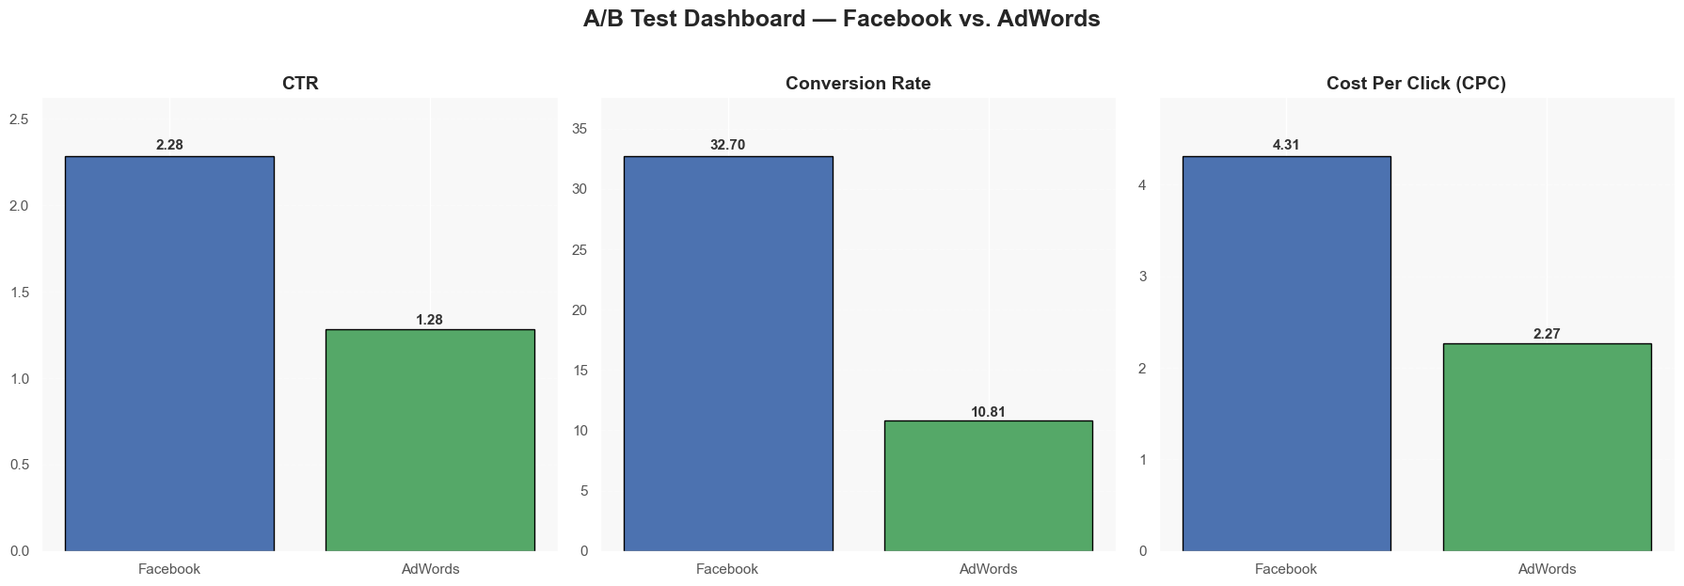
Figure 1. A/B Test Dashboard comparing Facebook and AdWords on key marketing performance metrics.

Metric Comparison Table
Metric | Facebook | AdWords | Significance (p-value)
CTR | 2.28% | 1.28% | 4.48e-111
Conversion Rate | 32.70% | 10.81% | 7.11e-165
Cost Per Click (CPC) | $4.31 | $2.27 | 2.79e-90

