Análisis de regresión

lunes, noviembre 04, 2019

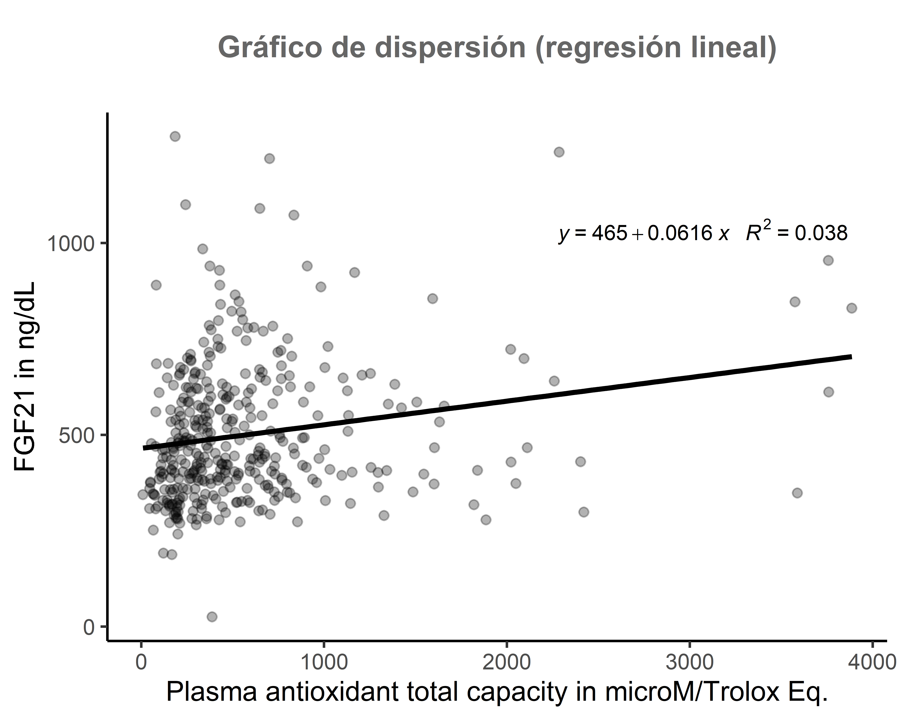

##   
## Resultados de la regresión lineal  
## ===============================================  
## Dependent variable:   
## ---------------------------  
## indep)   
## -----------------------------------------------  
## FGF21_OFICIAL 0.062***   
## (0.016)   
##   
## Constant 464.823***   
## (12.858)   
##   
## -----------------------------------------------  
## Observations 381   
## R2 0.038   
## Adjusted R2 0.035   
## Residual Std. Error 176.520 (df = 379)   
## F Statistic 14.831*** (df = 1; 379)   
## ===============================================  
## Note: *p<0.1; **p<0.05; ***p<0.01