Análisis de regresión

lunes, noviembre 04, 2019

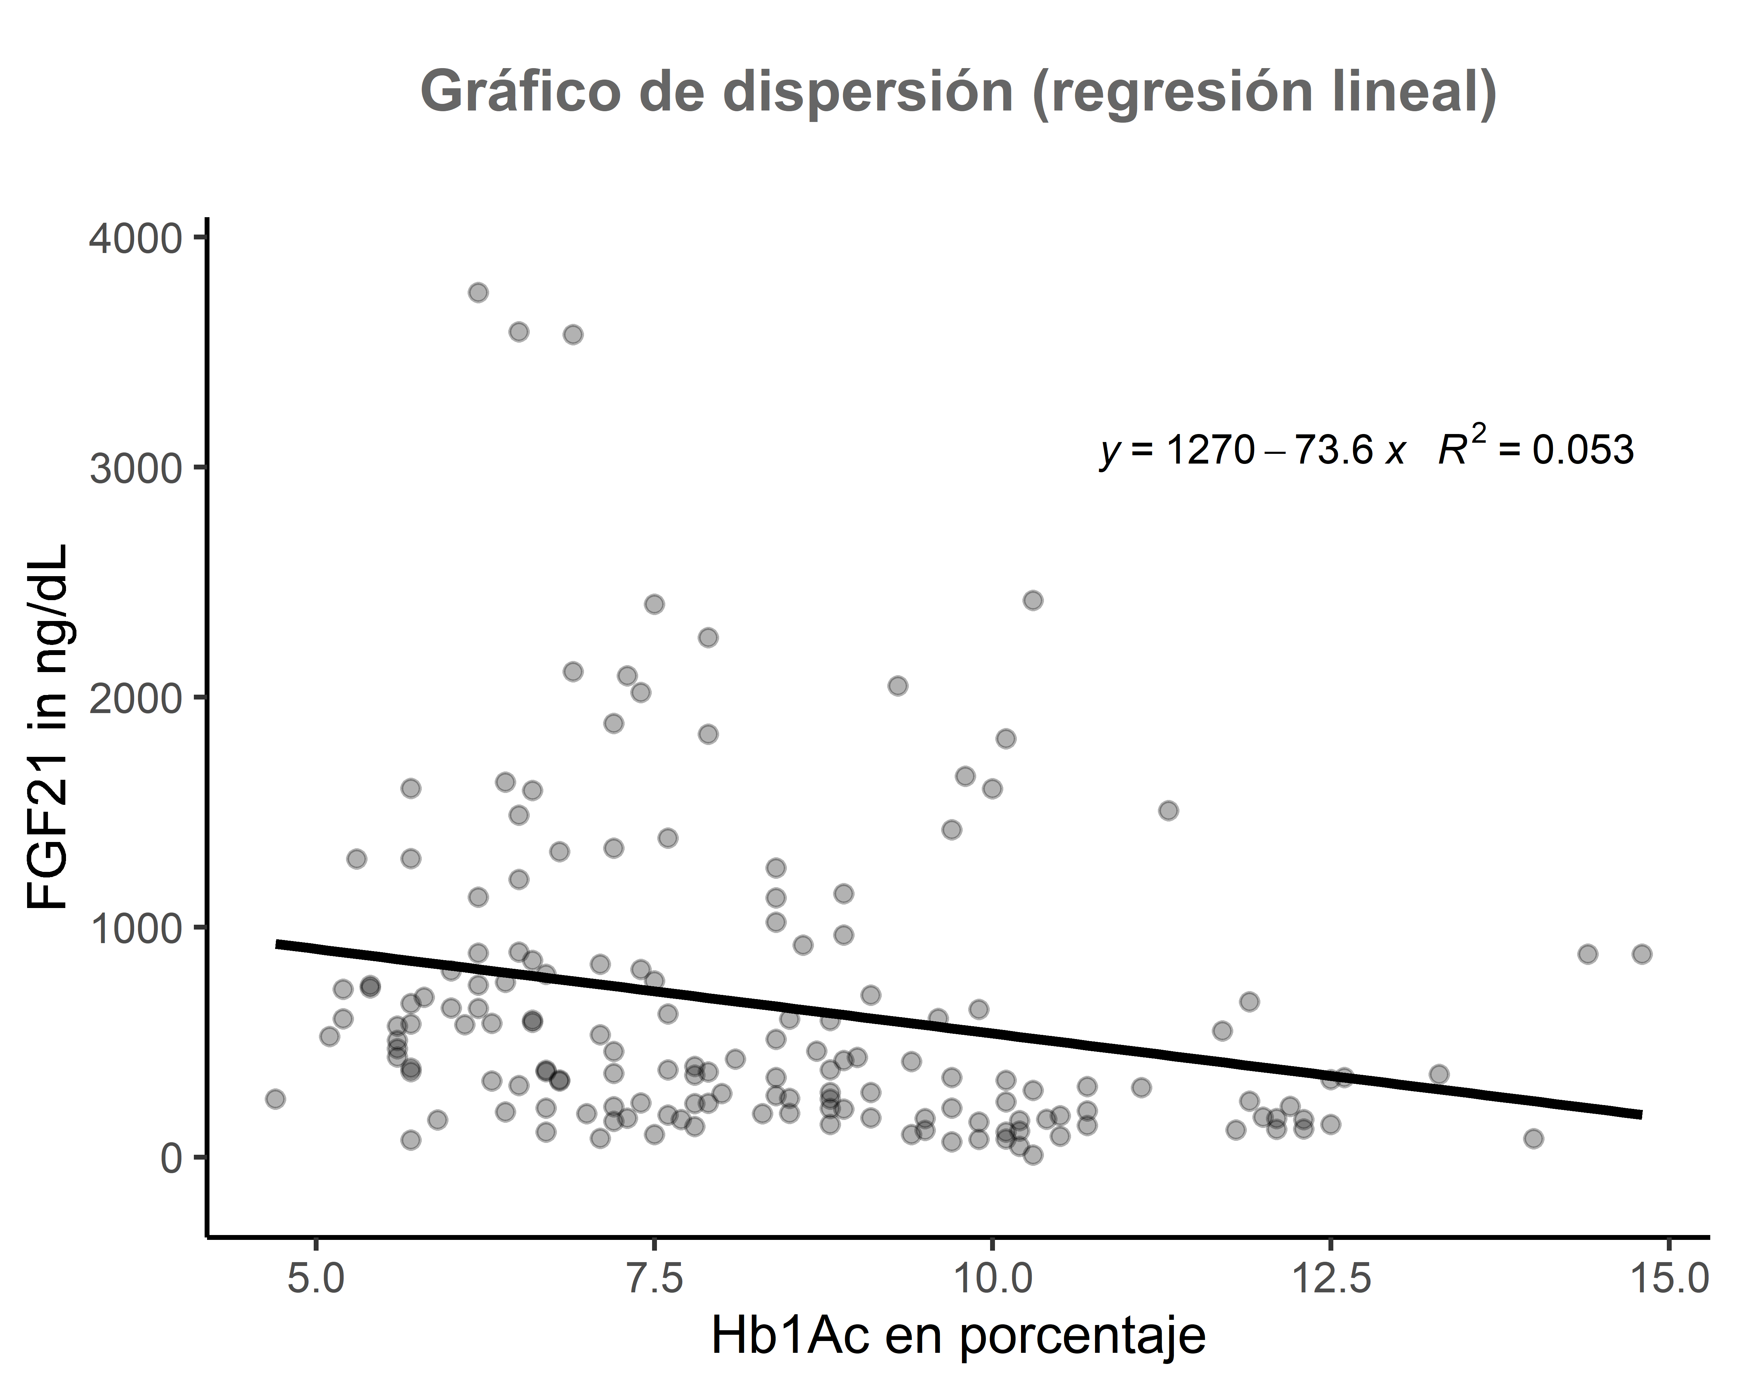

##   
## Resultados de la regresión lineal  
## ===============================================  
## Dependent variable:   
## ---------------------------  
## indep)   
## -----------------------------------------------  
## HbA1c -73.567***   
## (24.629)   
##   
## Constant 1,273.530***   
## (211.747)   
##   
## -----------------------------------------------  
## Observations 162   
## R2 0.053   
## Adjusted R2 0.047   
## Residual Std. Error 669.858 (df = 160)   
## F Statistic 8.923*** (df = 1; 160)   
## ===============================================  
## Note: *p<0.1; **p<0.05; ***p<0.01