Hada Labo Application Manual



Table of contents

Home page |  |  | 3
Start of Questionnaire |  |  | 4
Question 1 |  |  | 5
Error screen |  |  | 6
Question 2 |  |  | 7
Question 3 |  |  | 8
Question 4 |  |  | 9
Question 5 |  |  | 10
Question 6 |  |  | 11
Question 7 |  |  | 12
Result Page |  |  | 13
Product details page |  |  | 14

Home Page:



- Home screen of the application.
- Tap on START NOW button to start questionnaire.

Start of Questionnaire :

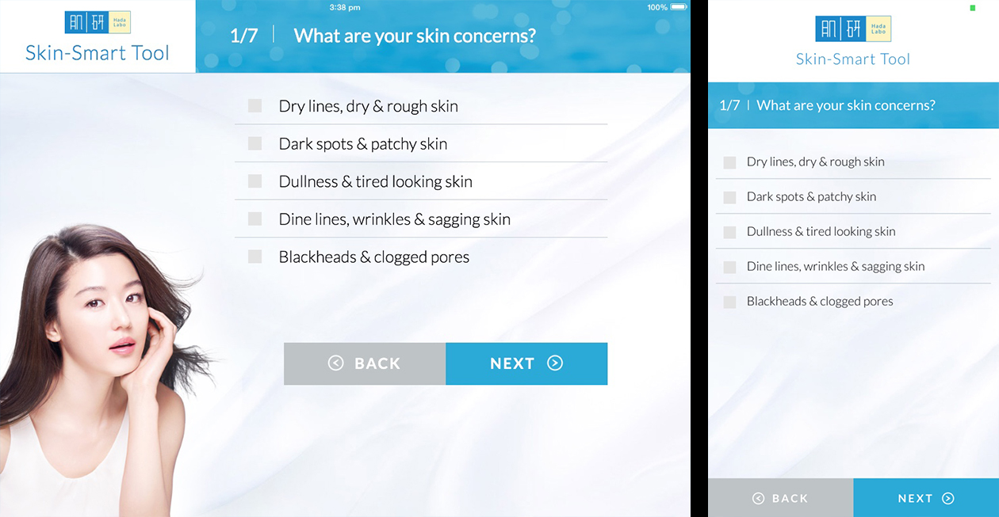

1. Once user tap on START NOW button in Home Page, application screen redirects to first question.
2. NEXT button will helpful to move on next question in sequence.
3. BACk button will helpful to go back to previous state of previous question.
Question 1, select options:

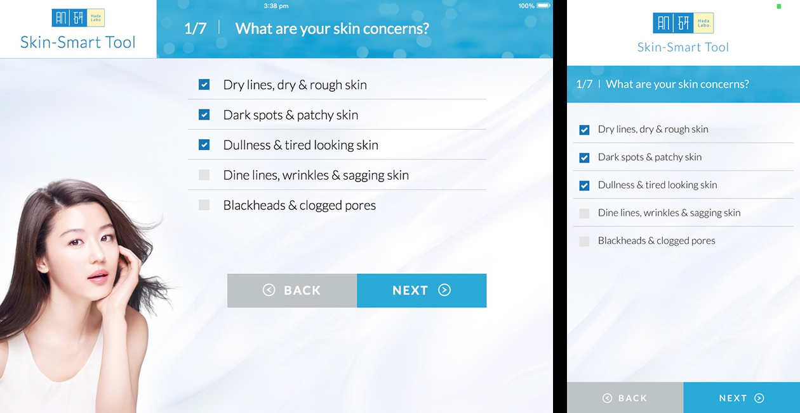

1. After selecting appropriate options for first question, tap on NEXT will redirects to second question.
2. If BACK button tapped at this stage will takes back to Home Page.

Error Screen :

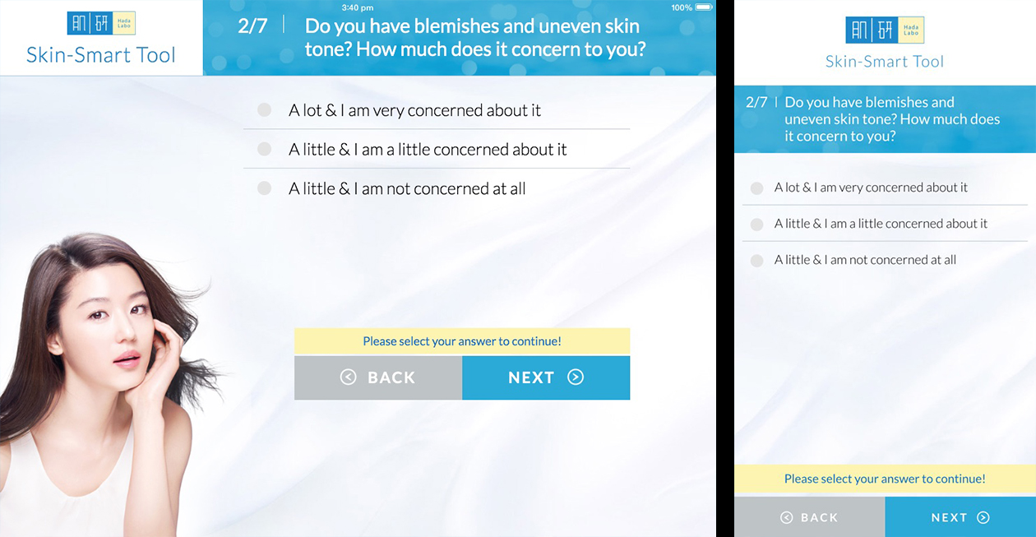

1. Clicking on NEXT button without selecting any available option, will result with error message “Please select your answer to continue!”.

Question 2:

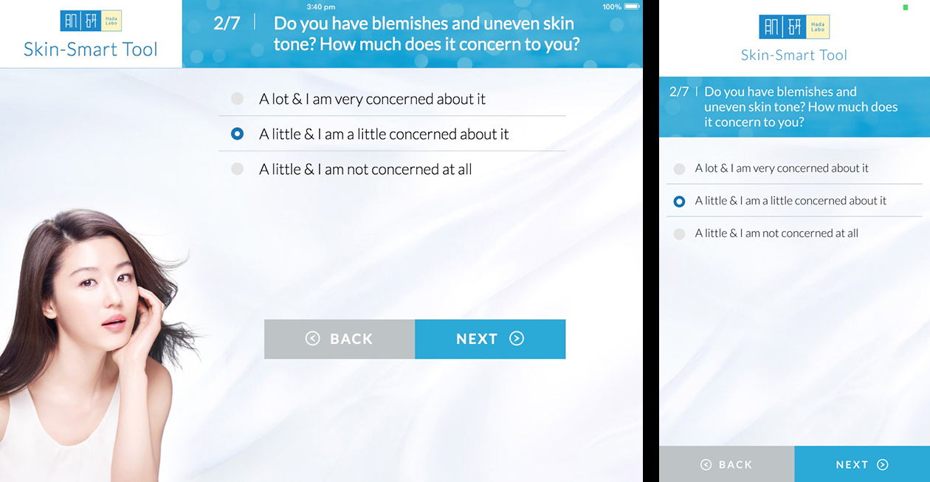

1. Select your choice on second question and tap on NEXT button will redirects to next question.
2. Tapping on BACK button will takes back to previous question, where user have option to recheck or change the selected options for previous question.

Question 3:

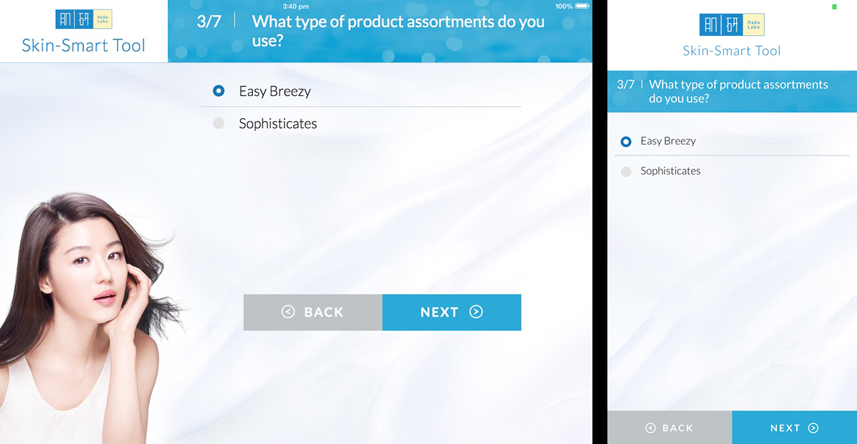

1. NEXT button will redirects to next question after successful selection of the option.
2. BACK button will redirects to previous question, where user can recheck or alter the previous selected optiions.

Question 4:

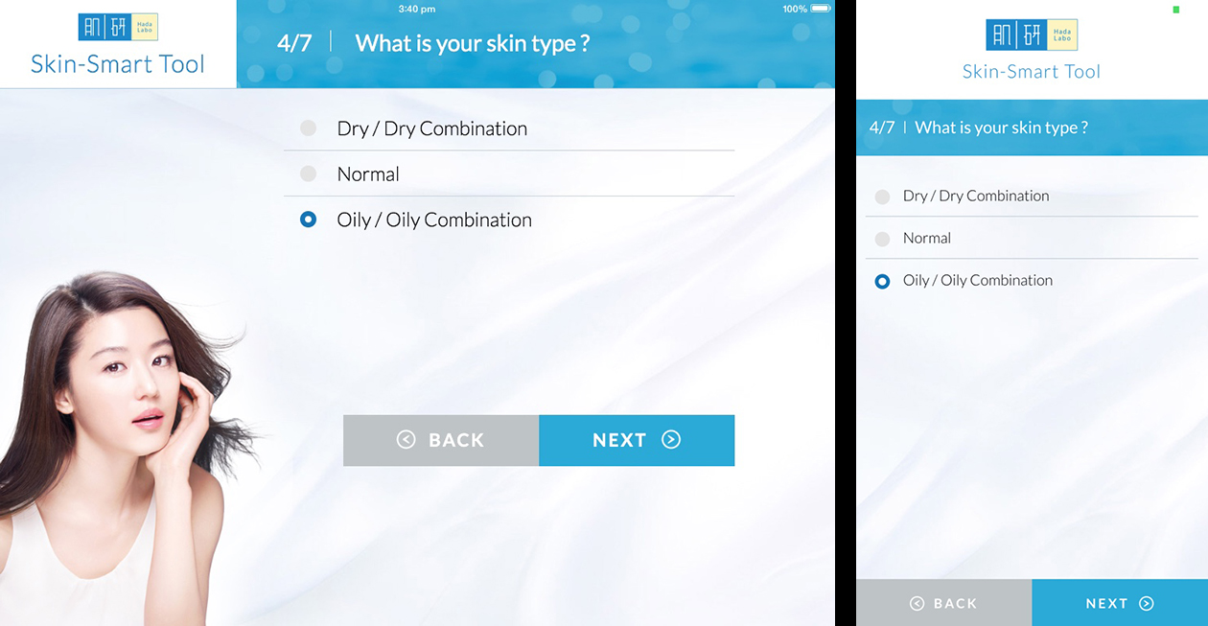

1. NEXT button will redirects to next question after successful selection of the option.
2. BACK button will redirects to previous question, where user can recheck or alter the previous selected optiions.

Question 5:

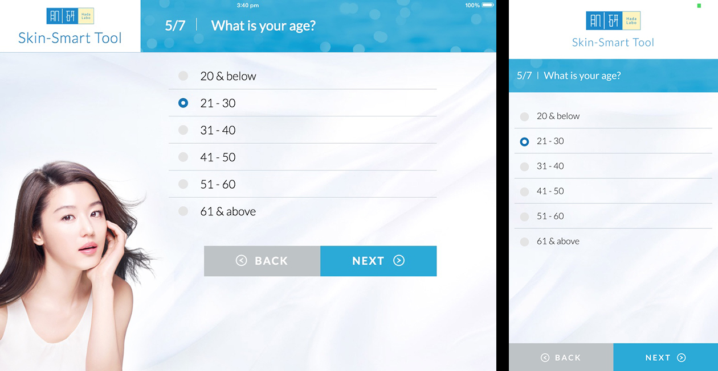

1. NEXT button will redirects to next question after successful selection of the option.
2. BACK button will redirects to previous question, where user can recheck or alter the previous selected optiions.

Question 6:

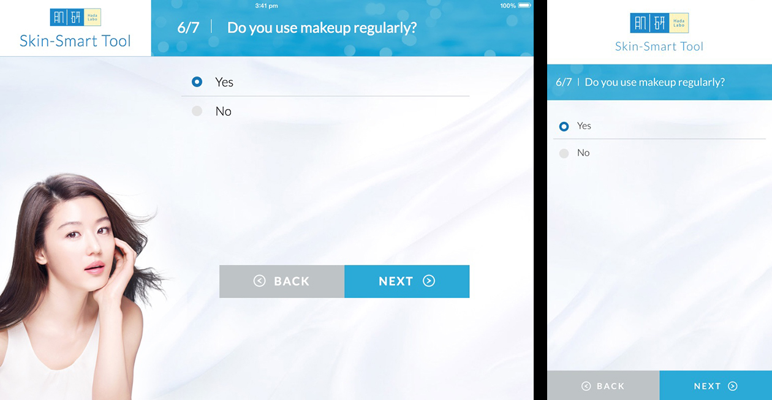

1. NEXT button will redirects to next question after successful selection of the option.
2. BACK button will redirects to previous question, where user can recheck or alter the previous selected optiions.

Question 7:

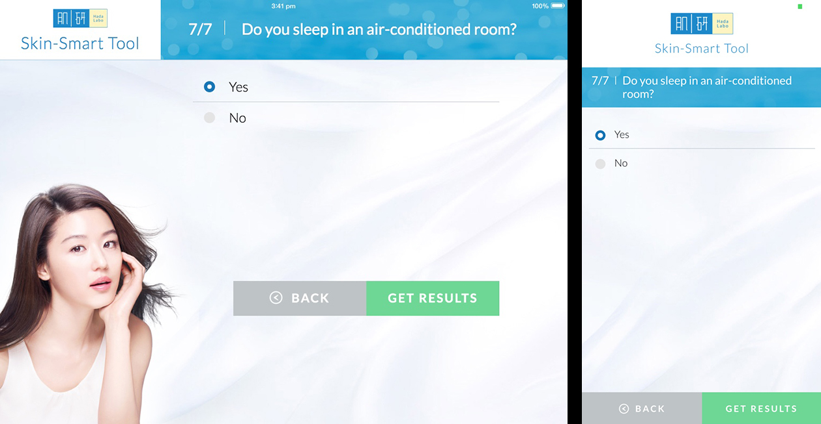

1. At last question, soon after user selects the one of the option, NEXT button will translates into GET RESULT button. Which indicates the end of questionnaire.
2. Clicking on GET RESULTS button will redirects to Result page, with suggested products and it’s details.
Result Page:

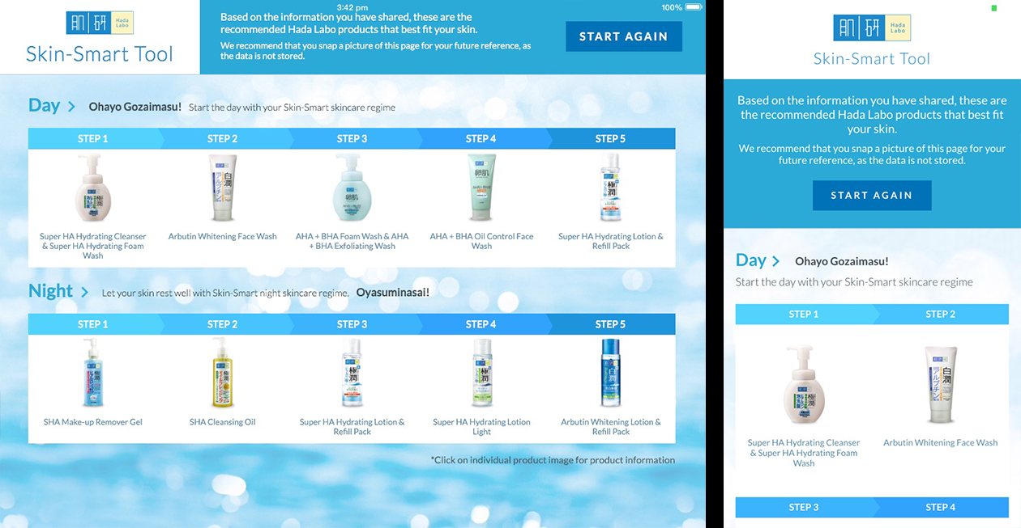

1. Results Page contains suggested products after evaluating options selected in questionnaire by user, also a button at the top read as “START AGAIN” allows to restart the questionnaire.

Product Details Page:

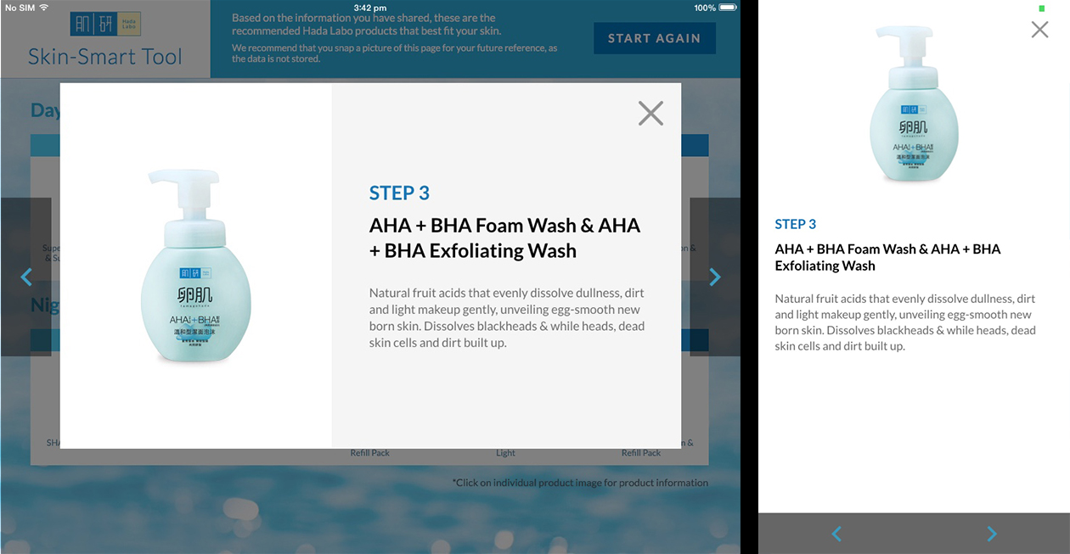

1. Taping on any product image in Result Page will opens a popup of choosen product and it’s details.
2. Navigation buttons will helps in navigating through the list of resulted products.

