Flow chart:
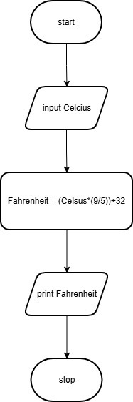
Algorithm:
- Start
- Input temperature in Celsius
- Calculate Fahrenheit using the formula:
- Fahrenheit = (Celsius × 9/5) + 32
- Print the value of Fahrenheit
- Stop

Code Tantra: 