A REPORT OF TWELVE WEEKS SUMMER INTERNSHIP

at

**ATC India Infrastructure Private Limited**

SUBMITTED IN PARTIAL FULFILLMENT OF THE REQUIREMENT FOR THE

AWARD

OF THE DEGREE OF

**BACHELOR OF ENGINEERING**

(Computer Science and Engineering)



MAY-JULY, 2019

SUBMITTED BY:

RAHUL CHANDRA

17BCS1811

DEPARTMENT OF COMPUTER SCIENCE AND ENGINEERING CHANDIGARH UNIVERSITY GHARUAN, MOHALI

**ACKNOWLEDGEMENT**

First and foremost, praises and thanks to the God, the Almighty, for His showers of blessings throughout my internship to complete the project successfully.

I would like to express my deep and sincere gratitude to my supervisor, PUSHPINDER GUPTA, Vice President, ATC INDIA, for giving me the opportunity to do project and providing invaluable guidance throughout this research.

I would also like to thanks my Mentors **Shubham Saxena** and **Amit Mohapatro** (Program Manager, ATC India) for their guidance before and throughout the project development.

I am extremely grateful to my parents for their love, prayers, caring and sacrifices for educating and preparing me for my future.

RAHUL CHANDRA (17BCS1811)

**CERTIFICATE**

This is to certify that the project entitled, submitted by RAHUL CHANDRA in partial fulfillment of the requirements for the award of be TWELVE WEEKS SUMMER INTERNSHIP in BE-CSE at the ATC is an authentic work carried out by her under my supervision and guidance.

CERTIFIED BY – PUSHPINDER GUPTA

**ABSTRACT**

The large amount of time wastage in standing in line has led to the development of this website. This project proposes the use of framework to develop website. This report provides a detailed summary of the project as part of fulfillment of the semester's Writing Project, Computer Science Department, Chandigarh University. The report includes a description of the topic, system architecture, and provides a detailed description of the work done till point. Included in the report are the detailed descriptions of the work done: snapshots of the implementations, various approaches, and tools used so far. The report also includes the project schedule and deliverable

**CANDIDATE’S DECLARATION**

I RAHUL CHANDRA hereby declare that I have undertaken 12 weeks of Summer Internship at ATC during a period from 13-05- 2019 to 12-07-2019 in partial fulfillment of requirements for the award of degree of B.E (COMPUTER SCIENCE AND ENGINEERING) at CHANDIGARH UNIVERSITY GHARUAN, MOHALI. The work which is being presented in the Internship report submitted to Department of Computer Science and Engineering at CHANDIGARH UNIVERSITY GHARUAN, MOHALI is an authentic record of Internship work.

Signature of the Student

**ABOUT CHANDIGARH UNIVERSITY**

Chandigarh University (CU) is a leading Indian Institution offering amalgamation of professional and academic excellence. Ranked among growing universities, CU has coupled the experience of top industry academicians and fosters a worldly approach.

Its students a unique Asia’s best and fastest leaders and renowned

Wide spectrum of programs paired with flexibility, experiential learning and interdisciplinary orientation emancipate our students to explore their interests and pursue fulfilling careers. At CU we are grooming students to be socially sensitive through intellectually challenging and contemporary diverse culture.

**Vision**

“To be globally recognized as a Centre of Excellence for Research, Innovation, Entrepreneurship and disseminating knowledge by providing inspirational learning to produce professional leaders for serving the society”

**Mission**

* Providing world class infrastructure, renowned academicians and an ideal environment for Research, Innovation, Consultancy and Entrepreneurship.
* Creating Curriculum to match international standards along with comprehensive Internship and inculcation of Human and Ethical values to meet the needs of industry and civil society.
* Creating a scientific, Transparent and Impartial Examination/Evaluation system to ensure an ideal certification.
* Establishing strategic relationship with leading National & International corporate and universities for academic as well as research collaborations.
* Undertaking ISR activities for women empowerment, upliftment of rural/deprived sections of the society and socially relevant research.

**Quality Policy**

* All round quality is assured through professional management of the University.
* Academic quality is assured through regular up gradation of curriculum, teaching

learning model and experiential learning with Industry participation, based on continuous critical self-appraisal.

* Traits of Critical Analysis, Creative Thinking & Communication Skills are inculcated among students for producing well-groomed professional leaders, possessing multifaceted personality, respect for professional & social ethics, national values, and the spirit of human emancipation.

**DEFINITIONS, ACRONYMS AND ABBREVIATIONS**

* **DFD(DATA FLOW DIAGRAM)**

A data-flow diagram (DFD) is a way of representing a flow of a data of a process or a system (usually an information system). The DFD also provides information about the outputs and inputs of each entity and the process itself.

* **ER DIAGRAM(ENTITY RELATIONSHIP DIAGRAM)**

Entity Relationship Diagram, also known as ERD, ER Diagram or ER model, is a type of structural diagram for use in database design. An ERD contains different symbols and connectors that visualize two important information: The major entities within the system scope, and the inter-relationships among these entities.

* **UML DIAGRAMS(UNIFIED MODELLING LANGUAGE)**

A UML diagram is a diagram based on the UML(Unified Modeling Language) with the purpose of visually representing a system along with its main actors, roles, actions, artifacts or classes, in order to better understand, alter, maintain, or document information about the system.

* **OS(OPERATING SYSTEM)**

An operating system (OS) is system software that manages computer hardware and software resources and provides common services for computer programs.

* **GUI(GRAPHICAL USER INTERFACE)**

The graphical user interface is a form of user interface that allows users to interact with electronic devices through graphical icons and visual indicators such as secondary notation, instead of text-based user interfaces, typed command labels or text navigation.

**CHAPTER 1 INTRODUCTION**

* 1. **ABOUT SYSTEM**

It is an web based application which is basically used to add/delete/update/edit the details the Book Details/Member Details/Librarian details. It runs basically on the browser like Firefox, Google Chrome, Internet Explorer and Edge.

1. To create a Library Management Portal (Booktique**)** which will be going to solve the problem for the Librarian to issue the book and return the book.
2. It will also help the company to find how many of them are thrive to learn and read about the employee.
3. It will also give them the statistical report according to the different parameters in the bar chart, line chart, box chart and pie chart.
4. It will reduce the manual work by the long term thinking of how to reduce the stress from the user.

**1.2 TECHNOLOGY USED**

**JSP:**

Architecturally, JSP may be viewed as a high-level abstraction of Java Servlets. JSPs are translated into servlets at runtime, therefore JSP is a Servlets; each JSP servlets is cached and re-used until the original JSP is modified. JSP can be used independently or as the view component of a server-side model view controller design, normally with Java Beans as the model and Java servlets (or a framework such as Apache Struts the controller.

**HTML:**

HTML (Hypertext Markup Language) is the most basic building block of the Web. It defines the meaning and structure of web content. Other technologies besides HTML are generally used to describe a web page's appearance/presentation (CSS) or functionality/behavior (JavaScript).

**CSS:**

Cascading Style Sheets is a style sheet language used for describing the presentation of a document written in a markup language like HTML. CSS is a cornerstone technology of the World Wide Web, alongside HTML and JavaScript.

**JAVASCRIPT:**

JavaScript, often abbreviated as JS, is a high-level, interpreted programming language that conforms to the ECMAScript specification. JavaScript has curly-bracket syntax, dynamic typing, prototype-based object-orientation, and first-class functions.

**MYSQL:**

MySQL is an open-source relational database management system. It is a structured query language used to create, insert and deleted table according to the needs and its workings.

**AJAX:**

Ajax is a set of web development techniques using many web technologies on the client side to create asynchronous web applications. With Ajax, web applications can send and retrieve data from a server asynchronously without interfering with the display and behavior of the existing page

**1.3 PURPOSE:**

This specification design document will detail the design of website for the selecting the most preferred language.

* To bring down the hassle to manually issue the book to member of the library.
* Ease the process to read and issue books by the members.
* Generating the reports(like Bar Chart, Pie Chart) going to help the Admin/ Company Management to find out the learning curve of the Team Member without any kind of the manual work.

**1.4 DOCUMENT CONVENTION**

While writing this design document it was inherited that all requirements have the same priority.

First an overview of the system is presented and then all features and functions are analyzed in detail.

**1.5 INTENDED AUDIENCE AND READING SUGGESTION**

Development: In order to be sure that our team is developing the right project that fulfill requirements provided in this document. In order to have an exact list of the features and functions that are required to respond according to requirements and provided diagrams

.Our team will get familiar with the idea of the project and suggest other features that would make it even more functional.

Users: In order to know exactly what they have to expect from the system right inputs and outputs and response in error situations.

Testers understand how java/jsp and html is supposed to work properly and identify bugs and error easier.

This document could be studied by the program developers, so they have the chance to identify and alter possible points which need improvement. Also, they can fully understand the nature of the program and implement new features. It is recommended to comprehensive study of the document for the full understanding of the program and to avoid errors.

**1.6 PROJECT SCOPE:**

It is an online website. It is build using HTML, CSS, JAVASCRIPT, BOOTSTRAP, JSP – Ajax, MySQL. It allows some amount of traffic currently. It supports local hosting feature also. Next chapters will allow a lot of traffic very easily.

**2. OVERALL DESCRIPTION**

It is a JSP based website so fundamental features related with TOMCAT server, JSP/Ajax libraries and MySQL data base determine the software requirements of that project.

**2.1 PRODUCT PERSPECTIVE**

The belongs to website category. These are the minimum requirements that are needed to run and built.

* OS: Linux, Mac, Windows XP
* RAM: 512MB
* Eclipse IDE
* Disc Space: 50MB
  1. **PRODUCT FEATURE**

It provides several options for the user.

* Simple website
  + Full support for all image formats
  + Shop owner user type option
  + Customer user type
  + option Show item option
* Cart option
  + Unlimited buying
  + option Order option
  + Account inform
  + features Secure Payment option

Add or remove items

**2.3 USER CLASSES AND CHARACTERISTICS**

Users that intend to buy or sell products. These users could be of any age, with no special knowledge. Knowing how to use a website is an essential.

User can also maintain their account information

Programmers- Software Developers –Open Source project participants of any age that could understand the program’s source code and expand or improve it. Must have knowledge of the programming language that the software is written in, in order to be able to understand exactly what it does and how it does it. Also some experience on programming will most certainly help on extending or improving the project.

**2.4 DESIGN AND IMPLEMENTATION CONSTANT**

This website is designed in HTML, CSS, JAVASCRIPT, BOOTSTRAP, JSP, MySql and using Ajax/Google Charts/JSON libraries which makes it simple and user friendly. It uses MySql to store the data into database. Every time users have to login themselves, firstly they have to signup first.

1. **SYSTEM FEATURES**

**3.1 FUNCTIONAL REQUIREMENTS**

Login/Signup: This feature will help user to proceed forward into the website.

Add items: This feature helps bakery owner users to add bakery item in their list.

Order: This feature helps bakery owner user to track the orders made by the users.

Show items: This feature help user to get show all the different items present on that website.

Cart: This feature shows which items they have selected to buy.

1. **EXTERNAL INTERFACE REQUIREMENTS**

**4.1 USER INTERFACE**

The system must provide a user interface for all types of users that is available through all Web browsers.

**4.2 HARDWARE INTERFACE**

There are no hardware interfaces to this website. The only interfaces are through a computer system. does not require additional material to run. The only peripheral equipment is the keyboard and the mouse.

**4.3 SOFTWARE INTERFACE**

* OS: Linux, Mac, Windows, Android
* Web Browser: such as Chrome, Firefox and Internet explorer.

1. **NON-FUNCTIONAL REQUIREMENTS:**

**5.1 PERFORMANCE REQUIREMENTS**

It requires a small amount of disk space. It is characterized by fast loading and executing times. It‘s not a heavy program and it can works while other programs are running.

**5.2 SAFETY REQUIREMENTS**

There are no specific safety requirements as cannot make user’s computer malfunction in any way. The only safety requirement is to upload your contact safely.

**5.3 PORTABILITY**

1. The system must be able to run on Windows systems.
2. The system must be able to run on Macintosh systems.
3. The system must be able to run on UNIX systems.
4. The code should be readable, well commented, and maintainable.

**5.4 MAINTAINABILITY**

Maintainability is very important for this system because another group will be maintaining it. Therefore, it is very important that all programmers comment their code anytime something is unclear. Eclipse IDE helps in maintaining the readability of code with proper indentation made automatically on it; therefore the code is guaranteed to be more readable.

**1.4 UML DIAGRAMS**

**1.4.1 USE CASE DIAGRAM:**

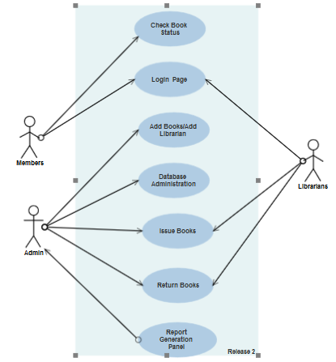

**1.4.2 SEQUENCE DIAGRAM:**

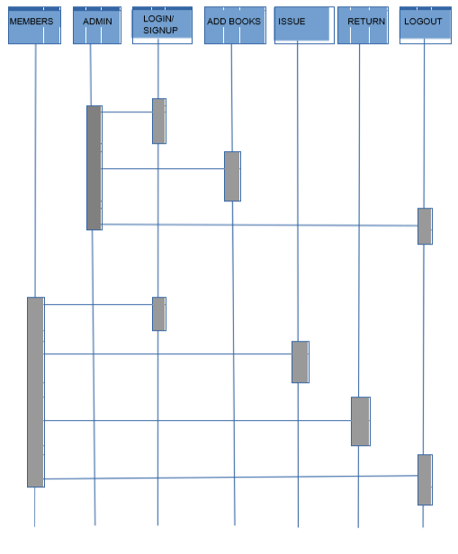

**1.4.3 DATA FLOW DIAGRAM:**

1. **Book Section:**

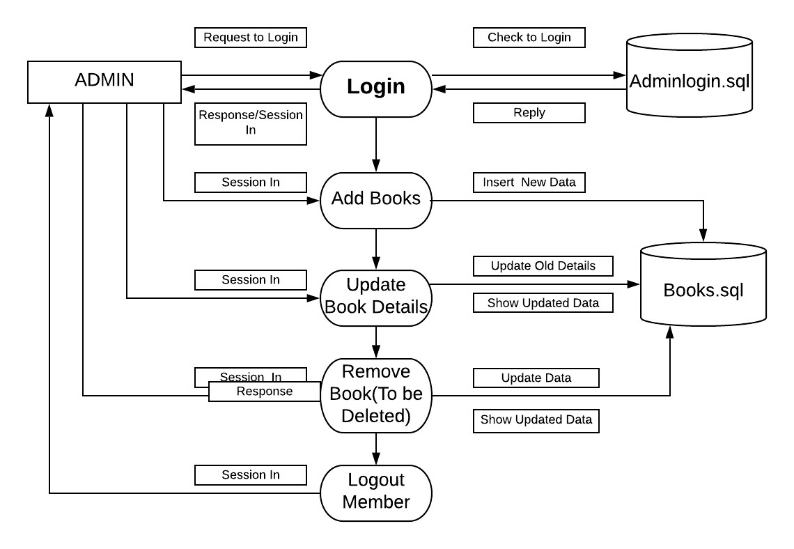

1. **Member Section:**

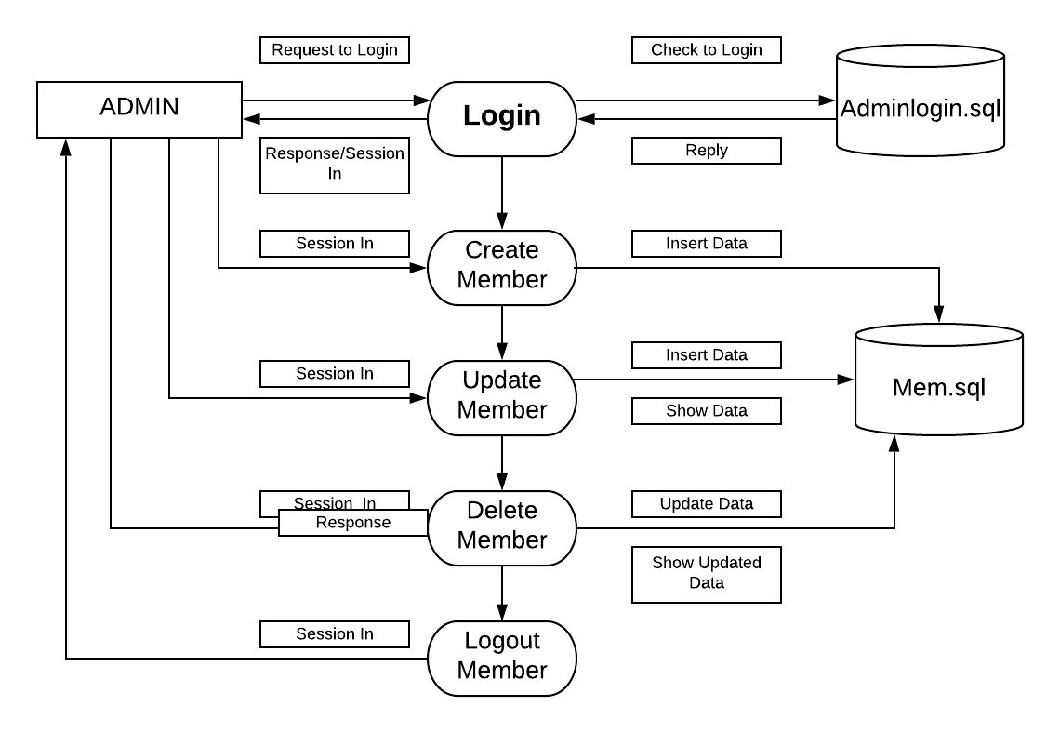

1. **Transaction Section:**

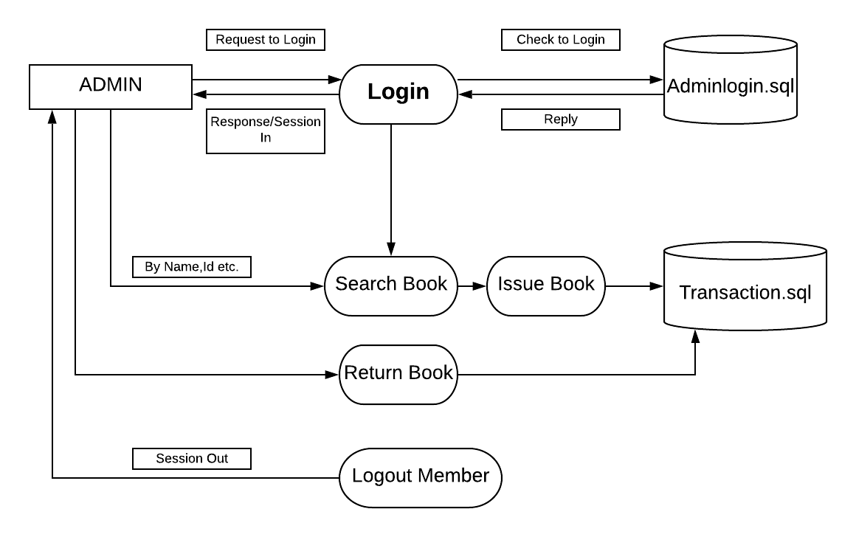

**1.4. SYSTEM FLOW DIAGRAM:**

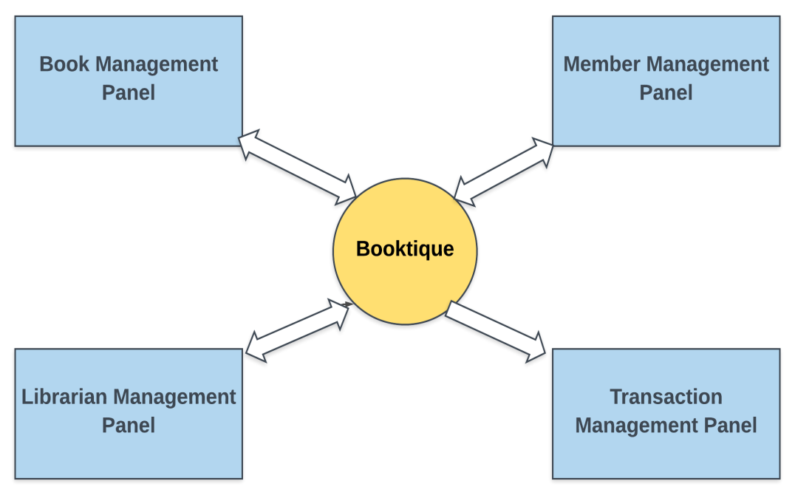

**PROJECT INFORMATION**:

**Project Goals:**

1. To create a Library Management Portal (Booktique**)** which will be going to solve the problem for the Librarian to issue the book and return the book.
2. It will also help the company to find how many of them are thrive to learn and read about the employee.
3. It will also give them the statistical report according to the different parameters in the bar chart, line chart, box chart and pie chart.
4. It will reduce the manual work by the long term thinking of how to reduce the stress from the user.

**The Booktique:**

**Project Abstract:**

**About Project:**

**ATC LIBRARY MANAGEMENT SYSTEM:** This project will be going to prove as a permanent solution for the LMS of ATC,through which the member (permanent/contractual), librarian and admin could work parallel without interruption of each other. It will also reduce the burden from both the Administrative Side and Member Side for issuing the book.

After of it the user will be able to generate some kind of the visualized report on the basis of different constraints like according to book demand (on the basis of author, publisher year, publisher name and others.)

**Situation before Booktique:**

Till now, the Librarian work was totally dependent on the Excel sheets and he/she had to manually maintain the data of the book issued/returned/added and also needed to take care of who are the members or not. Through this the Librarian are not aware of the more important task.

**Proposed Timeline and Objective:**

This is a tentative list of objective or overview, I am planning to achieve in the given time frame. There could be situations in which project may get delayed or get early completion. I had already planned to handle such situation with the help of a **buffer week** in which I will be going to do the documentation and testing part both so that whole project is in a good format all through.

**Week 1**

**Community Bonding Period**

**(13 May-18 May)**

* In this period I was first introduced with the team of ATC and got to meet my mentors and learnt about how Corporate works and plans before Project Commencement.
* Got to know about the requirement specification for the Project (Booktique).
* After of it I had tried to find more information through meetings and sessions with my mentors Amit Sir and Shubham Sir.

**Week 2**

**First Milestone**

**(19 May-25 May)**

* Created a dummy prototype with Java Swing and Palette, to find how Java works on the client side without any integration of Server.
* Learnt about the JSP configuration through Eclipse IDE and was also introduced with MySQL and Javascript Basics.
* Learnt how to do the configuration of Tomcat Server Version 9.0 with Eclipse, to run the project on Google Chrome, Firefox and Microsoft Edge.
* Created a Basic SRS Report and Database Table Report, which will be used to check required columns and data types used during the Project Development.

**Week 3**

**Second Milestone**

**(26 May-2 June)**

* Created 2 **modules** (Login Page and Home Page) in JSP.
* Created the database in MySQL through Command Line Client.
* With the help of mentors we were be able to set the basic layout of Project to find how it will be going to work.
* With session we had created the frameworks for the MySQL Database **Librarian** and find the different requirements before entering the data on it.

1. **June-4 June Phase 1 Evaluation**

**Week 4**

**Third Milestone**

**(4 June –18 June)**

* On the basis of First Evaluation, I had changed and added some more columns to the database according to the SRS for better data processing and entering.
* Add some animation features like Modal Box(Pop Up Box), Edit and Delete Records on the Add Book, Add Librarian, Add Member page, so that it will looks nice and good.
* Completed the 3 out of 4 modules like Book, Librarian, Members and added all the configuration to it with the help and support from the Mentors.

**Week 5**

**Fourth Milestone**

**(19 June- 12 July)**

* Add the features to download Static Report File(CSV file) through a button in the C: directory automatically of the PC/Laptop which will help them to easily work on the data without any hassle.
* Looking forward to change the Book Table both in MySQL and JSP to reduce data redundancy and making easier for the Librarian to update the quantity for the same book of same author but with different ISBN no and Publishing Year, it will help us to easily reduce the data redundancy
* Unit Testing, Integration Testing and Regression Testing had taken place in the **Fourth Milestone.**
* Deliver the final presentation to the **Pushpinder Sir** regarding the final presentation and working of the project.

**12 July**

**Phase 2 Evaluation Completed/Project Submission Completed**

**SCREENSHOTS:**

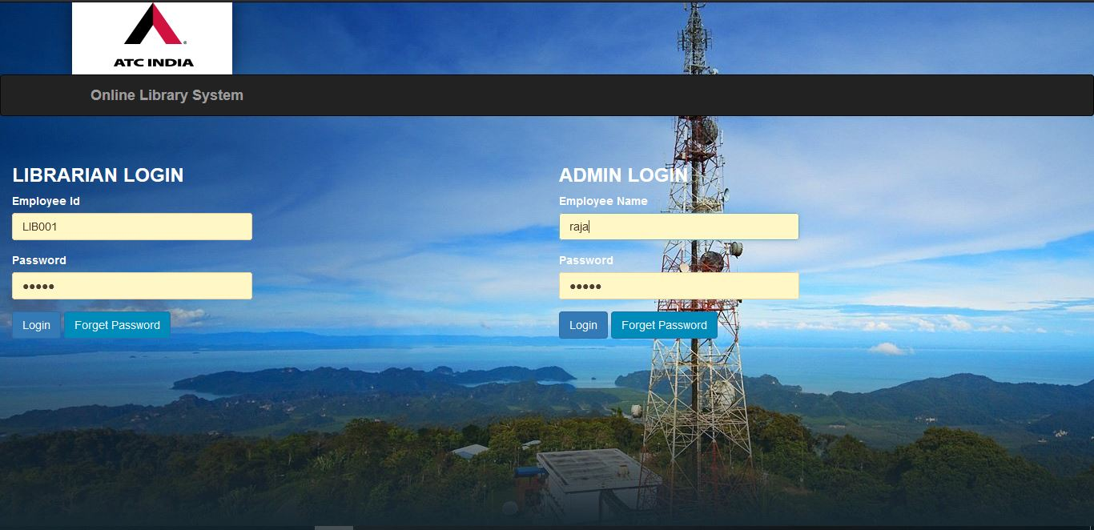

**Advance Features Implemented:**

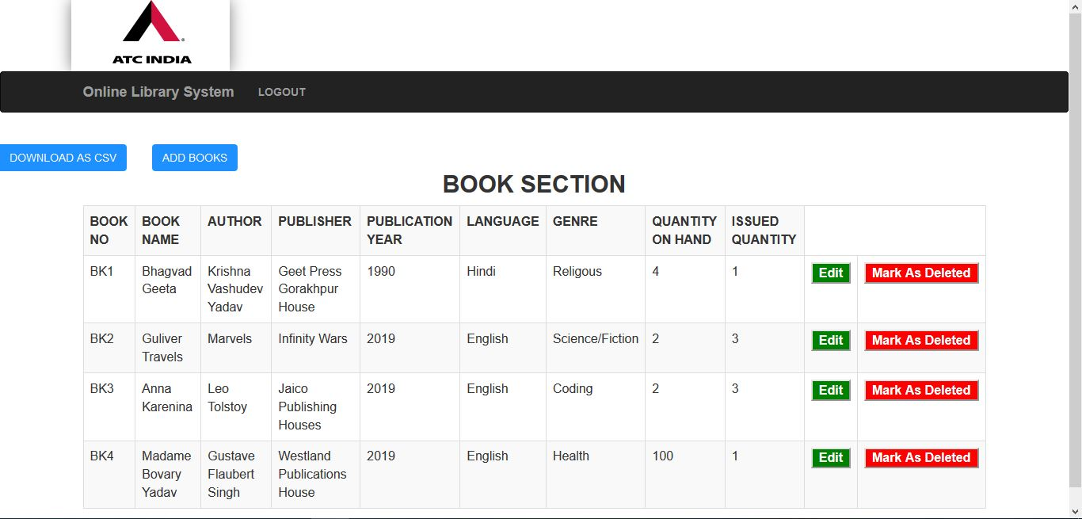

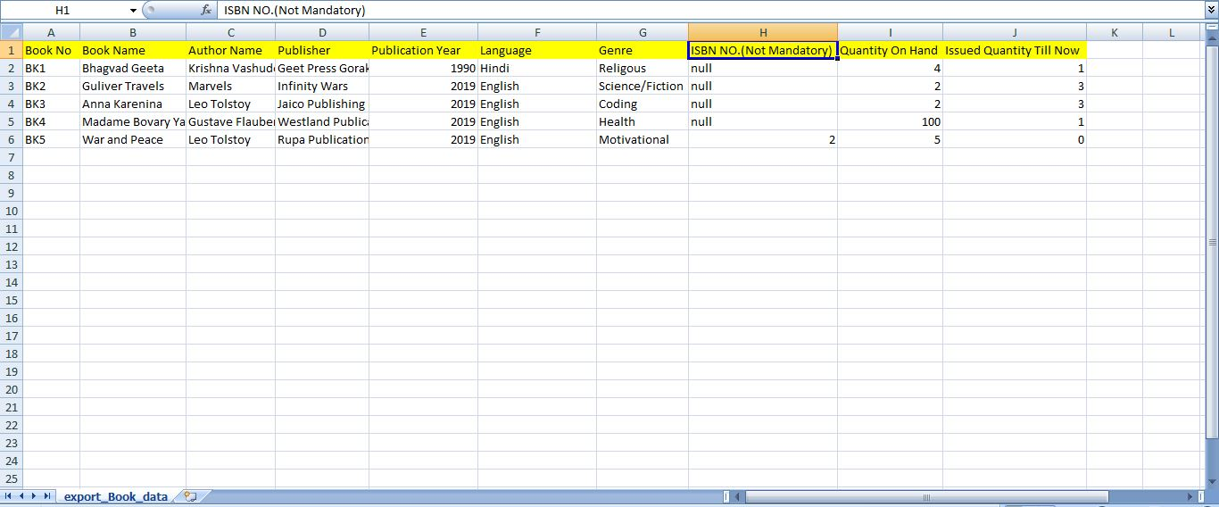

**Dynamic Modal Box Using Bootstrap for Add Modules:**

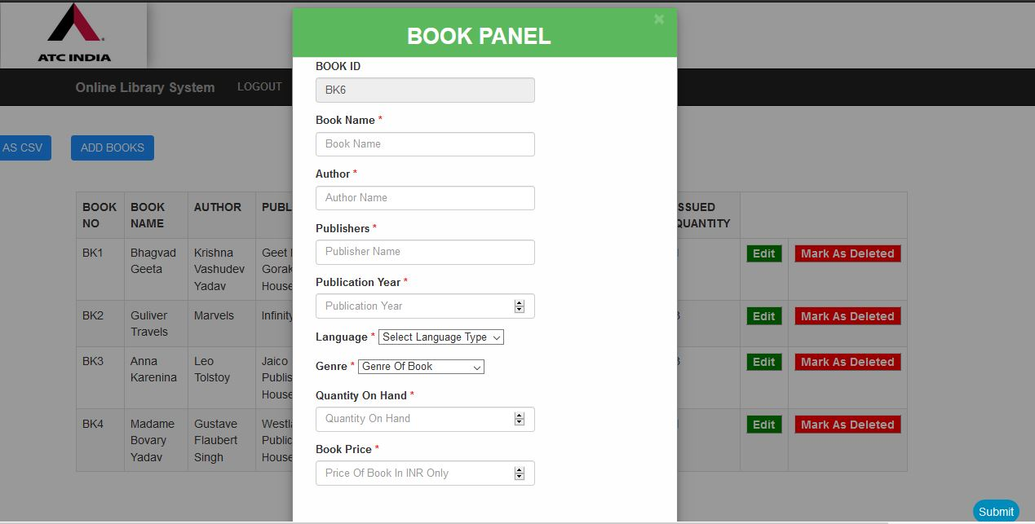

**Search Panel for Dynamic Searching:**

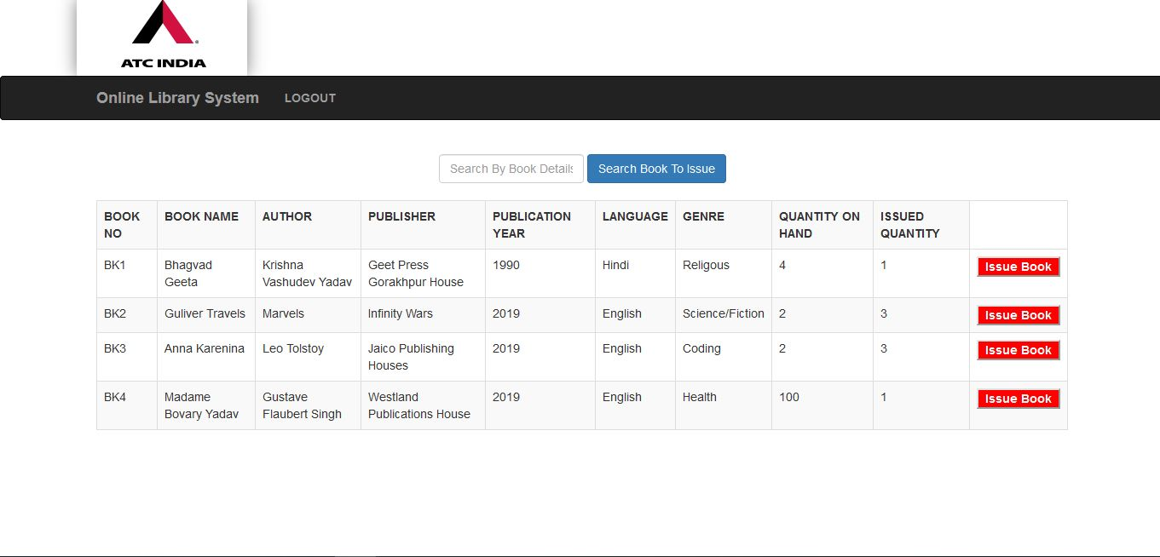



#### Admin Panel(After Login):

[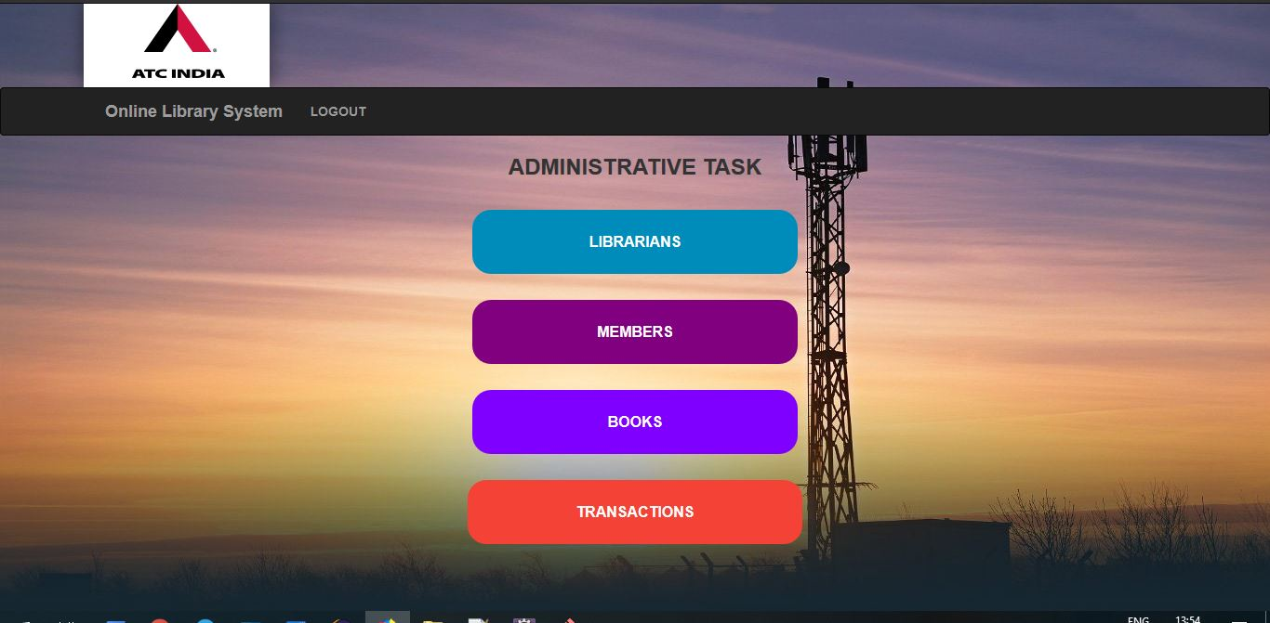](https://github.com/irahulcse/ATC-Booktique/blob/master/screenshots/adminpanel.JPG)

#### Book Section:

[](https://github.com/irahulcse/ATC-Booktique/blob/master/screenshots/bookpanel.JPG)

#### Bootstrap based Add Book Pop Up:

[](https://github.com/irahulcse/ATC-Booktique/blob/master/screenshots/addbook.JPG)

#### Delete Book Confirmation Box:

[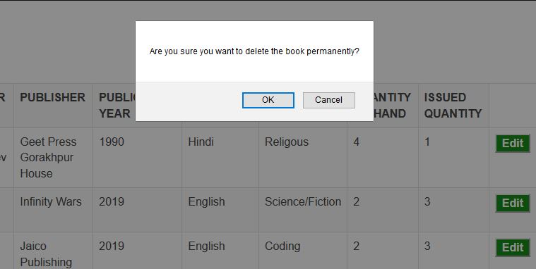](https://github.com/irahulcse/ATC-Booktique/blob/master/screenshots/deletemessage.JPG)

#### Member Section:

[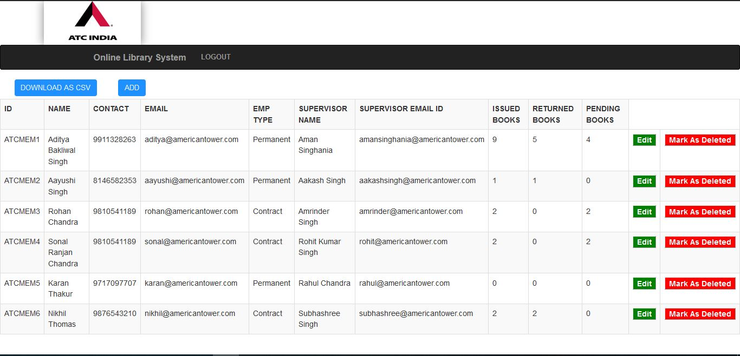](https://github.com/irahulcse/ATC-Booktique/blob/master/screenshots/mempanel.JPG)

#### Update Member Details within the defined constraints as shown below:

[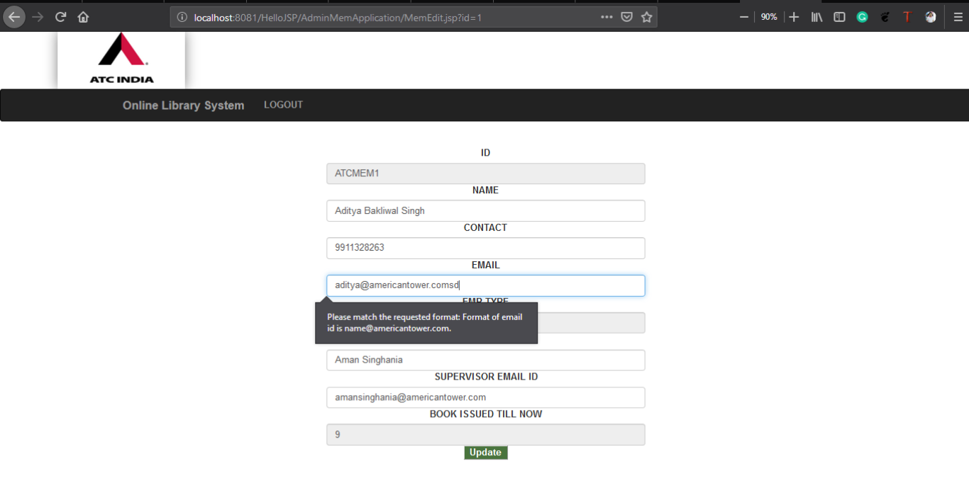](https://github.com/irahulcse/ATC-Booktique/blob/master/screenshots/memedit.png)

#### Already Issued Book Section:

[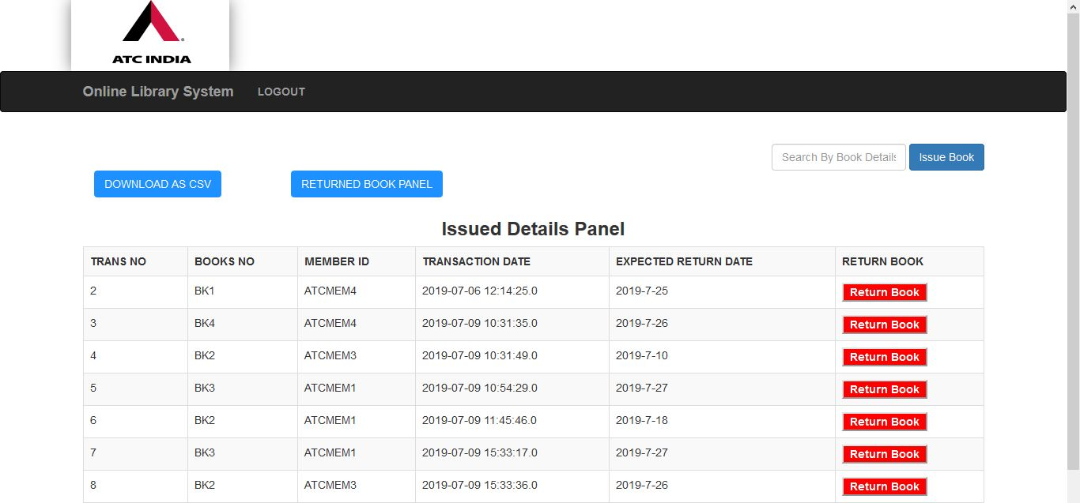](https://github.com/irahulcse/ATC-Booktique/blob/master/screenshots/memapplication.JPG)

#### Search Book Section/ Issue Book Confirmation:

[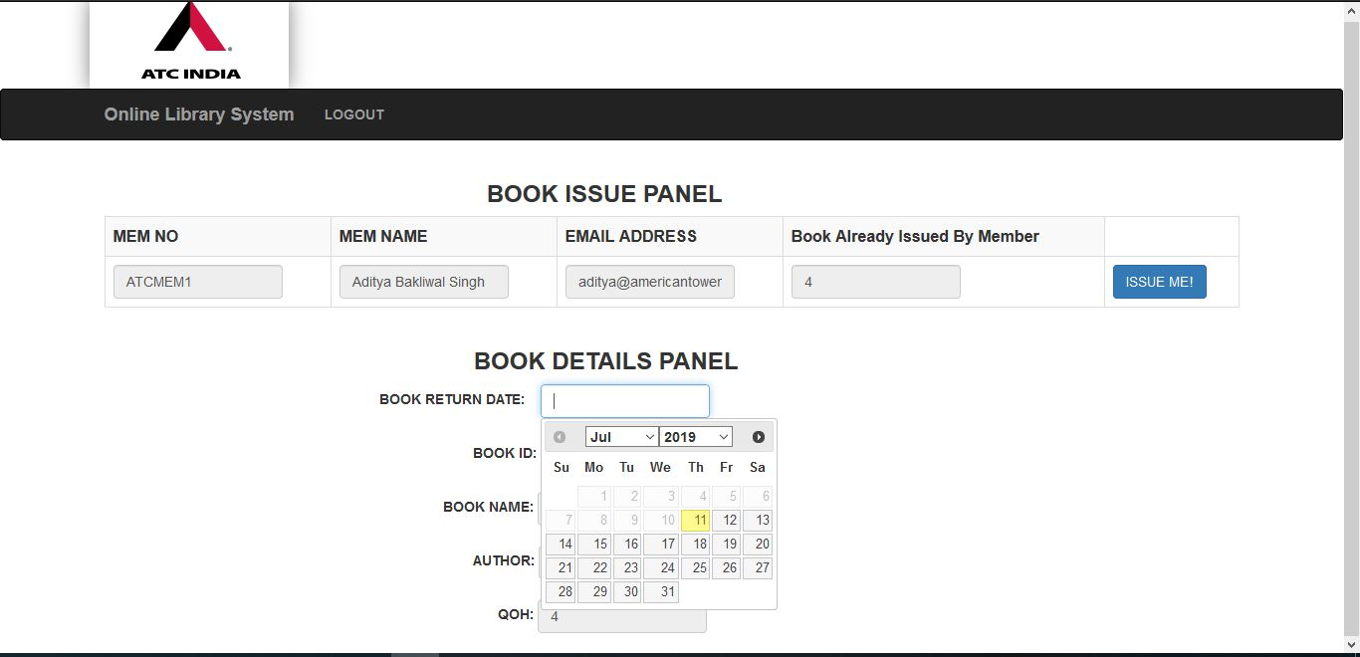](https://github.com/irahulcse/ATC-Booktique/blob/master/screenshots/issuebook.JPG)

#### Search Employee Section:

[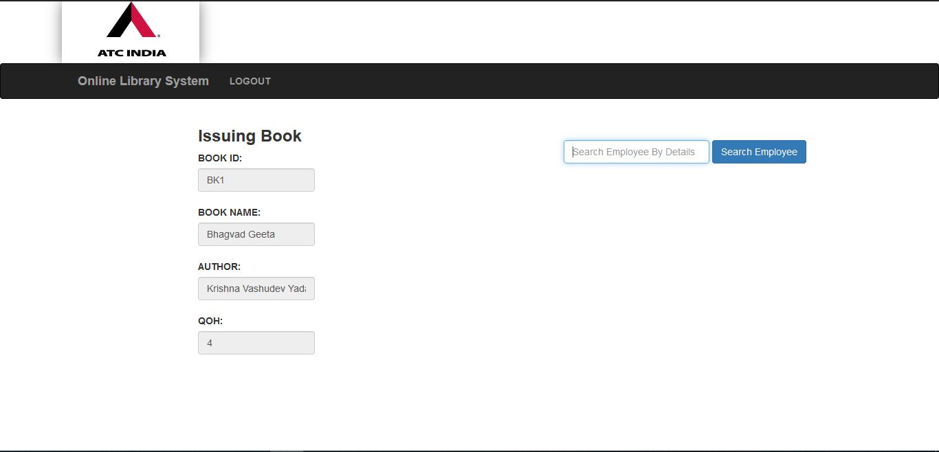](https://github.com/irahulcse/ATC-Booktique/blob/master/screenshots/searchemployee.JPG)

#### Returned Book Section(Already Returned Book):

[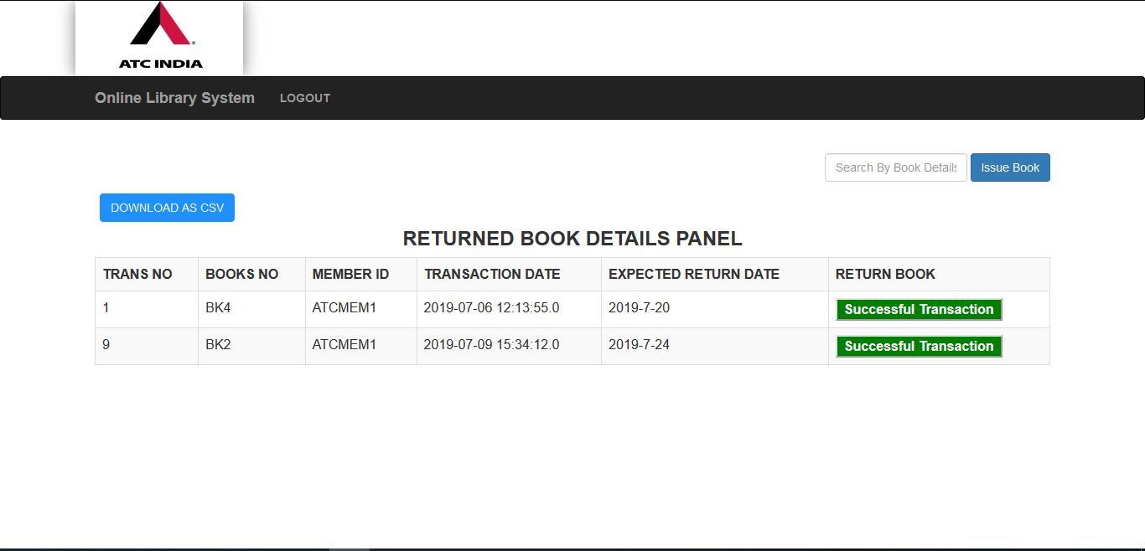](https://github.com/irahulcse/ATC-Booktique/blob/master/screenshots/returnedbookapplication.JPG)

#### Forget/Reset Admin and Librarian Password:

[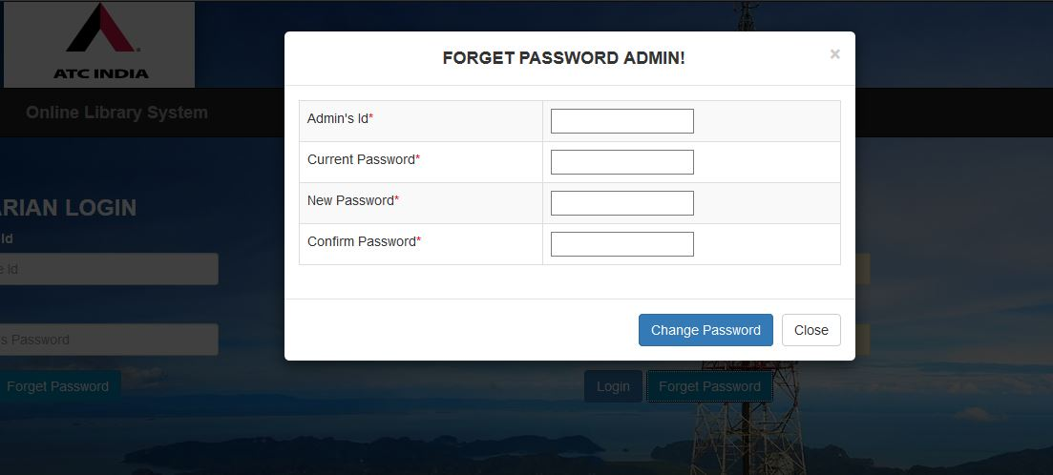](https://github.com/irahulcse/ATC-Booktique/blob/master/screenshots/forgetpasswordadmin.JPG)

#### Exported Records in Local System:

[](https://github.com/irahulcse/ATC-Booktique/blob/master/screenshots/exportbook.JPG)

**CHAPTER 4 FUTURE SCOPE**

**4.1 FUTURE SCOPE**

The future prospect as follows:

1. Improvisation in code so that the web app can handle more traffic easily.
2. Making web app more attractive.
3. Fix bugs

**References:**

1. [W3 School For Basic HTML and CSS.](https://www.w3schools.com/)
2. [JavaTPoint for the JSP and MySql based integeration and problems.](https://www.javatpoint.com/)
3. Q&A regarding the project and bugs [fixes](https://www.google.com/url?sa=t&rct=j&q=&esrc=s&source=web&cd=1&ved=2ahUKEwj4tqbfxejiAhXFeisKHfhKAr4QFjAAegQIVhAC&url=https%3A%2F%2Fstackoverflow.com%2F&usg=AOvVaw0C-i47dSU_h02E_IQoAztO)[.](https://www.youtube.com/watch?v=5-ptp9tRApM)
4. [Youtbe for finding the integeration of different visualisation through JSON in JSP.](https://www.youtube.com/watch?v=5-ptp9tRApM)