**day-009-29-jan-loops-and-pattern-programs**

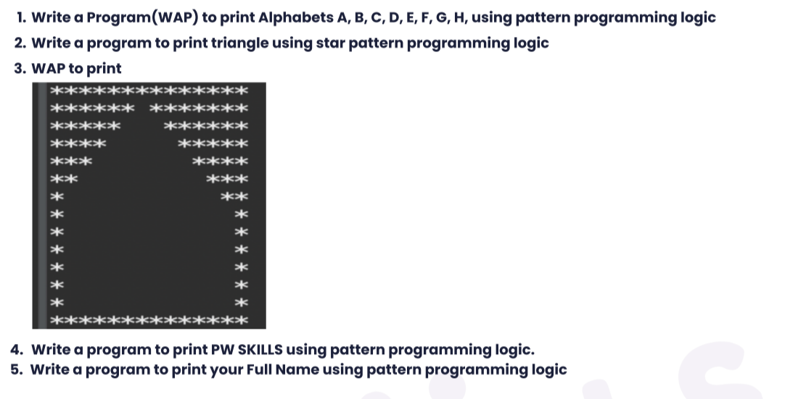

**1.**

Question_01.java

public class Question_01 {

// Number of lines for the alphabet's pattern

static *int* height = 5;

// Number of character width in each line

static *int* width = (2 * height) - 1;

// Function to print the pattern of 'A'

static *void* printA() {

*int* n = width / 2, i, j;

for (i = 0; i < height; i++) {

for (j = 0; j <= width; j++) {

if (

j == n ||

j == (width - n) ||

(i == height / 2 && j > n && j < (width - n))

) System.out.printf("*"); else System.out.printf(" ");

}

System.out.printf("\n");

n--;

}

}

// Function to print the pattern of 'B'

static *void* printB() {

*int* i, j, half = (height / 2);

for (i = 0; i < height; i++) {

System.out.printf("*");

for (j = 0; j < width; j++) {

if (

(i == 0 || i == height - 1 || i == half) && j < (width - 2)

) System.out.printf("*"); else if (

j == (width - 2) && !(i == 0 || i == height - 1 || i == half)

) System.out.printf("*"); else System.out.printf(" ");

}

System.out.printf("\n");

}

}

// Function to print the pattern of 'C'

static *void* printC() {

*int* i, j;

for (i = 0; i < height; i++) {

System.out.printf("*");

for (j = 0; j < (height - 1); j++) {

if (i == 0 || i == height - 1) System.out.printf("*"); else continue;

}

System.out.printf("\n");

}

}

// Function to print the pattern of 'D'

static *void* printD() {

*int* i, j;

for (i = 0; i < height; i++) {

System.out.printf("*");

for (j = 0; j < height; j++) {

if ((i == 0 || i == height - 1) && j < height - 1) System.out.printf(

"*"

); else if (

j == height - 1 && i != 0 && i != height - 1

) System.out.printf("*"); else System.out.printf(" ");

}

System.out.printf("\n");

}

}

// Function to print the pattern of 'E'

static *void* printE() {

*int* i, j;

for (i = 0; i < height; i++) {

System.out.printf("*");

for (j = 0; j < height; j++) {

if (

(i == 0 || i == height - 1) || (i == height / 2 && j <= height / 2)

) System.out.printf("*"); else continue;

}

System.out.printf("\n");

}

}

// Function to print the pattern of 'F'

static *void* printF() {

*int* i, j;

for (i = 0; i < height; i++) {

System.out.printf("*");

for (j = 0; j < height; j++) {

if ((i == 0) || (i == height / 2 && j <= height / 2)) System.out.printf(

"*"

); else continue;

}

System.out.printf("\n");

}

}

// Function to print the pattern of 'G'

static *void* printG() {

*int* i, j;

width--;

for (i = 0; i < height; i++) {

for (j = 0; j < width; j++) {

if (

(i == 0 || i == height - 1) && (j == 0 || j == width - 1)

) System.out.printf(" "); else if (j == 0) System.out.printf(

"*"

); else if (i == 0 && j <= height) System.out.printf("*"); else if (

i == height / 2 && j > height / 2

) System.out.printf("*"); else if (

i > height / 2 && j == width - 1

) System.out.printf("*"); else if (

i == height - 1 && j < width

) System.out.printf("*"); else System.out.printf(" ");

}

System.out.printf("\n");

}

}

// Function to print the pattern of 'H'

static *void* printH() {

*int* i, j;

for (i = 0; i < height; i++) {

System.out.printf("*");

for (j = 0; j < height; j++) {

if ((j == height - 1) || (i == height / 2)) System.out.printf(

"*"

); else System.out.printf(" ");

}

System.out.printf("\n");

}

}

public static *void* main(String[] *args*) {

printA();

System.out.println();

printB();

System.out.println();

printC();

System.out.println();

printD();

System.out.println();

printE();

System.out.println();

printF();

System.out.println();

printG();

System.out.println();

printH();

}

}

Output :

| **  * *  ******  * *  * *  ********  * *  ********  * *  ********  *****  *  *****  *****  * *  * *  * *  *****  ******  *  ****  *  ******  ******  *  ****  *  *  *****  *  * *****  * *  ******  * *  * *  ******  * *  * * |
| --- |

**2.**

Question_02.java

public class Question_02 {

public static *void* main(String *args*[]) {

//i for rows and j for columns

//row denotes the number of rows you want to print

*int* i, j, row = 6;

//outer loop for rows

for (i = 0; i < row; i++) {

//inner loop for columns

for (j = 0; j <= i; j++) {

//prints stars

System.out.print("* ");

}

//throws the cursor in a new line after printing each line

System.out.println();

}

}

}

Output :

| *  * *  * * *  * * * *  * * * * *  * * * * * * |
| --- |

**3.**

Question_03.java

**public class Question_03**

**{**

**public static *void* main(String[] *args*) {**

***int* n = 14;**

**for(*int* i=0;i<=n;i++)**

**{**

**for(*int* j=0;j<=n;j++)**

**{**

**if(i==0&&j<(n-1)||i==(n-1)&&j<(n-1)||j==0&&i<(n-1)||j==(n-1)&&i<=(n-1)||i==1&&j!=(n-1)/2&&i<(n/4)&&j<(n-1)||**

**i==2&&j!=(n-1)/2&&j<(n-1)&&j!=5&&j!=7||i==3&&j!=(n-1)/2&&j<(n-1)&&j!=6&&j!=5&&j!=4&&j!=7&&j!=8**

**||i==4&&j!=(n-1)/2&&j<(n-1)&&j!=3&&j!=5&&j!=4&&j!=7&&j!=8&&j!=9||**

**i==5&&j!=(n-1)/2&&j<(n-1)&&j!=3&&j!=5&&j!=4&&j!=7&&j!=8&&j!=9&&j!=2&&j!=10||**

**i==6&&j!=(n-1)/2&&j<(n-1)&&j!=3&&j!=5&&j!=4&&j!=7&&j!=8&&j!=9&&j!=2&&j!=10&&j!=1&&j!=11)**

**{**

**System.out.print("*");**

**}**

**else**

**{**

**System.out.print(" ");**

**}**

**}**

**System.out.println();**

**}**

**}**

**}**

Output :

| **************  ****** *******  ***** ******  **** *****  *** ****  ** ***  * **  * *  * *  * *  * *  * *  * *  ************** |
| --- |

**4.**

Question_04.java

public class Question_04 {

// Number of lines for the alphabet's pattern

static *int* height = 5;

// Number of character width in each line

static *int* width = (2 * height) - 1;

// Function to find the absolute value

// of a number D

static *int* abs(*int* *d*)

{

return *d* < 0 ? -1 * *d* : *d*;

}

// Function to print the pattern of 'P'

static *void* printP() {

*int* i, j;

for (i = 0; i < height; i++) {

System.out.printf("*");

for (j = 0; j < height; j++) {

if ((i == 0 || i == height / 2) && j < height - 1) System.out.printf(

"*"

); else if (

i < height / 2 && j == height - 1 && i != 0

) System.out.printf("*"); else System.out.printf(" ");

}

System.out.printf("\n");

}

}

// Function to print the pattern of 'W'

static *void* printW() {

*int* i, j, counter = height / 2;

for (i = 0; i < height; i++) {

System.out.printf("*");

for (j = 0; j <= height; j++) {

if (j == height) System.out.printf("*"); else if (

(i >= height / 2) && (j == counter || j == height - counter - 1)

) System.out.printf("*"); else System.out.printf(" ");

}

if (i >= height / 2) {

counter++;

}

System.out.printf("\n");

}

}

// Function to print the pattern of 'S'

static *void* printS() {

*int* i, j;

for (i = 0; i < height; i++) {

for (j = 0; j < height; j++) {

if ((i == 0 || i == height / 2 || i == height - 1)) System.out.printf(

"*"

); else if (i < height / 2 && j == 0) System.out.printf("*"); else if (

i > height / 2 && j == height - 1

) System.out.printf("*"); else System.out.printf(" ");

}

System.out.printf("\n");

}

}

// Function to print the pattern of 'K'

static *void* printK() {

*int* i, j, half = height / 2, dummy = half;

for (i = 0; i < height; i++) {

System.out.printf("*");

for (j = 0; j <= half; j++) {

if (j == abs(dummy)) System.out.printf("*"); else System.out.printf(

" "

);

}

System.out.printf("\n");

dummy--;

}

}

// Function to print the pattern of 'I'

static *void* printI() {

*int* i, j;

for (i = 0; i < height; i++) {

for (j = 0; j < height; j++) {

if (i == 0 || i == height - 1) System.out.printf("*"); else if (

j == height / 2

) System.out.printf("*"); else System.out.printf(" ");

}

System.out.printf("\n");

}

}

// Function to print the pattern of 'L'

static *void* printL() {

*int* i, j;

for (i = 0; i < height; i++) {

System.out.printf("*");

for (j = 0; j <= height; j++) {

if (i == height - 1) System.out.printf("*"); else System.out.printf(

" "

);

}

System.out.printf("\n");

}

}

public static *void* main(String[] *args*) {

printP();

printW();

System.out.println();

printS();

printK();

printI();

printL();

printL();

printS();

}

}

Output :

| *****  * *  *****  *  *  * *  * *  * * *  * * * *  ** **  *****  *  *****  *  *****  * *  * *  **  * *  * *  *****  *  *  *  *****  *  *  *  *  *******  *  *  *  *  *******  *****  *  *****  *  ***** |
| --- |

**5.**

Question_05.java

public class Question_05 {

// Number of lines for the alphabet's pattern

static *int* height = 5;

// Number of character width in each line

static *int* width = (2 * height) - 1;

// Function to print the pattern of 'A'

static *void* printA() {

*int* n = width / 2, i, j;

for (i = 0; i < height; i++) {

for (j = 0; j <= width; j++) {

if (

j == n ||

j == (width - n) ||

(i == height / 2 && j > n && j < (width - n))

) System.out.printf("*"); else System.out.printf(" ");

}

System.out.printf("\n");

n--;

}

}

// Function to print the pattern of 'D'

static *void* printD() {

*int* i, j;

for (i = 0; i < height; i++) {

System.out.printf("*");

for (j = 0; j < height; j++) {

if ((i == 0 || i == height - 1) && j < height - 1) System.out.printf(

"*"

); else if (

j == height - 1 && i != 0 && i != height - 1

) System.out.printf("*"); else System.out.printf(" ");

}

System.out.printf("\n");

}

}

// Function to print the pattern of 'H'

static *void* printH() {

*int* i, j;

for (i = 0; i < height; i++) {

System.out.printf("*");

for (j = 0; j < height; j++) {

if ((j == height - 1) || (i == height / 2)) System.out.printf(

"*"

); else System.out.printf(" ");

}

System.out.printf("\n");

}

}

// Function to print the pattern of 'L'

static *void* printL() {

*int* i, j;

for (i = 0; i < height; i++) {

System.out.printf("*");

for (j = 0; j <= height; j++) {

if (i == height - 1) System.out.printf("*"); else System.out.printf(

" "

);

}

System.out.printf("\n");

}

}

// Function to print the pattern of 'R'

static *void* printR() {

*int* i, j, half = (height / 2);

for (i = 0; i < height; i++) {

System.out.printf("*");

for (j = 0; j < width; j++) {

if ((i == 0 || i == half) && j < (width - 2)) System.out.printf(

"*"

); else if (

j == (width - 2) && !(i == 0 || i == half)

) System.out.printf("*"); else System.out.printf(" ");

}

System.out.printf("\n");

}

}

// Function to print the pattern of 'T'

static *void* printT() {

*int* i, j;

for (i = 0; i < height; i++) {

for (j = 0; j < height; j++) {

if (i == 0) System.out.printf("*"); else if (

j == height / 2

) System.out.printf("*"); else System.out.printf(" ");

}

System.out.printf("\n");

}

}

// Function to print the pattern of 'U'

static *void* printU() {

*int* i, j;

for (i = 0; i < height; i++) {

if (i != 0 && i != height - 1) System.out.printf(

"*"

); else System.out.printf(" ");

for (j = 0; j < height; j++) {

if (((i == height - 1) && j >= 0 && j < height - 1)) System.out.printf(

"*"

); else if (

j == height - 1 && i != 0 && i != height - 1

) System.out.printf("*"); else System.out.printf(" ");

}

System.out.printf("\n");

}

}

public static *void* main(String[] *args*) {

printR();

printA();

printH();

printU();

printL();

System.out.println();

printD();

printU();

printT();

printT();

printA();

}

}

Output :

| ********  * *  ********  * *  * *  **  * *  ******  * *  * *  * *  * *  ******  * *  * *    * *  * *  * *  ****  *  *  *  *  *******  *****  * *  * *  * *  *****  * *  * *  * *  ****  *****  *  *  *  *  *****  *  *  *  *  **  * *  ******  * *  * * |
| --- |