**day-013-array-assignment**

**1. What is the default value of Array for different data types?**

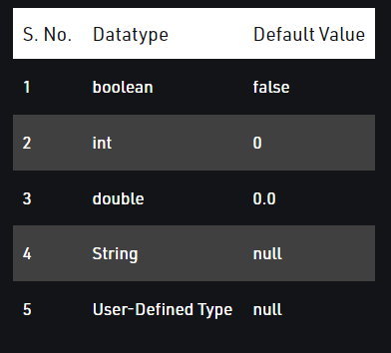

**2. Can you pass the negative number in Array size?**

No, you cannot use a negative integer as size, the size of an array represents the number of elements in it, –ve number of elements in an array makes no sense.

**3. Where does Array stored in JVM memory ?**

In Java, arrays are stored in the heap memory area of the Java Virtual Machine (JVM). The heap is the portion of memory used for dynamic memory allocation, which includes the memory required for objects and arrays in Java.

**4. What are the disadvantages of Array?**

Arrays have several disadvantages including:

Fixed size: Arrays have a fixed size, so if you need to store more items, you need to create a new array and copy all elements, which is time-consuming.

Inefficient for inserting/deleting elements: Inserting or deleting an element in the middle of an array requires shifting all the following elements, which is slow.

Costly search operation: Searching for a specific element in an array requires iterating through the entire array, which can be time-consuming for large arrays.

Limited functionality: Arrays provide limited functionality compared to other data structures like linked lists and trees.

Limited data types: Arrays are limited to storing elements of the same data type, making it difficult to store elements of different data types in a single array.

Not suitable for hierarchical data: Arrays are not well-suited for storing hierarchical data, which is better stored in data structures like trees.

**5. What is an Anonymous Array in Java ? Give an example?**

An anonymous array in Java is an array that is created and used without being assigned to a variable. An anonymous array is useful when you need to pass an array as an argument to a method or use an array in a single expression.

Example:

Copy code

public class Main {

public static void main(String[] args) {

// Anonymous array

sum(new int[]{1, 2, 3, 4});

}

public static void sum(int[] array) {

int sum = 0;

for (int i : array) {

sum += i;

}

System.out.println("Sum: " + sum);

}

}

In the example, the sum method takes an array of integers as a parameter. The anonymous array new int[]{1, 2, 3, 4} is passed as an argument to the sum method. The sum of elements in the anonymous array is calculated and printed.

**6. What are the different ways to traverse an Array in java?**

Traversing through an array

You can traverse through an array using for loop or forEach loop. Using the for loop − Instead of printing element by element, you can iterate the index using a for loop starting from 0 to length of the array (ArrayName. length) and access elements at each index.

**7. What is the difference between length and length() method Give an Examples?**

length and length() are two different things in Java, as follows:

length: length is a property of an array in Java and returns the number of elements in the array.

Example:

int[] numbers = {1, 2, 3, 4};

System.out.println("Length of the array: " + numbers.length); // Output: Length of the array: 4

length(): length() is a method of the String class in Java and returns the number of characters in a string.

Example:

String str = "Hello";

System.out.println("Length of the string: " + str.length()); // Output: Length of the string: 5

String str = "Hello";

System.out.println("Length of the string: " + str.length()); // Output: Length of the string: 5

In short, length is used with arrays to get the number of elements and length() is used with strings to get the number of characters.