**day-023-interface**

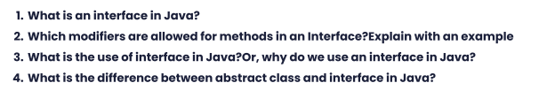

1. In Java, an interface is a collection of method signatures (methods without a body) and constants that can be implemented by any class that declares it. It defines a contract that a class must follow to be considered a valid implementation of the interface. Interfaces can be thought of as a blueprint for classes to follow in order to provide specific functionality.
2. The only two modifiers that are allowed for methods in an interface are "public" and "default". "Public" is used to make the method available to any class that implements the interface, while "default" is used to provide a default implementation for the method. Here's an example:

public interface MyInterface {

public void myMethod();

default void myDefaultMethod() {

System.out.println("This is a default implementation of MyInterface");

}

}

In this example, the interface "MyInterface" has a method "myMethod()" that must be implemented by any class that implements the interface. It also has a default method "myDefaultMethod()" that provides a default implementation for the method.

1. The use of an interface in Java is to provide a way to define a set of methods that a class must implement to be considered a valid implementation of the interface. This allows for greater flexibility in designing software systems, as classes can be written to implement multiple interfaces, allowing them to provide various types of functionality. Interfaces also allow for easier testing and maintenance of code, as they provide a clear separation between the interface and its implementation.
2. The main difference between an abstract class and an interface in Java is that an abstract class can have both abstract and non-abstract methods, while an interface can only have abstract methods (methods without a body) and constants. Additionally, a class can only extend one abstract class, but it can implement multiple interfaces. Abstract classes can also have instance variables, while interfaces cannot.