**day-026-collection-framework**

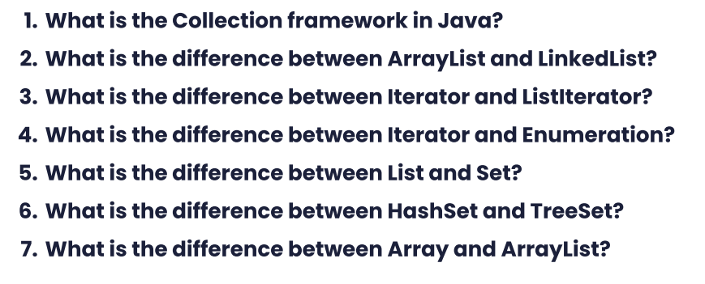

**Answers**

1. The Collection framework in Java is a set of classes and interfaces that provide a unified architecture for storing, manipulating, and processing groups of objects. It provides several implementations of common data structures like lists, sets, maps, queues, and more.
2. The main difference between ArrayList and LinkedList is their underlying implementation. ArrayList is implemented as a resizable array, while LinkedList is implemented as a doubly linked list. ArrayList provides constant time access to elements using their index, but adding or removing elements at the beginning or middle of the list can be slow. On the other hand, LinkedList provides fast insertion and deletion operations, but accessing elements using their index can be slow.
3. Iterator and ListIterator are both interfaces used to traverse the elements of a collection, but ListIterator is a subinterface of Iterator and provides additional methods like adding and removing elements while traversing the collection, as well as bidirectional iteration.
4. Iterator is a Java interface introduced in Java 1.2 that provides a way to traverse collections in a generic way, whereas Enumeration is an older interface that was replaced by the Iterator interface. Enumeration is only used for legacy code and can only be used to traverse collections in a forward direction.
5. List and Set are both interfaces in the Java Collection framework, but they differ in their implementation and behavior. A List allows duplicate elements and maintains the order of elements, while a Set does not allow duplicates and does not maintain any order.
6. HashSet and TreeSet are both implementations of the Set interface, but they differ in their implementation and behavior. HashSet uses a hash table to store the elements, and provides constant time performance for add, remove, and contains operations, but does not maintain any order. TreeSet is implemented as a balanced tree, and provides guaranteed log(n) time performance for add, remove, and contains operations, but maintains the elements in sorted order.
7. An array is a fixed-size data structure that stores a collection of elements of the same type, whereas ArrayList is a dynamic data structure that can grow or shrink as needed to accommodate new elements. Arrays are faster than ArrayList when accessing elements by index, but ArrayList provides more flexibility in terms of adding or removing elements at any position in the list.