**day-008-28-jan-operators-and-loops**

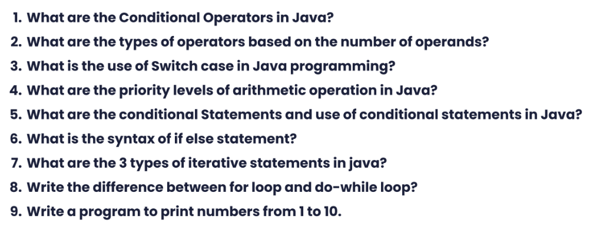

**1.**

Types of Conditional Operator

There are three types of the conditional [operator in Java](https://www.javatpoint.com/operators-in-java):

* Conditional AND - &&
* Conditional OR - ||
* Ternary Operator - ?:

**2.**

There are two types of mathematical operators: unary and binary. Unary operators perform an action with a single operand. Binary operators perform actions with two operands.

**3.**

The switch statement or switch case in java is a multi-way branch statement. Based on the value of the expression given, different parts of code can be executed quickly. The given expression can be of a primitive data type such as int, char, short, byte, and char. With JDK7, the switch case in java works with the string and wrapper class and enumerated data types also.

**4.**

| Operators | Precedence |
| --- | --- |
| multiplicative | * / % |
| additive | + - |

**5.**

A conditional statement tells a program to execute an action depending on whether a condition is true or false

Java has the following conditional statements:

* Use if - to specify a block of code to be executed, if a specified condition is true
* Use else - to specify a block of code to be executed, if the same condition is false
* Use else if - to specify a new condition to test, if the first condition is false
* Use switch - to specify many alternative blocks of code to be executed

**6.**

if (condition) {

// block of code to be executed if the condition is true

}

**7.**

Iteration Statements

* ' while' loop.
* ' do while' loop.
* ' for' loop.

**8.**

The major difference between for loop and the while loop is that for loop is used when the number of iterations is known, whereas execution is done in the while loop until the statement in the program is proved wrong.

For loop provides a concise way of writing the loop structure. Unlike a while loop, a for statement consumes the initialization, condition and increment/decrement in one line thereby providing a shorter, easy to debug structure of looping.

| **For Loop** | **While Loop** |
| --- | --- |
| It is used when the number of iterations is known. | It is used when the number of iterations is not known. |
| In case of no condition, the loop is repeated infinite times. | In case of no condition, an error will be shown. |
| Initialization is not repeated. | Initialization is repeated if carried out during the stage of checking. |
| Statement of Iteration is written after running. | It can be written at any place. |
| Initialization can be in or out of the loop | Initialization is always out of the loop. |
| The nature of the increment is simple. | The nature of the increment is complex. |
| Used when initialization is simple. | Used when initialization is complex. |

**9.**

Input :

Question_09.java

public class Question_09 {

public static *void* main(String[] *args*)

{

for(*int* i = 1; i <= 10; i++)

{

System.out.println(i);

}

}

}

Output :

