**day-012-array-assignment**

**1. What do you mean by an Array?**

An array is a container object that holds a fixed number of values of a single type. The length of an array is established when the array is created. After creation, its length is fixed. You have seen an example of arrays already, in the main method of the "Hello World!" application.

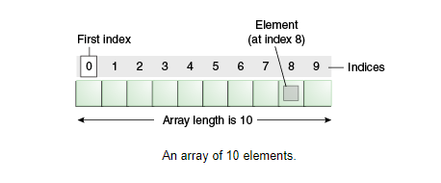

**2. How to create an Array?**

Syntax to Declare an Array in Java

dataType[] arr; (or)

dataType []arr; (or)

dataType arr[];

Instantiation of an Array in Java

arrayRefVar = new datatype[size];

**3. Can we change the size of an array at run time?**

We can't change the size of the array after it's constructed.

**4. Can you declare an array without assigning the size of an array?**

Yes. We can declare an array without size but before using it needs to be initialised.

**5. What is the default value of Array?**

java will assign the default value 0 to each element of the array in the case of an int array. Similarly, in the case of a boolean array, it will be false, in the case of a String array the default value is null in java, and in the case of a char array, the default value is Unicode (\u0000).

**6. What is a 1D array with an example?**

A One-Dimensional Array in Java programming is a special type of variable that can store multiple values of only a single data type such as int, float, double, char, etc. at a contagious location in computer memory. Here contagious location means at a fixed gap in computer memory.

A One-Dimensional Array is also known as 1D Array.

Suppose we want to store the age of 10 students. In that case, we have to declare 10 variables in our Java program to store the age of 10 students.

Now here comes the use of a one-dimensional array. With the help of 1D Array, we will declare a single variable in our Java program that can store the age of 10 students at a time.

**Declaration Syntax of a One Dimensional Array in Java**

datatype variable_name[] = new datatype[size];

Or

datatype[] variable_name = new datatype[size];

**Example**

int a[]=new int[5];

Or

int[] a=new int[5];

int a[]=new int[] {12,18,6};

**7. Write a program on a 2D array?**

Question_05.java

import java.util.Scanner;

class Question_05

{

public static *void* main(String *args*[])

{

Scanner sc=**new** Scanner(System.in);

System.out.println("Enter Row length of an array : ");

*int* row=sc.nextInt();

System.out.println("Enter column length of an array : ");

*int* column=sc.nextInt();

*int* a[][]=**new** *int*[row][column];//declaration

System.out.print("Enter " + row*column + " Elements to Store in Array :\n");

for (*int* i = 0; i < row; i++)

{

for(*int* j = 0; j < column; j++)

{

a[i][j] = sc.nextInt();

}

}

System.out.print("Elements in Array are :\n");

for (*int* i = 0; i < row; i++)

{

for(*int* j = 0; j < column; j++)

{

System.out.println("Row ["+i+"]: Column ["+j+"] :"+a[i][j]);

}

}

}

}

Output

