**day-027-map-and-generics**

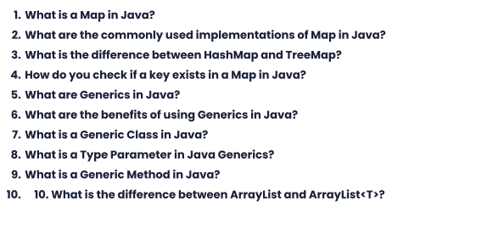

1. In Java, a Map is an interface that represents a collection of key-value pairs. It provides a way to associate a value with a key, and allows retrieval of the value using the key.
2. The commonly used implementations of Map in Java are:

* HashMap: an implementation that uses hash codes to store and retrieve key-value pairs, providing O(1) lookup time on average.
* TreeMap: an implementation that uses a red-black tree to store key-value pairs in sorted order, providing O(log n) lookup time on average.
* LinkedHashMap: an implementation that maintains the order of insertion of key-value pairs, providing O(1) lookup time on average.
* ConcurrentHashMap: an implementation that provides thread-safe access to a map using a partitioned array, providing high concurrency.

1. The main difference between HashMap and TreeMap is their underlying data structure and performance characteristics. HashMap uses a hash table to store key-value pairs, providing constant-time access on average, while TreeMap uses a red-black tree to store key-value pairs in sorted order, providing logarithmic-time access on average. HashMap allows null values and keys, while TreeMap does not allow null keys but allows null values.
2. To check if a key exists in a Map in Java, you can use the containsKey() method. This method returns true if the map contains a mapping for the specified key, and false otherwise. For example:

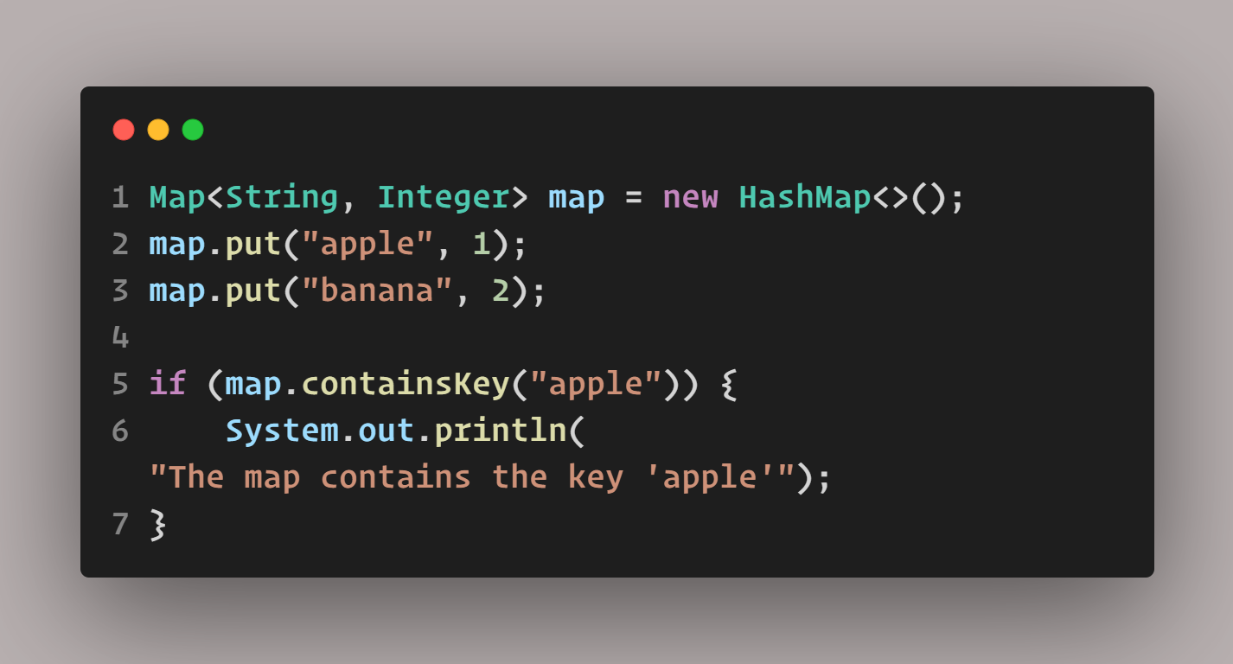

1. Generics in Java is a feature that allows classes and methods to be parameterized by one or more types. It provides a way to write reusable code that can work with different types, without having to write separate implementations for each type.
2. The benefits of using Generics in Java include:

Type safety: Generics provide compile-time type checking, which helps to prevent runtime errors caused by type mismatches.

Code reuse: Generics allow the same code to be used with different types, reducing code duplication and increasing maintainability.

Performance: Generics can improve performance by eliminating the need for type casting and allowing the JVM to optimize code.

1. A Generic Class in Java is a class that is parameterized by one or more types. The type parameters are specified in angle brackets after the class name, and can be used to define the types of instance variables, method parameters, and return types in the class. For example:



1. A Type Parameter in Java Generics is a placeholder for a type that is specified when a generic class or method is instantiated. It is specified using a single uppercase letter, such as T, E, or K, and can be used to define the types of instance variables, method parameters, and return types in the generic class or method.
2. A Generic Method in Java is a method that is parameterized by one or more types. It is defined using type parameters in angle brackets before the method return type, and can be used to define the types of method parameters and return types. For example:

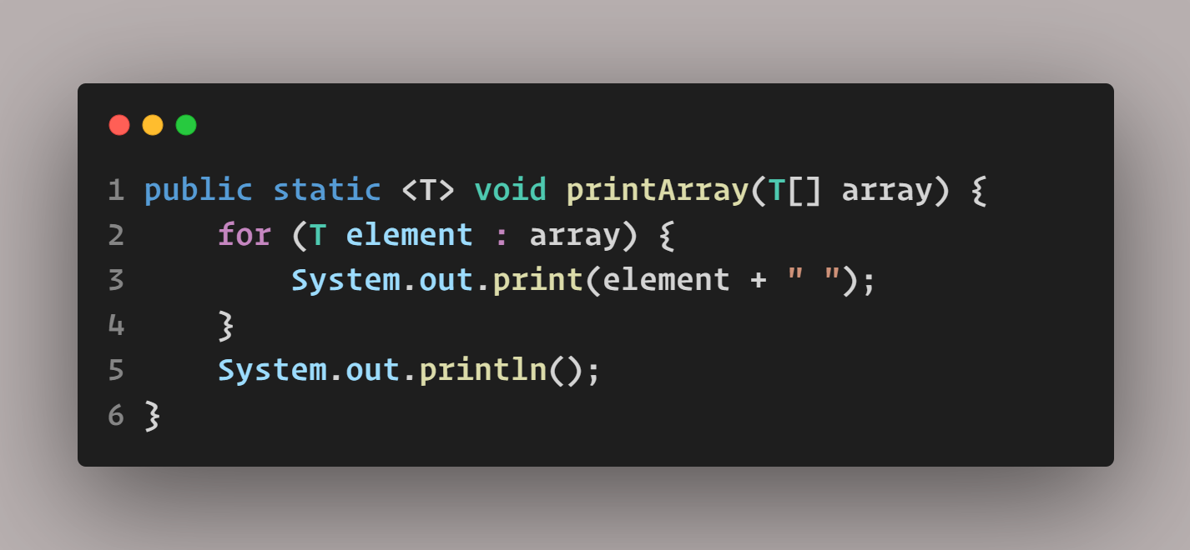

1. ArrayList is a raw type in Java, while ArrayList<T> is a parameterized type. The key difference between the two is that raw types do not provide compile-time type safety, while parameterized types do. When using raw types, the compiler cannot check if the types being used are compatible, which can lead to runtime errors. In contrast, parameterized types allow the compiler to ensure that only compatible types are used, providing greater safety and reducing the risk of errors. Therefore, it is generally recommended to use parameterized types like ArrayList<T> instead of raw types like ArrayList in Java.