**VISVESVARAYA TECHNOLOGICAL UNIVERSITY**

**BELGAUM, KARNATAKA - 590 014**



MINI-PROJECT SYNOPSIS

ON

“DIGITAL BLUEBOOK”

Submitted By

RAHUL M.K [4JK19IS038]

MANVITH SHETTY [4JK19IS025]

# UNDER THE GUIDANCE

# Mr./Mrs./Ms./ Faculty Name

# Assistant Professor, Dept. of ISE

# AJIET, Mangalore.

# COORDINATOR

# Mrs. ARUNA KUMARI G.K

Assistant Professor, Dept. of ISE

AJIET, Mangalore.

# A.Y :2020-2021



**Department of Information Science & Engineering**

#### A J INSTITUTE OF ENGINEERING AND TECHNOLOGY

#### (A unit of Laxmi Memorial Education Trust®)

#### NH-66, Kottara Chowki, Mangaluru -575006

INTRODUCTION

The following report describes the development of the Digital bluebook, this is the academic report of the student to keep track of the student, Student details, academic performance. The user can get the details of the above by registering. The user after logging on the system can fetch the necessary information of the student. The admin can add, update, delete student details, marks and also analyse statistics.

PROBLEM DEFINATION

Digital Bluebook is a project used to maintain the records of a student like marks, phone number, address, marks, branch etc. It is an automated version of store manual student. The main requirement of this project is to maintain an efficient database. The admin has all the right to add the records into database. The admin can make all the necessary changes. The teacher can add, update, delete, view the information of a student. The teacher can get all the details of individual student. In case of manual system, they need a lot of time, manpower etc. Here almost all work is computerized and accuracy is maintained. This project will give the information regarding all the details of the students. The computerized data helps in making the working process fast. Moreover, it is also less time consuming.

**SCOPE**

The main objective of our project is to maintain a student’s details and update it time to time which allows admin:

* To insert a Student Detail
* To delete a Student Detail
* To update Student Detail
* To insert new Student Detail
* To insert student marks
* To delete student marks

SOFTWARE REQUIREMENT SPECIFICATION

A software requirements specification (SRS) is a detailed description of a software system to be developed with its functional and non-functional requirements. The software requirement specification document consistent of all necessary requirements required for project development.

HARDWARE REQUIREMENT SPECIFICATION

• PROCESSOR: Intel core™ 2 Duo

• SPEED: 2.10GHz

• RAM: 2.00 GB Minimum

• SPACE ON DISC:20GB Minimum

SOFTWARE REQUIREMENT SPECIFICATION

* VS code
* Programming languages: Java, MySQL, HTML, CSS, Java Script.
* Xampp

DESIGN

Software design is the process by which an agent creates specification of software artifact, intended to accomplish goals, using the set of primitive components and subject to constraints.

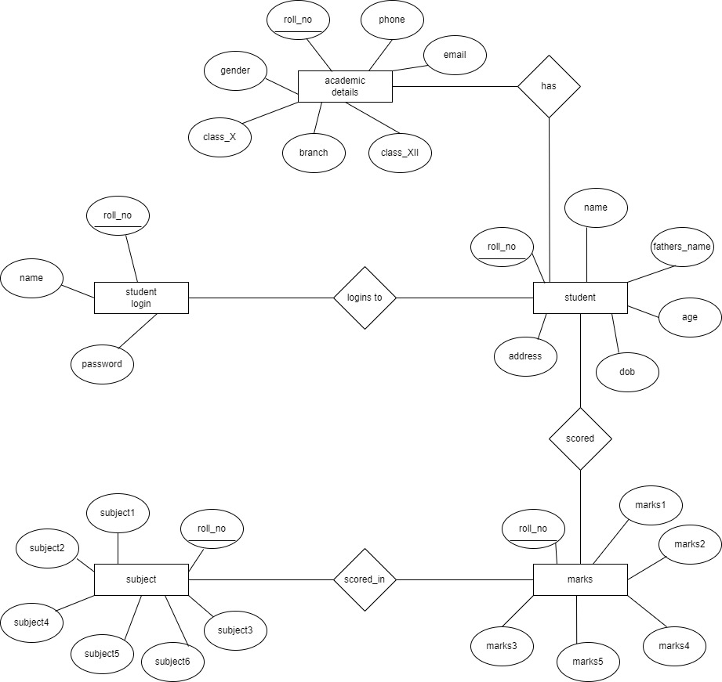ER-MODEL

SCHEMA DIAGRAM

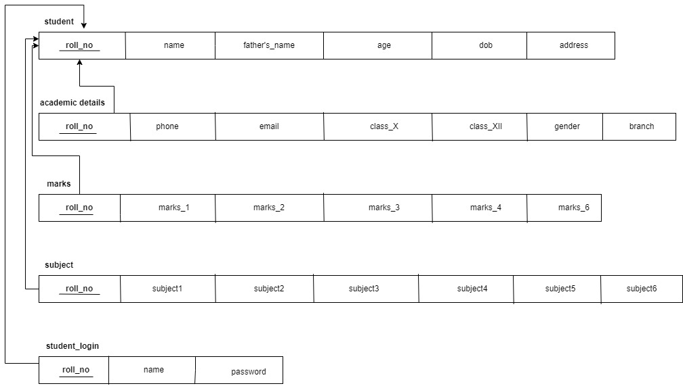

DISADVANTAGES OF DIGITAL BLUEBOOK

* The student result management system is prone to hacks.
* Administration cannot edit or modify scores after the deadline.
* Minor technical glitches and issues.

FUTURE SCOPE

* In the future the students can also be able to download or upload the notes.
* A few more minor tweaks here and there for making the application more visually appealing and will have statistics, tracking and analytics.
* The whole project will be made available as an android app for far more ease of use and mobility.

CONCLUSION

* It was a wonderful and learning experience for us while working on this project,
* This software is very easy to use so all educational institute can use this frequently,

* So, we can hope that our software will be very popular and get sponsors to develop in future

References.

[Bootstrap Made](https://bootstrapmade.com)

[HTML Reference](https://www.w3schools.com/html/)

[CSS Reference](https://www.w3schools.com/css/)

[Java Script Reference](https://www.w3schools.com/js/)