# VISVESVARAYA TECHNOLOGICAL UNIVERSITY, BELAGAVI – 590018

**MINI PROJECT**

**ON**

**“DIGITAL BLUEOOK”**

***Submitted by***

**RAHUL M.K 4JK19IS038**

**MANVITH SHETTY 4JK19IS025**

**Under the guidance of**

**Mrs. ARUNA KUMARI G.K**

**(Asst Professor, Department of ISE)**



**DEPARTMENT OF INFORMATION SCIENCE AND ENGINEERING**

**A. J. INSTITUTE OF ENGINEERING AND TECHNOLOGY Kottara Chowki, Mangaluru -575006, Karnataka.**

**2021-2022**

### A. J. INSTITUTE OF ENGINEERING AND TECHNOLOGY Kottara Chowki, Mangaluru -575006

**DEPARTMENT OF INFORMATION SCIENCE AND ENGINEERING**



CERTIFICATE

*This is to certify that the Mini project entitled* ***“Digital Bluebook (Academic Report)”*** *is a bonafide work carried out by*

***RAHUL M.K 4JK19IS038***

***MANVITH SHETTY 4JK19IS025***

*Students of fifth semester B.E. Information Science & Engineering, and submitted as a part of the course DBMS Laboratory with Mini Project (17CSL58), during the academic year 2021-2022.*

**----------------------------**

**--------------------------------**

### Mrs. Aruna Kumari G.K Dr Nagesh H R Project Guide Head of the Department

**Name of the Examiners Signature with Date**

1. 1.

2. 2.

## ABSTRACT

As the name specifies “DIGITAL BLUEBOOK (Academic Report)” is a software developed for managing various activities of a student in school or college. For the past few years, the number of educational institutions is increasing rapidly. And hence there is a lot of strain on the person who is maintaining the records of individual student and software’s are not usually used in this context. This particular project deals with the problems on managing a student’s data and to avoid the problems which occur when carried manually.

Identification of the drawbacks of the existing system leads to the designing of computerized system that will be compatible to the existing system with the system Which is more user friendly and more GUI oriented. We can improve the efficiency of the system, thus overcome the drawbacks of the existing system.

i

# ACKNOWLEDGEMENT

We dedicate this page to acknowledge and thank those responsible for the shaping of the project. Without their guidance and help, the experience while constructing the dissertation would not have been so smooth and efficient.

We sincerely thank the **Management of A. J. Institute of Engineering and Technology,** (A Unit of Laxmi Memorial Education Trust®) for their continuous support.

We are extremely thankful to our **Principal Dr. Shantharama Rai C,** for his support and encouragement.

We owe our profound gratitude to **Dr. Nagesh H R, Head of the Department**, Information Science and Engineering, whose kind consent and guidance helped us to complete this work successfully.

We sincerely thank **Mrs. Aruna Kumari G.K, Assistant Professor**, Information Science and Engineering, for her guidance and valuable suggestions which helped us to fulfill the experiments prescribed by the university.

We would like to thank all our Information Science and Engineering staff members who have always been with us extending their support, precious suggestions, guidance and encouragement through the project.

We also like to extend thanks to our friends and family members for their continuous support.

## CONTENTS

**Sl No. Title Page No.**

1. Introduction…………………………………………………………... 01

1.1 Problem Definition………………………………………... 01

1.2 Scope……………………………………………………… 01

1. Software Requirement Specification…………………………..……... 02
   1. Functional Requirements………………………………….. 02
   2. Hardware Requirements…………………………………... 02
   3. Software Requirements…………………………………… 02

3. System Design………………………………………………………... 04

3.1 ER Model…………………………………………………. 04

3.2 Schema Diagram………………………………………….. 05

3.3 Table Description…………………………………………. 05

4. Implementation………………………………………………………... 08

4.1 Details of the language…………………………………….. 08

5. Screenshots……………………………………………………..……... 09

Screenshots of the table created……………………………. 09

5.2 Screenshot of the Front-end……………………………….. 12

6. Conclusion And Future Work………………………………….……... 19

References……………………………………………………………... 20

|  |  |  |
| --- | --- | --- |
| **Figure No.** | **Title** | **Page No.** |
| Figure 3.1 | ER Diagram for Digital Bluebook………………..…… | 04 |
| Figure 3.2 | Schema Diagram for Digital Bluebook……………….. | 05 |
| Figure 5.1 | Database table…………………………………………. | 09 |
| Figure 5.2 | Student table…………………………………………… | 09 |
| Figure 5.3 | Marks table…………………………………………….. | 10 |
| Figure 5.4 | Subject table…………………………………………… | 10 |
| Figure 5.5 | Login table…………………………………………….. | 11 |
| Figure 5.11 | Front End of Login page………………………………. | 12 |
| Figure 5.12 | Front End of Menu page………………………………. | 13 |
| Figure 5.13 | Front End of Add Student page……………….............. | 14 |
| Figure 5.14 | Front End of Add Marks page…………………............. | 15 |
| Figure 5.15 | Front End of Update Details page……………………… | 16 |
| Figure 5.16 | Front End of Student details page……………………... | 16 |
| Figure 5.17 | Front End of Marks Display page……………………… | 17 |
| Figure 5.18 | Front End of Student details page……………………... | 17 |
| Figure 5.19 | Front End of Marks Display page……………………… | 18 |
| Figure 5.20 | Front End of Individual Student details………………... | 18 |

|  |  |  |
| --- | --- | --- |
| **Table No**  3.1 | **Title**  Student Table………………………………………….. | **Page No.**  06 |
| 3.2 | Marks Table…………………………………………… | 06 |
| 3.3 | Subject Table…………………………………………… | 07 |
| 3.4 | Login Table……………………………………………. | 07 |

# CHAPTER 1

## INTRODUCTION

The following report describes the development of the Digital bluebook this is the academic report of the student to keep track of the student, Student details, academic performance. The user can get the details of the above by registering. The user after logging on the system can fetch the necessary information of the student. The admin can add, update, delete student details, marks and also analyse statistics.

### Problem Definition

Digital Bluebook is a project used to maintain the records of a student like marks, phone number, address, marks, branch etc. It is an automated version of store manual student. The main requirement of this project is to maintain an efficient database. The admin has all the right to add the records into database. The admin can make all the necessary changes. The teacher can add, update, delete, view the information of a student. The teacher can get all the details of individual student. In case of manual system, they need a lot of time, manpower etc. Here almost all work is computerized and accuracy is maintained. This project will give the information regarding all the details of the students. The computerized data helps in making the working process fast. Moreover, it is also less time consuming.

### Scope

The main objective of our project is to maintain a student’s details and update it time to time which allows admin:

* + 1. To insert a Student Detail
    2. To delete a Student Detail
    3. To update Student Detail
    4. To insert new Student Detail
    5. To insert student marks
    6. To delete student marks

# CHAPTER 2

## SOFTWARE REQUIREMENT SPECIFICATION

A software requirements specification (SRS) is a detailed description of a software system to be developed with its functional and non-functional requirements. The software requirement specification document consistent of all necessary requirements required for project development.

### Functional Requirements

* + - The system asks for user information such as user name, password.
    - The system provides the menu after logging in.
    - User should be able to insert student details.
    - User should be able to login using his user name, password.
    - User should be able to select the Details of the student.

### Hardware Requirement Specification

* + - PROCESSOR: Intel core™ 2 Duo
    - SPEED: 2.10GHz
    - RAM: 2.00 GB Minimum
    - SPACE ON DISC:20GB Minimum

### Software Requirement Specification

* + - NetBeans IDE
    - MySQL
    - Programming languages: Java, MySQL.

### NetBeans IDE

**NetBeans** is an integrated development environment (IDE) for JAVA. NetBeans allows applications to be developed from a set of modular [software components](https://en.wikipedia.org/wiki/Software_component) called modules. NetBeans runs on [Windows](https://en.wikipedia.org/wiki/Microsoft_Windows), [macOS](https://en.wikipedia.org/wiki/MacOS), [Linux](https://en.wikipedia.org/wiki/Linux) and [Solaris](https://en.wikipedia.org/wiki/Solaris_(operating_system)). In addition to Java development, it has extensions for other languages like [PHP,](https://en.wikipedia.org/wiki/PHP) [C,](https://en.wikipedia.org/wiki/C_(programming_language)) [C++,](https://en.wikipedia.org/wiki/C%2B%2B) [HTML5](https://en.wikipedia.org/wiki/HTML5) and [JavaScript](https://en.wikipedia.org/wiki/JavaScript).

NetBeans is used to develop almost any kind of Java applications, from Java desktop apps (Swing & JavaFX) to Java web apps. For Swing development, the GUI Builder helps you visually design layout and drag and drop user interface components. Likewise, the Scene Builder helps design JavaFX applications quickly and easily.

### MySQL

**MySQL** is a freely available open-source Relational Database Management System (RDBMS) that uses Structured Query Language (**SQL**). **SQL** is the most popular language for adding, accessing and managing content in a database. It is most noted for its quick processing, proven reliability, ease and flexibility of use. One of the most important things about using **MySQL** is to have a **MySQL** specialized host. Although it can be used in wide range of applications, MySQL is most often associated with web application and online publishing. MySQL is an important component of an open source enterprise stack called LAMP.

# CHAPTER 3

**DESIGN**

Software design is the process by which an agent creates specification of software artifact, intended to accomplish goals, using the set of primitive components and subject to constraints.

### ER Model

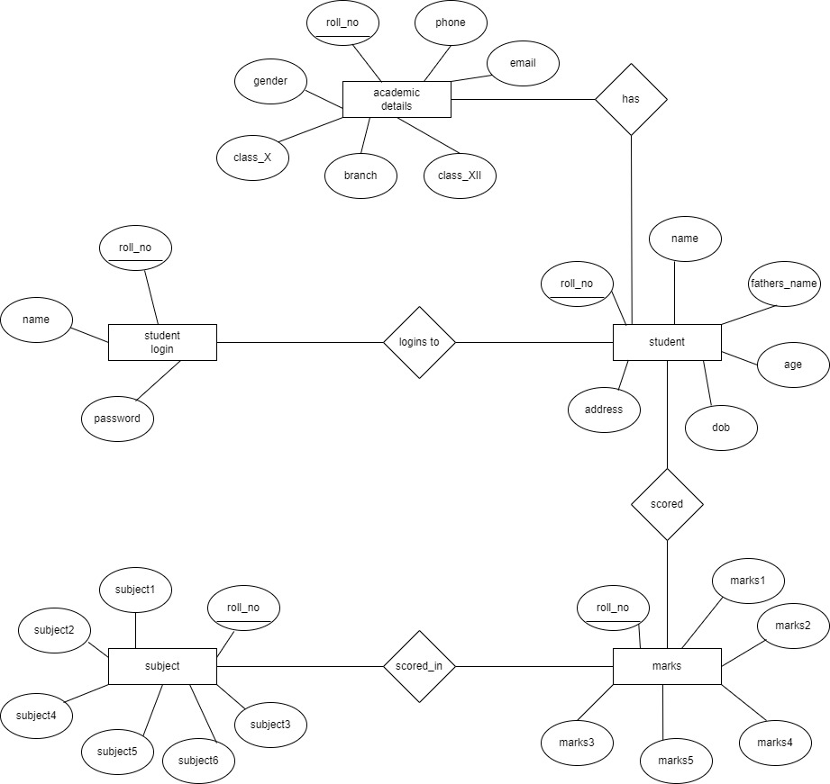An entity set is a group of similar entities and these entities can have attributes. In terms of DBMS and entity is a table or attribute of a table in database, so by showing relationship among tables and their attributes, ER diagram shows the complete logical structure of a database.

**Figure 3.1: ER Diagram for Digital Bluebook**

ENTITY TYPES: Student, marks, subject. Each user will sign in using their username and password. The password and username should be same when they registered earlier to log-in. Through this the user will gain access to the database.

### SCHEMA DIAGRAM

A Database schema is the skeleton structure that represents the logical view of the entire database. It defines how the data is organized and how the relations among them are associated.

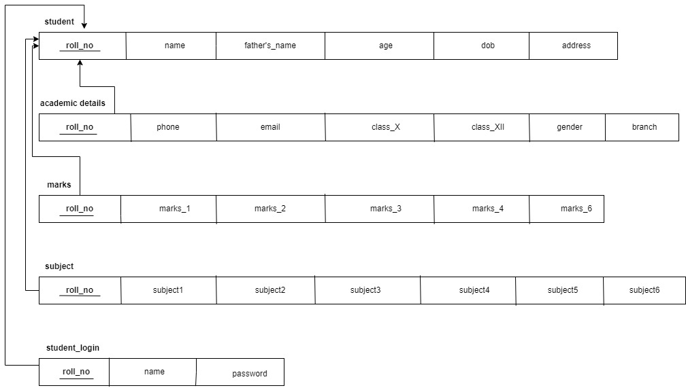

**Figure 3.2: Schema Diagram for Digital Bluebook**

The Schema diagram of our project Digital Bluebook is shown above. We can observe that in the table student the attribute rollno is the primary key. In the table marks and subject rollno is the foreign key as it required to fetch the necessary information of a particular student.

### TABLE DESCRIPTION

A table is a named original data base data set that is organized by rows and columns. The relational table is a fundamental relational data base concept because tables are the primary form of data storage. Columns form the table’s structure and rows form the content.

**Table 3.1: Student**

|  |  |  |  |
| --- | --- | --- | --- |
| **Attributes** | **Data type** | **Constraints** | **Description** |
| name | varchar |  | Name of the Student |
| Father name | Varchar |  | Students parent name |
| Age | Int |  | Age of Student |
| Dob | Varchar |  | Date of birth of student |
| address | Varchar |  | Student’s Address |
| Phone | Varchar |  | Student’s phone number |
| Email | Varchar |  | Student’s Email id |
| Class_X | Varchar |  | Class 10th marks |
| Class_Xll | Varchar |  | Class 12th marks |
| Aadhar | Varchar |  | Student’s Aadhar number |
| rollno | Varchar | Primary key | Student’s Roll number |
| Gender | Varchar |  | Student’s Gender |
| Branch | Varchar |  | Student’s Branch |

In table 3.1: name, father’s name, age, dob, address, phone, email, class_X, class_Xll, aadhar, rollno, gender, branch are the attributes and roll no is the primary key.

**Table 3.2: Marks**

|  |  |  |  |
| --- | --- | --- | --- |
| **Attributes** | **Data type** | **Constraints** | **Description** |
| Rollno | varchar | Primary key | Roll Number of the student |
| Marks1 | Int |  | Subject1 marks |
| Marks2 | Int |  | Subject2 marks |
| Marks3 | Int |  | Subject3 marks |
| Marks4 | Int |  | Subject4 marks |
| Marks5 | Int |  | Subject5 marks |
| Marks6 | Int |  | Subject6 marks |

In the table 3.2: rollno, marks1, marks2, marks3, marks4, marks5, marks6 are the attributes and rollno is primary key. The attribute rollno is of varchar datatype and all other attributes are of int datatype.

**Table 3.3: Subjects**

|  |  |  |  |
| --- | --- | --- | --- |
| **Attributes** | **Data type** | **Constraints** | **Description** |
| rollno | varchar | Primary key | Roll Number of the student |
| Subject1 | Varchar |  | Subject1 name |
| Subject2 | Varchar |  | Subject2 name |
| Subject3 | varchar |  | Subject3 name |
| Subject4 | Varchar |  | Subject4 name |
| Subject5 | Varchar |  | Subject5 name |
| Subject6 | varchar |  | Subject6 name |

In table 3.3: rollno, subject1, subject2, subject3, subject4, subject5, subject6 are the attributes. rollno is a primary key of datatype int and all the attributes are of datatype varchar.

**Table 3.4: Login**

|  |  |  |  |
| --- | --- | --- | --- |
| **Attributes** | **Data type** | **Constraints** | **Description** |
| Rollno | varchar | Primary key | Roll Number of the student |
| Marks1 | Int |  | Subject1 marks |
| Marks2 | Int |  | Subject2 marks |

In table 3.4 : Username and passwords are the attributes of datatype varchar.

# CHAPTER 4

## IMPLEMENTATION

Implementation is defined as specific set of activities designed to put into practice an activity or program of known dimensions. Implementation processes are purposeful and are described in sufficient details such that independent can detect the presence and strength of the specific set of activities related to implementation.

### Details of the Language

Our project is implemented using java. The reason we chose Java because it is simple to comprehend than other programming languages. Since it is easy and powerful language, it has been widely used.

### JAVA

**Java** is a [class-based,](https://en.wikipedia.org/wiki/Class-based_programming) [object-oriented](https://en.wikipedia.org/wiki/Object-oriented_programming) [programming language](https://en.wikipedia.org/wiki/Programming_language) that is designed to have as few implementation [dependencies](https://en.wikipedia.org/wiki/Dependency_(computer_science)) as possible. Java applications are typically compiled to [bytecode](https://en.wikipedia.org/wiki/Java_bytecode) that can run on any [Java virtual machine](https://en.wikipedia.org/wiki/Java_virtual_machine) (JVM) regardless of the underlying [computer architecture.](https://en.wikipedia.org/wiki/Computer_architecture) The [syntax](https://en.wikipedia.org/wiki/Syntax_(programming_languages)) of [Java](https://en.wikipedia.org/wiki/Java_(software_platform)) is similar to [C](https://en.wikipedia.org/wiki/C_(programming_language)) and [C++](https://en.wikipedia.org/wiki/C%2B%2B), but has fewer [low-level](https://en.wikipedia.org/wiki/Low-level_programming_language) facilities than either of them. The Java runtime provides dynamic capabilities (such as reflection and runtime code modification)

## MySQL

Structured Query Language, commonly known as SQL, is a standard [programming](https://www.thebalancecareers.com/what-does-a-computer-programmer-do-525996) [language](https://www.thebalancecareers.com/what-does-a-computer-programmer-do-525996) for relational databases. Despite being older than many other types of code, it is the most widely implemented database language.

Because SQL is so common, knowing it is valuable to anyone involved in computer programming or who uses databases to collect and organize information. Learn more about what SQL is and career opportunities in the field.

# CHAPTER 5

## SCREENSHOTS

The following screenshots includes database table structures and front-end view of an Digital Bluebook (Academic report). Database is used for Digital Bluebook is MySQL. The below tables used in Digital Bluebook Database.

### 5.1 Screenshots of the table created

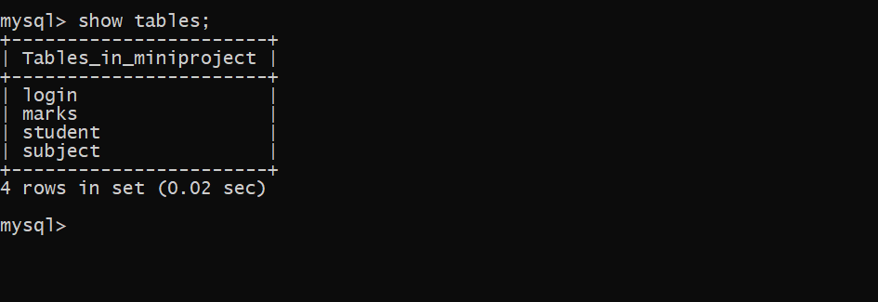

**Figure 5.1: Digital Bluebook Database table**

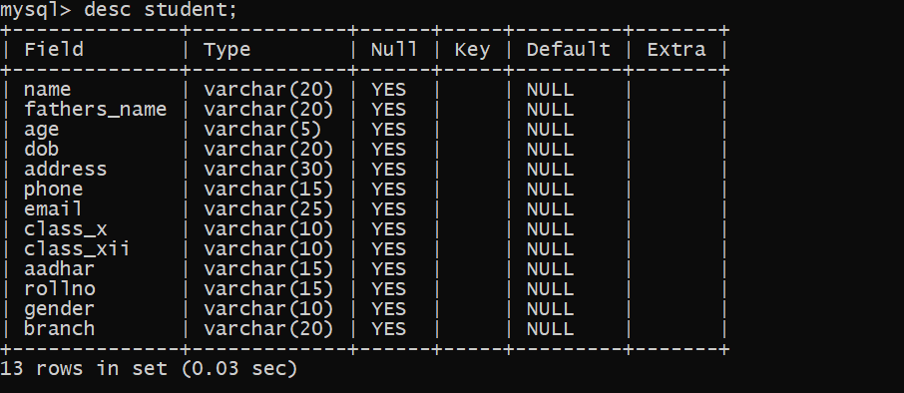

**Figure 5.2: Student table**

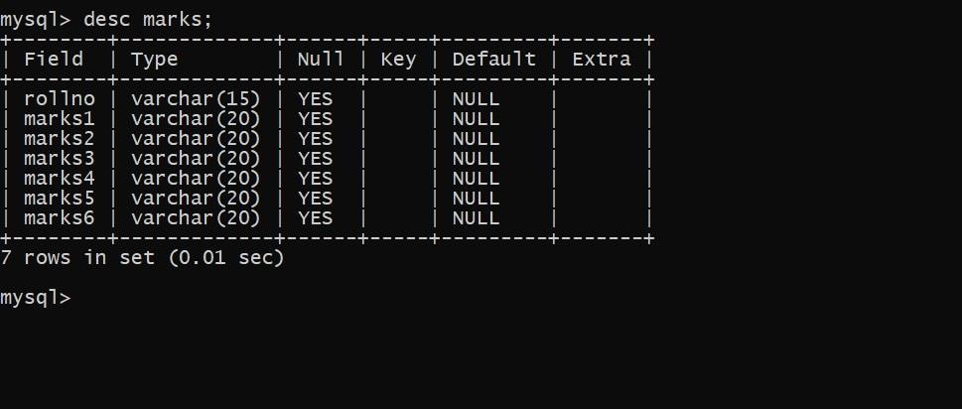

**Figure 5.3: Marks table**

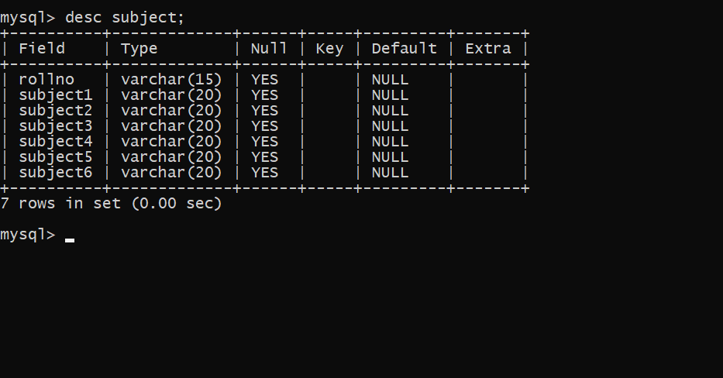

**Figure 5.4: Subject table**

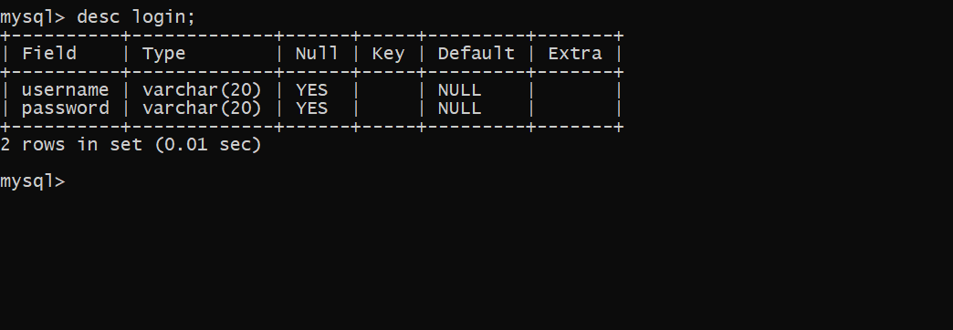

**Figure 5.5: login table**

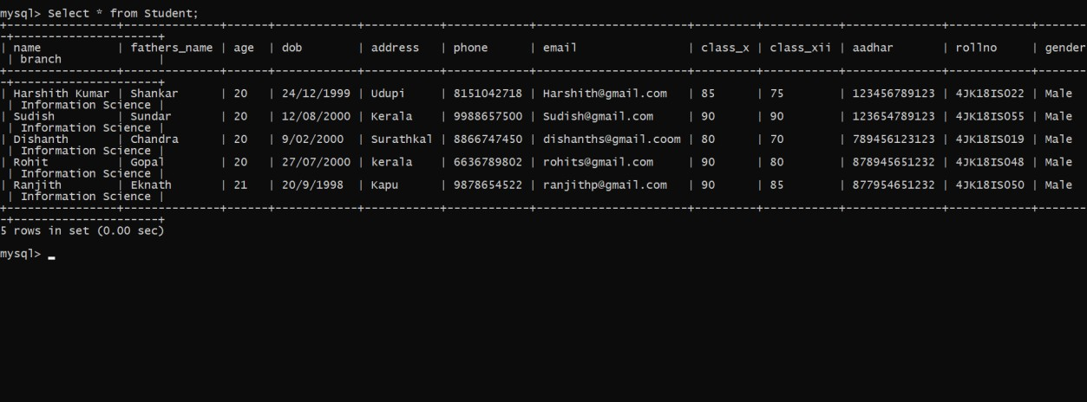

**Figure 5.6: Student table**

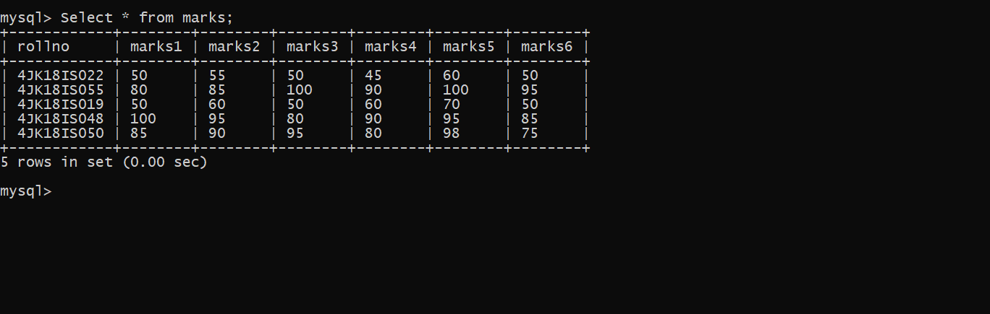

**Figure 5.7: Marks table**

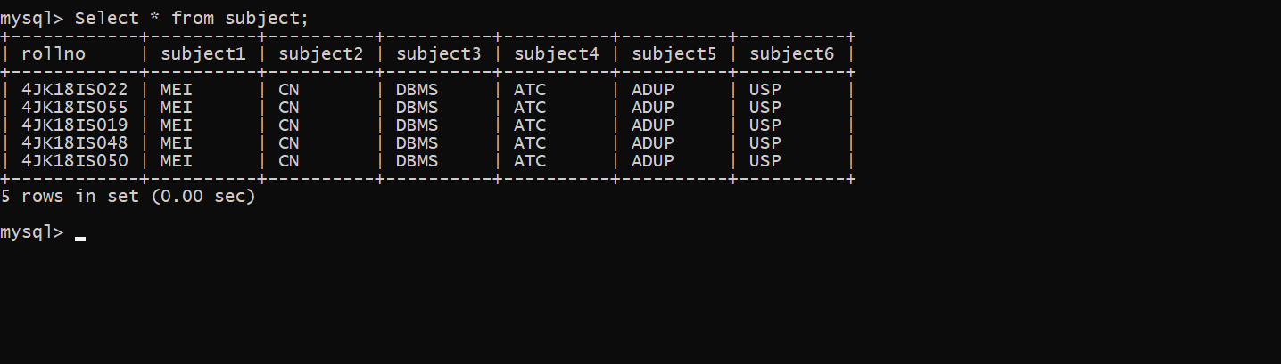

**Figure 5.8: Subject table**

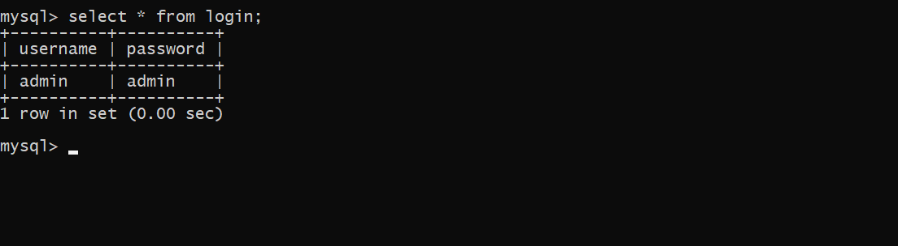

**Figure 5.9: Login table**

### 5.10 Front-End Screenshots

This is representation of how our front end looks like when the user is working on the project.

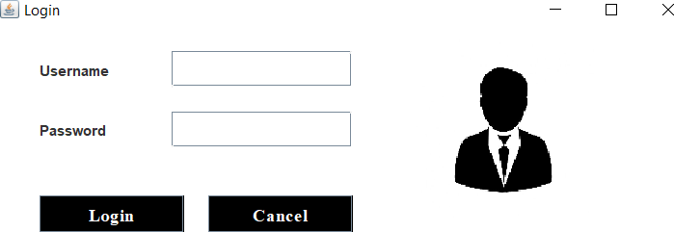

**Figure 5.11: Login Page**

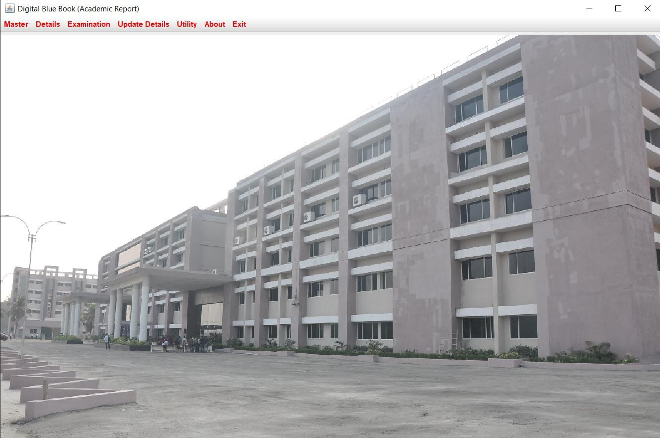

**Figure 5.12: Main Menu**

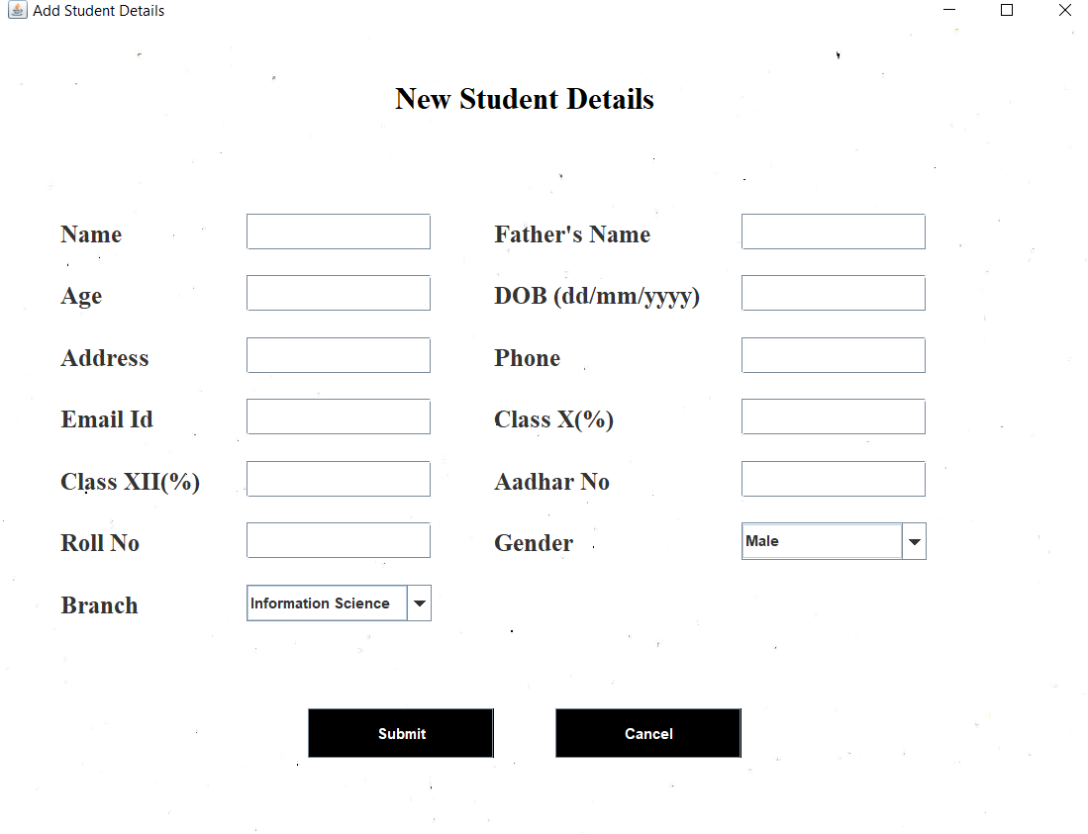

**Figure 5.13: Add Student Details**

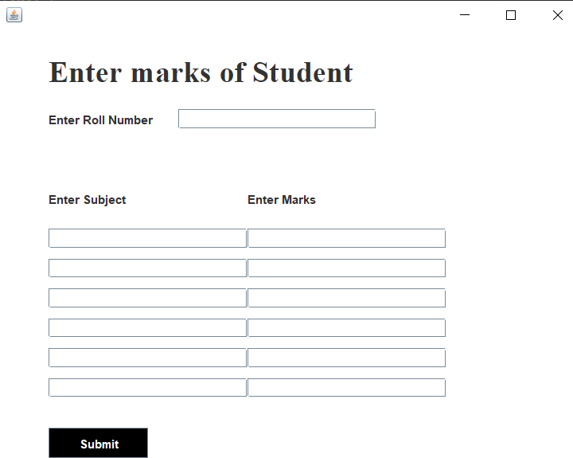

**Figure 5.14: Add Student marks**

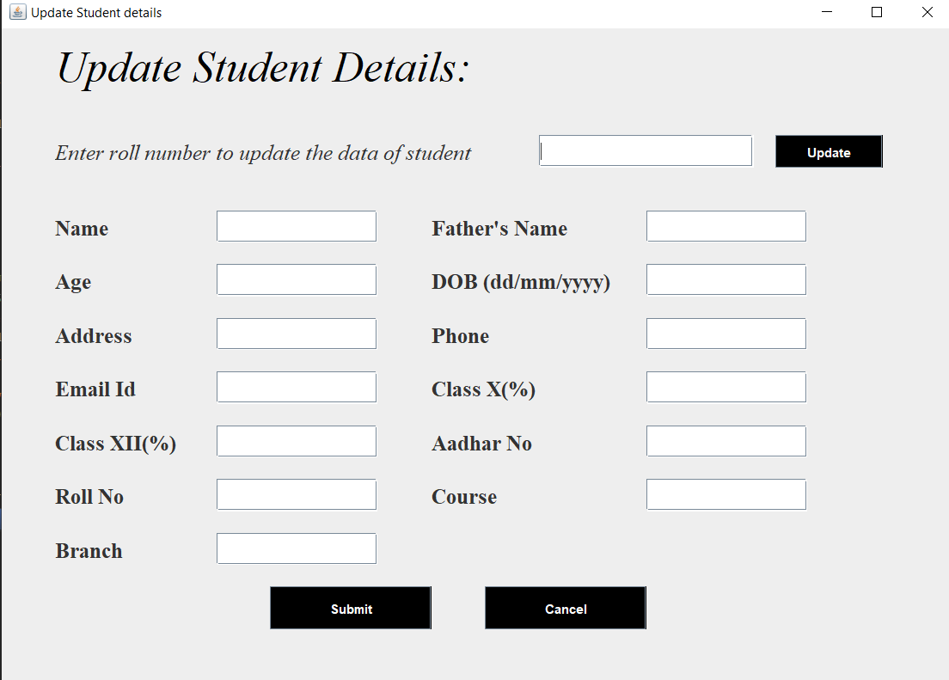

**Figure 5.15: Update student details**

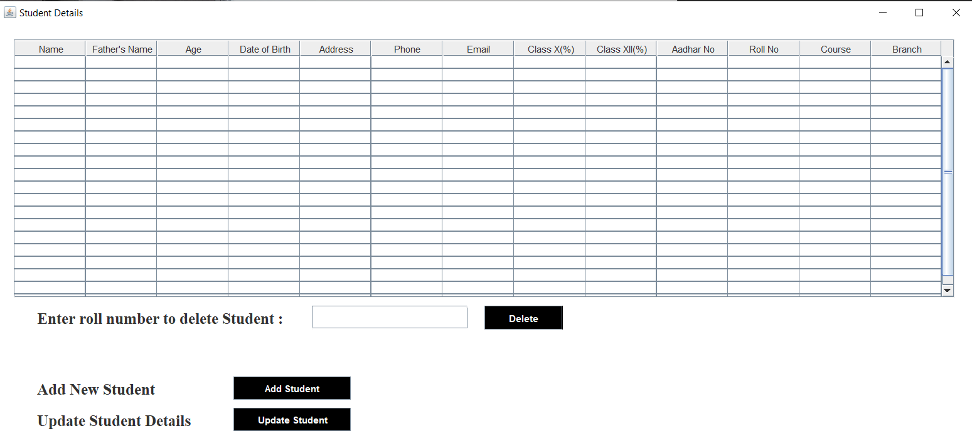

**Figure 5.16: Student details will be displayed here**

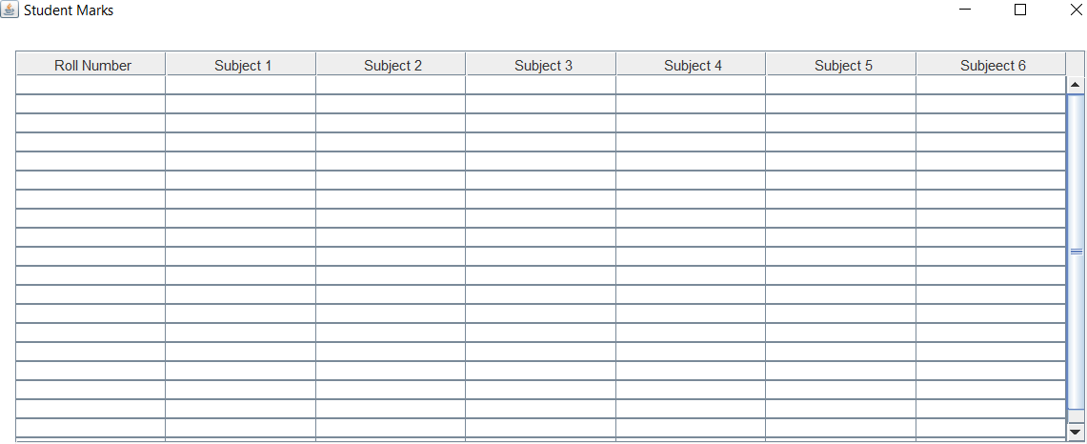

**Figure 5.17: Student marks will be displayed here**

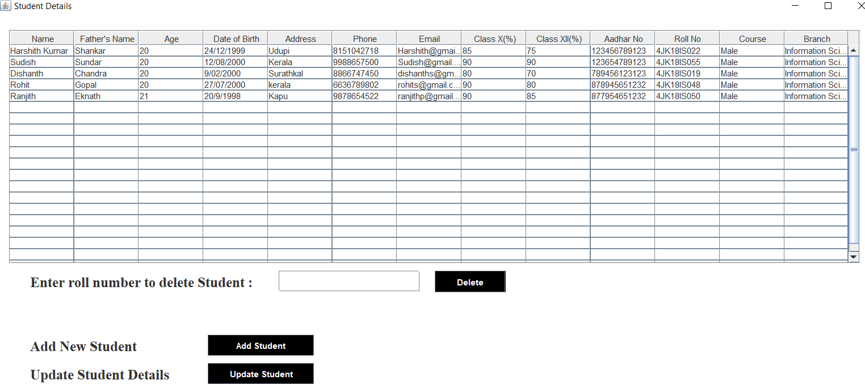

**Figure 5.18: Details of all the students**

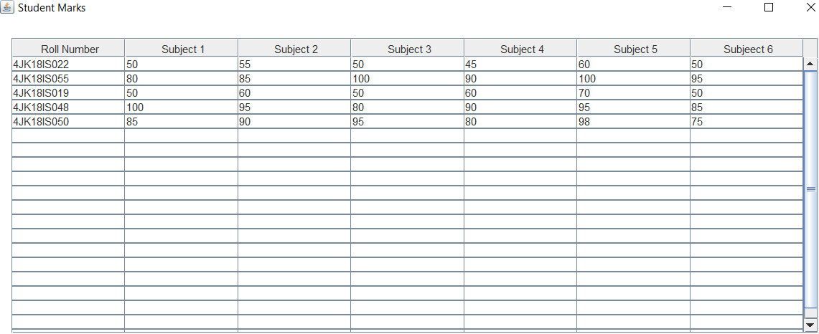

**Figure 5.19: Marks of all the students**

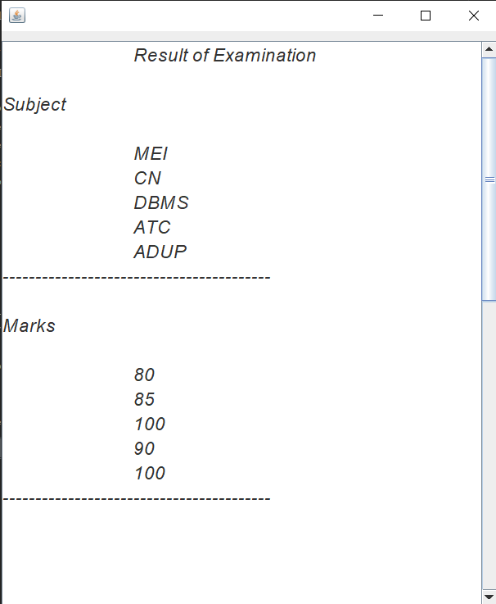

**Figure 5.20: Marks of individual students**

# CHAPTER 6

## CONCLUSION AND FUTURE WORK

### Conclusion

Here the main objective of this project is to reduce the work of teacher in maintaining the record of their students. To sequentially maintain all the details of a student and also keep the record of the academic performance. We have successfully implemented our project Digital bluebook which helps teachers to maintain their student’s data.

### Future Work

As a part of future enhancement, we can add semester section and differentiate the students based on their semester and this could be used by all the faculty with a login id to get the details of the required student. The future enhancement can provide the teacher about the performance of the student in each semester.

## REFERENCES

* + 1. RamezElmasri and Shamkanth B Navathe “Database System Models language, Dsign and application program” – Pearson, 7th Edition, 2017
    2. Silberschatzkorth and Sudarshan, “Database System Concepts” 6th edition McGraw Hill, 2013.
    3. Ramakrishnan and Gehrke, “Database Management Systems” 3rd Edition, 2014, McGraw Hill.
    4. K.Torp, C.S. Jensen, M.H. Bohlen, “Layered temporal DBMS : Concepts and tecchniques”, DASFA, pp.371-380, 1997.
    5. T. harder, A.Reuter, “Database Systems for Non-Standard Application”, Proc. Int computing symposium, 1983.
    6. [URL:ht](http://www.w3schools.com/java)tp:[//www.w3schools.com/java](http://www.w3schools.com/java)
    7. URL:https://stackoverflow.com/mysql