

Project Report

CSE0001:Digital Literacy

NAME: RAHUL KUMAR PATHAK
REG.NO. 25BCY10247
SLOT:E21
Introduction
This project was completed as part of the Digital Literacy course with the objective of understanding the importance of digital skills in today’s technology-driven world. As a student digital ambassador, my role was to explore and demonstrate how digital tools and platforms can be used effectively, responsibly, and safely.

In this project, I worked on multiple tasks that focused on different aspects of digital literacy. These included creating an awareness info graphic,building a professional digital portfolio, exploring coding and collaboration platforms, practicing email etiquette, and studying cybercrime awareness. Each task helped me develop both technical and communication skills.

Through this project,I gained practical knowledge about using online platforms such as GitHub, LinkedIn, and Hacker Rank, and learned how to maintain a professional digital presence. I also understood the importance of safe internet practices and responsible online behavior. Overall, this project has enhanced my confidence in using digital tools and prepared me for future academic and professional challenges.

Task1: Create a Digital Literacy Awareness Infographic
For Task1,I created a digital literacy awareness infographic using Canva. Digital literacy is an essential skill in today’s modern world, where technology plays a major role in education, communication, and daily activities. The purpose of this infographic was to create awareness among students about the importance of digital literacy and how it can be applied in real life.

The infographic includes key topics such as the meaning of digital literacy, its importance, useful digital tools, safe internet practices, professional online presence, and email etiquette. Each section was carefully designed with appropriate icons and headings to make the content easy to understand and visually attractive.

I used Canva as the design tool because it provides a wide variety of templates, icons, and customization options. It helped me create a clean and professional layout. The most interesting part of this task was converting theoretical concepts into a visual format that can be easily understood by others.

The main challenge I faced was maintaining proper alignment, spacing, and balance between text and visuals without making the infographic look crowded. This task helped me improve my design skills and understand how to present information effectively using visuals, which is an important aspect of digital communication.

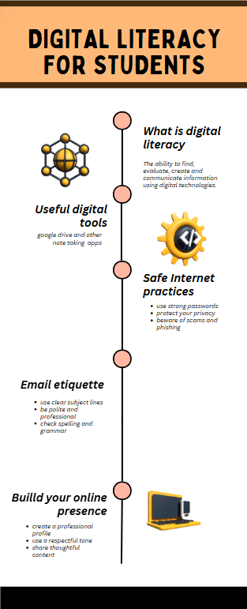
Figure1:Digital Literacy Awareness Infographic

Task2: Build Your Student Digital Portfolio
In Task2,I focused on building my digital portfolio by creating and updating my profiles on important professional platforms such as LinkedIn and GitHub. In today’s digital world, having an online presence is essential for students as it helps in showcasing skills, connecting with professionals, and exploring career opportunities.

On LinkedIn, I created a professional profile by adding my education details, including my course, institution, and expected graduation year. I also added a suitable headline and basic information to present myself professionally. This platform will help me build connections and explore internship opportunities in the future.

On GitHub, I explored repositories and learned how projects are managed and shared. I also understood the importance of GitHub as a platform to showcase technical work and projects. It will help me track my progress and build a strong portfolio over time.

This task helped me understand how digital platforms can be used effectively for personal and professional growth. In the coming years, I plan to actively use these platforms to improve my skills and create a strong digital presence.

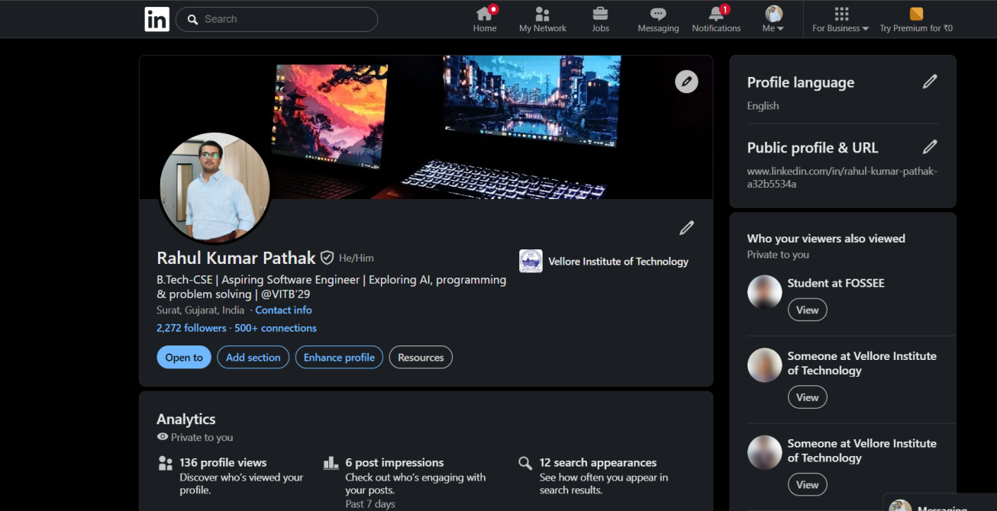
Figure2:LinkedIn Professional Profile
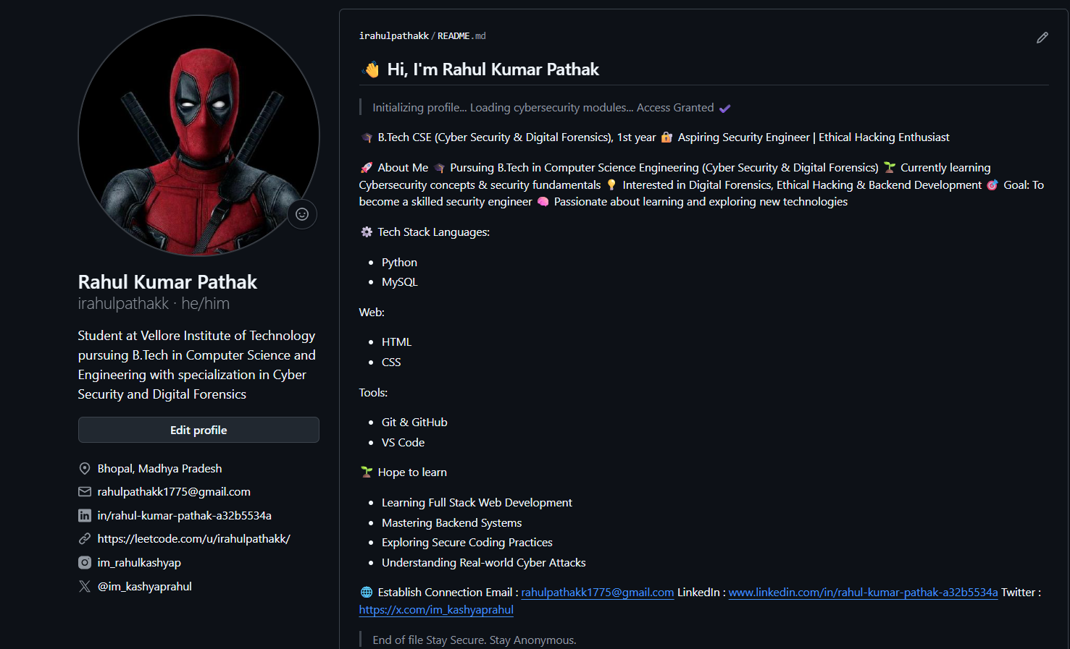
Figure3:GitHub Repository Overview

Task3: Explore Coding & Collaboration Platforms

Part A–Coding Practice
For Part A of Task 3, I used Hacker Rank as a coding practice platform. I created an account and explored beginner-level Python challenges. I completed several problems such as “Say Hello, World!”, “Python If-Else”, and “Loops”, which helped me understand the basics of programming and problem-solving.

In addition to solving challenges, I also completed the “Problem Solving(Basic)” certification on Hacker Rank. This certification tested my understanding of basic programming concepts and logical thinking.

Through this platform, I learned how coding challenges are structured and how solutions are evaluated based on correctness. It also helped me improve my problem-solving skills and build confidence in coding.

Hacker Rank is a useful platform for students as it provides structured learning and tracks progress through badges, scores, and certifications. Overall, this task helped me gain practical coding experience and improve my technical skills.

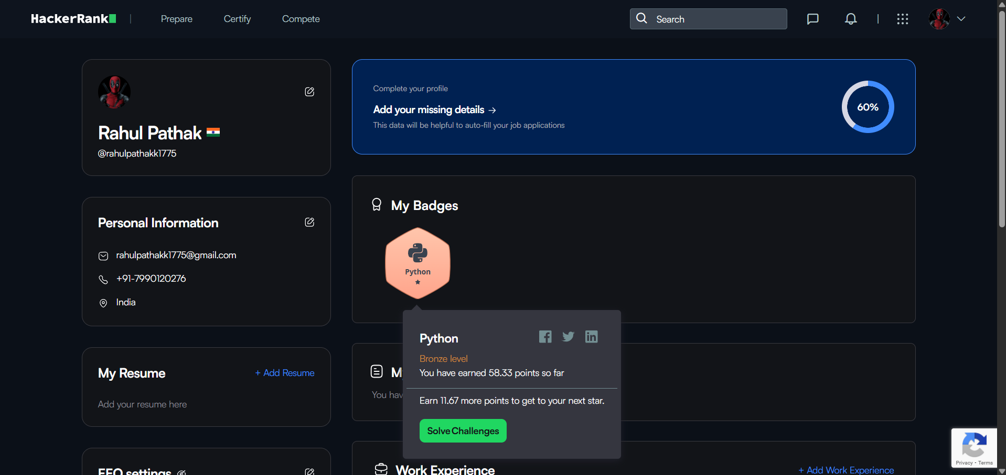
Figure4:HackerRankProfileScreenshot
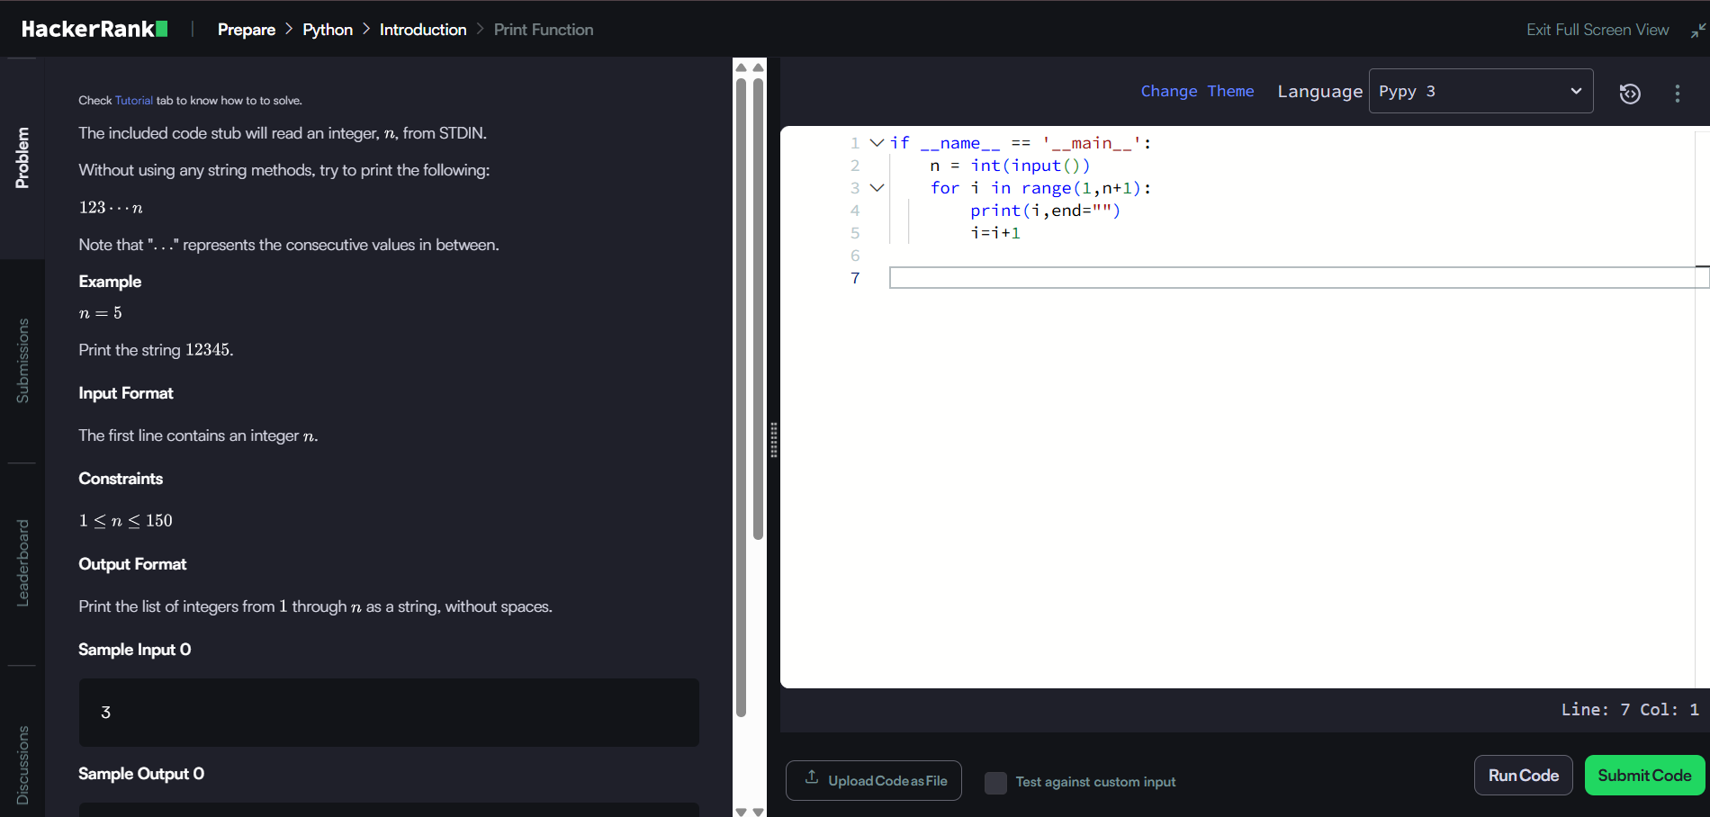
Figure5:HackerRankSolvedProblemScreenshot

Part B–Google Workspace Collaboration
For Part B of Task3,I created a Google Form titled “Digital Literacy Awareness Quiz”to assess basic understanding of digital literacy concepts. The form consists of five questions, including multiple-choice, checkbox, and short-answer types.

The questions cover topics such as digital literacy, safe passwords, online safety, phishing, and digital tools.This form helps in testing awareness about responsible internet usage.

I also explored the responses feature of Google Forms, where responses are automatically collected and organized in Google Sheets. This makes it easy to analyze data and understand user responses.

This task helped me understand how online tools can be used for creating quizzes, collecting data, and analyzing results efficiently. It is a useful tool for academic and collaborative purposes.

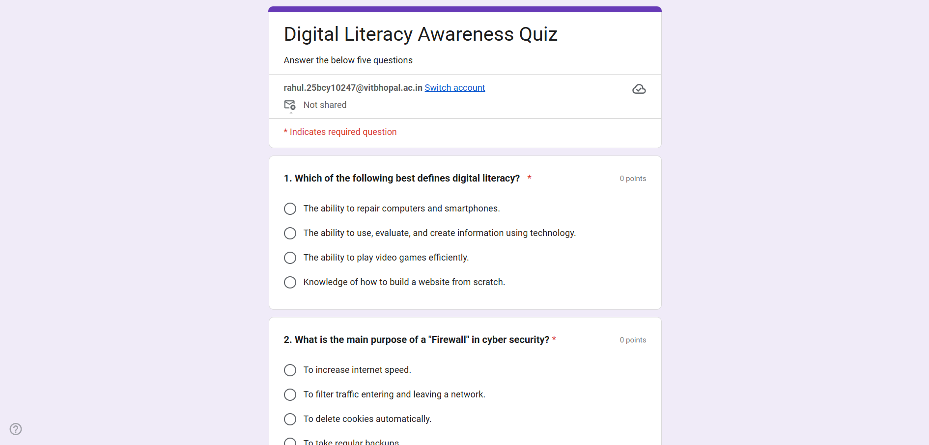
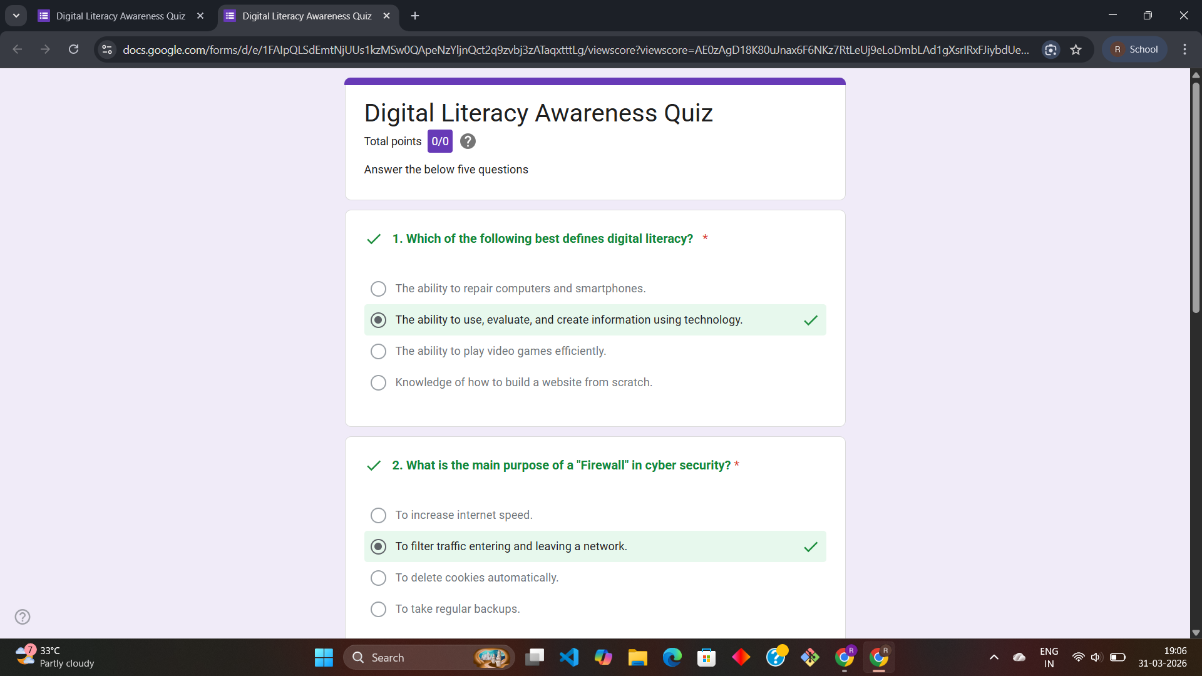
Figure6: Google Forms Quiz and answers Screenshot

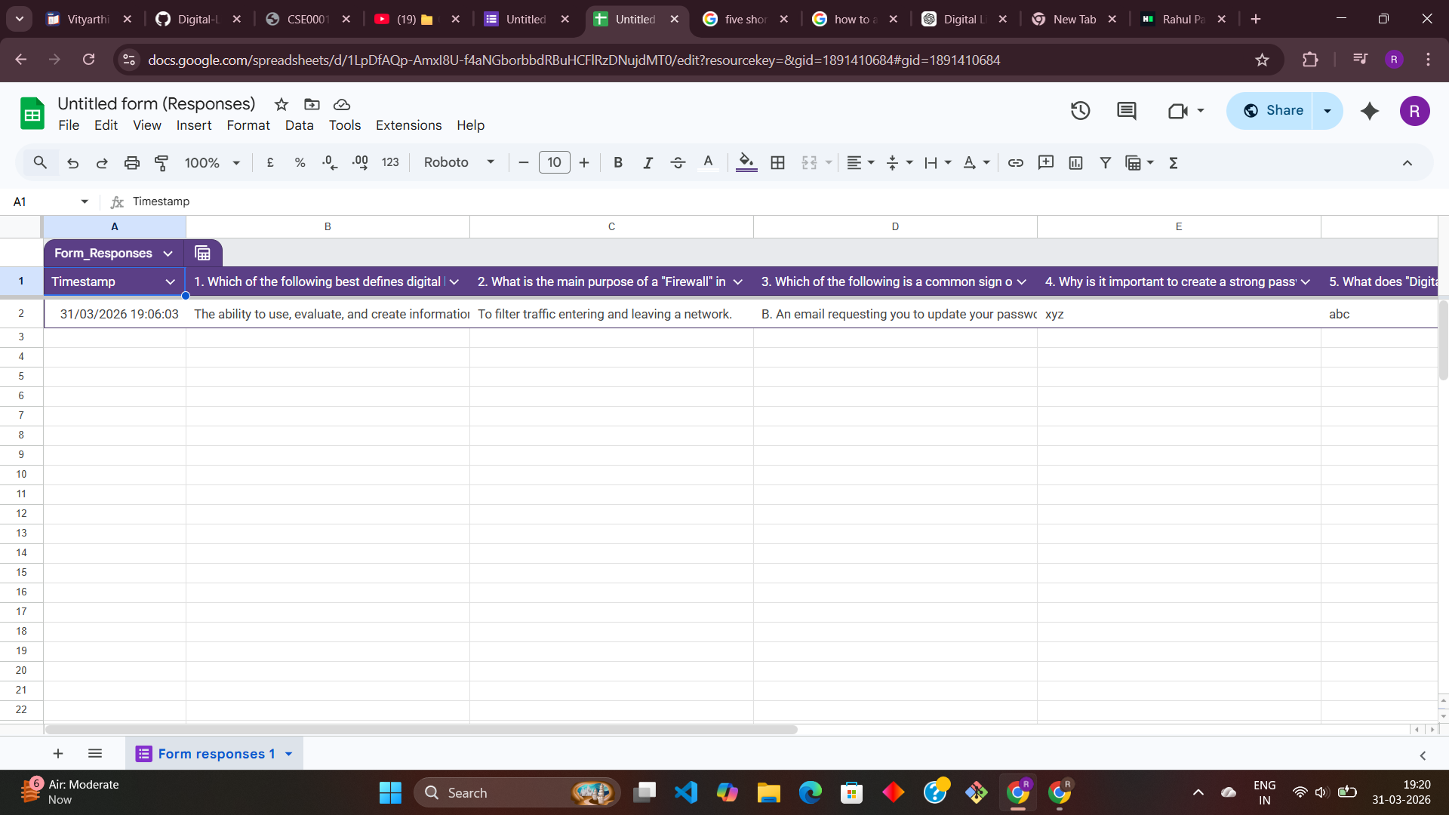
Figure7:Google Forms Response Screenshot

Task4:DraftaProfessionalEmail&EtiquetteGuide

PartA–Writetwoprofessionalemails
For Part A of Task 4, I wrote two professional emails to understand proper email communication.Thefirstemailwaswrittentoaprofessorrequestinganextensionforan assignment submission. The second email was written to an internship coordinator expressing interest in a summer internship opportunity.

While writing these emails, I focused on maintaining a formal tone, clear subject lines, andproperstructure.Eachemailincludedapolitegreeting,awell-organizedbody,anda professional closing with a signature.

This task helped me understand the importance of email etiquette in academic and professional communication. Writing clear and respectful emails ensures effective communicationandcreatesapositiveimpression.Ialsolearnedthatemailsshouldbe concise, polite, and free from informal language.

Overall,thispartofthetaskimprovedmyabilitytocommunicateprofessionallythrough email, which is an essential skill for students and future professionals.

PartB–CreateaSocialMediaDo'sandDon'tschecklist
For Part B of Task 4, I created a checklist of do’s and don’ts for responsible social media usage. The checklist includes important practices such as using strong passwords, maintainingprivacy,verifyinginformationbeforesharing,andrespectingothersonline.It also highlights actions to avoid, such as sharing personal information, posting inappropriate content, clicking suspicious links, and engaging in cyberbullying.

Thischecklisthelpsstudentsunderstandhowtobehaveresponsiblyonsocialmedia platforms and protect themselves from potential risks.

One situation where poor digital communication can cause problems is when a student sendsaninformalorunclearmessagetoaprofessororpostsinappropriatecontentonline. This can create a negative impression and may affect academic or professional opportunities.

Task5:CybercrimeAwarenessCaseStudy&Prevention Guide

PartA–Case Study
Phishing is a type of cybercrime in which attackers trick individuals into revealing sensitive information such as passwords, bank details, or OTPs by pretending to be a trustedsource.Thisiscommonlydonethroughfakeemails,messages,orwebsitesthat look similar to legitimate ones.

Atypicalphishingscenarioinvolvesastudentreceivinganemailormessagethatappears to be from a bank or UPI service, asking them to verify their account details. The message contains a link that redirects to a fake website designed to look real. When the user enters their login credentials or OTP, the attacker gains access to their account and may misuse the information for financial fraud.

Phishingattacksoftentargetstudentsandyoungusersbecausetheyareactiveonlineand may not always verify the authenticity of messages. The consequences can include financial loss, identity theft, and misuse of personal data.

Thiscasestudyhighlightstheimportanceofbeingcautiouswhileclickinglinksand sharing information online, and the need to verify sources before taking any action.

PartB–PreventionChecklist
Inthistask,Ilearnedaboutcybercrime,especiallyphishing,andhoweasilypeoplecan become victims of such attacks. What surprised me the most was how attackers create fake websites and messages that look very real, making it difficult for users to identify scams.

Thistaskmadememoreawareofonlinethreatsandtheimportanceofstayingcautious while using digital platforms. One habit I will change is that I will always verify links, messages, and sources before clicking or sharing any personal information. I will also avoid responding to unknown or suspicious messages.

Overall,thistaskhelpedmeunderstandtheimportanceofcybersafetyandencouraged me to follow safe online practices in my daily digital activities.

Conclusion:

Thisprojecthelpedmeunderstandtheimportanceofdigitalliteracyintoday’sworld. Through different tasks, I learned how to use digital tools, build a professional online presence,andcommunicateeffectivelyusingemails.Ialsoexploredcodingplatforms and gained basic problem-solving experience. The cybercrime task increased my awareness about online threats and safety practices.

Overall,thisprojectimprovedmytechnicalknowledge,communicationskills,anddigital awareness. It also helped me become more responsible while using online platforms. The skills and knowledge gained from this project will be useful for my academic journey as well as future professional growth.

References:

- -Canva– https://www.canva.com
- -GitHub– https://www.github.com
- -LinkedIn–https://www.linkedin.com
- -HackerRank–https://www.hackerrank.com
- -GoogleForms–https://forms.google.com
- -NationalCyberCrimePortal–https://cybercrime.gov.in

