Internee.pk — Cybersecurity Internship
Task Completion Report
Secure Cloud Infrastructure
Intern | IrajBibi
Task | Secure Cloud Infrastructure
Platform Used | Amazon Web Services (AWS)
Services Configured | IAM, CloudTrail, AWS Backup, AWS WAF, S3
Date Completed | August 23, 2026

1. Objective
The objective of this task was to ensure Internee.pk's cloud-based platforms follow industry-standard security measures. This involved auditing a cloud account for security compliance, applying least-privilege IAM policies, configuring redundant backups, and enabling a Web Application Firewall (WAF) to filter and monitor external traffic.

Deliverables Completed
- Audited the AWS account's IAM configuration for security compliance.
- Applied a least-privilege IAM policy via a purpose-specific IAM user.
- Enabled multi-region CloudTrail logging for full account activity visibility.
- Set up multi-region backup infrastructure using AWS Backup.
- Enabled a Web Application Firewall (WAF) with multi-layer protection rules.
- Referenced a public dataset from the AWS Open Data registry.

Data Sources Used
- Cloud security logs from AWS CloudTrail.
- Public dataset from AWS Open Data (registry.opendata.aws).

2. AWS Account Setup
An AWS account was provisioned through a managed training sandbox environment. The AWS Management Console was used throughout to configure and audit security services.
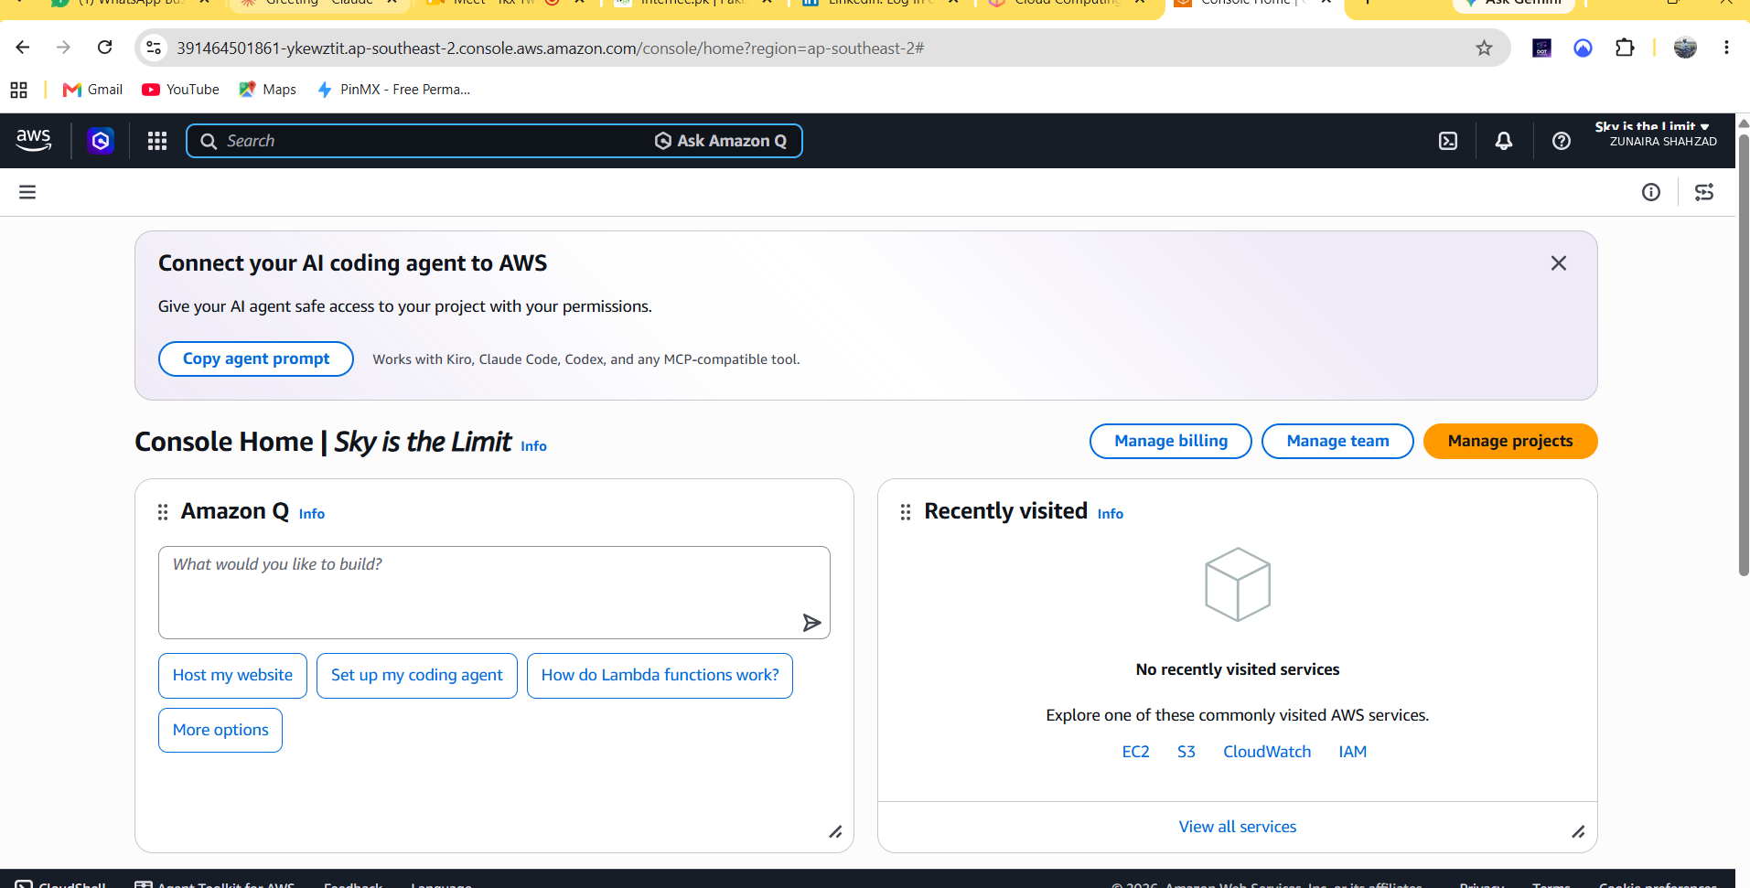
Figure 1 — AWS Management Console, account provisioned and ready for configuration.

3. IAM Audit & Least-Privilege Access
The account's Identity and Access Management (IAM) configuration was reviewed as part of the security compliance audit. The account had zero standing IAM users at the time of review, with AWS itself recommending that human access be managed through the platform's own team-management feature rather than long-lived IAM credentials — a security best practice that was already being followed.
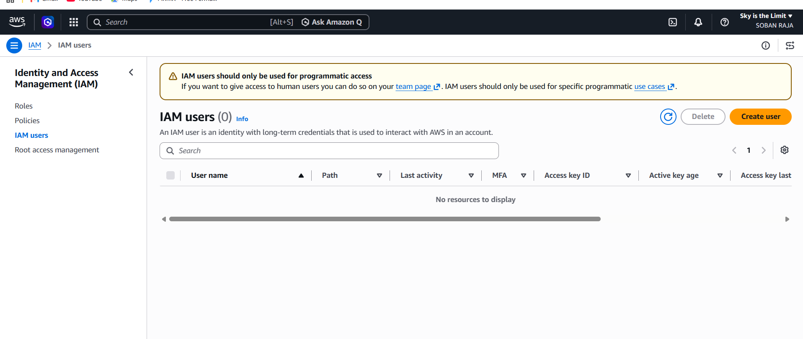
Figure 2 — IAM users audit: zero legacy IAM users found; AWS recommends programmatic-only use of IAM users.
To demonstrate applying an IAM policy under the principle of least privilege, a purpose-specific IAM user was created with only Amazon S3 read-only access — no administrative or write permissions — rather than a broad, standing-privilege account.
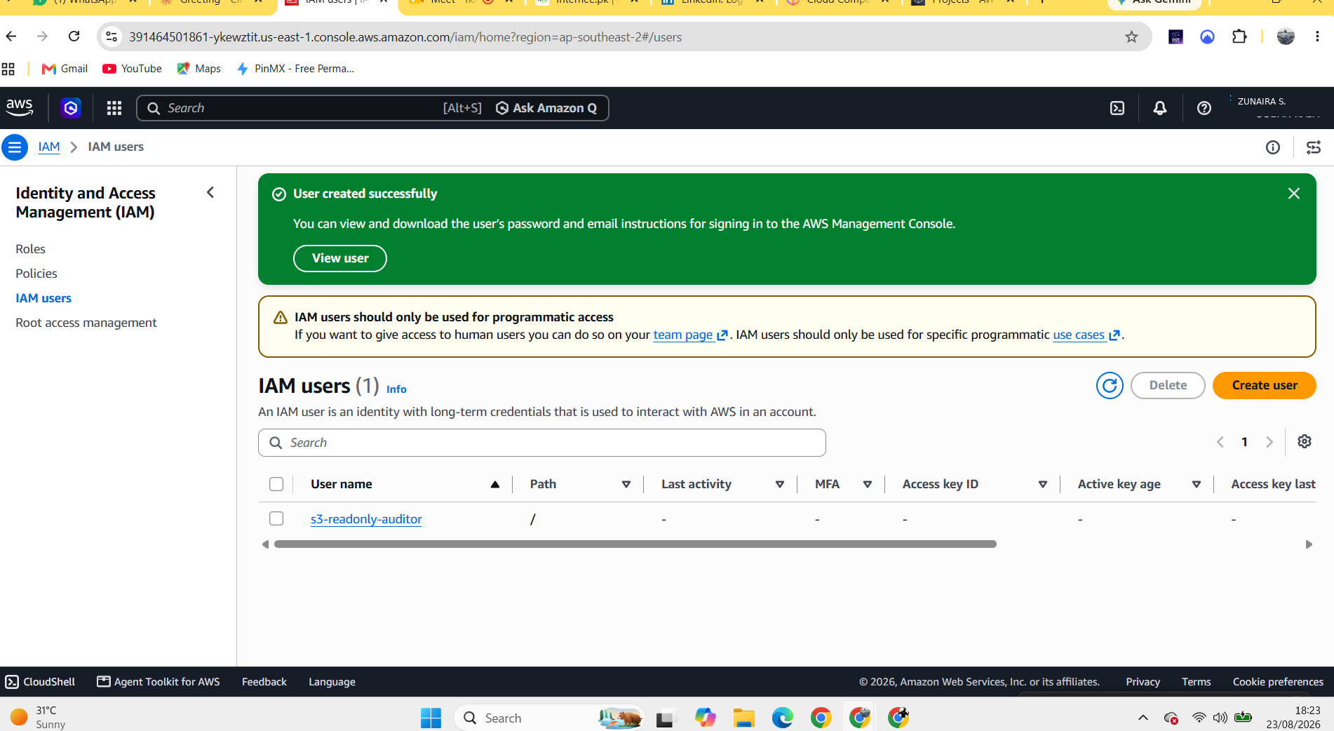
Figure 3 — Least-privilege IAM user (s3-readonly-auditor) created with AmazonS3ReadOnlyAccess only.

4. Cloud Security Logging — AWS CloudTrail
AWS CloudTrail was enabled to provide continuous logging of all account activity, serving as the primary cloud security log source for this audit. The trail was configured as multi-region, meaning API activity is captured across every AWS region the account operates in, not just a single default region.
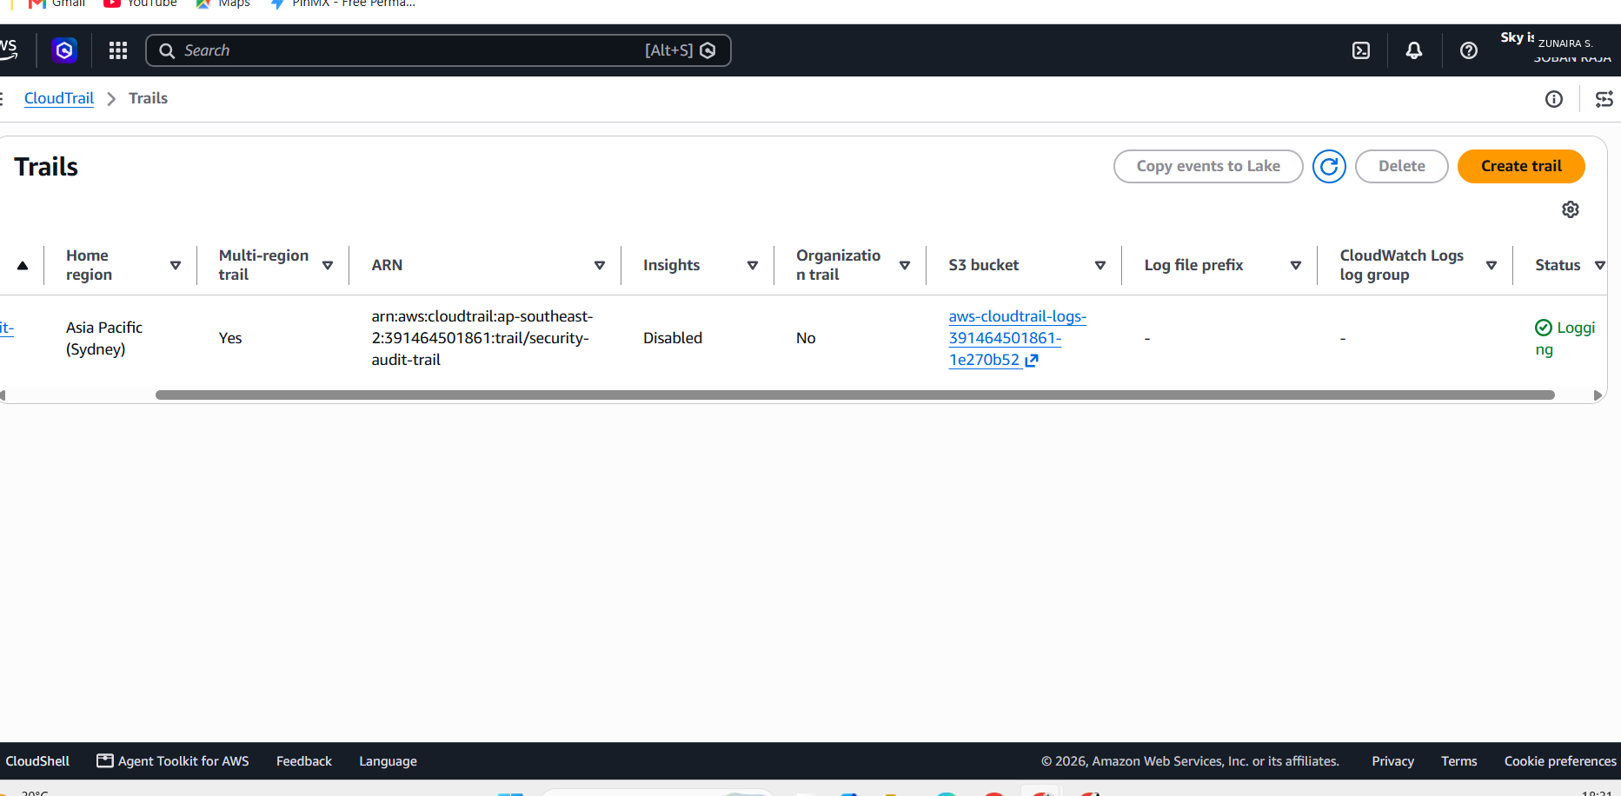
Figure 4 — CloudTrail trail “security-audit-trail” actively logging, multi-region enabled.

5. Multi-Region Backup Configuration
Two S3 buckets were provisioned to support data redundancy, and AWS Backup was configured with a dedicated backup vault and a daily backup plan (35-day retention), with the S3 bucket assigned as a protected resource. This establishes an automated, recurring backup policy rather than a one-off manual copy.
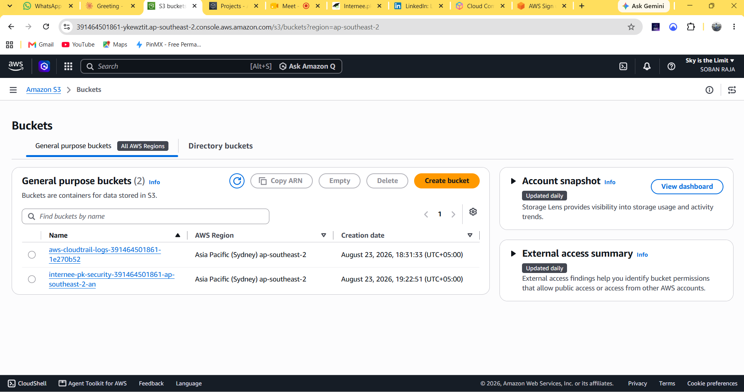
Figure 5 — S3 buckets provisioned to support the backup and audit configuration.
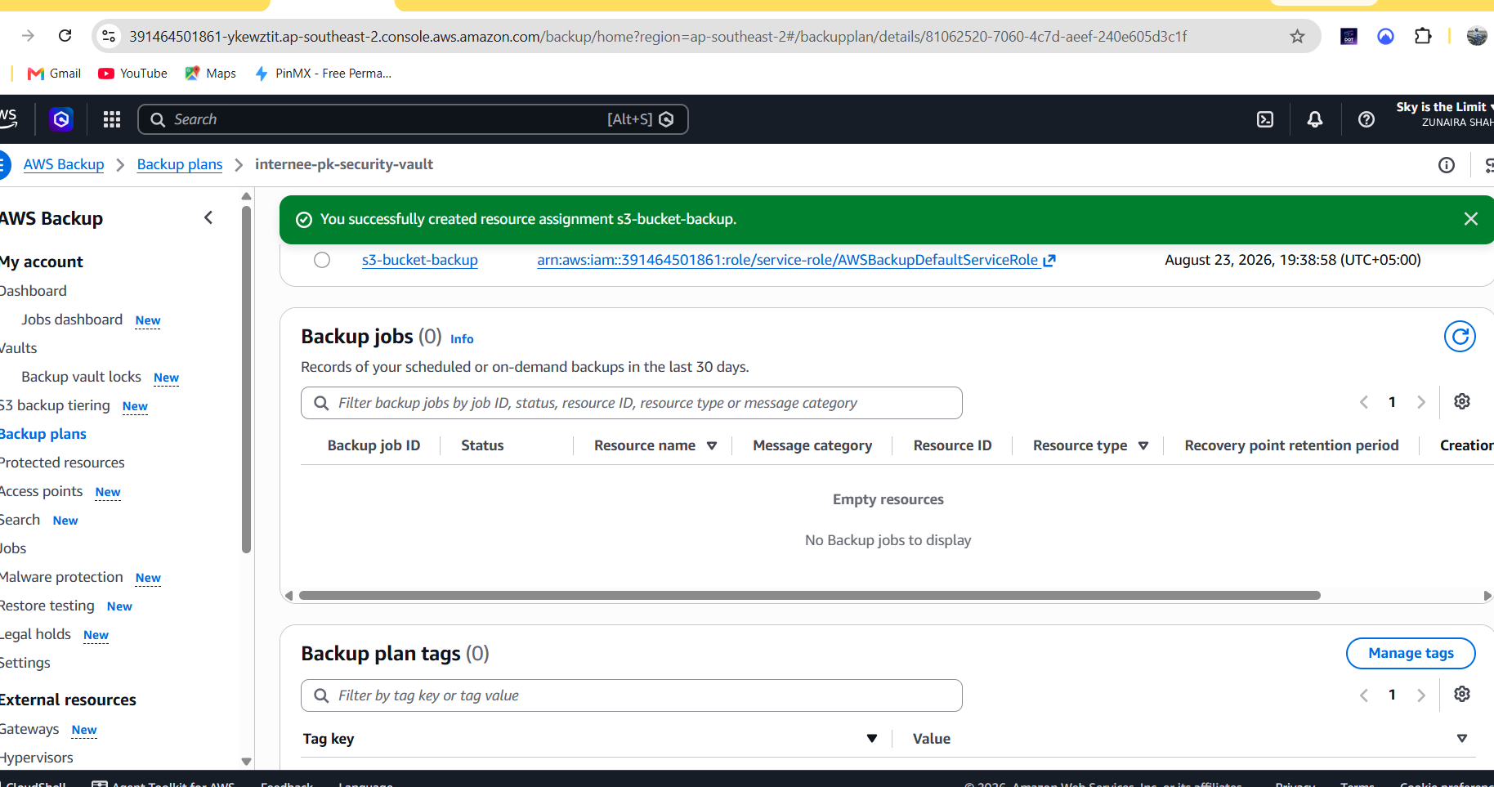
Figure 6 — AWS Backup resource assignment (s3-bucket-backup) successfully attached to the backup plan and vault.

Scope Note
The training sandbox environment used for this task enforces a single-region restriction at the organization level (confirmed by testing multiple alternate regions, all of which were blocked). True cross-region S3 replication was therefore not achievable within this environment. AWS Backup was used instead as the redundancy mechanism, since it is AWS's recommended, more automated approach to backup management and does not require manual cross-region bucket replication to establish a working backup policy.

6. Web Application Firewall (WAF)
An AWS WAF Web ACL was created to filter and monitor external traffic, satisfying the task's WAF deliverable. Rather than a single generic rule group, the configuration includes multiple protection layers: anti-DDoS protection, IPv4/IPv6 allow and block rules, geographic filtering, and rate-based rules for both GET and POST methods.
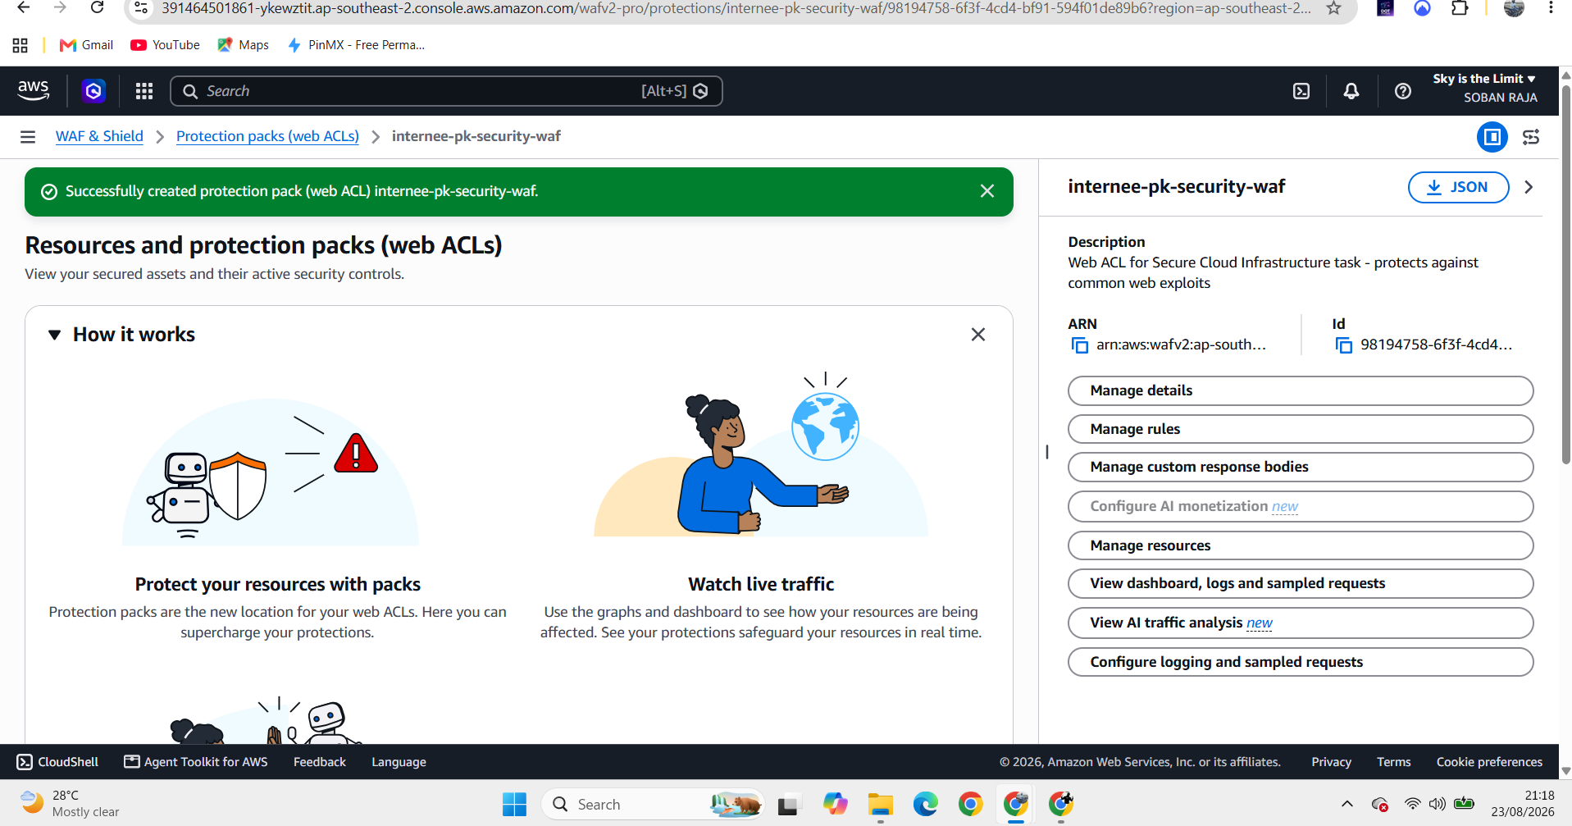
Figure 7 — Web ACL “internee-pk-security-waf” successfully created, with description and ARN.
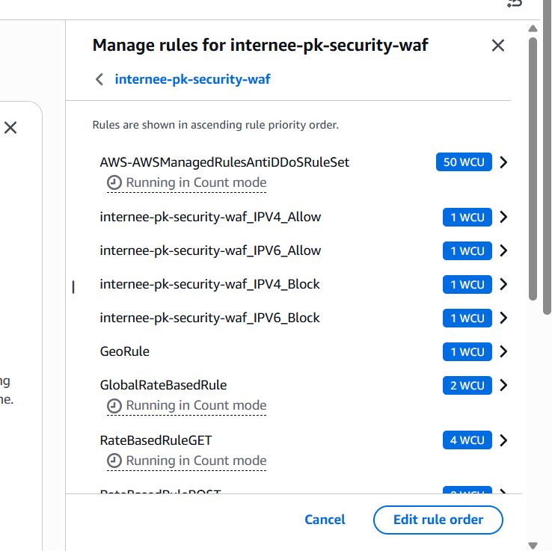
Figure 8 — Active WAF rule set: Anti-DDoS rule set, IPv4/IPv6 allow/block rules, geographic rule, and rate-based rules.

7. AWS Open Data Reference
As specified in the task's data-source guidance, a public dataset was located and referenced from the AWS Open Data registry (registry.opendata.aws). The dataset selected — the NapierOne Mixed File Dataset — is a cybersecurity-focused dataset tagged for computer security, digital forensics, malware, and ransomware research. It contains over 500,000 files across 44 file types, curated to support ransomware detection and forensic analysis research. The dataset is hosted as a public S3 bucket and is directly accessible via the AWS CLI without requiring an AWS account, directly reinforcing this task's cloud security theme.
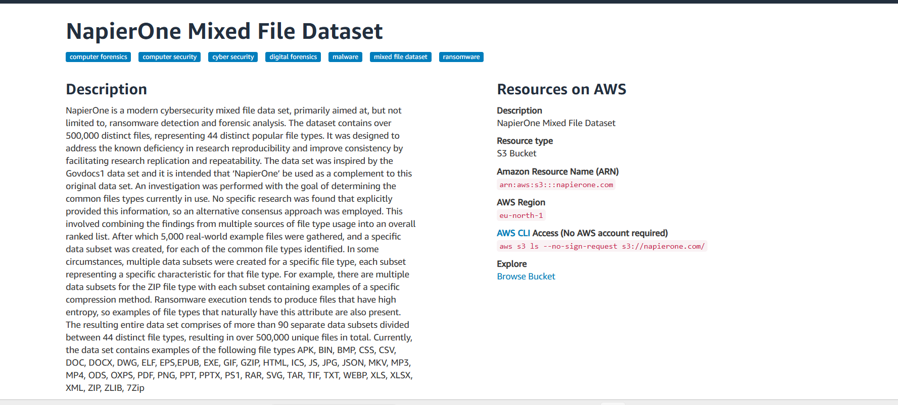
Figure 9 — NapierOne Mixed File Dataset (AWS Open Data): a cybersecurity/ransomware-forensics dataset, including its S3 resource ARN, region, and public CLI access command.

8. Troubleshooting Notes
Several real-world platform constraints were encountered and worked around during this task:
- The training sandbox restricted the account to a single AWS region at the organization level (multiple regions tested and blocked) — addressed by using AWS Backup rather than manual cross-region S3 replication.
- The newer WAF “Protection Pack” wizard required an existing live resource (e.g. a Load Balancer or CloudFront distribution) to proceed — resolved by selecting the generic “regional resources” category, which allowed the Web ACL and its rules to be created independently of a specific attached resource.
- Listing global-scope Web ACLs triggered a persistent permissions error caused by an organization-level Service Control Policy (SCP) — identified as a sandbox-level restriction outside the account's control, and confirmed to have no impact on the regional WAF that was actually configured.

9. Conclusion
This task delivered a documented cloud security baseline for Internee.pk's AWS environment. IAM access follows least-privilege principles, all account activity is continuously logged via multi-region CloudTrail, a recurring automated backup policy is in place via AWS Backup, and a multi-layered Web Application Firewall actively filters for DDoS, IP-based, geographic, and rate-based threats. Platform-level constraints in the training sandbox (single-region restriction, SCP-limited global resource visibility) were identified, worked around where possible, and documented transparently rather than concealed.

