**1. Start up the Wireshark program (select an interface and press start to capture**

**packets).**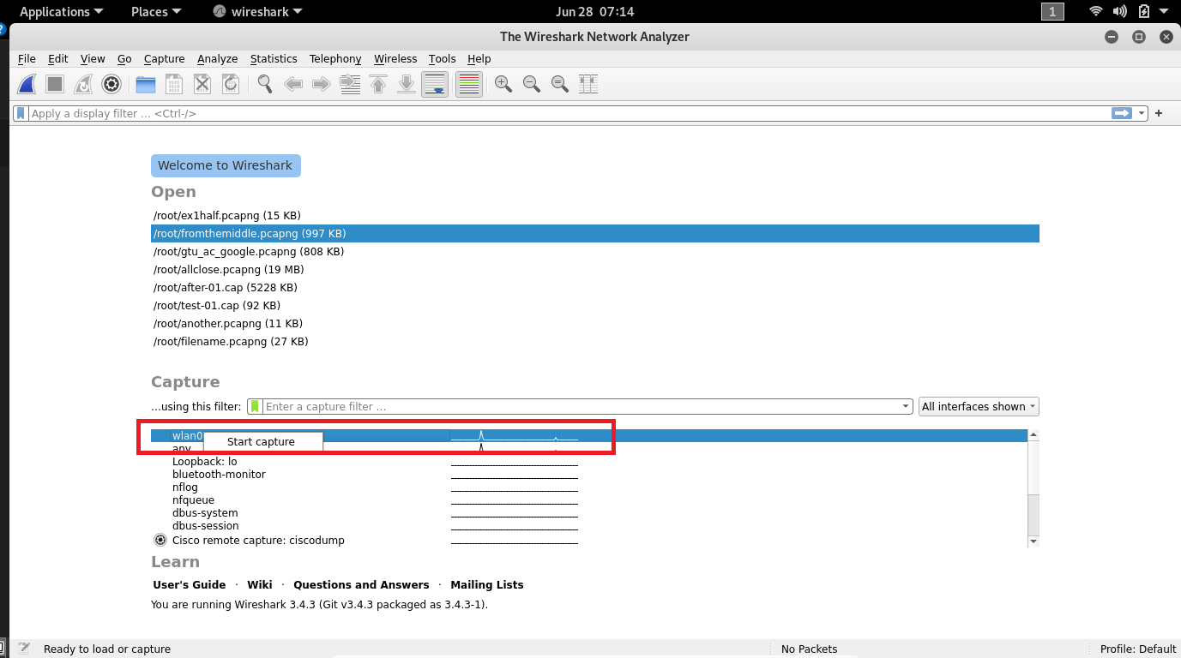

**2. Start up your favorite browser.**

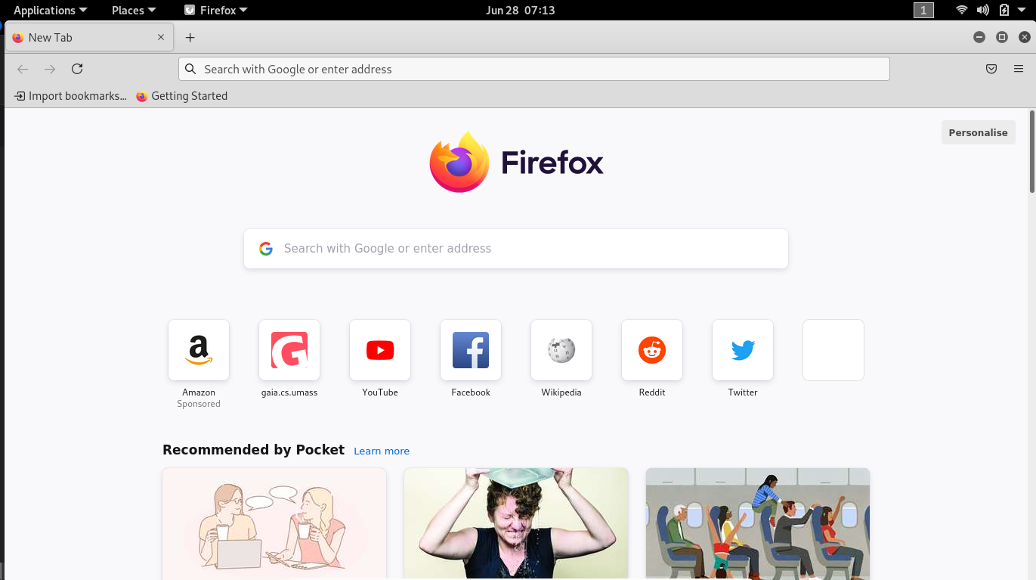

**3. In your browser, go to Gujarat Technological University homepage by typing** [**www.gtu.ac.in**](http://www.gtu.ac.in)

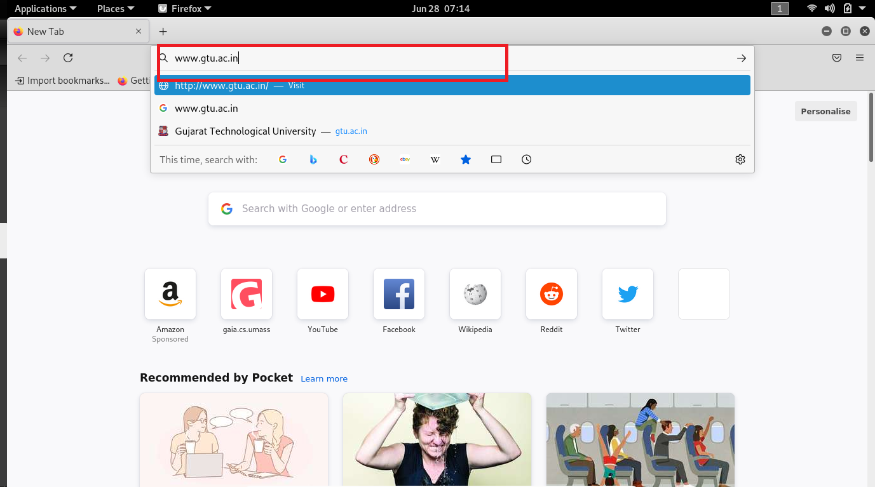

**Page look like this**

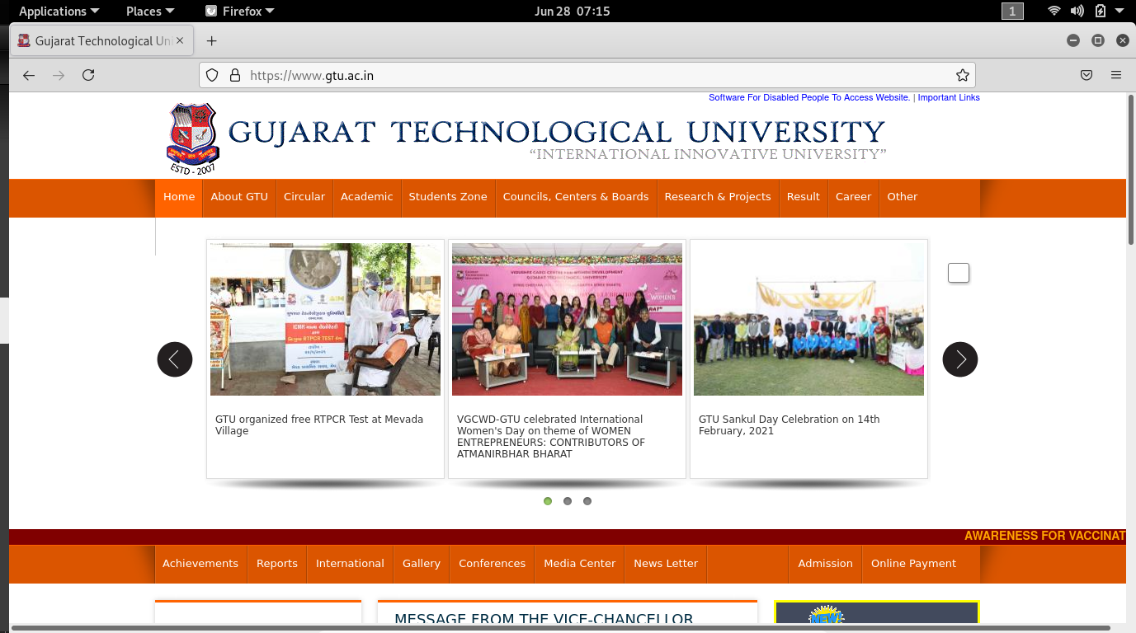

**4. After your browser has displayed the http://www.gtu.ac.in page, stop Wireshark packet capture**

**by selecting stop in the Wireshark capture window. This will cause the Wireshark capture window**

**to disappear and the main Wireshark window to display all packets captured since you began**

**packet capture, new window will appear:**

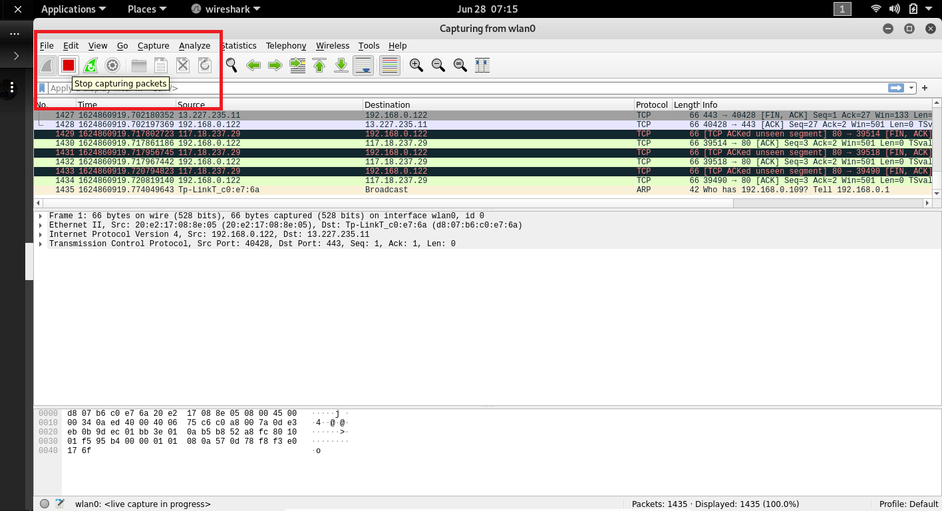

**5. Color Coding: You’ll probably see packets highlighted in green, blue, and black. Wireshark**

**uses colors to help you identify the types of traffic at a glance. By default, green is TCP traffic,**

**dark blue is DNS traffic, light blue is UDP traffic, and black identifies TCP packets with problems**

**— for example, they could have been delivered out-of-order.**

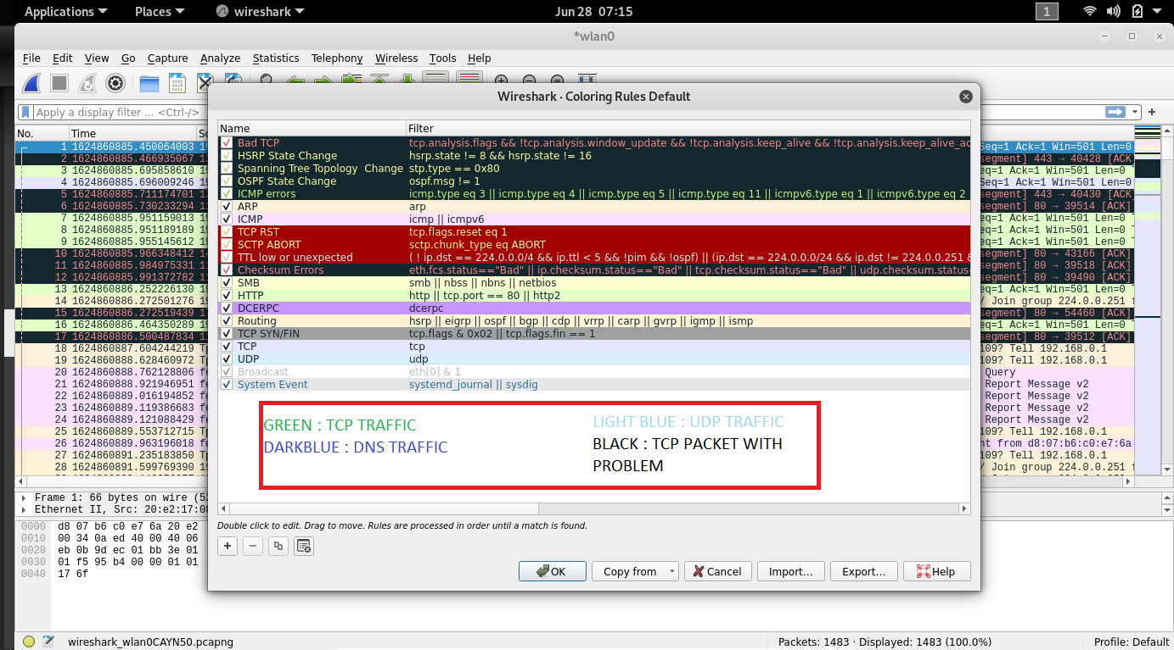

**7. To further filter packets in Wireshark, we need to use a more precise filter. By setting**

**the http.host==www.gtu.ac.in or http.host==www.facebook.com , we are restricting the view**

**to packets that have as an http host the www.gtu.ac.in website or www.facebook.com web site.**

**Notice that we need two equal signs to perform the match “==” not just one. new screenshot will**

**appear.**

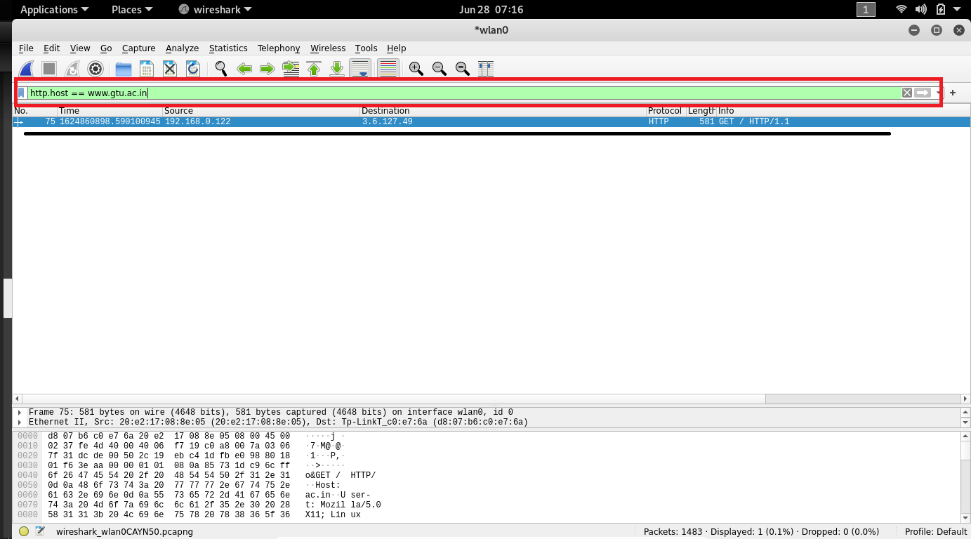

**8. Discuss http GET and RESPONSE**

The GET Method

**GET is used to request data from a specified resource.**

**GET is one of the most common HTTP methods.**

Note that the query string (name/value pairs) is sent in the URL of a GET request:

/test/demo_form.php?name1=value1&name2=value2

**Http Response 🡪** An **HTTP response** is made by a server to a client. The aim of the **response** is to provide the client with the resource it requested, or inform the client that the action it requested has been carried out; or else to inform the client that an error occurred in processing its request.