1. **Count the total number of HTTP GET requests.**

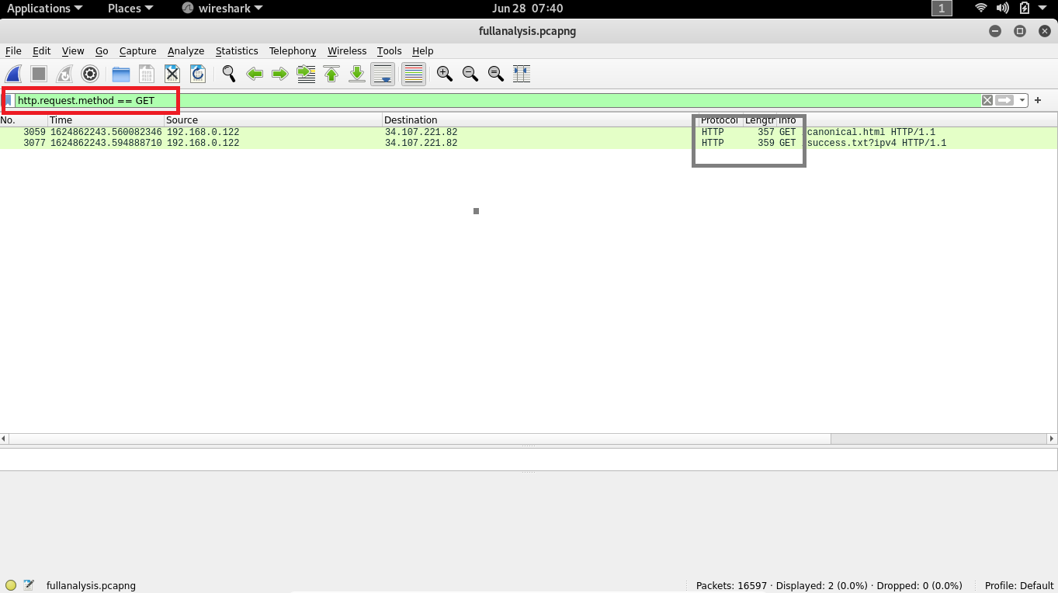there are 2 requests made

1. **The first HTTP GET request was sent by the client to access the ............... webpage.**

**ANS 🡪** canonical.html

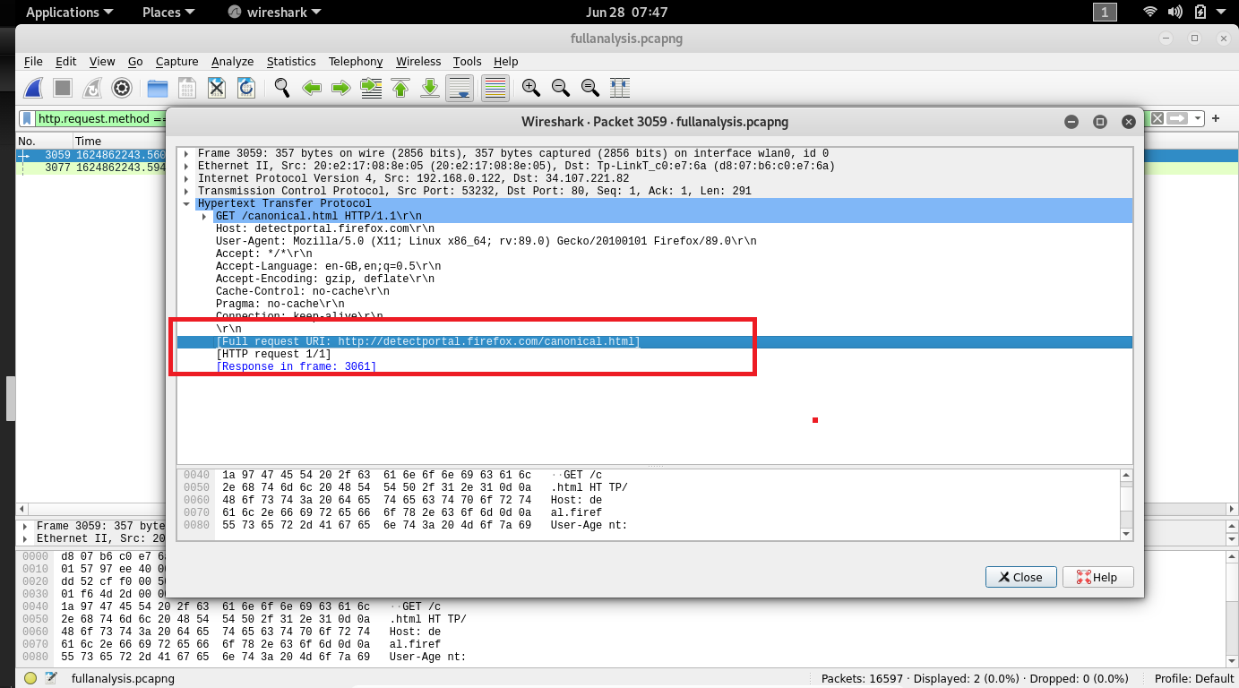

1. **What server software is running on the server side?**

**ans🡪 nginx**

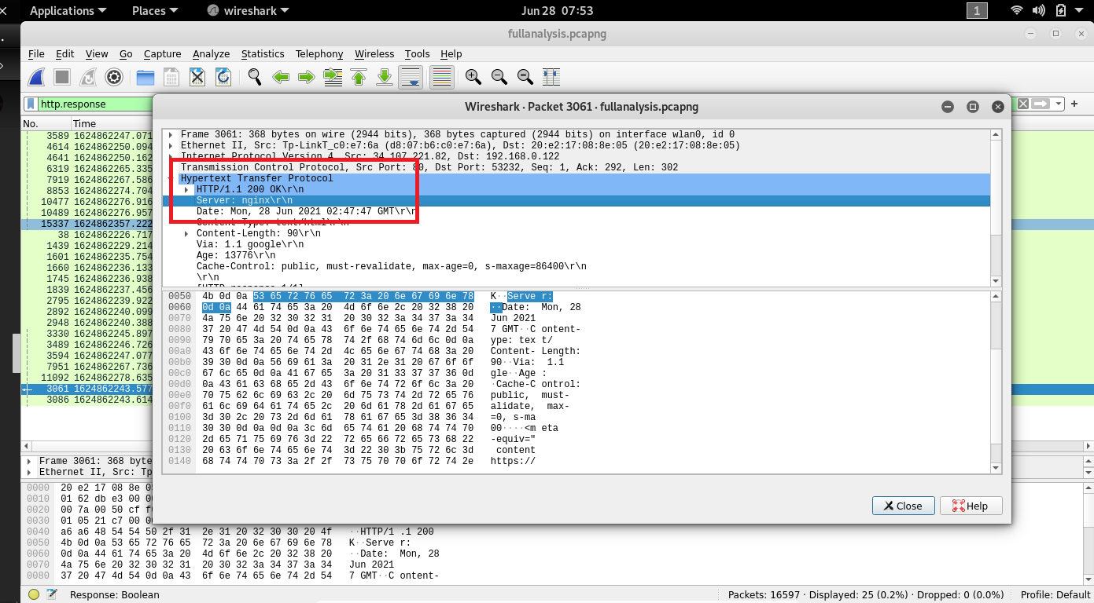

**4. How much time elapsed between the first HTTP GET request from client and the HTTP**

**response (OK) from server?**

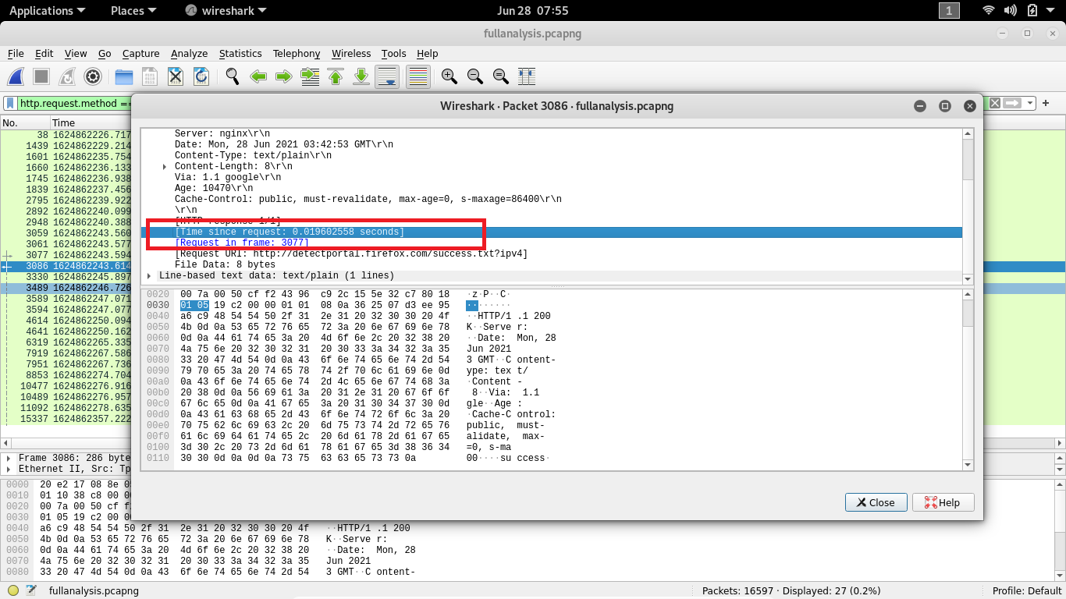

1. **Identify the source and destination ports used to transfer the first HTTP GET request**

**source port : 53234**

**destination port : 80**

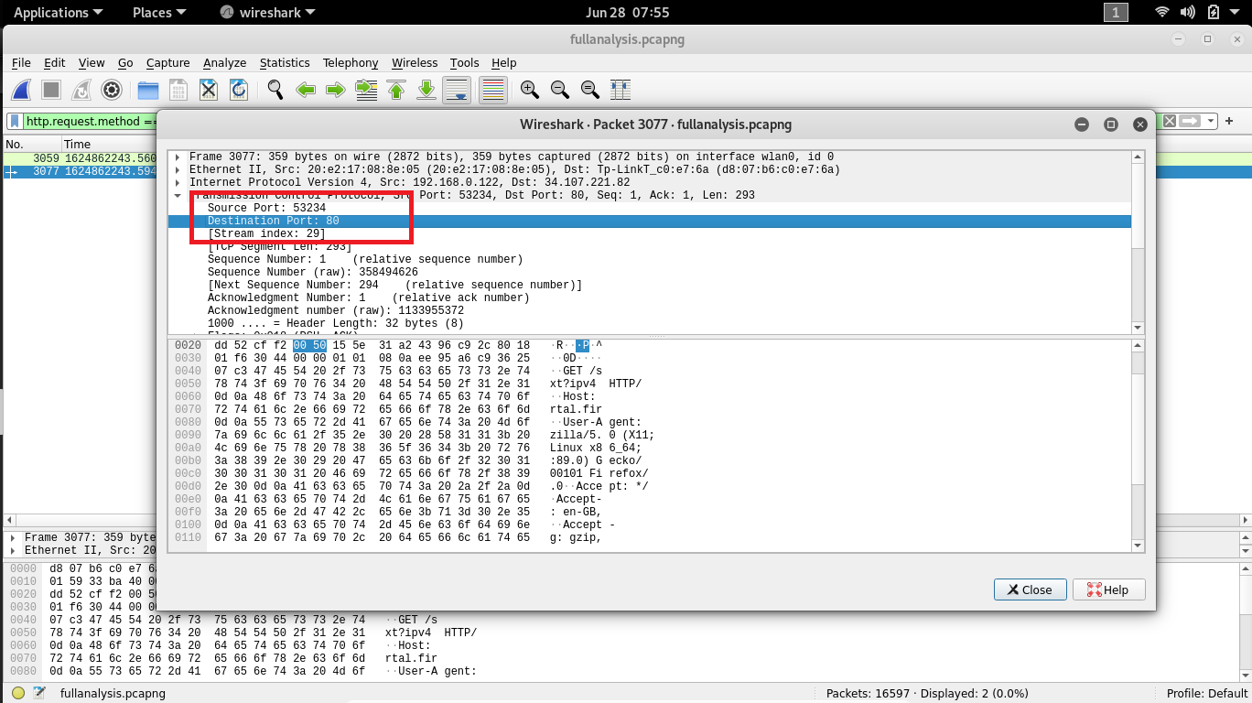

1. **Identify the client and server ip address in the first HTTP GET request?**
2. **Identify the client and server ip address in the first HTTP GET request?**

**ans🡪** Source Address : 192.168.0.122

Destination Address : 34.107.221.82

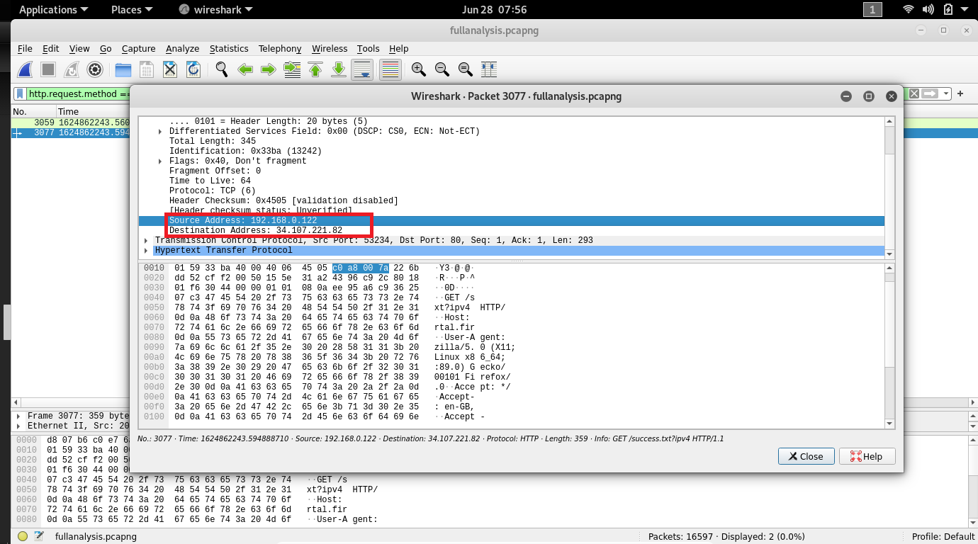

1. **Identify the client and server MAC address in the first HTTP GET request?**

**ANS 🡪** Destination : Tp_link_c0:e7:6a(d8:07:b6:c0:e7:6a)

Source : 20:e2:17:08:8e:05

