**Start packet capture**

Double click on selected interface

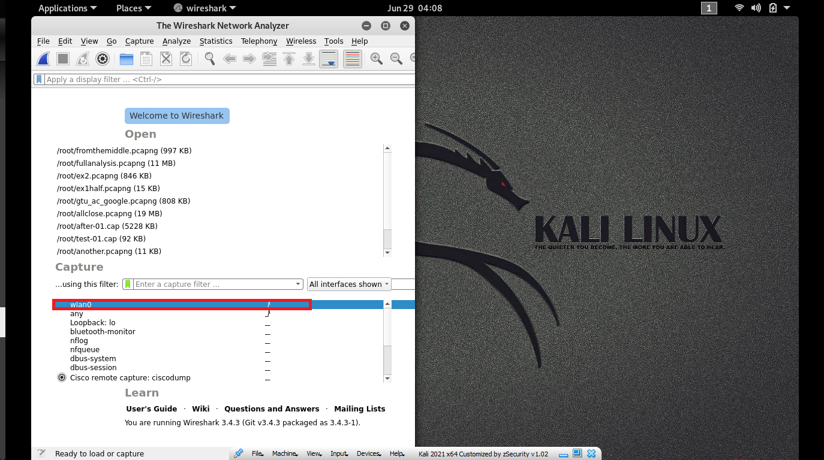

**At Command prompt > Nslookup** [**www.sandesh.com**](http://www.sandesh.com)

**1 ) open terminal**

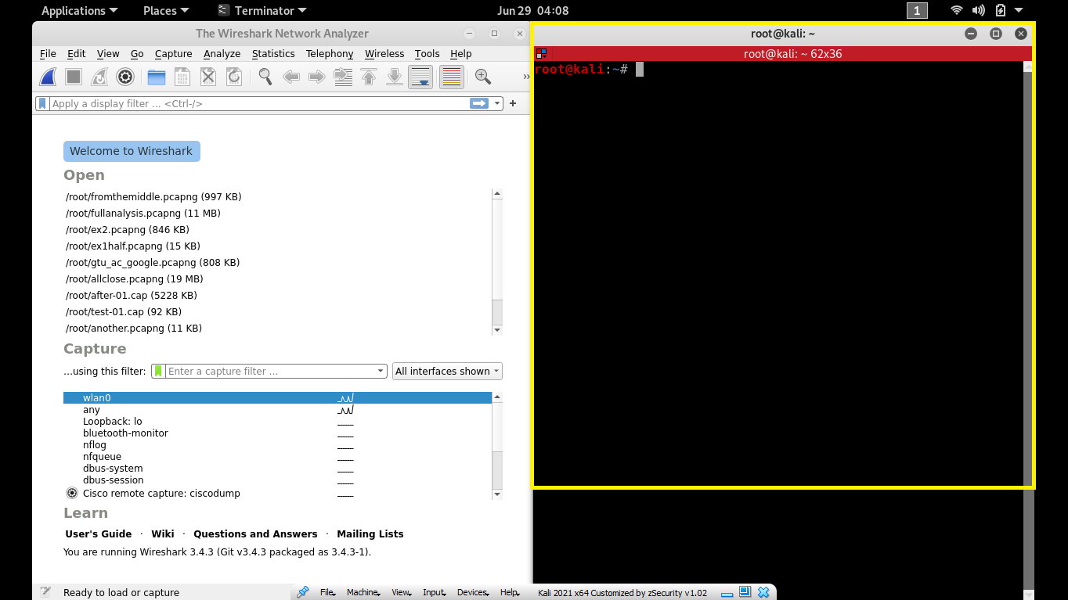

**I have linux so I’ve terminator…(if you are on window os just press start type cmd and press enter)**

**2) after open cmd or terminator type Nslookup** [**www.sandesh.com**](http://www.sandesh.com)

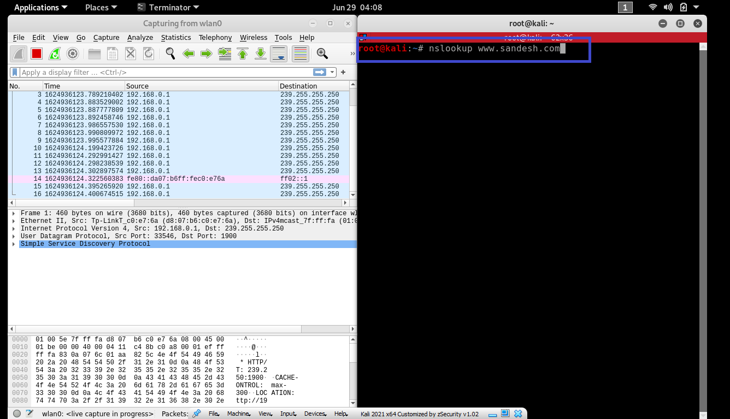

**Stop packet capture**

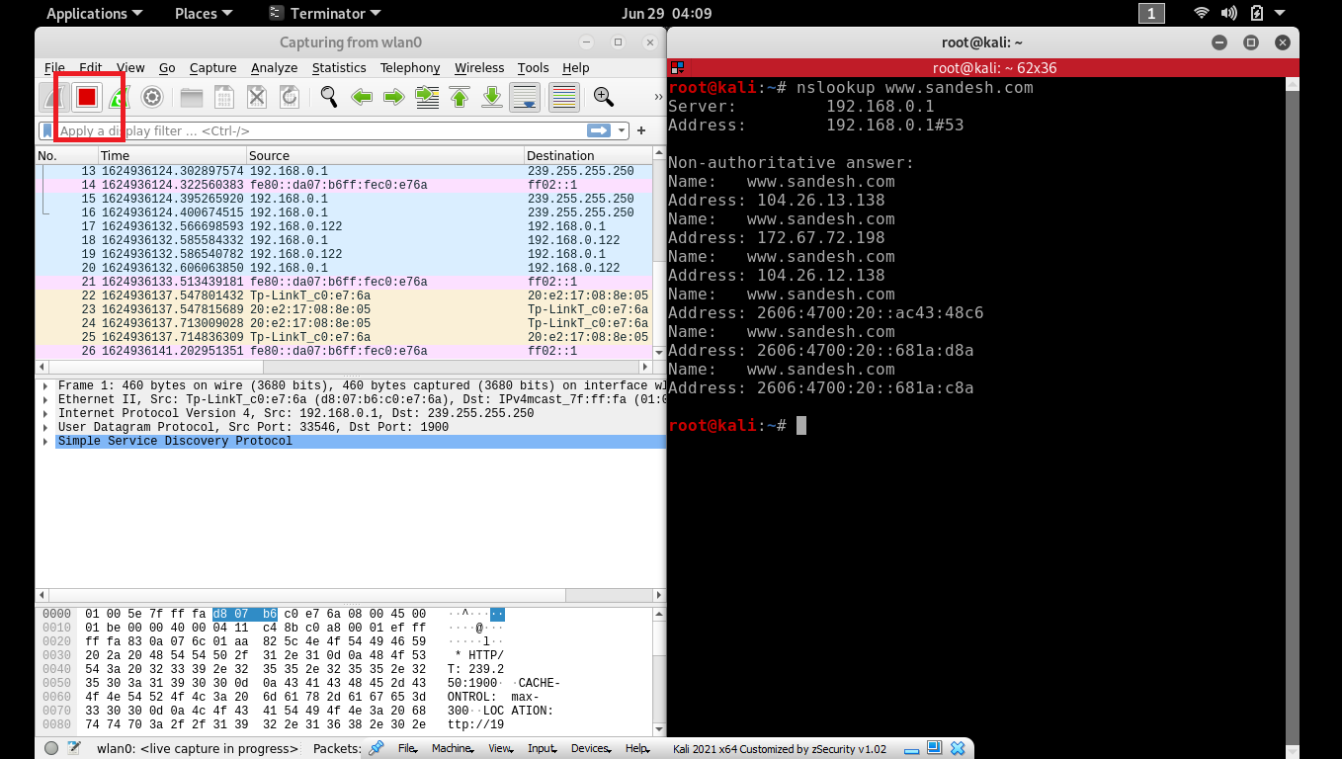

**Filter : ip.address== IP address of sandesh.com**

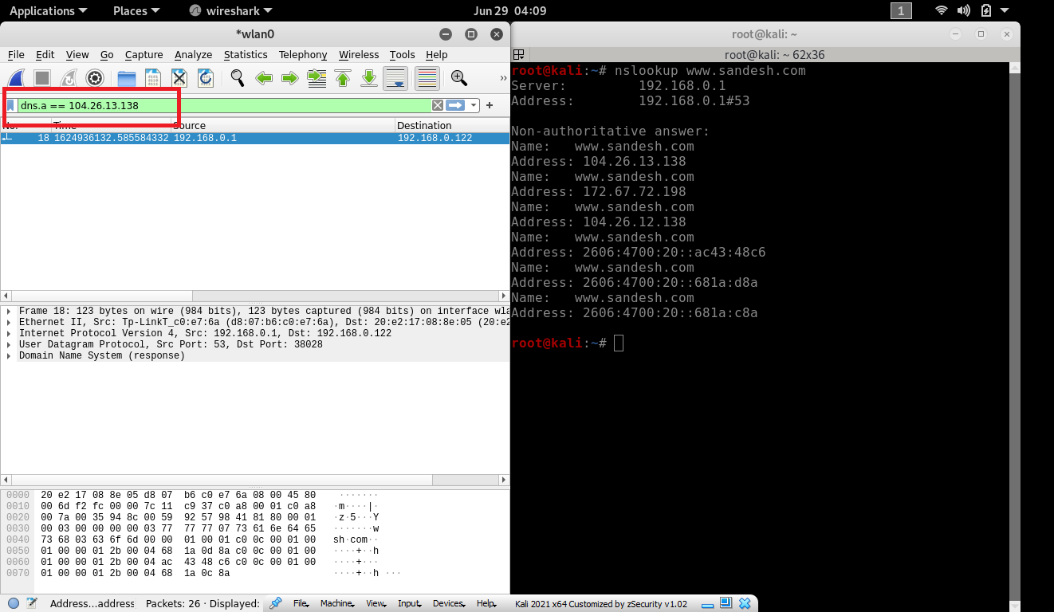

**Find These Questions**

**1. What is the destination port for the DNS query message ? What is the source port of of**

**DNS response message?**

**Ans 🡪 destination port : 38028**

**Source port : 53**

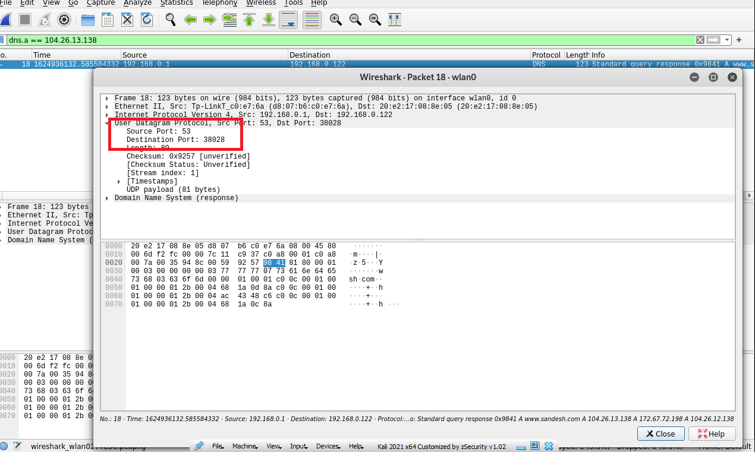

**2. To what IP address is the DNS query message sent ? Is this the IP address of your default**

**local DNS server ?**

**ans 🡪 The DNS Query is sent to IP Address 192.168.0.1, the same address as my default local DNS Server.**

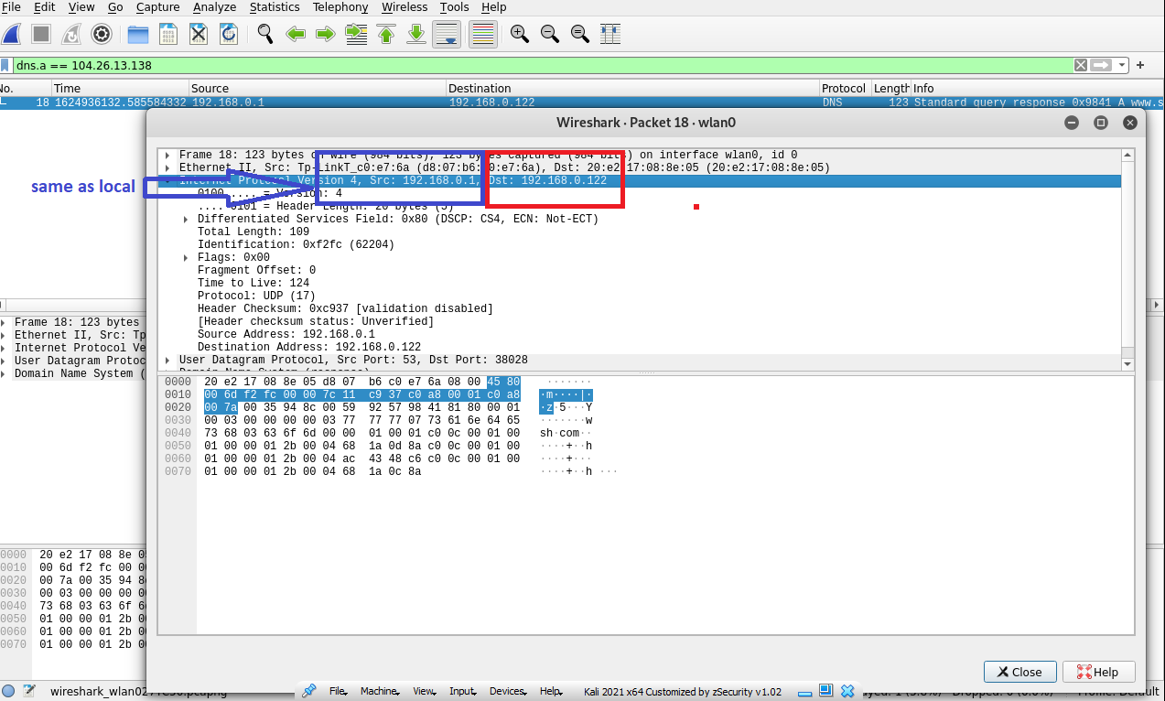

**3. Examine the DNS query message. What “Type” of DNS query is it? Does the query**

**message contain any “answers”?**

**ans🡪 The DNS query message is a type “A” query,containg only one questions and not containing any answers**

**4. Examine the DNS response message. How many “answers” are provided? What does each**

**of these answers contain?**

**ANS🡪 The response message contains one anser to the aforementioned query which is the type “A” address of** [**www.sandesh.com**](http://www.sandesh.com) **or 104.26.13.138.it also contained information about class,time to live and data length** 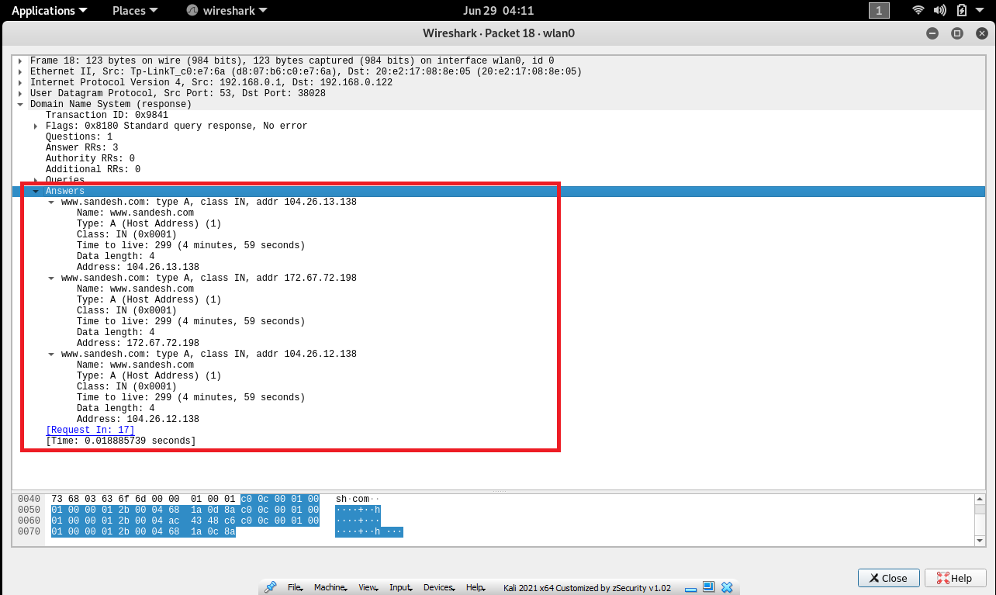

**Repeat the following steps**

Open wireshark and terminator then start capturing

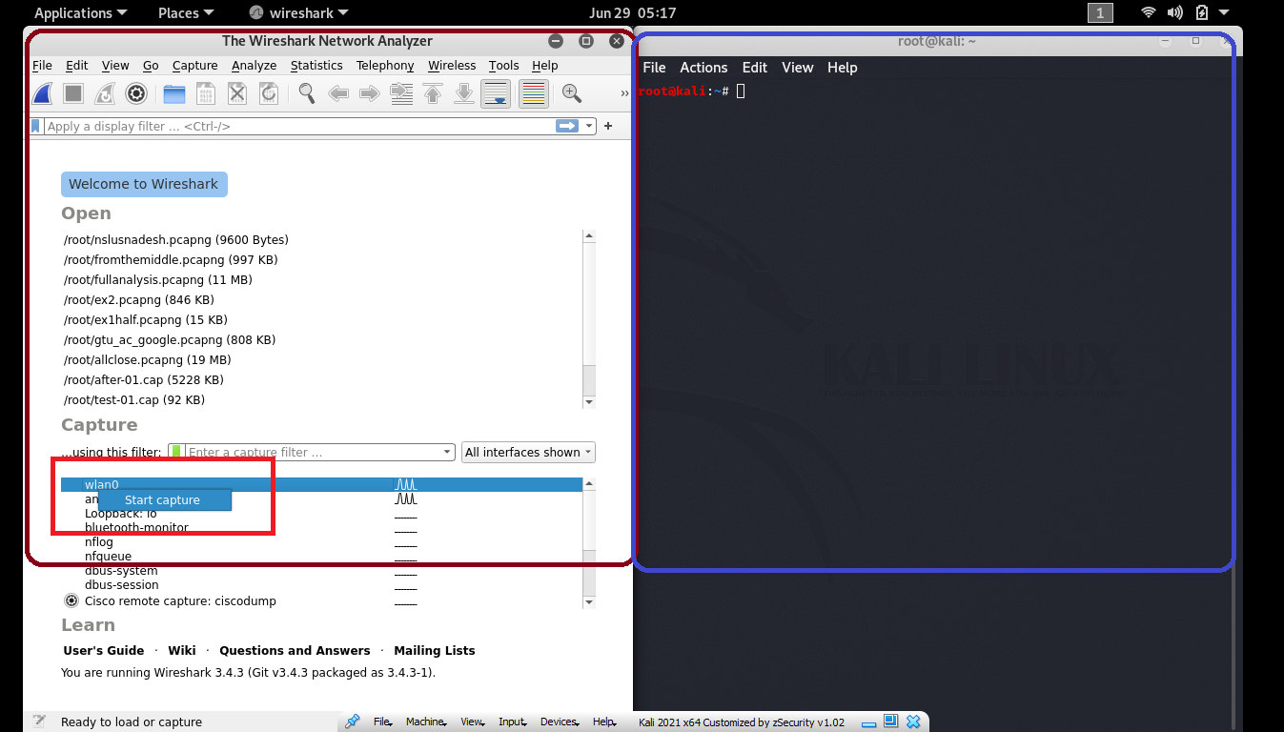

At Command prompt > Nslookup –type=NS [www.sandesh.com](http://www.sandesh.com)

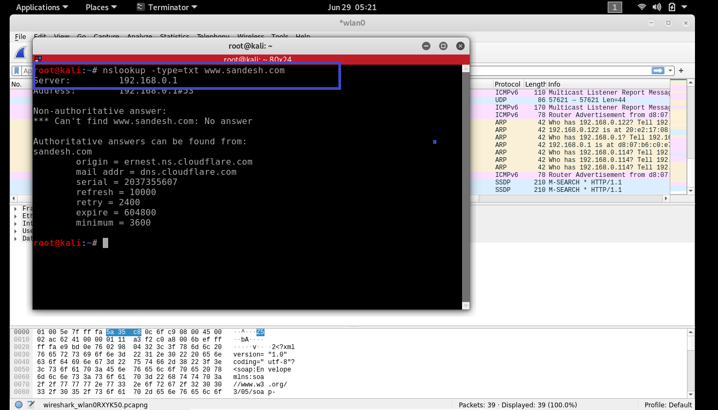

Differences in command

For linux os : Nslookup –type=NS [www.sandesh.com](http://www.sandesh.com)

For windpws os : Nslookup –type=txt [www.sandesh.com](http://www.sandesh.com)

NOW stop the capturing

**Filter : ip.address== IP address of sandesh.com**

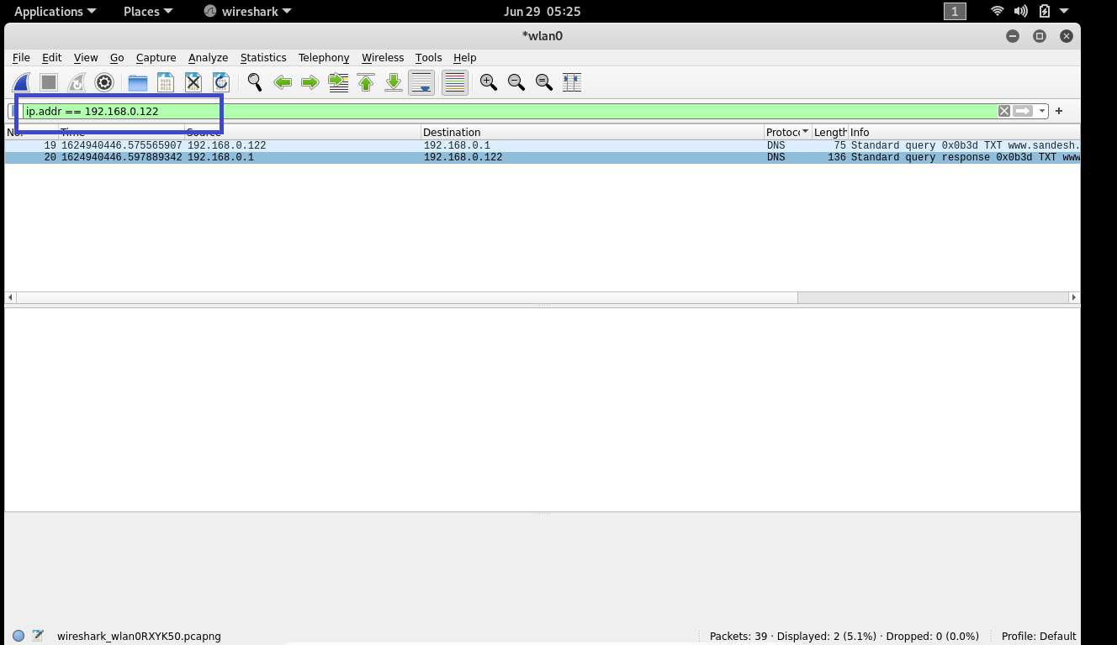

1. **To what IP address is the DNS query message sent ? Is this the IP address of your default local DNS server ?**

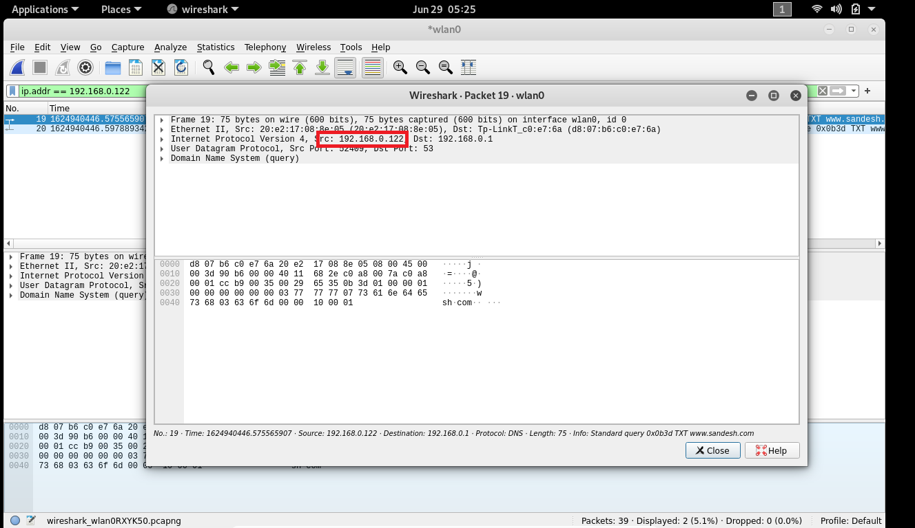

**2. Examine the DNS query message. What “Type” of DNS query is it? Does the query message contain any “answers”?**

**ans🡪** type “SOA” which contain one question

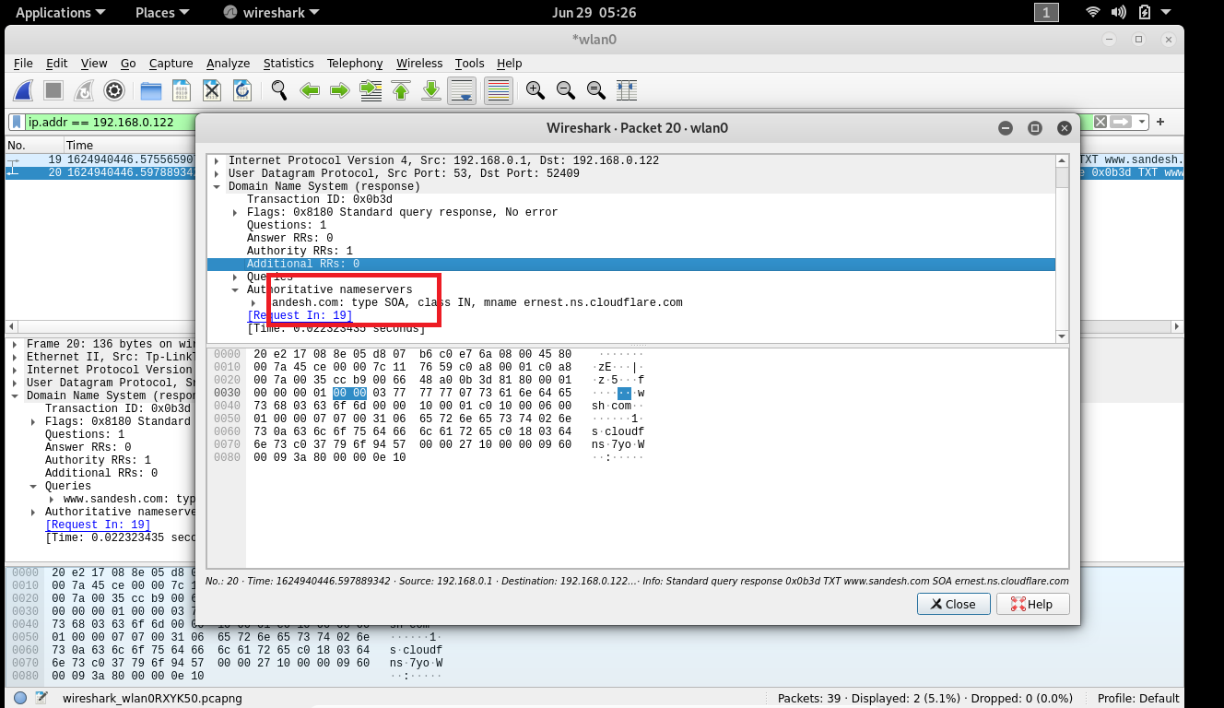

**3. Examine the DNS response message.What sandesh.com name servers does the response message provide ? Does this response message also provide the IP addresses of the Sandesh name servers ?**

**Ans🡪** The DNS Response not contained any answer.