Fatima Jinnah Women University
DEPARTMENT OF SOFTWARE ENGINEERING
BS(SE) – Semester V
ASSIGNMENT 01 – SOLUTION REPORT
Git, Gitea, GitHub, Git LFS, and GitHub Pages
Name: Iraj Taimur Malik
Registration Number: FA24B1-SE-015
Course: Cloud Computing (BSE-410)
Section: A
GitHub Username: irajtaimurmalik
Submission Date: 10 October 2026

Environment Setup
Before starting the tasks, the required tools were installed and configured on the Ubuntu server (hostname ubuntu, user irajtaimurmalik). The server runs as a VMware virtual machine with IP address 192.168.28.131.

1. Install Git LFS
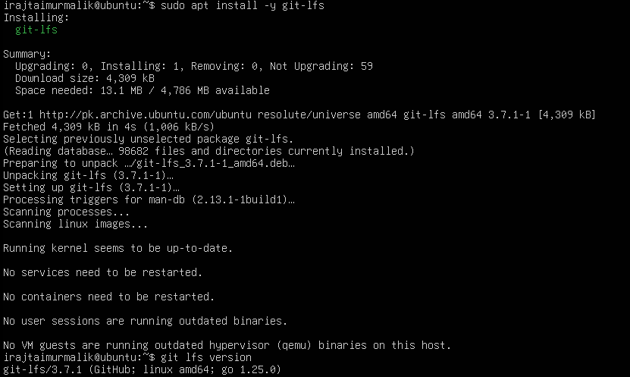
Figure 1: Installing Git LFS with apt and checking its version (git-lfs/3.7.1).

2. Configure Git Identity
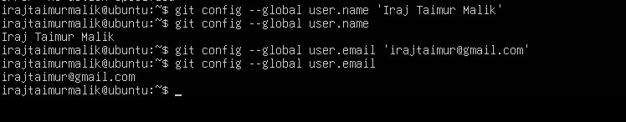
Figure 2: Setting and verifying the Git user name and email.

3. Install Docker Engine
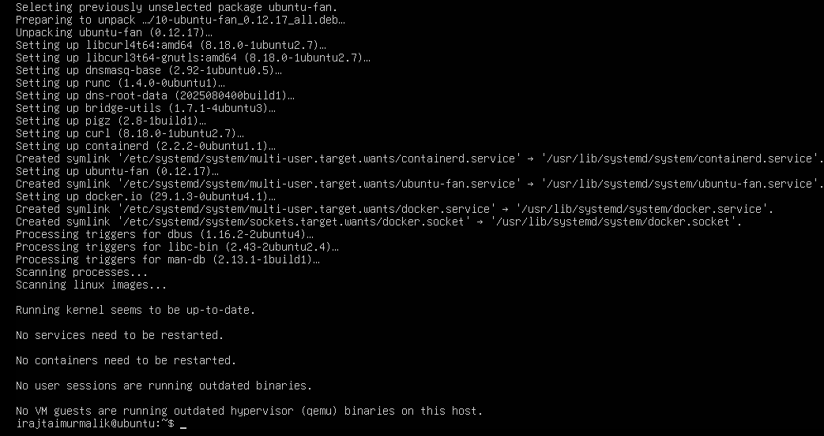
Figure 3: Installing docker.io and curl on the Ubuntu server.

4. Docker Compose Plug-in
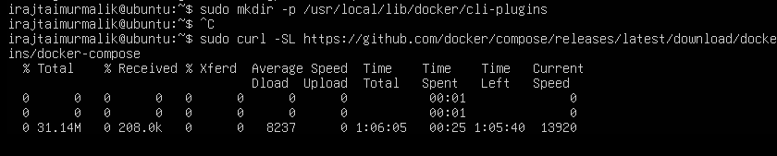
Figure 4: Creating the Docker CLI plug-in directory and starting the Docker Compose download (the slow download was stopped and Docker Compose was installed from the Ubuntu package repository instead).

5. Verify Installations
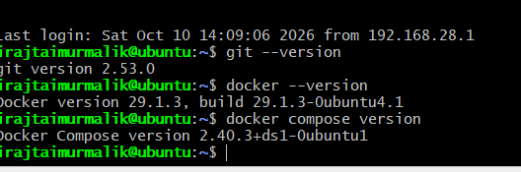
Figure 5: Versions of Git, Docker, and Docker Compose displayed on the Ubuntu server.

Task 1: Install Gitea and Push a Repository from the Ubuntu Server

Step 1.1: Install and Run Gitea
The instructor-provided Gitea repository was cloned and Gitea with PostgreSQL was started using the supplied compose.yaml.
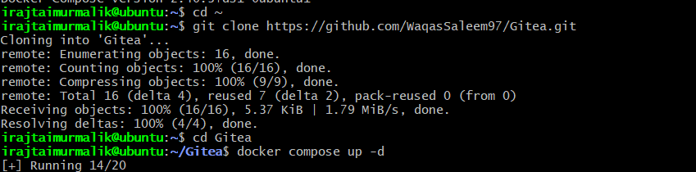
Figure 6: Cloning the instructor’s Gitea repository and starting the containers with docker compose up -d.
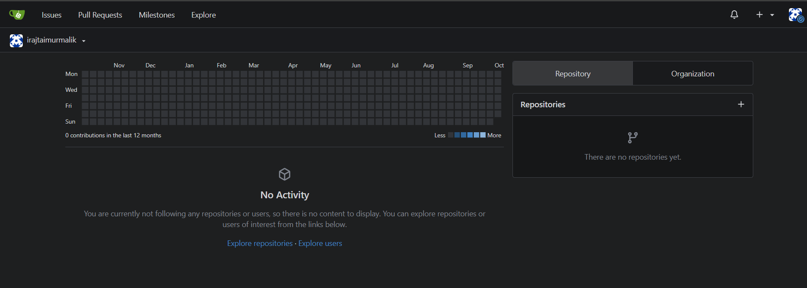
Figure 7: Gitea installation completed and the administrator account (irajtaimurmalik) logged in.
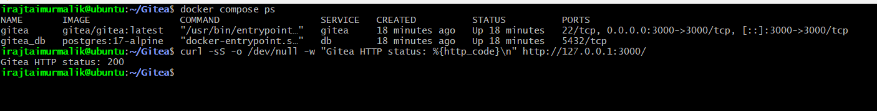
Figure 8: docker compose ps showing the Gitea and PostgreSQL containers running, with Gitea HTTP status 200 (task1_gitea_running.png).

Step 1.2: Create and Push the Initial Repository
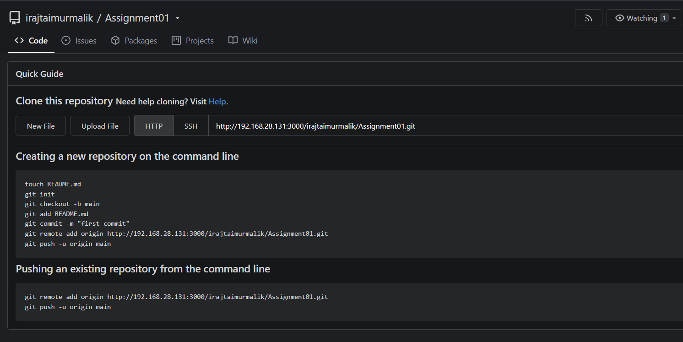
Figure 9: Empty public Assignment01 repository created in Gitea.
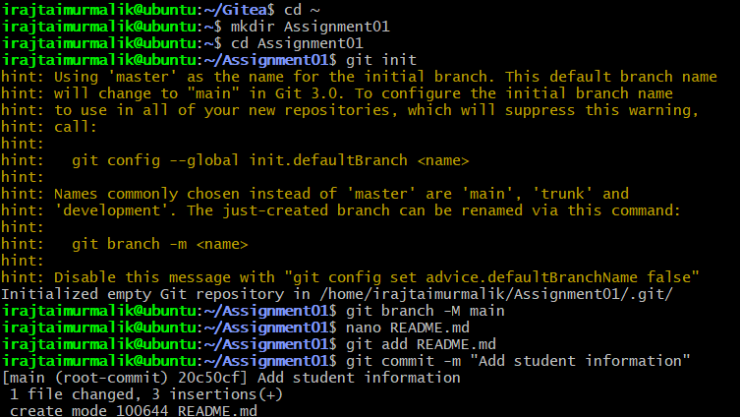
Figure 10: Creating the local Assignment01 repository, adding README.md, and committing it.
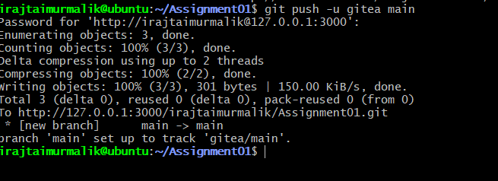
Figure 11: Pushing the main branch to the gitea remote using the personal access token as the password (task1_gitea_push.png).

Step 1.3: Verify the Gitea Repository
[Insert screenshot here: task1_gitea_repository.png]
Figure 12: Gitea Assignment01 repository showing the owner, public status, and rendered README (task1_gitea_repository.png).

Task 2: Push the Same Repository to GitHub

Step 2.1: Add the GitHub Remote and Verify Both Remotes
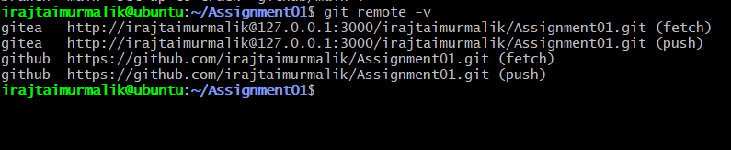
Figure 13: git remote -v showing both the gitea and github remotes with no token in the URLs (task2_remotes.png).

Step 2.2: Push to GitHub
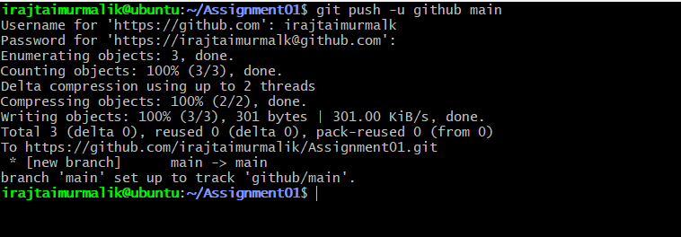
Figure 14: Pushing the main branch to the github remote (task2_github_push.png).

Step 2.3: Verify the GitHub Repository
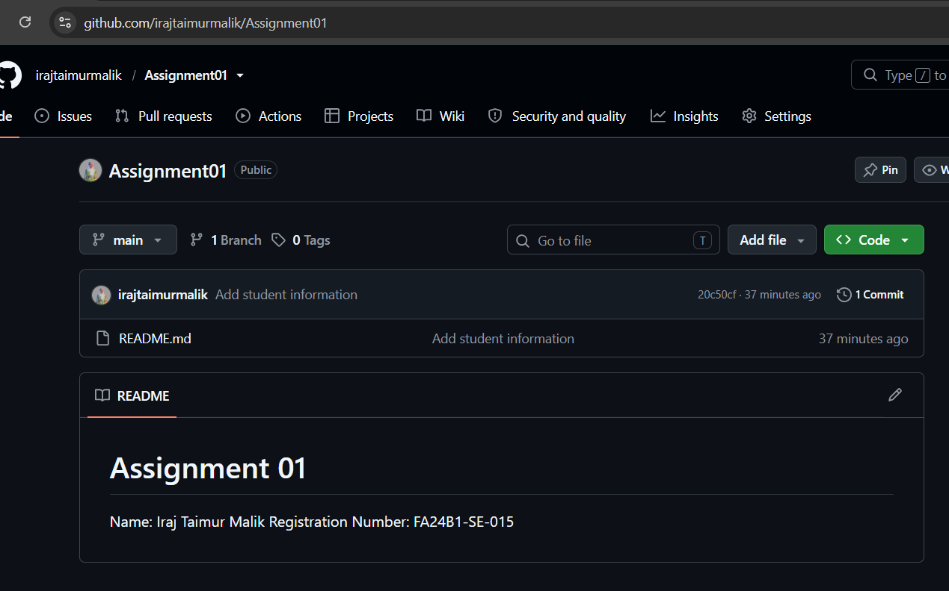
Figure 15: Public GitHub repository irajtaimurmalik/Assignment01 with the rendered README (task2_github_repository.png).

Task 3: Track Three Large Files with Git LFS

Step 3.1: Configure Git LFS
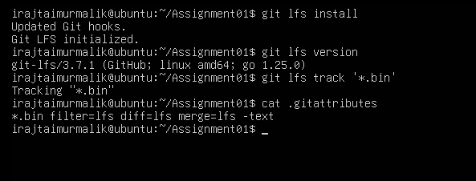
Figure 16: Initializing Git LFS, checking the version, tracking *.bin files, and the resulting .gitattributes rule (task3_lfs_setup.png).

Step 3.2: Create and Verify Three LFS Files
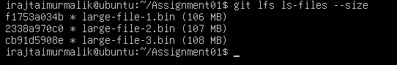
Figure 17: Three files larger than 100 MiB listed by git lfs ls-files --size (task3_lfs_files.png).

Step 3.3: Commit and Push the LFS Files
[Insert screenshot here: task3_lfs_push.png]
Figure 18: Git LFS upload completing (3/3) while pushing to GitHub (task3_lfs_push.png).

Task 4: Create a Portfolio or CV with GitHub Pages

Step 4.1: Create and Push the Portfolio Repository
[Insert screenshot here: task4_pages_repository.png]
Figure 19: Repository irajtaimurmalik.github.io containing index.html and styles.css (task4_pages_repository.png).

Step 4.2: Publish with GitHub Pages
[Insert screenshot here: task4_pages_deployment.png]
Figure 20: GitHub Pages settings showing the site is live (task4_pages_deployment.png).

Step 4.3: Verify the Live Portfolio
[Insert screenshot here: task4_portfolio_live.png]
Figure 21: Live portfolio at https://irajtaimurmalik.github.io/ (task4_portfolio_live.png).

Submission Links
GitHub Assignment01 repository: https://github.com/irajtaimurmalik/Assignment01
Portfolio (GitHub Pages): https://irajtaimurmalik.github.io/
CC repository: https://github.com/irajtaimurmalik/CC

