WORLD BANK SANITATION DATA ANALYTICS SYSTEM
Final Project Report
Indicator SH.STA.BASS. ZS
People using at least basic sanitation services (% of population)

Field | Details
Student | IRAKOZE Laura Karen
Project Type | Final Project / Examination
Technology Stack | Python • PostgreSQL • SQL • Tableau • Gemini AI • Pytest
Dataset Period | 2000–2024
Records | 6,338
Date | August 2026

Prepared as a complete project report and technical documentation. The report documents the implemented pipeline, analysis, database, dashboard, AI assistant, and automated testing results.

Executive Summary
This project implements an end-to-end World Bank sanitation data analytics system built around indicator SH.STA.BASS.ZS, which represents the percentage of the population using at least basic sanitation services. I automated data extraction from the World Bank API, transformed and cleaned the data in Python, stored it in PostgreSQL and CSV, and then carried out exploratory analysis, SQL analysis, Tableau visualization, and natural-language querying through a Gemini-powered AI assistant.
The completed dataset contains 6,338 records covering 2000–2024. The observed sanitation percentage has an overall mean of 73.22%, a minimum of 2.97%, and a maximum of 100.00%. The dataset contains 100 missing country-code values, while the country, year, and sanitation-percentage fields are complete.
I designed the AI component so that Python performs dataset retrieval and numerical calculations while Gemini communicates the results in natural language. For example, the system successfully retrieves Rwanda's 2024 value as 81.33% and calculates an increase of approximately 37.44 percentage points between 2000 and 2024. Automated testing was also completed, with 12 of 12 tests passing.

1. Introduction
Access to sanitation is an important development and public-service indicator. Large international datasets can be difficult to interpret directly because they contain many countries, regions, and yearly observations. This project addresses that challenge by building a reproducible data pipeline around a World Bank indicator and exposing the processed information through database queries, visual analytics, and an AI assistant.
I designed the project as an integrated analytics solution rather than a single script. Each component has a specific role: Python handles data engineering and analysis, PostgreSQL provides persistent structured storage, SQL supports querying, Tableau provides interactive visualization, Gemini supports natural-language interaction, and Pytest verifies important system behavior.

2. Project Objectives
- Automatically obtain sanitation indicator data from the World Bank API.
- Clean and standardize the downloaded data for analysis.
- Store the cleaned data in CSV format and PostgreSQL.
- Perform exploratory data analysis and calculate descriptive statistics.
- Provide SQL queries for structured analysis of countries, years, and sanitation values.
- Create an interactive Tableau dashboard for visual interpretation.
- Develop an AI assistant that can answer questions using the actual dataset.
- Implement automated tests to validate data and AI-analysis functions.
- Produce a reproducible and explainable end-to-end analytics workflow.

3. Indicator and Dataset

3.1 Indicator
Code: SH.STA.BASS.ZS
Description: People using at least basic sanitation services (% of population).
The indicator is expressed as a percentage, so values are interpreted on a 0–100 scale. For example, Rwanda's 2024 observation in the processed dataset is 81.330732%, which I report in the project as 81.33% when rounded to two decimal places.

3.2 Dataset Structure
Column | Meaning | Observed Status
country | Country or regional entity name | 6,338 non-null
country_code | World Bank country/region code | 6,238 non-null
year | Observation year | 6,338 non-null
sanitation_percent | Sanitation indicator value (%) | 6,338 non-null

3.3 Dataset Statistics
Metric | Result
Number of records | 6,338
Earliest year | 2000
Latest year | 2024
Mean sanitation percentage | 73.22%
Minimum sanitation percentage | 2.97%
Maximum sanitation percentage | 100.00%
Missing country_code values | 100

4. System Architecture
The project follows an ETL-oriented architecture. The World Bank API is the source, Python is the main orchestration and processing layer, and the cleaned output is consumed by multiple downstream components.
Layer | Component | Purpose
Source | World Bank API | Provides SH.STA.BASS.ZS observations.
Extraction | Python / main.py | Downloads source data.
Transformation | Python / pandas | Cleans, types, validates, and prepares records.
Storage | CSV + PostgreSQL | Persists cleaned data for reuse and querying.
Analysis | Python + SQL | Calculates descriptive and analytical results.
Visualization | Tableau | Presents interactive charts and dashboard views.
AI | Gemini + Python | Supports natural-language questions and explanations.
Testing | Pytest | Validates data and analytical functions.
Pipeline: World Bank API → Extraction → Cleaning → sanitation_cleaned.csv → PostgreSQL / Tableau / AI Assistant → Analysis and reporting.

5. Development Environment and Project Structure
I developed the project in a Python virtual environment. The environment includes packages used for data processing, visualization, machine learning, database connectivity, testing, and AI integration, including pandas, NumPy, scikit-learn, matplotlib, seaborn, psycopg2-binary, python-dotenv, google-genai, and pytest.
Folder / File | Role
data/ | Raw and cleaned datasets.
logs/ | Application/testing logs where configured.
models/ | Model artifacts.
notebooks/ | Notebook-based analysis workspace.
sql/ | SQL queries and database analysis.
tableau/ | Tableau-related project assets.
tests/ | Automated Pytest tests.
venv/ | Python virtual environment.
main.py | Main ETL/analysis orchestrator.
train_models.py | Model training/evaluation component.
ai_assistant.py | Gemini-powered natural-language assistant.

6. Data Extraction and Transformation

6.1 Extraction
The extraction stage obtains the sanitation indicator data from the World Bank API. Automating extraction makes the workflow repeatable and avoids relying on manual copying of data.

6.2 Transformation and Cleaning
The transformation stage creates the cleaned dataset used by the downstream components. The resulting data contains four main fields: country, country_code, year, and sanitation_percent. Numeric fields are represented using appropriate numeric types so that statistical calculations can be performed reliably.
The completed dataset showed no missing values in country, year, or sanitation_percent. There were 100 missing country_code values. This is an important data-quality observation and should be acknowledged rather than silently treating the field as complete.

7. Exploratory Data Analysis
I performed exploratory analysis after the data was cleaned, calculating descriptive statistics for year and sanitation percentage and examining missing values.
Statistic | Year | Sanitation %
Count | 6,338 | 6,338
Mean | 2011.94 | 73.22
Standard deviation | 7.15 | 28.62
Minimum | 2000 | 2.97
25th percentile | 2006 | 51.02
Median | 2012 | 85.76
75th percentile | 2018 | 97.64
Maximum | 2024 | 100.00
The difference between the mean and median sanitation percentage indicates that the observations are not distributed symmetrically across the full dataset. The wide range from 2.97% to 100.00% also demonstrates substantial variation among country/region-year observations.

8. PostgreSQL Database
PostgreSQL was used as the relational database layer. The cleaned data was successfully loaded into PostgreSQL, where SQL queries can be used to filter records, calculate aggregates, compare years, and investigate individual countries.
A representative query used during validation was:
SELECT country, country_code, year, sanitation_percent FROM sanitation_data WHERE country = 'Rwanda' AND year = 2024;
The database returned Rwanda's 2024 observation of 81.330732%, confirming that the value used by the analysis and AI components exists in the stored dataset.

9. SQL Analysis
SQL was used to demonstrate structured database analysis. Typical operations include selecting records, filtering by country or year, counting records, calculating averages, and comparing observations.
Purpose | Example
View records | SELECT * FROM sanitation_data LIMIT 10;
Count records | SELECT COUNT(*) FROM sanitation_data;
Rwanda 2024 | Filter country = 'Rwanda' and year = 2024
Year analysis | GROUP BY year and calculate aggregate sanitation values

10. Tableau Dashboard
The cleaned CSV, sanitation_cleaned.csv, was connected to Tableau to create the project dashboard. The dashboard provides a visual interface for exploring sanitation values across countries and years, complementing the Python and SQL components by making analytical patterns easier to communicate to a non-technical audience.
Suggested report evidence: insert a screenshot of the completed Tableau dashboard here, showing the dashboard title, major charts/KPIs, and any filters used.
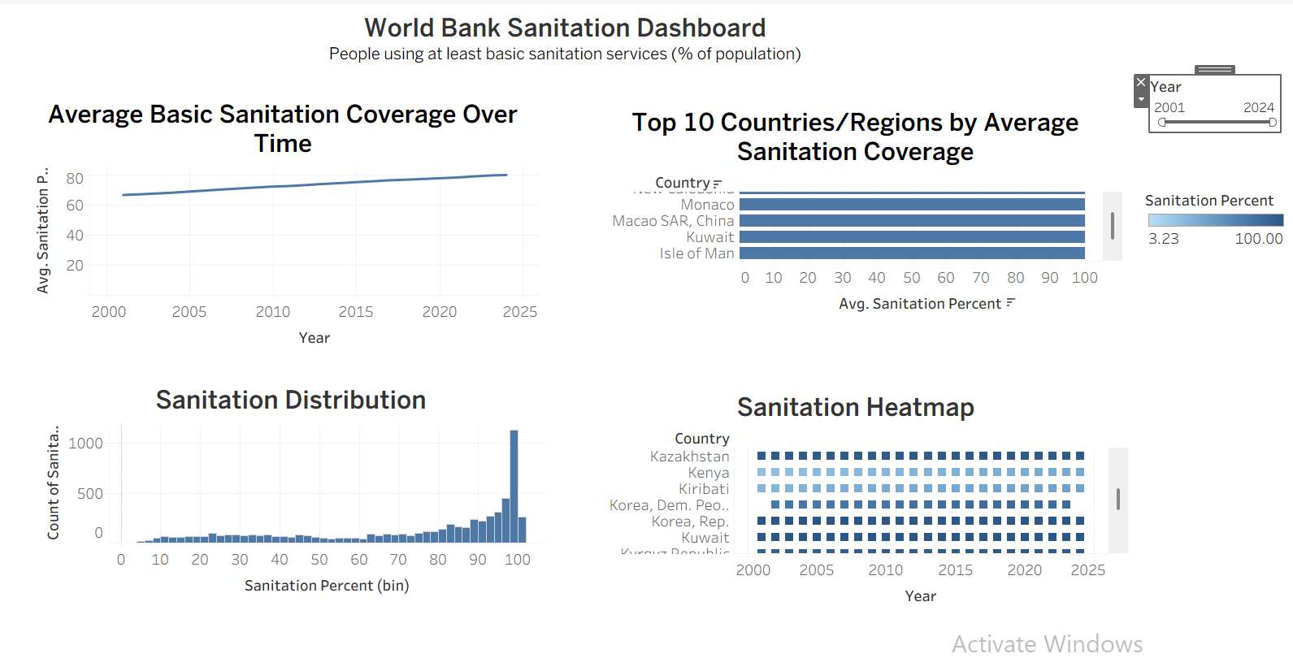Figure: Tableau dashboard for World Bank sanitation analysis.

11. AI Assistant
I implemented the AI assistant in Python and connected it to Gemini using an API key loaded from environment configuration. The assistant reads the cleaned dataset and uses Python logic to identify countries and years and to perform calculations before sending the factual analysis to Gemini.
This design deliberately separates numerical computation from language generation. Python is responsible for retrieving and calculating values from the dataset; Gemini is responsible for turning those verified results into natural-language explanations. This reduces the risk of relying on an AI model to invent statistics.

11.1 Example: Rwanda
I tested the assistant with the question: “What was Rwanda's sanitation percentage in 2024?” The actual dataset contains Rwanda (RWA), 2024, with a sanitation percentage of 81.330732%. The assistant therefore reports approximately 81.33%.

11.2 Example: Rwanda Improvement
The assistant also supports comparison between two years. Rwanda's values are 43.887641% in 2000 and 81.330732% in 2024. The calculated difference is approximately 37.44 percentage points.
The term “percentage points” is used because the calculation subtracts one percentage value from another: 81.33% − 43.89% = 37.44 percentage points.
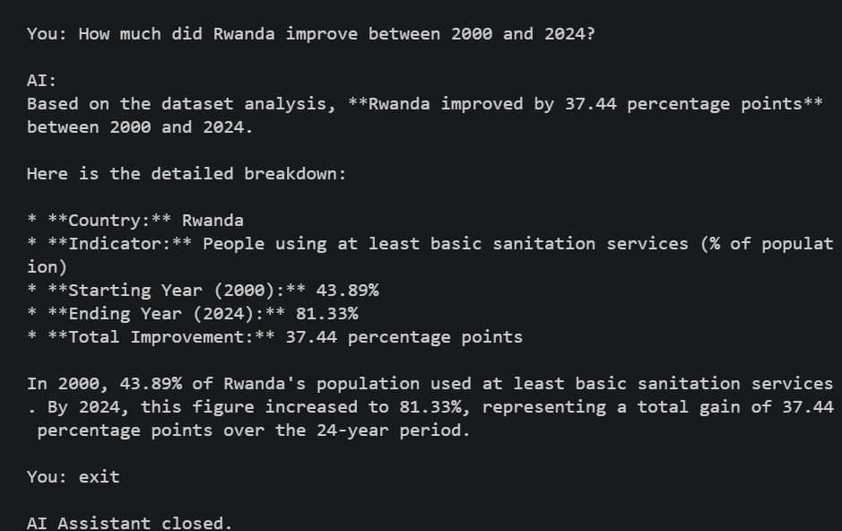Figure: AI assistant answering a question using the sanitation dataset.

12. Automated Testing
I implemented automated testing with Pytest. The final test run collected 12 test cases and produced the following result:
12 passed, 1 warning in 20.74s
Test Area | Validation
Dataset existence | Checks that sanitation_cleaned.csv exists.
Dataset loading | Checks that the CSV can be loaded and is not empty.
Required columns | Checks country, country_code, year, sanitation_percent.
Record count | Checks that records are present.
Year range | Checks the 2000–2024 range.
Sanitation range | Checks values remain between 0 and 100.
Rwanda 2024 | Validates the 81.33% rounded value.
Country detection | Validates Rwanda recognition.
Year detection | Validates 2024 recognition.
Multiple years | Validates 2000 and 2024 detection.
AI analysis | Validates Rwanda lookup and improvement calculation.
The single warning was a deprecation warning emitted by a Google GenAI dependency. It did not cause a test failure; all 12 project tests passed successfully.
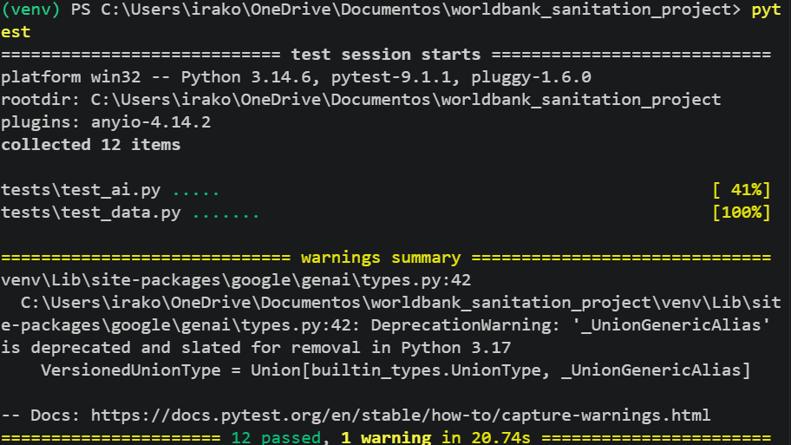Figure: Automated Pytest test results showing 12 passed tests.

13. System Validation Results
Component | Result
World Bank data extraction | Successful
Data cleaning | Successful
Cleaned CSV creation | Successful
PostgreSQL loading | Successful
EDA | Successful
SQL queries | Successful
Tableau dashboard | Completed
Gemini AI assistant | Successful
Rwanda 2024 retrieval | 81.33%
Rwanda 2000–2024 improvement | 37.44 percentage points
Automated tests | 12/12 passed

14. Security and Configuration
The Gemini API key is configured outside the application source through environment variables rather than being hard-coded into the assistant. This is a better practice because credentials should not be embedded directly in publicly shared source code. The virtual environment also isolates project dependencies from the system Python installation.
Database credentials should likewise remain in environment configuration or another secure configuration mechanism when the project is submitted or deployed.

15. Challenges Encountered and Solutions
Challenge | Solution
PowerShell blocked virtual-environment activation | Used a process-scoped execution-policy bypass, then activated the environment.
PostgreSQL database initially did not exist | Created/configured the required database and verified the connection.
Gemini model returned 404 errors | Checked available models and updated the assistant to use a currently available model.
AI initially could not answer Rwanda 2024 | Added dataset retrieval/search logic so Python supplies the actual record to Gemini.
Improvement question was misinterpreted | Added multiple-year detection and explicit two-year difference calculation.
ML code used unsupported squared argument | Updated RMSE calculation to work with the installed scikit-learn version.
Need to validate the project | Added Pytest tests; final run produced 12/12 passing tests.

16. Limitations
- The dataset contains 100 missing country-code values, so country codes should not be assumed complete.
- The AI assistant's analytical coverage depends on the questions and analytical rules implemented in Python.
- Tableau is a visualization layer and depends on the cleaned data source being refreshed when new data is extracted.
- The current project is primarily an analytical and decision-support system rather than a production public-service application.
- AI-generated wording should be treated as an explanation layer; factual numerical results should continue to come from the dataset and Python calculations.

17. Recommendations and Future Improvements
- Automate scheduled data refreshes from the World Bank API.
- Add more robust handling of country aliases and natural-language date ranges.
- Expand the AI assistant to support additional SQL-backed questions.
- Add dashboard-level data refresh automation.
- Add more comprehensive integration tests for the PostgreSQL layer.
- Improve logging and monitoring for failed API, database, and AI requests.
- Add authentication and a web interface if the system is deployed for multiple users.
- Track dataset versions so analytical results remain reproducible over time.

18. Conclusion
This project successfully demonstrates an end-to-end data analytics workflow built around the World Bank sanitation indicator SH.STA.BASS.ZS. The final system combines automated data extraction, cleaning, database storage, SQL, exploratory analysis, Tableau visualization, Gemini-based natural-language interaction, and automated testing.
The final dataset contains 6,338 records covering 2000–2024. Key validation results include an overall mean sanitation percentage of 73.22%, Rwanda's 2024 value of 81.33%, and a calculated Rwanda improvement of 37.44 percentage points from 2000 to 2024. Most importantly, I tested the project using Pytest, and all 12 implemented tests passed.
The resulting architecture demonstrates how data engineering, databases, analytics, visualization, AI, and software testing can be integrated into one reproducible project.

19. Recommended Screenshot Checklist
No. | Screenshot to Insert | Where It Belongs
1 | Cleaned sanitation_cleaned.csv | Data cleaning/transformation section
2 | PostgreSQL table/query results | Database section
3 | Rwanda 2024 SQL result | SQL analysis/validation section
4 | Completed Tableau dashboard | Tableau section
5 | AI assistant answering Rwanda 2024 | AI section
6 | AI assistant answering Rwanda improvement | AI section
7 | pytest showing 12 passed | Testing section
8 | Successful python main.py output | System validation section

20. Viva / Examination Preparation
The following questions are likely useful when defending the project:
Question | Key Answer
What is your indicator? | SH.STA.BASS.ZS: people using at least basic sanitation services (% of population).
Why use an API? | It automates reproducible data collection from the World Bank.
What is ETL? | Extract, Transform, Load: the core data pipeline used by the project.
Why PostgreSQL? | Persistent relational storage and structured SQL querying.
Why Tableau? | Interactive visual exploration and communication of results.
Why Gemini? | Natural-language interaction and explanation of verified analytical results.
Why Python calculations before Gemini? | To ensure numerical answers are based on the actual dataset rather than generated text.
How many records? | 6,338.
What years? | 2000–2024.
Rwanda 2024? | 81.33%.
Rwanda improvement 2000–2024? | 37.44 percentage points.
Testing result? | 12 tests passed successfully.

Appendix A — Core Project Commands
Purpose | Command
Activate virtual environment | .\venv\Scripts\Activate.ps1
Run pipeline | python main.py
Run AI assistant | python ai_assistant.py
Run tests | pytest

Appendix B — Key Evidence Values
The following values were directly observed during project execution and are useful for validating screenshots and demonstrating consistency across components.
Evidence | Value
Dataset records | 6,338
Dataset years | 2000–2024
Overall sanitation mean | 73.22%
Overall sanitation minimum | 2.97%
Overall sanitation maximum | 100.00%
Missing country_code | 100
Rwanda 2024 | 81.330732% (81.33% rounded)
Rwanda 2000 | 43.887641% (43.89% rounded)
Rwanda 2000–2024 change | 37.443091 percentage points (37.44 rounded)
Pytest | 12 passed, 1 warning

