Theory:

What is decision tree?
A decision tree is a graph that uses a branching method to illustrate every possible outcome of a decision.
Decision trees can be drawn by hand or created with a graphics program or specialized software. Informally, decision trees are useful for focusing discussion when a group must make a decision. Programmatically, they can be used to assign monetary/time or other values to possible outcomes so that decisions can be automated. Decision tree software is used in data mining to simplify complex strategic challenges and evaluate the cost-effectiveness of research and business decisions. Variables in a decision tree are usually represented by circles.
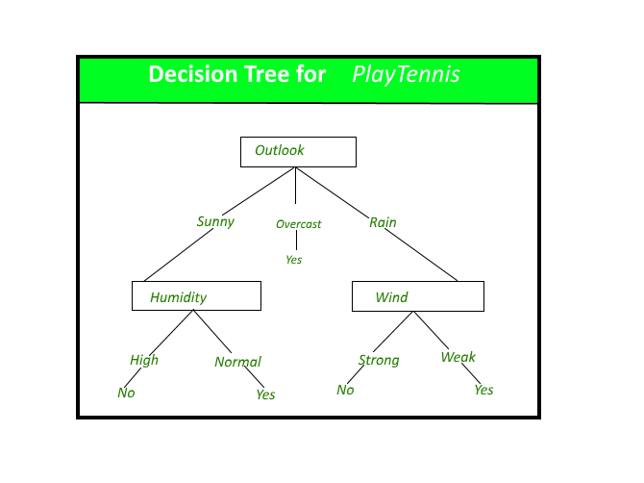

What is Entrophy ?
Entropy is the measures of impurity, disorder or uncertainty in a bunch of examples.

What an Entropy basically does?
Entropy controls how a Decision Tree decides to split the data. It actually effects how a Decision Tree draws its boundaries.
The Equation of Entropy:
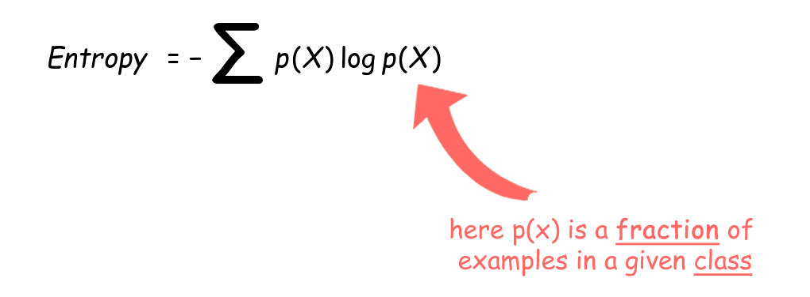
what is information gain?
Information gain (IG) measures how much “information” a feature gives us about the class.
Information gain is the main key that is used by Decision Tree Algorithms to construct a Decision Tree.
- Decision Trees algorithm will always tries to maximize Information gain.
- An attribute with highest Information gain will tested/split first.

The Equation of Information gain:

Program Code:

# Classification template
# Importing the libraries
import numpy as np
import matplotlib.pyplot as plt
import pandas as pd
# Importing the dataset
dataset = pd.read_csv('Social_Network_Ads.csv')
X = dataset.iloc[:, [2, 3]].values
y = dataset.iloc[:, 4].values
# Splitting the dataset into the Training set and Test set
from sklearn.model_selection import train_test_split
X_train, X_test, y_train, y_test = train_test_split(X, y, test_size = 0.25, random_state = 0)
# Feature Scaling
from sklearn.preprocessing import StandardScaler
sc = StandardScaler()
X_train = sc.fit_transform(X_train)
X_test = sc.transform(X_test)
# Fitting classifier to the Training set
from sklearn.tree import DecisionTreeClassifier
classifier = DecisionTreeClassifier(criterion='entropy', random_state = 0)
classifier.fit(X_train, y_train)
# Predicting the Test set results
y_pred = classifier.predict(X_test)

# Making the Confusion Matrix
from sklearn.metrics import confusion_matrix
cm = confusion_matrix(y_test, y_pred)
# Visualising the Training set results
from matplotlib.colors import ListedColormap
X_set, y_set = X_train, y_train
X1, X2 = np.meshgrid(np.arange(start = X_set[:, 0].min() - 1, stop = X_set[:, 0].max() + 1, step = 0.01),
np.arange(start = X_set[:, 1].min() - 1, stop = X_set[:, 1].max() + 1, step = 0.01))
plt.contourf(X1, X2, classifier.predict(np.array([X1.ravel(), X2.ravel()]).T).reshape(X1.shape),
alpha = 0.75, cmap = ListedColormap(('red', 'green')))
plt.xlim(X1.min(), X1.max())
plt.ylim(X2.min(), X2.max())
for i, j in enumerate(np.unique(y_set)):
plt.scatter(X_set[y_set == j, 0], X_set[y_set == j, 1],
c = ListedColormap(('red', 'green'))(i), label = j)
plt.title('Decision Tree Classification (Training set)')
plt.xlabel('Age')
plt.ylabel('Estimated Salary')
plt.legend()
plt.show()
# Visualising the Test set results
from matplotlib.colors import ListedColormap
X_set, y_set = X_test, y_test
X1, X2 = np.meshgrid(np.arange(start = X_set[:, 0].min() - 1, stop = X_set[:, 0].max() + 1, step = 0.01),
np.arange(start = X_set[:, 1].min() - 1, stop = X_set[:, 1].max() + 1, step = 0.01))
plt.contourf(X1, X2, classifier.predict(np.array([X1.ravel(), X2.ravel()]).T).reshape(X1.shape),
alpha = 0.75, cmap = ListedColormap(('red', 'green')))
plt.xlim(X1.min(), X1.max())
plt.ylim(X2.min(), X2.max())
for i, j in enumerate(np.unique(y_set)):
plt.scatter(X_set[y_set == j, 0], X_set[y_set == j, 1],
c = ListedColormap(('red', 'green'))(i), label = j)
plt.title('Decision Tree Classification (Test set)')
plt.xlabel('Age')
plt.ylabel('Estimated Salary')
plt.legend()
plt.show()# Classification template
# Importing the libraries
import numpy as np
import matplotlib.pyplot as plt
import pandas as pd
# Importing the dataset
dataset = pd.read_csv('Social_Network_Ads.csv')
X = dataset.iloc[:, [2, 3]].values
y = dataset.iloc[:, 4].values
# Splitting the dataset into the Training set and Test set
from sklearn.model_selection import train_test_split
X_train, X_test, y_train, y_test = train_test_split(X, y, test_size = 0.25, random_state = 0)
# Feature Scaling
from sklearn.preprocessing import StandardScaler
sc = StandardScaler()
X_train = sc.fit_transform(X_train)
X_test = sc.transform(X_test)
# Fitting classifier to the Training set
from sklearn.tree import DecisionTreeClassifier
classifier = DecisionTreeClassifier(criterion='entropy', random_state = 0)
classifier.fit(X_train, y_train)
# Predicting the Test set results
y_pred = classifier.predict(X_test)
# Making the Confusion Matrix
from sklearn.metrics import confusion_matrix
cm = confusion_matrix(y_test, y_pred)

# Visualising the Training set results
from matplotlib.colors import ListedColormap
X_set, y_set = X_train, y_train
X1, X2 = np.meshgrid(np.arange(start = X_set[:, 0].min() - 1, stop = X_set[:, 0].max() + 1, step = 0.01),
np.arange(start = X_set[:, 1].min() - 1, stop = X_set[:, 1].max() + 1, step = 0.01))
plt.contourf(X1, X2, classifier.predict(np.array([X1.ravel(), X2.ravel()]).T).reshape(X1.shape),
alpha = 0.75, cmap = ListedColormap(('red', 'green')))
plt.xlim(X1.min(), X1.max())
plt.ylim(X2.min(), X2.max())
for i, j in enumerate(np.unique(y_set)):
plt.scatter(X_set[y_set == j, 0], X_set[y_set == j, 1],
c = ListedColormap(('red', 'green'))(i), label = j)
plt.title('Decision Tree Classification (Training set)')
plt.xlabel('Age')
plt.ylabel('Estimated Salary')
plt.legend()
plt.show()
# Visualising the Test set results
from matplotlib.colors import ListedColormap
X_set, y_set = X_test, y_test
X1, X2 = np.meshgrid(np.arange(start = X_set[:, 0].min() - 1, stop = X_set[:, 0].max() + 1, step = 0.01),
np.arange(start = X_set[:, 1].min() - 1, stop = X_set[:, 1].max() + 1, step = 0.01))
plt.contourf(X1, X2, classifier.predict(np.array([X1.ravel(), X2.ravel()]).T).reshape(X1.shape),
alpha = 0.75, cmap = ListedColormap(('red', 'green')))
plt.xlim(X1.min(), X1.max())
plt.ylim(X2.min(), X2.max())
for i, j in enumerate(np.unique(y_set)):
plt.scatter(X_set[y_set == j, 0], X_set[y_set == j, 1],
c = ListedColormap(('red', 'green'))(i), label = j)
plt.title('Decision Tree Classification (Test set)')
plt.xlabel('Age')
plt.ylabel('Estimated Salary')
plt.legend()
plt.show()

OUTPUT:
