- Create new instance on Cloud sql service provide the required parameters
- Create user
- Go to cloud sql studio
- Create data base
- Create table, insert records into it
- Go big query studio
- Click add data
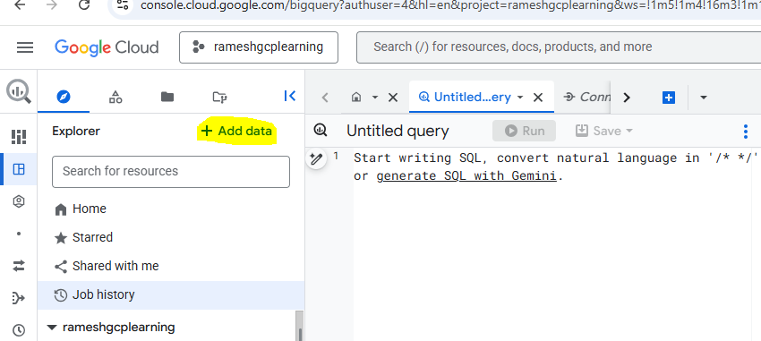
- Choose data source type as mysql
- Choose big query federation
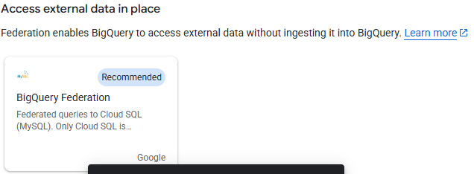
Provide the required details
Copy the cloud sql connection name from cloud sql instance property
Provide DB name user name and password and create connection click create connection
- Click connection
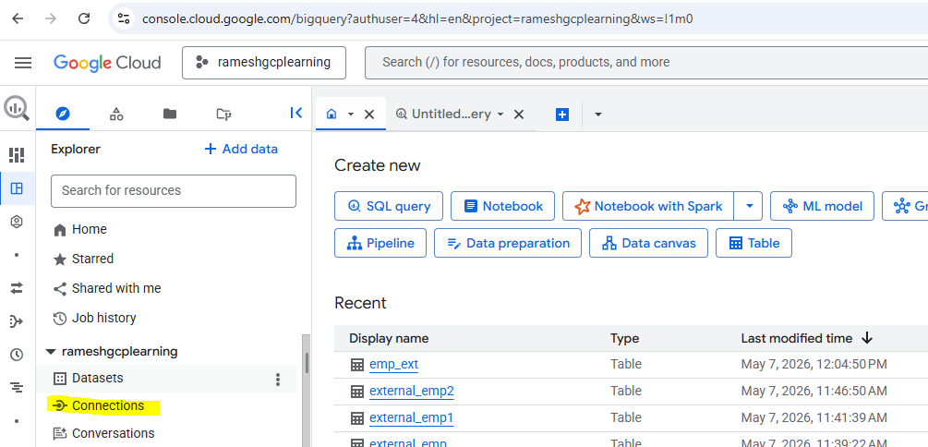

Click query
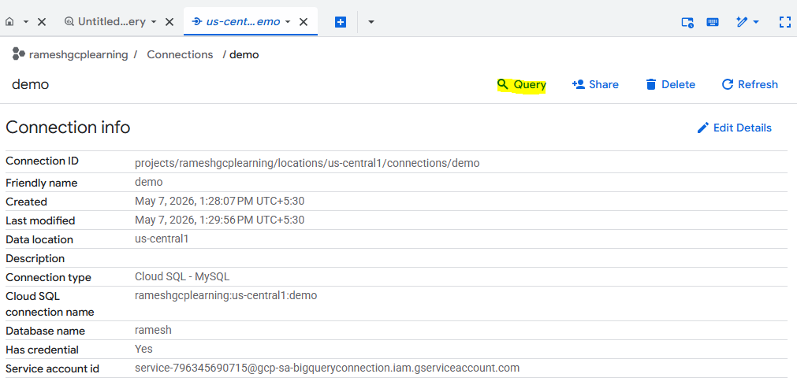
Execute the below statement
SELECT * FROM EXTERNAL_QUERY("rameshgcplearning.us-central1.demo", "select * from ramesh.emp");

Delete option is disabled by default in cloud sql instance run the below command to enable it
gcloud sql instances patch <instance name> \
--no-deletion-protection

gcloud sql instances patch demo \
--no-deletion-protection

