Exploring the Ratio of Dumbbell Press to Flat Bench Press
Weightlifters often use the bench press as a common benchmark for strength, but dumbbells require more balance and control because each arm has to stabilize its own weight. The dumbbell-to-barbell ratio summarizes whether dumbbell pressing is keeping up with barbell benching, or whether stabilization is limiting the dumbbells.

Flat dumbbell press is when the lifter lies on a flat bench with their arms positioned at roughly 45 degree angles, lifts two equal sized dumbbells, brings them back to the chest, and then presses them up. Barbell bench press is when the lifter lies on a bench and lifts a horizontal bar (the barbell) with equal weighted plates on both sides, lowering it to the chest and pressing it back up.

When calculating the ratio, the weight of one dumbbell is multiplied by two in order to account for the total weight lifted during a flat dumbbell press (since there are two dumbbells). You obtain the ratio by multiplying the weight of one dumbbell by 2 and dividing that total by the amount someone is able to barbell bench press.

A low dumbbell-to-barbell ratio can suggest that balance and control are holding back the dumbbell press, meaning the stabilizing muscles (and coordination) may be a limiting factor. A high ratio can suggest the opposite issue: the barbell bench may be lagging due to less practice, discomfort, or inconsistent technique/range of motion, making the dumbbell numbers look unusually close to the barbell.

For example, say Melissa is able to flat dumbbell press two 30 lb dumbbells. The total amount she can flat dumbbell press is 30 lbs (one dumbbell for each arm). On barbell bench press, she can lift 75 lbs. Her ratio would be calculated by dividing flat dumbbell press by barbell bench press (60/75) which equals 0.8, meaning that Melissa can lift two dumbbells up to 80% as heavy as she can bench press the barbell.
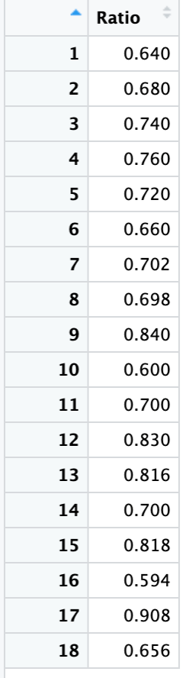
The data is sourced from a self-reported Reddit open forum. Users provided their weight for both a flat dumbbell press and a barbell bench press, and it was compiled by another user into the corresponding weight ratio. It is important to note that this is a self-reported open forum.
Below is a dataset with observations from 18 weightlifters and their corresponding ratio, as well as summary statistics and a dot plot. These data are also available in the file, dumbbell_barbell_weight_ratio.csv.
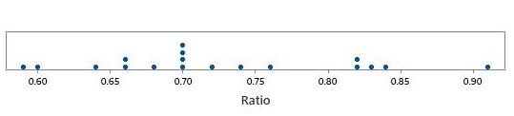
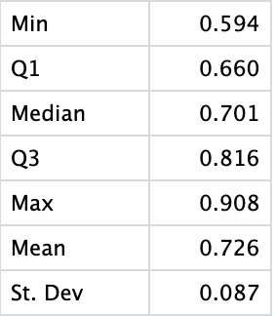

- Based on the dot plot and the data table, what could be a concern regarding the distribution of the data with respect to building a confidence interval for the average?

- What potential problems could arise from the way the data was collected? What population might we still generalize to?

- Regardless of your answer to the previous questions, calculate and interpret a 95% confidence interval for the mean ratio between flat dumbbell press and barbell bench press.

- The typical experienced weightlifter is likely to be able to press more with the barbell than with dumbbells. This is largely due to the barbell being easier to balance and control, so you can focus on pushing more weight. Does the confidence interval you calculated in the previous question support this idea? Briefly explain why or why not.

- Considering your previous concerns regarding data, do you believe that the range of plausible values for the “average ratio” presented in this confidence interval is meaningful? If so, what audience would it apply to? If not, why do you feel it not useful? Explain your answer.

- We’ve seen that Melissa has a ratio of 0.8. Suppose that she is an avid follower of r/Fitness. Now, she has a goal to become more “balanced” and have more of an average ratio in line with what she believes to be her peers. What should she do in order to achieve this? Explain both in terms of the ratio and the exercises involved.

- Suppose you wish to further investigate the strength ratio. How would you go about finding more generalizable results? Be specific.

- Instead of just the ratio, what other information might be useful to collect that might make the data more useful?

Reddit Thread: https://www.reddit.com/r/Fitness/comments/35q4i3/how_much_do_you_dumbbell_flat_bench_compared_to/

