Exploring the Ratio of Dumbbell Press to Flat Bench Press
Weightlifters often use the bench press as a common benchmark for strength, but dumbbells require more balance and control because each arm has to stabilize its own weight. The dumbbell-to-barbell ratio summarizes whether dumbbell pressing is keeping up with barbell benching, or whether stabilization is limiting the dumbbells.

Flat dumbbell press is when the lifter lies on a flat bench with their arms positioned at roughly 45 degree angles, lifts two equal sized dumbbells, brings them back to the chest, and then presses them up. Barbell bench press is when the lifter lies on a bench and lifts a horizontal bar (the barbell) with equal weighted plates on both sides, lowering it to the chest and pressing it back up.

When calculating the ratio, the weight of one dumbbell is multiplied by two in order to account for the total weight lifted during a flat dumbbell press (since there are two dumbbells). You obtain the ratio by multiplying the weight of one dumbbell by 2 and dividing that total by the amount someone is able to barbell bench press.

A low dumbbell-to-barbell ratio can suggest that balance and control are holding back the dumbbell press, meaning the stabilizing muscles (and coordination) may be a limiting factor. A high ratio can suggest the opposite issue: the barbell bench may be lagging due to less practice, discomfort, or inconsistent technique/range of motion, making the dumbbell numbers look unusually close to the barbell.

For example, say Melissa is able to flat dumbbell press two 30 lb dumbbells. The total amount she can flat dumbbell press is 60 lbs (one dumbbell for each arm). On barbell bench press, she can lift 75 lbs. Her ratio would be calculated by dividing flat dumbbell press by barbell bench press (60/75) which equals 0.8, meaning that Melissa can lift two dumbbells up to 80% as heavy as she can bench press the barbell.
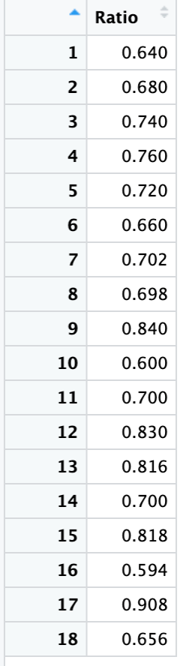
The data is sourced from a self-reported Reddit open forum. Users provided their weight for both a flat dumbbell press and a barbell bench press, and it was compiled by another user into the corresponding weight ratio. It is important to note that this is a self-reported open forum.
Below is a dataset with observations from 18 weightlifters and their corresponding ratio, as well as summary statistics and a dot plot. These data are also available in the file, dumbbell_barbell_weight_ratio.csv.
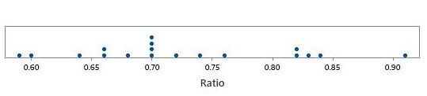
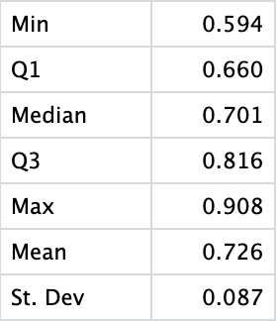

- Based on the dot plot and the data table, what could be a concern regarding the distribution of the data with respect to building a confidence interval for the average?

With a relatively small sample size, it is difficult to get a good understanding of the shape of the distribution. (e.g., Is it actually unimodal and symmetric?) Luckily, there aren’t any outliers, so the Central Limit Theorem could likely still apply here – assuming we can use the values to represent a population. (It is worth noting that using normality assessing tools such as Normal QQ plots and/or Normality tests indicate that the data look fairly Normal.)
- What potential problems could arise from the way the data was collected? What population might we still generalize to?
Since the data was based on self-reporting and from an online open forum such as Reddit, we are very limited in to whom these results can be generalized to. For example, are these results reflective of typical young adult fitness enthusiasts or do we have a more limiting data set. With a small sample size coming from a relatively unknown population, we would want to be cautious interpreting these data.

Further, when self-reporting, there is bound to be bias and noise in the data. At best, this will just increase the variability in our data, further decreasing the precision of our results. At worst, it may invalidate the results due to any unforeseeable biases.

- Regardless of your answer to the previous questions, calculate and interpret a 95% confidence interval for the mean ratio between flat dumbbell press and barbell bench press.

If using t-distributions should get (0.682, 0.769) (using df = 17 and t* = 2.110, and se = 0.0205).

If using bootstrap interval, you should get approximately (0.687, 0.765). (See screenshot from StatKey below.)

Example interpretation: Based on 95% confidence and a sample of size 18, on average, the dumbbell press to barbell press weight ratio is between 0.682 and 0.769. That is, on average, a person can dumbbell press somewhere between 68.2% to 76.9% of the barbell bench press weight.

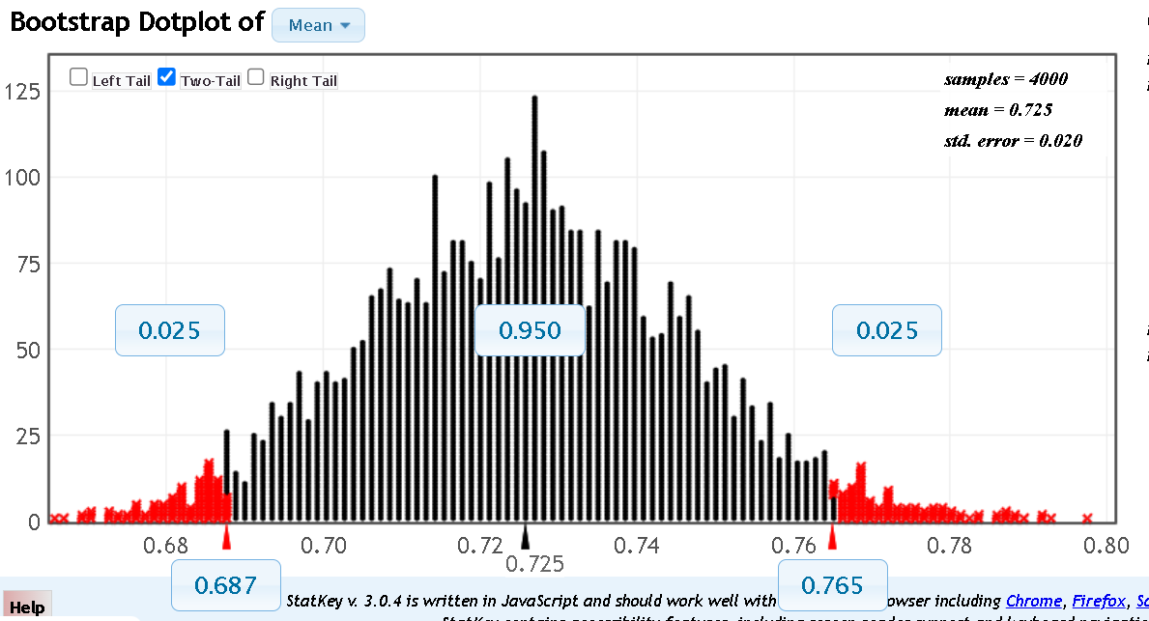

- The typical experienced weightlifter is likely to be able to press more with the barbell than with dumbbells. This is largely due to the barbell being easier to balance and control, so you can focus on pushing more weight. Does the confidence interval you calculated in the previous question support this idea? Briefly explain why or why not.

Yes, this would imply that barbell > dumbbell, which in turn implies that the ratio would be less than one.

- Considering your previous concerns regarding data, do you believe that the range of plausible values for the “average ratio” presented in this confidence interval is meaningful? If so, what audience would it apply to? If not, why do you feel it not useful? Explain your answer.

Answers vary and no answer is likely 100% correct. Some answers could mimic something like:

Students that feel it is meaningful:

If we limit ourselves to just people similar to those that would likely be on a fitness subreddit, we can provide them with some rough guidance on what is a meaningful balance between the two exercises.

Students that feel it is not meaningful:

The sample size is too small and there is likely too many issues with the data collection to be able to provide a reasonable, precise estimate for the population mean. As of right now, this would only apply to people who regularly do these exercises and work out, as the people who self-reported their data probably lean more towards that audience. Perhaps if there was a larger sample size, the population mean presented in the confidence interval could apply to a larger audience.

Again, we note that there is no clear answer to this question. Like many datasets we encounter in real life we need to decide if limited data are still useful, or if their shortcomings invalidate any results. (tldr; is this a case of “garbage in, garbage out?”)

- We’ve seen that Melissa has a ratio of 0.8. Suppose that she is an avid follower of r/Fitness. Now, she has a goal to become more “balanced” and have more of an average ratio in line with what she believes to be her peers. What should she do in order to achieve this? Explain both in terms of the ratio and the exercises involved.

Since Melissa’s ratio is below the average, she would need to decrease her ratio. Assuming she is interested in gaining strength, she can become more balanced by getting better at barbell bench press (i.e., increasing the denominator of ratio) so that it is even more than the amount she can flat dumbbell press (the numerator) and thus making the ratio smaller.

- Suppose you wish to further investigate the strength ratio. How would you go about finding more generalizable results? Be specific.

To get more useful data some of the things that you would need to consider are

- Devise a (more) clear group of individuals you wish to learn about,
- Develop a sampling procedure to collect data from the desired population, and
- Determine how large of a sample size would be sufficient to obtain the wanted precision for the CI.

This question can provide the beginnings of a discussion related to study planning and may then extend into topics such as sampling design and sample size calculations. Further, it allows instructors to discuss with students the difficulty in collecting “perfect data” and/or how crude data, such as from Reddit forums, can be used for generating hypotheses and guiding more extensive, controlled studies.

- Instead of just the ratio, what other information might be useful to collect that might make the data more useful?

Answers will likely vary, but the idea is to have students think about the limitations of just recording the ratio. As a simple example, recording the amount of weight associated with both the dumbbell press and bench press could be useful. One could be convinced that for people that aren’t lifting large weights, the “stabilizer muscles” might not be as much of a limitation for dumbbell press. (Or statistically, people lifting lighter might naturally have ratios closer to 1. We would need the weights associated with each portion to investigate this.)

Reddit Thread: https://www.reddit.com/r/Fitness/comments/35q4i3/how_much_do_you_dumbbell_flat_bench_compared_to/

