Understanding Variability in Boston Marathon Finish Times
The Boston Marathon is an annual marathon traditionally held on Patriots’ Day, the third Monday of April. Begun in 1897, the event is one of the world’s oldest annual marathons and ranks as one of the world’s most prestigious road racing events. The Boston Marathon attracts runners from all over the world, featuring thousands of participants and extensive spectator support, embodying the spirit of community and endurance.
We will be investigating the results from the 2023 Boston Marathon - which consists of 26,598 runners that completed the race. In addition to the name and gender of the runner, the finish_net_minutes variable shows the race result time of the runner that is timed from when they cross the starting gate at the beginning of the race to the finish line. The full data (boston_marathon_2023.csv) is available at SCORE Data Repo and contains many more variables associated with the runner information and times.
- The histogram below displays the distribution of finish times for all 26,598 participants. Use it to help answer the following questions.

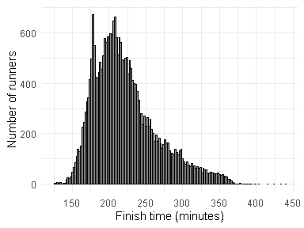
- Describe the shape, center, and spread of the distribution.

- Identify some potential confounding variables that might help explain why there is variability in finish times.

- The output below displays the distribution of finish times participants separated by gender (M = Men, W = Women) as well as some summary statistics. Use it to help answer the following questions.
 | M | W
Mean | 212.42 | 235.93
SD | 43.66 | 40.14
Max | 433.65 | 440.52
Q3 | 233.74 | 255.87
Med | 200.93 | 226.05
Q1 | 179.56 | 207.68
Min | 125.9 | 141.63
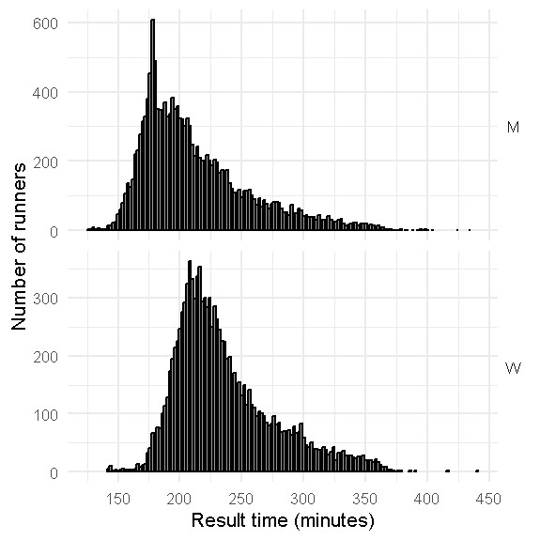
- Compare and contrast the distributions for men and women finish times. Be sure to comment on how the centers, spreads, and shapes compare.

- Evans Chebet, from Kondabilet, Kenya, was the fastest male to complete the race clocking in at 125.9 minutes. (Evans also won the 2022 Boston and 2022 New York marathons) Hellen Obiri, from Kisii, Kenya, won the women’s competition with a time of 141.63 minutes. (Hellen also won the 2023 New York marathon and is a two-time silver medalist in the 5000m event.) Relative to the competition of the same gender, which runner, Evans or Hellen, had the better finishing time? Justify your answer numerically.

