The dataset ironman_lake_placid_female.csv contains data on female finishers of the Lake Placid Ironman Triathlon from 2002 to 2022. The motivation for this data analysis is to explore the relationship between swim, bike, and run times (in minutes) in order to gain insights into the performance patterns of the athletes. For this activity, we will specifically focus on times from 2022 Canadian Finishers. Use the output provided on the final pages to help answer the following questions.
Model 1: Bike Times
- Fit and report the least squares regression equation for predicting Run Time (the last stage of the event) using Bike Time (in minutes).
$$\hat{RunTime}= -74.2+0.9109(BikeTime)$$

- Examine residual plots for this model. Do you have any concerns about the appropriateness of this linear model?
There is no curvature or other trends in residual vs. fits plot – Linearity
There is no fanning or funneling in residuals vs. fits plot – Equal Variance
The Normal Probability plot follows the expected linear trend.
Overall, there are no concerns about the appropriateness of a linear model.

- Test (include all steps) if there is evidence that Bike Time (in minutes) is a useful predictor of Run Time?
Step 1:
$$H_{o}: β_{1}=0$$
$$H_{a}: β_{1}≠0$$

Step 3: Test Statistic
t = 11.12
df = 62
p-value = 0.000

Step 2: Conditions
Already checked in Question 2

Step 4: Conclusion
Reject the Null
There is very strong evidence that Bike Time is a useful predictor of Run Time

Model 2: Swim Times
- Fit and report the least squares regression equation for predicting Run Time using Swim Time (in minutes).
$$\hat{RunTime}= 115.7+2.417(SwimTime)$$

- Examine residual plots for this model. Do you have any concerns about the appropriateness of this linear model?
There is no curvature or other trends in residual vs. fits plot – Linearity
There is no fanning or funneling in residuals vs. fits plot – Equal Variance
The Normal Probability plot follows the expected linear trend.
Overall, there are no concerns about the appropriateness of a linear model.

- Construct and interpret a 95% confidence interval for the population slope relating Run Time and Swim Time.
$$β_{1}±t^{*}\left(SE_{β_{1}}\right)$$
$$3.579 ±2(0.526)$$
(2.527 , 4.631)
Conditions: Already checked in Question 5
n = 64
df = 62
t* = 2

With 95% confidence, when the Swim Time increases by 1 minute, the predicted Run Time will increase between 2.527 and 4.631 minutes

- Based on your confidence interval, is there evidence that Swim Time is a useful predictor of Run Time? Explain briefly.
Yes. Because 0 (meaning not useful) is not contained in the confidence interval

Model 3: Both
- Now put both Bike Time and Swim Time. (in minutes) in the model as predictors of Run Time. Report the resulting equation below. This is a multiple linear regression model.
$$\hat{RunTime}= -68.6+1.093\left(SwimTime\right)+0.656(BikeTime)$$

- Predict the Run Time of Melanie McQuaid who had Bike Time of 305.53 minutes and a Swim time of 58.05 minutes
$$\hat{RunTime}= -68+0.973\left(58.05\right)-0.377\left(305.53\right)= 207.4 minutes$$

- Compute the residual of the Melanie McQuaid. The actual run time was 205.75 minutes
$$205.75-207.4= -1.65 minutes$$

- Contrast the output from this multiple linear regression model with the output from Models 1 and 2. What differences do you notice?
Answers may vary
Sample Response: The biggest difference from the new output is that Swim Time is no longer significant, but when it was in a model by itself, it was a useful predictor. Possible reasons for this is that Swimming and Biking are also correlated with one another, so you only need one of them to predict Run Times, and Bike Times just happens to do a better job.

- Which model would you recommend using and why?

Answers will likely involve comparing R-Squared and/or significance values.

Model 1 Output
Regression Equation
Run.Time | = | -72.4 + 0.9109 Bike.Time
Coefficients
Term | Coef | SE Coef | T-Value | P-Value | VIF
Constant | -72.4 | 34.2 | -2.11 | 0.039
Bike.Time | 0.9109 | 0.0819 | 11.12 | 0.000 | 1.00
Model Summary
S | R-sq | R-sq(adj) | R-sq(pred)
30.1830 | 66.62% | 66.08% | 64.64%
Analysis of Variance
Source | DF | Adj SS | Adj MS | F-Value | P-Value
Regression | 1 | 112706 | 112706 | 123.72 | 0.000
Bike.Time | 1 | 112706 | 112706 | 123.72 | 0.000
Error | 62 | 56483 | 911
Total | 63 | 169188
Fits and Diagnostics for Unusual Observations
Obs | Run.Time | Fit | Resid | Std Resid
1 | 205.75 | 205.95 | -0.20 | -0.01 |  | X
44 | 375.48 | 307.76 | 67.72 | 2.26 | R
57 | 399.78 | 337.29 | 62.50 | 2.10 | R
63 | 417.40 | 355.22 | 62.18 | 2.10 | R
R Large residual
X Unusual X
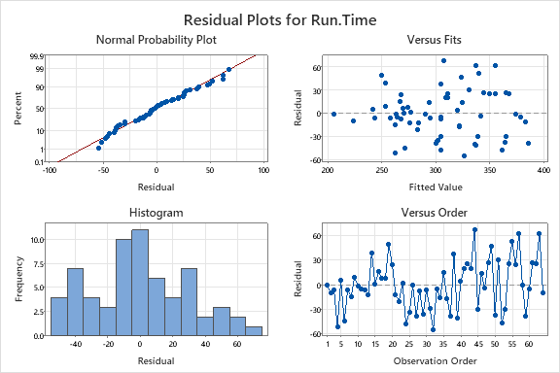

Model 2 Output
Regression Equation
Run.Time | = | 305.88 + 0.0015 Swim.Time
Coefficients
Term | Coef | SE Coef | T-Value | P-Value | VIF
Constant | 305.88 | 6.84 | 44.73 | 0.000
Swim.Time | 0.0015 | 0.0154 | 0.10 | 0.923 | 1.00
Model Summary
S | R-sq | R-sq(adj) | R-sq(pred)
52.2344 | 0.02% | 0.00% | 0.00%
Analysis of Variance
Source | DF | Adj SS | Adj MS | F-Value | P-Value
Regression | 1 | 26 | 25.78 | 0.01 | 0.923
Swim.Time | 1 | 26 | 25.78 | 0.01 | 0.923
Error | 62 | 169163 | 2728.43
Lack-of-Fit | 60 | 167361 | 2789.36 | 3.10 | 0.275
Pure Error | 2 | 1801 | 900.63
Total | 63 | 169188
Fits and Diagnostics for Unusual Observations
Obs | Run.Time | Fit | Resid | Std Resid
34 | 305.9 | 311.1 | -5.3 | -3.99 | R | X
63 | 417.4 | 306.0 | 111.4 | 2.15 | R
R Large residual
X Unusual X
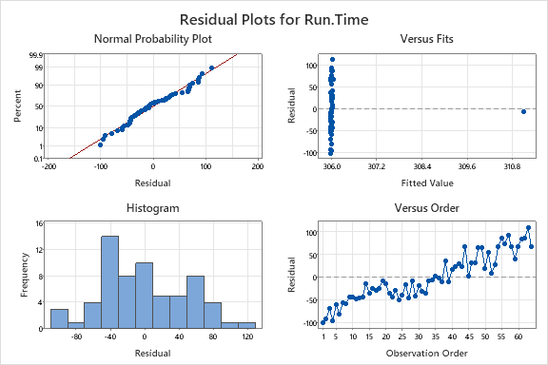

Model 3 Output
Regression Equation
Run.Time | = | -72.9 - 0.00494 Swim.Time + 0.9138 Bike.Time
Coefficients
Term | Coef | SE Coef | T-Value | P-Value | VIF
Constant | -72.9 | 34.4 | -2.12 | 0.038
Swim.Time | -0.00494 | 0.00896 | -0.55 | 0.584 | 1.00
Bike.Time | 0.9138 | 0.0825 | 11.07 | 0.000 | 1.00
Model Summary
S | R-sq | R-sq(adj) | R-sq(pred)
30.3540 | 66.78% | 65.69% | 0.00%
Analysis of Variance
Source | DF | Adj SS | Adj MS | F-Value | P-Value
Regression | 2 | 112985 | 56493 | 61.31 | 0.000
Swim.Time | 1 | 279 | 279 | 0.30 | 0.584
Bike.Time | 1 | 112959 | 112959 | 122.60 | 0.000
Error | 61 | 56203 | 921
Total | 63 | 169188
Fits and Diagnostics for Unusual Observations
Obs | Run.Time | Fit | Resid | Std Resid
34 | 305.9 | 305.4 | 0.4 | 0.78 |  | X
44 | 375.5 | 308.1 | 67.4 | 2.24 | R
57 | 399.8 | 337.6 | 62.2 | 2.07 | R
63 | 417.4 | 355.6 | 61.8 | 2.08 | R
R Large residual
X Unusual X
