This statistics worksheet examines the goals and shots in two prominent lacrosse leagues: the Premier Lacrosse League (PLL) and the National Lacrosse League (NLL). The PLL and NLL are highly regarded professional lacrosse leagues that feature top-tier athletes from around the world. The PLL is played in an indoor, smaller field while the NLL plays on an outdoor field with traditional dimensions. This worksheet will provide an analysis of goal-scoring within these leagues. The data is collected from the PLL and NLL website. Specifically, all games played in the 2021-2022 season.

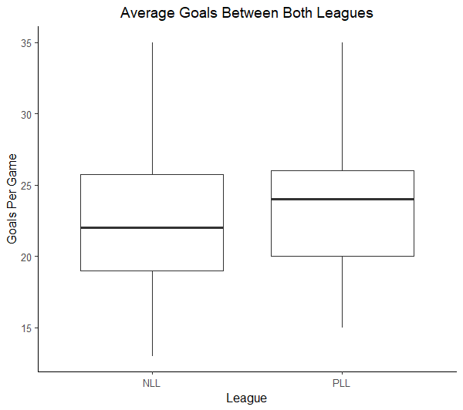

**Descriptive Statistics for Goals:**

|  |  |  |  |
| --- | --- | --- | --- |
| **League** | **N** | **Mean** | **StDev** |
| NLL | 126 | 22.262 | 4.847 |
| PLL | 36 | 23.889 | 4.496 |

1. Identify both variables in this data.
2. Do these data provide evidence that, on average, goals scored in the PLL and NLL differ? Include all details of the appropriate hypothesis test.
3. Construct a 95% confidence interval in average goals for NLL and PLL lacrosse games. What do you notice about this confidence interval?

Upon further analysis of the leagues, you discover that the NLL and the PLL play their games for different amounts of time. The PLL plays games for 48 minutes, while the NLL’s games are 60 minutes long. In an effort to correct this mistake, we will “scale down” the NLL goals to a 48 minute rate.

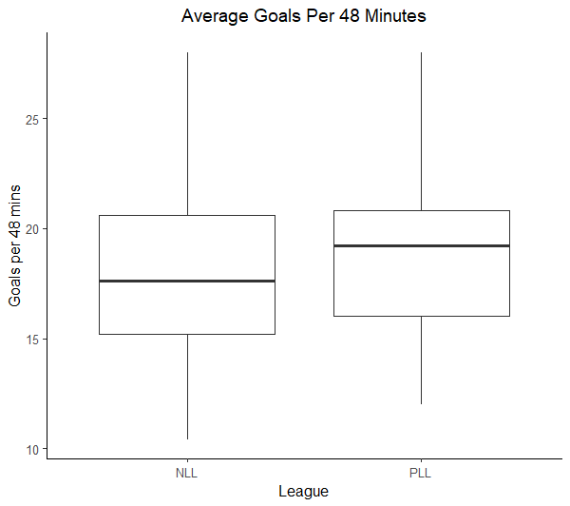

**Descriptive Statistics for Goals (per 48 minutes):**

|  |  |  |  |
| --- | --- | --- | --- |
| **League** | **N** | **Mean** | **StDev** |
| NLL | 126 | 17.810 | 3.877 |
| PLL | 36 | 23.889 | 4.496 |

1. Do the new data provide evidence that, on average, goals scored in the PLL and NLL differ? Compute a new test statistic and state your findings.
2. Construct a 95% confidence interval in average goals for NLL and PLL lacrosse games per 48 minutes.   
   What is different about this confidence interval?
3. Based on the confidence interval, what can we conclude about the amount of goals in theh